Linux System Activity Reporting
Produced by: Douglas.Gaer@noaa.gov
Last modified: 05/03/2011

Overview:
This is a short procedure used to graph various operating system statistics. This procedure is intended to be used for producing system snapshots over time periods of intense system usage.

Linux Setup:
This procedure requires the Linux System Activity Reporter or SAR. SAR is part of the Red Hat Enterprise (RHEL) 5 and 6 distributions but is not part of a minimal operating system installation. Under RHEL 5 and 6 SAR is installed as part of the “sysstat” package. To check for the systat package on your workstation, run the following command:

> rpm -qa | grep sysstat

You should see the following output, where “x.x.x-xx” represents the version number of the package:

sysstat-x.x.x-xx

If you do not have the systat package installed the RPM command will not return any output. NOTE: To install the package you will need “root” access or your system administrator will need to install the following:

> sudo su - root
# yum install sysstat
# exit

Once installed the sysstat package will place a cron in “/etc/cron.d” that will collect system statistics. The SAR reports are stored as flat files in the system logging directory:

/var/log/sa

NOTE: The “/var/log/sa” directory can be read as any user. As any user you can view SAR reports from the command line:

> sar

Or:

> sar | less

In the example above, press 'q' to exit the “less” command. The commands above will output something similar to the follow.

Linux 2.6.32-71.18.2.el6.x86_64 (SRH-LW-TIBITO1 05/03/2011 _x86_64_ (2 CPU)

12:00:01 AM CPU %user %nice %system %iowait %steal %idle
12:10:02 AM all 1.98 0.00 0.31 0.93 0.00 96.79
12:20:01 AM all 0.08 0.00 0.14 0.98 0.00 98.80
12:30:01 AM all 0.35 0.00 0.16 0.78 0.00 98.70
12:40:01 AM all 0.09 0.00 0.14 0.90 0.00 98.88

Graphing SAR Reports Using KSAR:
KSAR is a free Java-based utility that allows you to graph SAR reports. The KSAR utility is available at:

http://sourceforge.net/projects/ksar/

Using Firefox on you Linux workstation navigate to the above URL and download the latest distribution to your Desktop. NOTE: This is Java-based program so your Linux workstation will need the Java run-time environment installed. If it is not possible to run KSAR on your Linux workstation or server you can collect the “/var/log/sa” files and use KSAR on another workstation or on a Windows desktop to graph offline “/var/log/sa” files.

After downloading KSAR to your Desktop, unpack and start the utility:

> cd $HOME
> unzip ${HOME}/Desktop/kSar-5.0.6.zip
> cd $HOME/kSar-5.0.6
> chmod 755 run.sh
> ./run.sh

When KSAR starts you will have 3 options to load system report data.

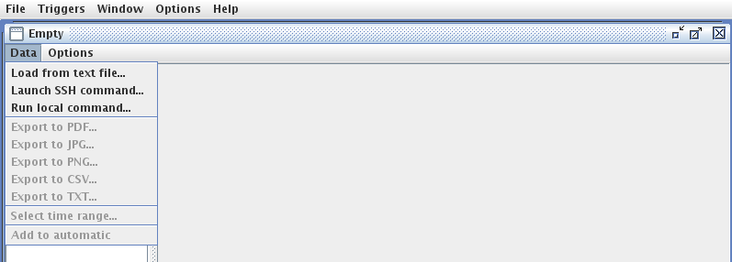
For real time statistics select the Run local command option. When you select the Run local command option you will be prompted with the following:

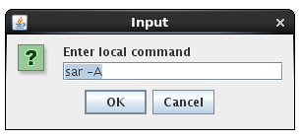
Click on the OK button and KSAR will compile your system statistics. To graph your CPU statistics expand the CPU tree and select CPU all or individual CPU 0, 1, etc statistics:

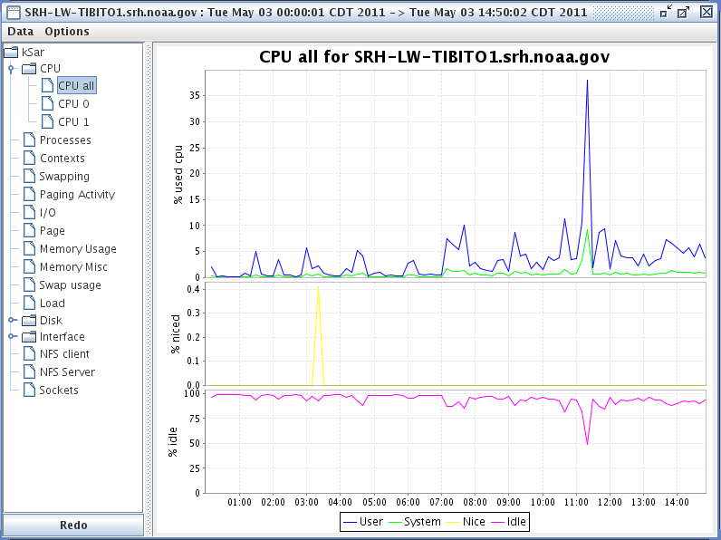

To graph your memory statistics click on Memory usage:

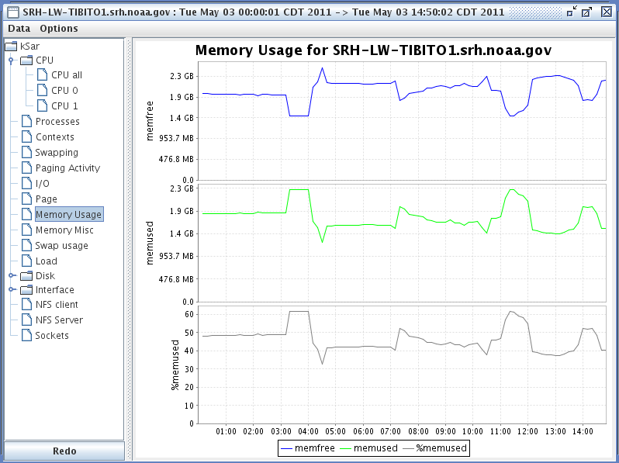

To load offline reports click on the Load from text file option:

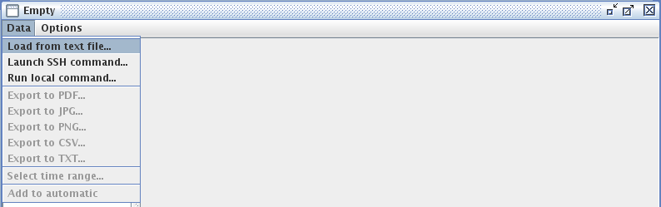

A dialog will appear asking you for a file to load. Navigate to the offline location of your SAR log files and select the file for the day you would like to generate statistics for:

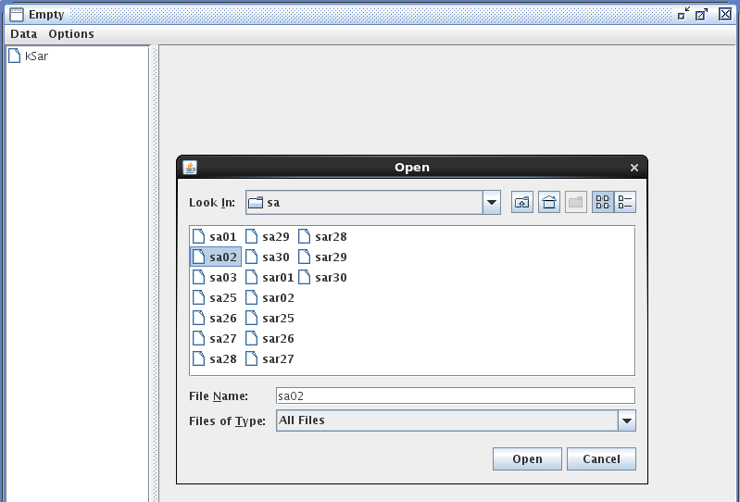
After selecting the file, KSAR will generate the graphical reports.

