David Gajda

Programming Portfolio Project: Client-Server Chat Game

1. a) My program is python3. To run the program, in the terminal go into the directory where the ‘client.py’ and ‘server.py’ files are located. Once there, type ‘python3 server.py’. This will have the server waiting for connection from the client. Then open a new terminal tab in the same directory and type python3 ‘client.py’. Now you will be able to use the program.

b) **Screenshots of running program:**

The server.py running:

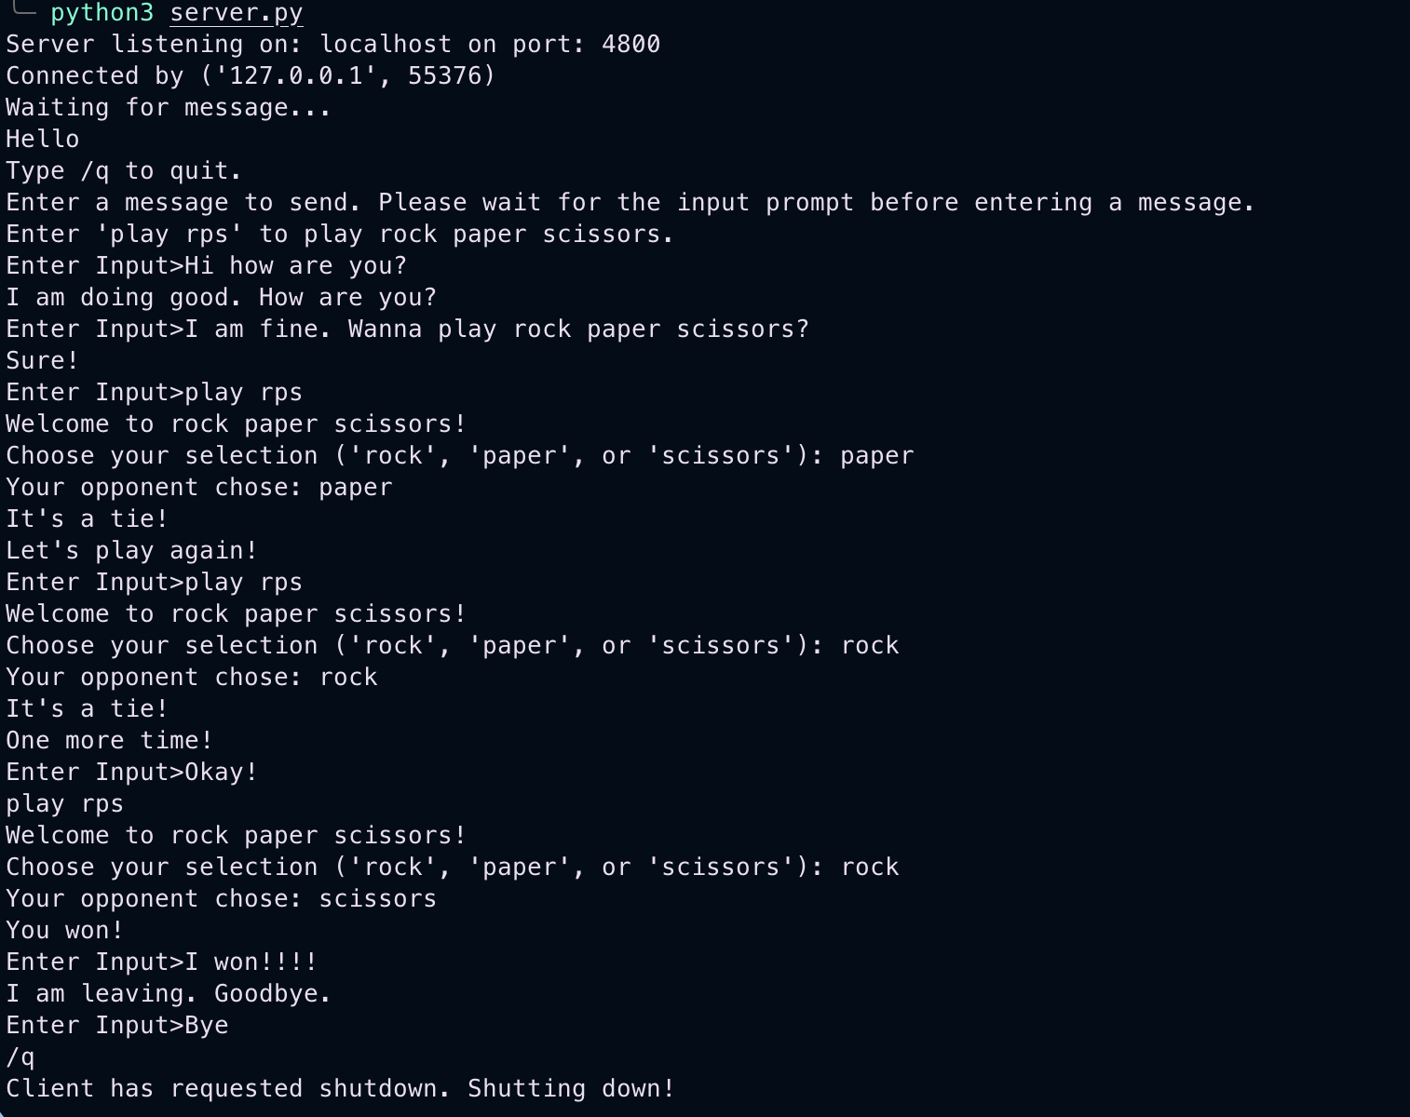

Same run of the program but from the client side:

c**) I also added some validation in the rock paper scissors game to make sure the user inputs a valid selection. Here are screenshots of that happening:**

Server end:

Client end:

Also wanted to add that the rock paper scissors game can be started from both the client and the server. One more thing, the connection can be closed from both client and server as well.