**David Gajda**

[**gajdad@oregonstate.edu**](mailto:gajdad@oregonstate.edu)

**Solar System Model**

1. **The text from your proposal:**

Here is my original text from my final project proposal: For my final project, I am planning on creating a solar system. While this is most likely a common selection, I think it will be good for training implementing my own “physics” as well as various objects. My solar system will consist of all the planets, including Pluto (not a planet) and they will be in orbit around the sun. I will keep their scaling relative (except for the sun which would be much too big). I will implement textures on each planet as well as shadows (if I am able to succeed with them). This project will push me to be creative while also keeping a model (the actual solar system) in mind which will give me a goal that I can work towards.

1. **What you actually did for your project:**

In my project, I created a visually appealing solar system model. The model has correct scaling between each planet’s respective size and orbital radius. Incorrect scaling is found when you compare the planet size with the orbital radius, as well as the sun size. However, this was a design choice I had to make so that my project would display every planet and so that every planet was visible. If I used 100% accurate scaling, the sun would overtake the entire seen and the outer planets would be too far away to see. Besides scaling, I also implemented Kepler’s third law of planetary motion. This is visible in my project because, while all planets begin the animation at the same location in their orbit, they vary, with the closest planets to the sun have a faster orbit and the farther planets having a slower one. In addition to Kepler’s third law, I also added lighting from the sun on the scene. This gives a more realistic look as the back side of each planet is dark, like that of the real solar system. I have also included each planet’s orbit as a ring making it easily visible.

1. **How your project differs from what you proposed, and why:**

When comparing to my final project proposal, I made a few changes while implementing my project. First, I did not end up including Pluto. Looking at Pluto’s relative distance to the sun compared to the other planets, I found it to be unreasonably far, and it would have made my project look less clean. I believe that excluding it was a better choice as I can view the correct scaling while maintaining a clean aesthetic throughout. The second change from my outline was that I did not include shadows on my planets. I found that the point light and ambient light settings that I used implemented realistic lighting and shadows were not necessary to make my solar system look good. Also, while I didn’t mention it in my outline, one thing that I added that is slightly different from the solar system notes is that each planet’s orbit has a different color. Not only does this make the project look better overall, but it also easily differs the various planet orbits from each other.

1. **(optional) Any impressive cleverness you want us to know about:**

While I wouldn’t say it is necessarily clever, but good coding practice saved me a lot of time when working on this project. Creating good global variables, creating functions to perform repetitive work, and using consistent scaling practices all allowed my project to compute its own math within the code. Outside of the code, I did not have to compute exact numbers as I just allowed the code to do the computing for me.

1. **What you learned from doing this project (i.e., what you know now that you didn't know when you started):**

My biggest takeaway from this project is the effectiveness of using clean code practices. My implementing clean code, I saved myself an immense amount of time whereas, otherwise, I would spend decent time computing calculations and ensuring my scaling is correct. Using clean code, I was able to change one value, to adjust scaling and every planet was updated consistently, not just one. I also was able to solidify the content that I learned throughout the course withing this project. I used lighting, textures, animations, and object generation to create my project. I combined most of the topics we learned about throughout the semester into one project.

1. **Some images that are especially representative of what you did:**

Here are some images from my project:

Here is an overall view:

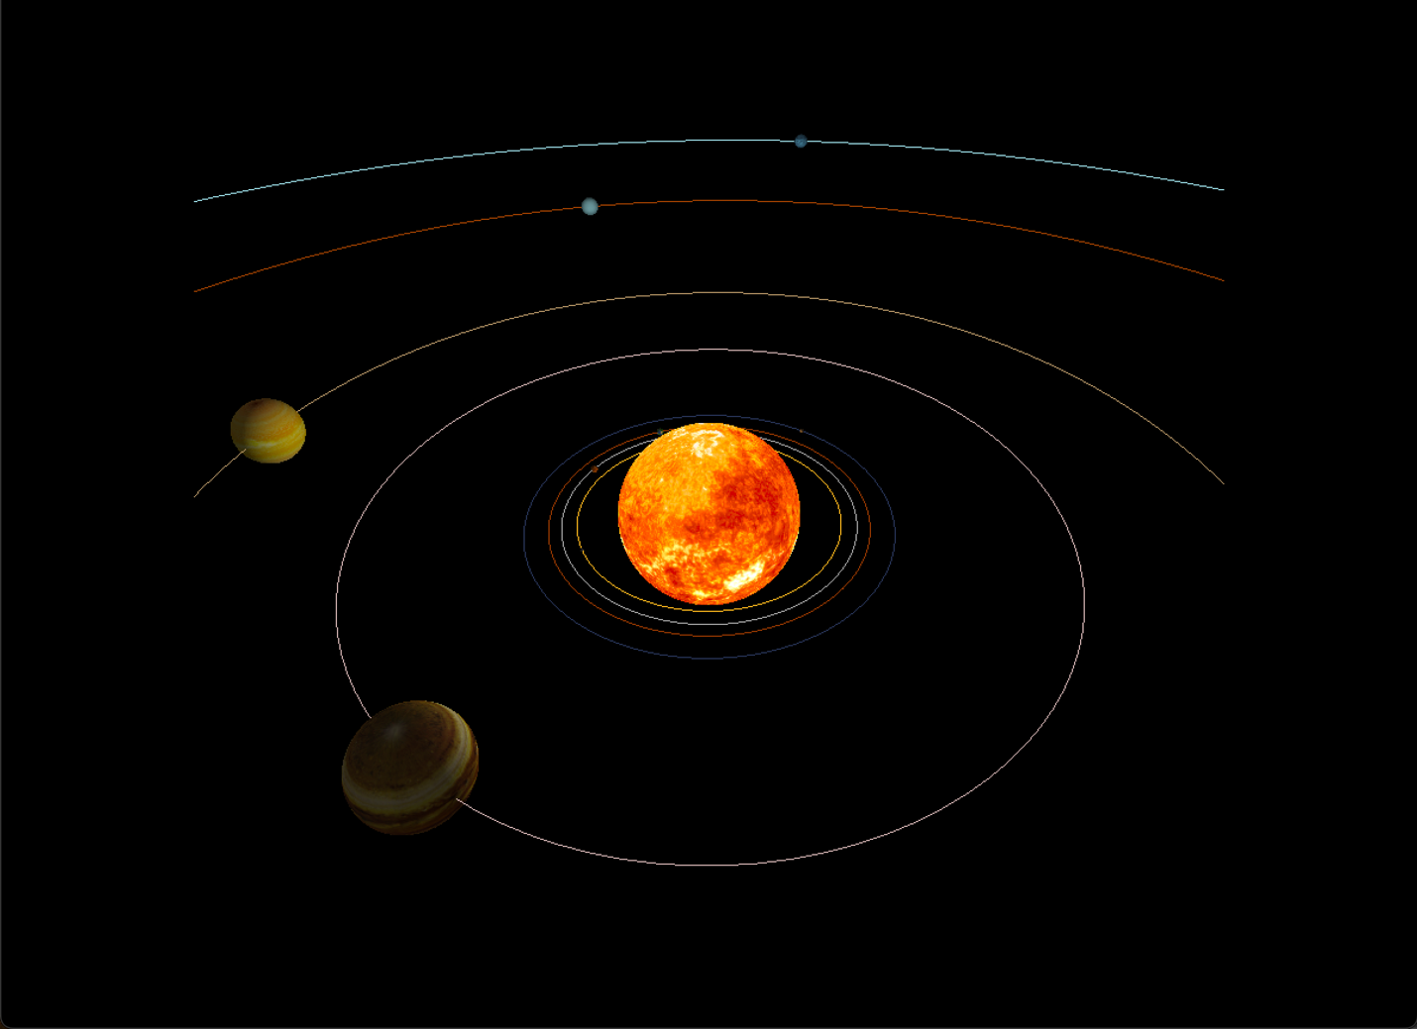

Here is a closeup on the planets closer to the sun:

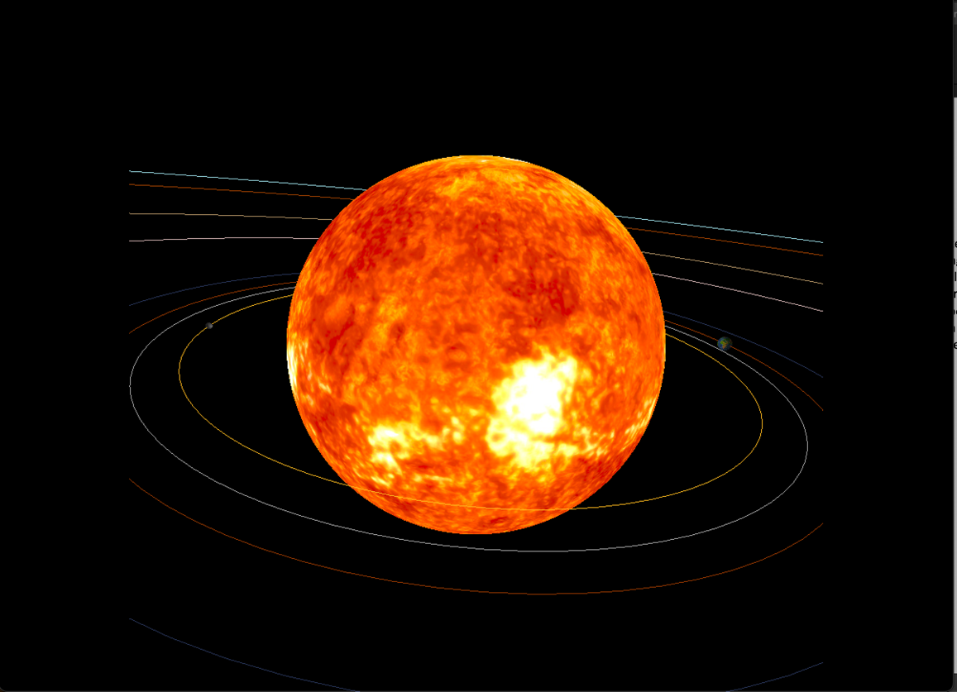

Here is a top-down view, where you can see the correct orbital radius scaling:

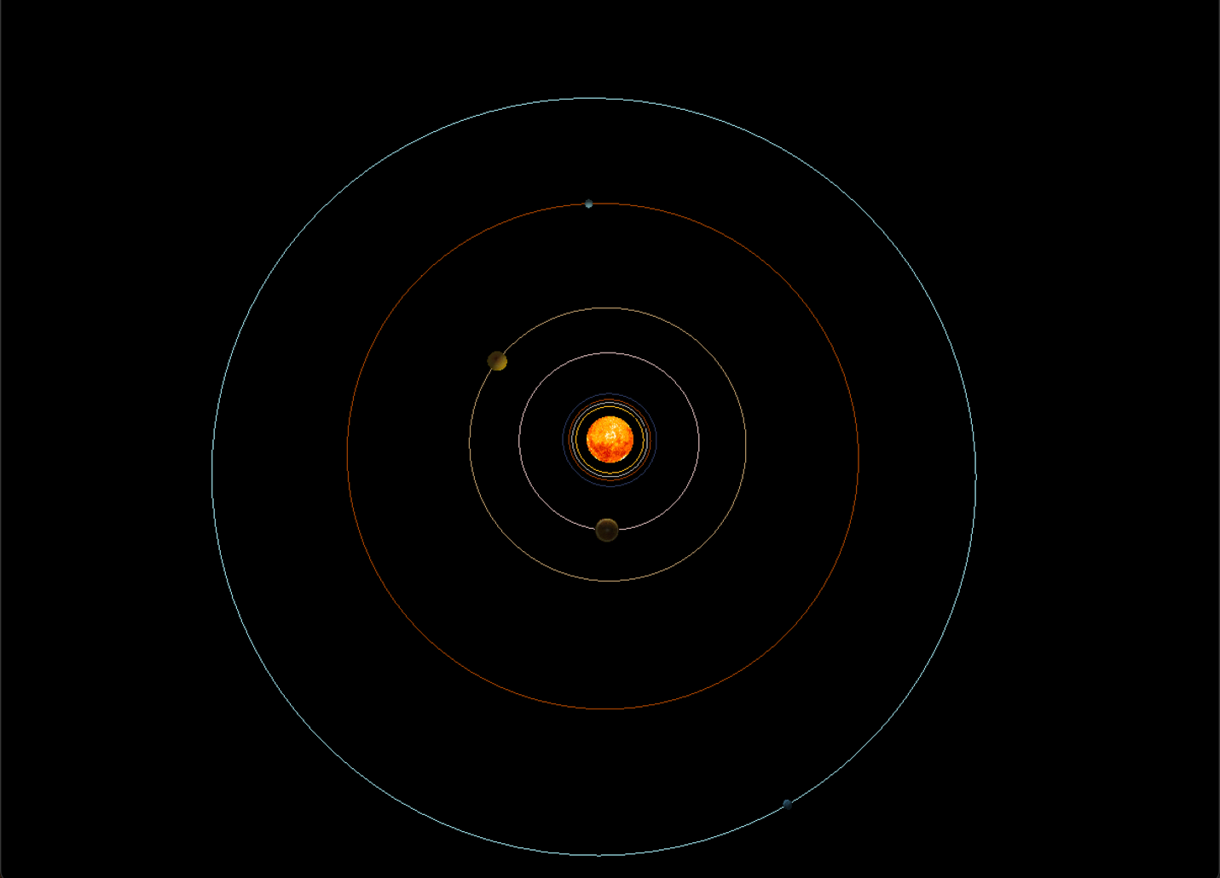

Here is a view where you can see the front and backside of a planet. It is demonstrating that lighting is working correctly.

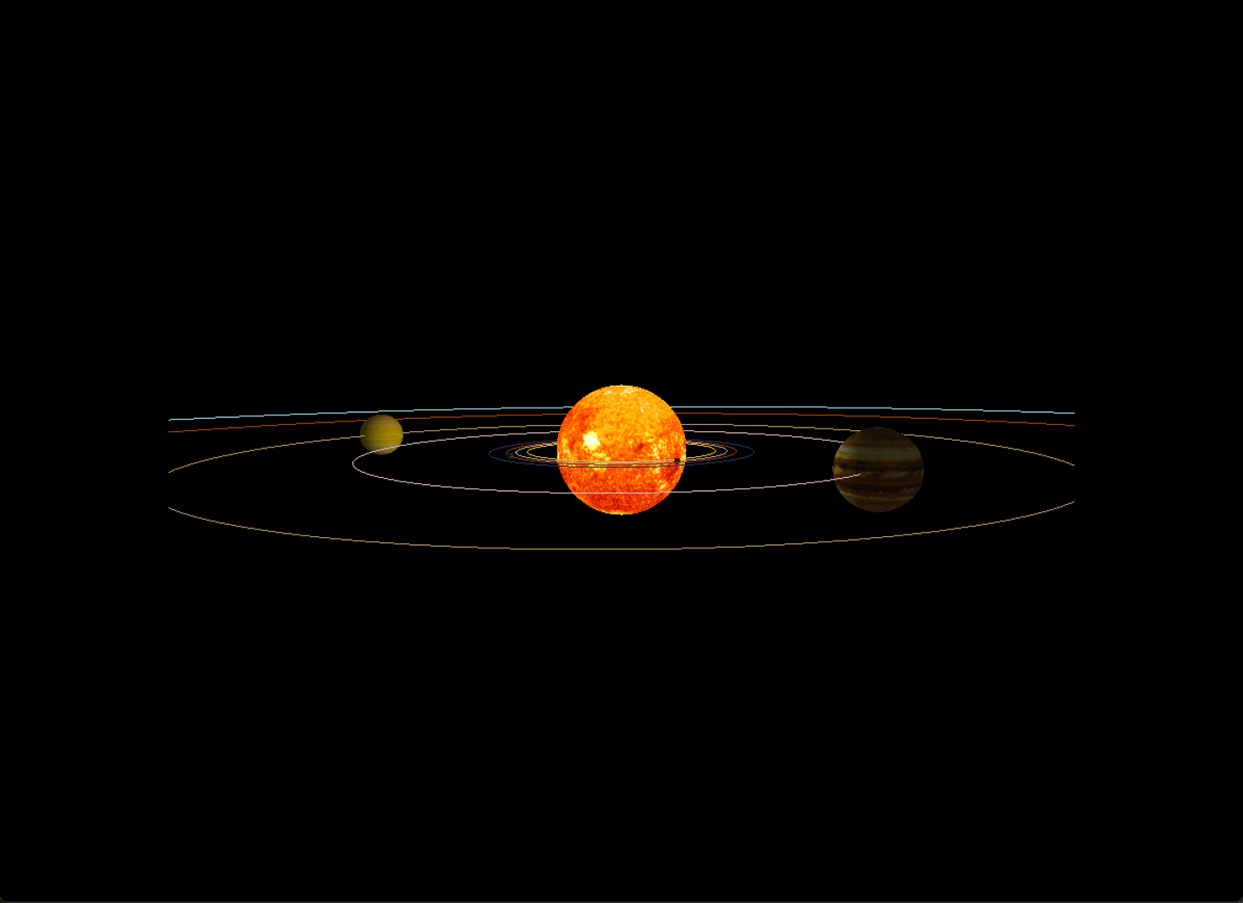

1. **A link to the video showing off your project:**

Here is the link to my Kaltura video: <https://media.oregonstate.edu/media/t/1_9zlf18w3>

**References:**

The textures I used came from: <https://nasa3d.arc.nasa.gov/images>