Contents

Contents 1
Introduction 1
Getting Started 2
How do I use the main menu? 3
How do I know where I am? 4
How do I get back to the main menu? 4
Using the different features 5
Making a booking! 5
Editing a booking! 6
Viewing bookings! 7
Delete bookings! 8
Delete all bookings! 9
Exiting the program! 9

Introduction

This manual explains how to correctly operate Airline Booking Systems. Please read this user manual carefully before using Airline Booking Systems and then keep it near you for quick reference.

Airline Booking Systems is a program written in Pascal (an old programming language which produces text-based output).

The program allows you to virtually (it doesn’t happen in “real-life”) create, delete, view and edit bookings for an airline company (called Transman Airlines).

Getting Started

To start the program...

- Locate the file named airbook.exe, move your mouse cursor over it and double click with your left mouse button.
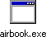
The icon should look just like this (above).
- This will open the program in an MS-DOS window. Once you have started the program, you will be prompted with a main menu (fig. 1.1). See how to use the main menu on the next page!
Fig. 1.1
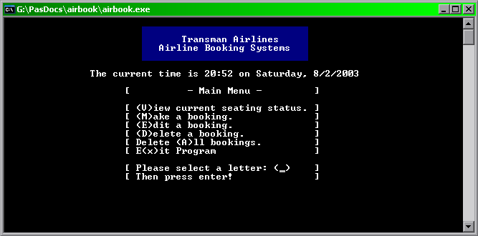
As the program is not actually connected to a remote server, Airline Booking Systems will only store the information you enter for as long as it is open; the ‘session’ will cease when you exit.

How do I use the main menu?
The menu works with 2 simple, easy steps...

1) Choose a letter which corresponds with your choice (fig. 2.1)
The corresponding letters are in brackets; i.e. “Select (m)e now?” - indicating that ‘m’ is the corresponding letter to that option.

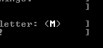
fig. 2.1

The user chose to “(M)ake a booking”.
2) Pressing Enter! (fig. 2.2)
Which will show an animated “Busy” dialogue, then take you to the page you chose.
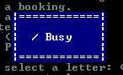
fig. 2.2

The requested action is now loading! Please be patient.

Caution!
Pressing keys whilst loading will most likely result in unwanted actions. Please be patent until the program asks you for your input.

How do I know where I am?
Each page has a “title” just below the time and blue logo (fig 2.3).
fig. 2.3

The “title” has been highlighted in white to show you an example of where it will be on each page.
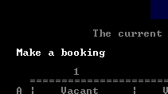

How do I get back to the main menu?
In this version of the program, there is no easy or quick way of going back to the menu once you are in a section of the program. The most advisable way of ‘going back’ to the menu, is to simply complete the action you are doing and then the program will automatically return you to the main menu.

Tip
You can enter uppercase letters, or lowercase letters when inputting options into the program. (e.g. from the main menu)

Using the different features

Making a booking!
To make a booking for a passenger, you first need to navigate yourself to the “Make a booking” section (using the instructions given erlier).

Once in the section, you will see an overview of the seating positions and all the Vacancies and Bookings. Cells marked “vacant” indicate that this seat has not yet been booked! If a seat has been booked already, you will not be able to re-book over it (as a failsafe). To replace a booking there are two methods; Delete a booking, then Make booking – or, Edit booking. These are described erlier.

To make a booking follow these easy steps...

1) Choose the ROW (horizontal).
ROWs are labled with letters (A to G). Once you have chosen a letter, press ENTER to continue (as shown below).


2) Next you will have to select a COLUMN (vertical).
The columns are labled with numbers (1 to 4). Once you have chosen a number, press ENTER to continue (as shown below).
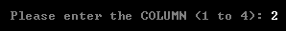
Tip
Don’t worry if you have accidentally entered a number instead of a letter, or vice versa; the program will automatically ask you to re-enter the value!

3) You will now have to confirm the ROW and COLUNM number (seat number).
The confirmation works on a yes or no answer; Y being for ‘yes’, and N being for ‘No’. Simply enter Y or N to either continue (Y) or abort and try again (N).

4) The next step is to enter a name of which the user is booked under.
First, simply enter a name – for example, Mr J Bloggs. Then press enter; this will also ask for confirmation (just like the last step); Y will make the booking, and N will abort.

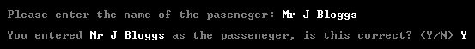

5) Complete the booking!
To complete the booking, all you have to do is overview all the information you have input and press enter! (As shown below).

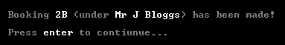

Upon pressing enter, you will automatically be taken back to the main menu.

Editing a booking!

The booking editor feature is exactly the same as the “Make a booking” feature, only instead of stopping you from re-booking, it simply overwrites the original entry with the new one!

Caution!
This action can NOT be “undone” once it has been carried out; it is permanent!

Viewing bookings!

To view the current seating status, simply navigate your way to the main menu, and choose V (for View current seating status) then press enter.

This will take you to an overview screen (which will look something like the following)...

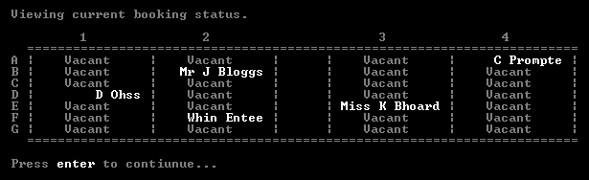

To continue back to the main menu, simply press enter (no option selecting is needed).

Delete bookings!

In order to delete a booking you have made, navigate yourself to the main menu and choose D (for (D)elete a booking) then press enter (just like before).

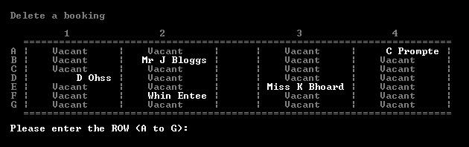

Just like the “Make booking” feature, you must select a ROW and a COLUMN so the program knows which booking you would like to delete.

1) Select the ROW, COLUMN then confirm (as shown below).

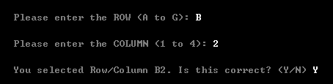

Remember to press ENTER after you enter each letter or number (B, 2 and Y).

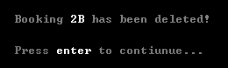

Once you have pressed enter after confirming the row and column, the computer will then confirm you exactly what it has done! In this case, the computer has deleted the booking on 2B (Column 2, Row B). To continue back to the main menu press enter.

Delete all bookings!

If you wish to reset the whole booking system so that there are no bookings whatsoever, you can easily do this by choosing A at the main menu (for Delete (A)ll Bookings). This will bring you to a confirmation screen where all you need to do is press enter to delete all the bookings.

Caution!
This action can NOT be “undone” once it has been carried out; it is permanent!

Exiting the program!

Once you have finished using Airline Booking Systems simply navigate your way back to the main menu, and choose the letter X (for E(x)it Program).

Caution!
The information you enter will not be saved once the session ends (once you close the program). There is also no way of saving data at all in this program (being only a simulation!)

Thank You for using Airline Booking Systems!

