Contents

Contents 1
Introduction 2
Getting Started 3
Get connected! 4
Valid account number? 4
Now for your PIN! 4
What NOT to do! 5
So you’re finally in? 6
Balance check 6
Main menu 6
View Balance 7
Withdraw Cash 7
Print Mini-Statement 7
Time to leave 8

Introduction

This manual explains how to correctly operate Virtual ATM Machine. Please read this user manual carefully before using Virtual ATM Machine and then keep it near you for quick reference.

Virtual ATM Machine is a program written in Pascal (an old programming language which produces text-based output).

As this the application only virtual, no official information is stored or required regarding real financial information.

Getting Started

To start the program in Windows

- Locate the file fwdatm.exe, and double click it with your left mouse button.
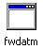
- Being an MS-DOS Program, it should start up in its own MS-DOS window.

To start the program in DOS

- Navigate to the directory (a folder) where the executable is (typing dir will list the directory contents).
- Once you locate the correct directory, type fwdatm.exe at the command prompt (Should look like - C:\>).

Once you have started the program, you will be prompted to enter your account number (as you obviously can’t swipe a card through your PC).

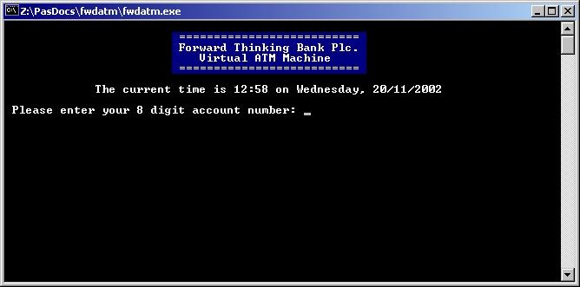

Get connected!

As the program is not actually connected to a remote server, Virtual ATM Machine will accept a valid account number.

Valid account number?
The valid account number consists of 8 digits and needs to be a number greater than 15151515 - i.e. 87654321.
If the account number is invalid (as shown below), the program will ask you if you would like to retry (to retry, you must enter Y).
Pressing N will exit the program (but not in all instances, as we will see later).

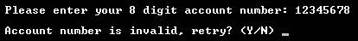

QuickTip
When you have entered the desired information into the program (be it letters or numbers), you must always press the enter key to proceed.

Now for your PIN!
All programs with security will always ask you for a password, this is so that only you can access your personal data. An ATM machine will do the same thing – when you swipe your card, you are always asked for a PIN (Personal Identification Number).

On Virtual ATM Machine, your PIN number can be any number which is either 4 or 6 digits long. For example:

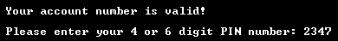

In the above example, the PIN 2347 was used. If you enter an invalid PIN, like 5 or 7 digits long, the program will ask if you would like to retry (same as with the account number).

What NOT to do!
At the current stages of development, Virtual ATM Machine does have some restrictions…

Danger!
When the program asks you to enter a NUMBER you must not enter anything but NUMBERS! Otherwise you will crash the program!

Although I do plan to fix this bug if the program is developed further, but for now you will just have to avoid putting letters in where numbers should be.

If the program does happen to crash, its perfectly ok to just go back to the beginning and start again!

So you’re finally in?

Balance check
Most ATM Machines nowadays will ask you if you would “like to check your balance on-screen before you proceed?”.

This is because when you want to use an ATM Machine, it’s always useful to know how much you can actually take out.

To check your balance, you must to enter y, or yes and then press enter!

You will se the “Press enter to continue...” message a lot in this program, as it is the GUI (Graphic user interface) equivalent to “Click OK to continue”.

Main menu
When you are all done and you have worked your way to the main menu, you will see a list of options. Anybody’s natural reaction to this is to grab your mouse and click on the option... notice how that doesn’t work here?

You have to use the numbers at the side of the options. Simply type the number next to the option you require and then press enter (as shown below).

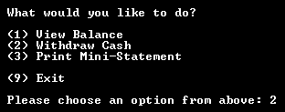

View Balance
Pressing 1, then enter will take you to the View Balance feature (offered just after you connect). This will bring up the exact same thing as if you were to say “yes” to the “would you like to check your balance on-screen before you proceed?” option.

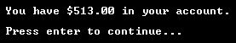

Withdraw Cash
This feature is almost exactly alike that of a real ATM machine; you can either enter a preset amount (i.e. 10s, 20s or 50s) – or you could key in a custom amount – e.g. 450.
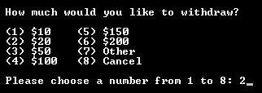

In this instance I have chosen to withdraw $20 – by entering in 2 and pressing enter.

If I was to need an amount that wasn’t on there, I would press 7 then enter. (as shown below)...

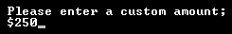

Once you have entered the desired amount, simply press enter and it will deduct it from your total balance.

Print Mini-Statement
You can get to this feature just like any other feature (by using the main menu as described above). This will not actually print a mini-statement of any shape or form. But it will simulate the printing of a mini-statement, just like a real ATM.

Time to leave
Once you need to leave the program, simply use the menu in the way that is demonstrated prior to now. To exit, you must be at the main menu!
The program doesn’t actually tell you this, but not only can you use 9 to exit the program. You can also use x or c...

