Dylan Gallup

CS 260 OOP

WK2 PAY CALCULATOR

Sources:

1. John Bontjes
2. Mr. Boulware

CRC CARD TABLE

|  |  |  |  |  |
| --- | --- | --- | --- | --- |
| Class Name | Responsibilities | Operations | Attributes | Collaborators |
| Main_Employee | Begins and ends the program.  Instantiates Employee to make and display Employee data. | Main.  Gets Employee Information.  Displays Employee Information. |  | Employee  Helpers |
| Employee | Business class that collects Employee data from the user and calculates the Gross Pay. | Calculate Gross Pay | Employee Name.  Pay Rate.  Hours Worked. | Main_Employee |

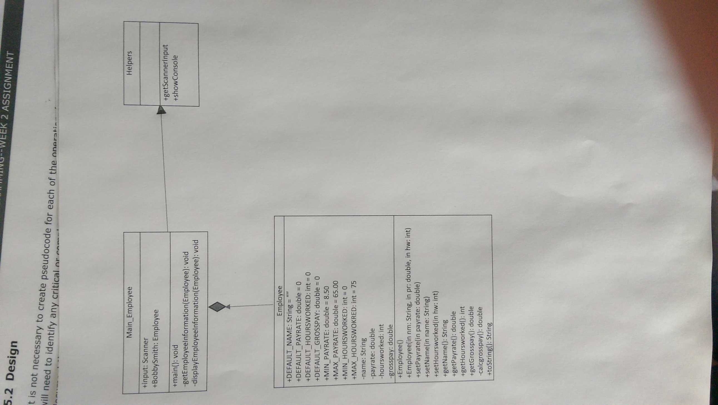UML Class/Object Diagram

Method Specification Form

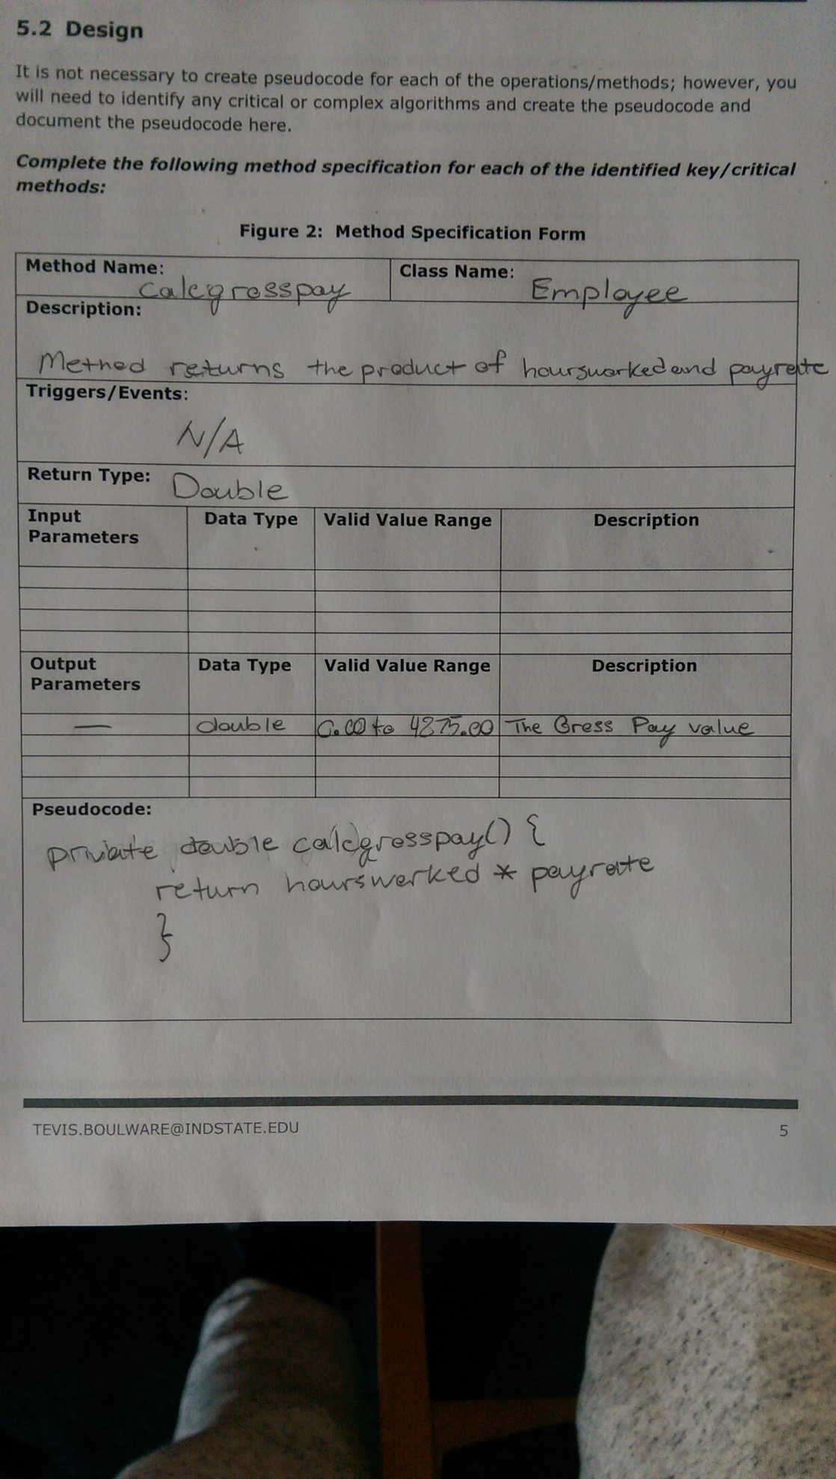

TEST CASES

|  |  |  |  |  |  |
| --- | --- | --- | --- | --- | --- |
| # | Purpose | Input Values | Expected Results | Pass/Fail | Comments |
| 1. | Check Bounds | Name: John  Pay rate: **-1**  Hours worked: 1 | Keep prompting for a value with in the acceptable range. | Pass |  |
| 2. | Check Bounds | Name: John  Pay rate: **66**  Hours worked: 1 | Keep prompting for a value with in the acceptable range. | Pass |  |
| 3. | Check Bounds | Name: John  Pay rate: **30**  Hours worked: 1 | Print:  Name: John  Pay rate: **30**  Hours worked: 1  Gross Pay = 30 | Pass |  |
| 4. | Check Bounds | Name: John  Pay rate: 9.00  Hours worked: **-1** | Keep prompting for a value with in the acceptable range. | Pass |  |
| 5. | Check Bounds | Name: John  Pay rate: 9.00  Hours worked: **76** | Keep prompting for a value with in the acceptable range. | Pass |  |
| 6. | Check Bounds | Name: John  Pay rate: 9.00  Hours worked:  **33** | Print:  Name: John  Pay rate: 9.00  Hours worked: **33**  Gross Pay = 297 | Pass |  |