Dylan Gallup

CS260: Object Oriented Programming

Professor Tevis Boulware

Week 4 Assignment

Sources: Professor Tevis Boulware

**UML Class/Object Diagram**

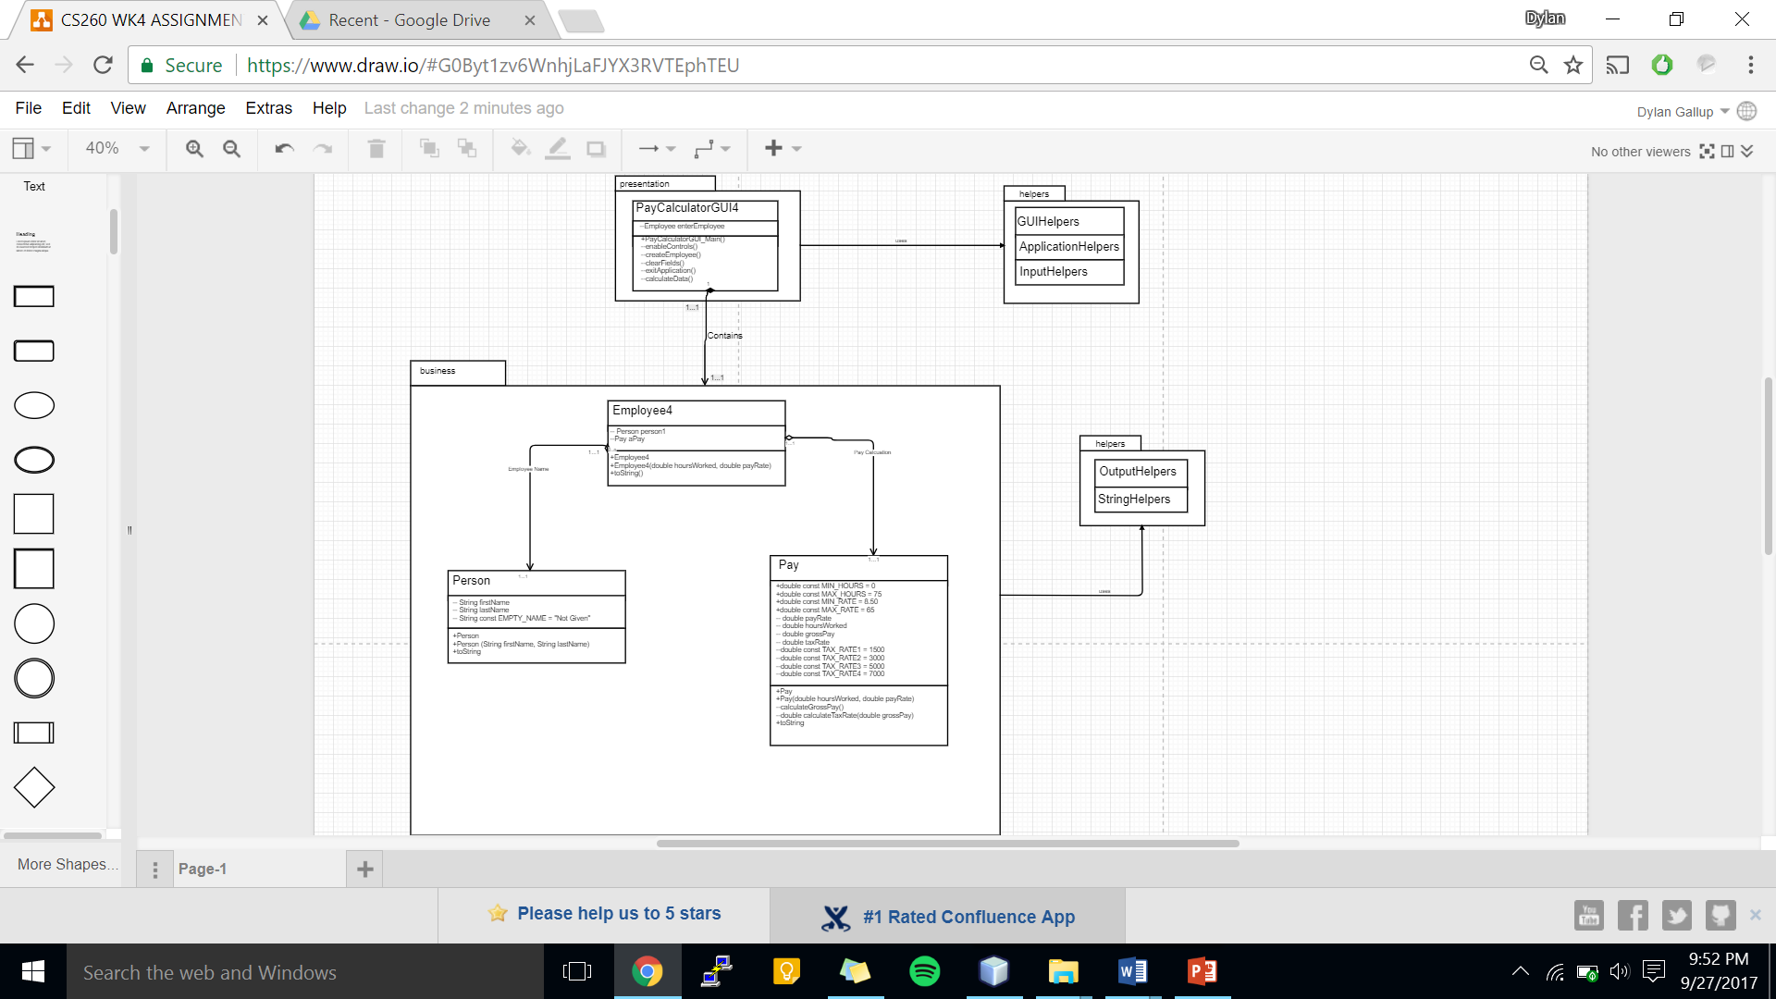

Method Specification Form

|  |  |  |  |  |
| --- | --- | --- | --- | --- |
| **Method Name**: netPayCalculation | | | **Class Name**: Pay | |
| **Description:**  Function uses grossPay calculation and taxRate to compute the Net Pay | | | | |
| **Triggers/Events**: | | | | |
| **Return Type:** double | | | | |
| **Input Parameters** | **Data Type** | **Valid Value Range** | | **Description** |
| grossPay | double | 0 or greater | | Takes grossPay for calculation |
|  |  |  | |  |
|  |  |  | |  |
|  |  |  | |  |
| **Output Parameters** | **Data Type** | **Valid Value Range** | | **Description** |
| netPay | double | 0 or greater | | Value after taxRate * grossPay |
|  |  |  | |  |
|  |  |  | |  |
|  |  |  | |  |
| **Pseudocode:**  if (grossPay < range 1) taxRate = .15  if(1500 <= grossPay < 3000) taxRate = .19  if(3000 <= grossPay < 5000) taxRate = .21  if(5000 <= grossPay < 7000) taxRate = .23  if(grossPay >= 7000) taxRate = .27  return taxRate * grossPay; | | | | |

**Test Cases**

Test Case Scenarios

|  |  |  |  |  |  |
| --- | --- | --- | --- | --- | --- |
| **#** | **Purpose** | **Input Values** | **Expected Results** | **Pass/Fail** | **Comments** |
|  | Check bounds | All valid inputs except  txtFirstName = NULL | Error Prompt to appear | **Pass** |  |
|  | Check bounds | All valid inputs except txtLastName = NULL | Error Prompt to appear | **Pass** |  |
|  | Check bounds | All valid inputs except  TxtHours = -1 | Error Prompt to appear | **Pass** |  |
|  | Check bounds | All valid inputs except  txtHours = 76 | Error Prompt to appear | **Pass** |  |
|  | Check bounds | All valid inputs except  txtPayRate = 7.00 | Error Prompt to appear | **Pass** |  |
|  | Check bounds | All valid inputs except  txtPayRate = 66.00 | Error Prompt to appear | **Pass** |  |
|  | Check Jbutton: Calculate | All valid inputs | Prints out Employee Data | **Pass** | Proves that program works to satisfaction |
|  | Check Menu Item: Calculate | All valid inputs | Prints out Employee Data | **Pass** | Proves that program works to satisfaction |
|  | Check Jbutton: Clear | Input in all text fields | Clears all text fields | **Pass** |  |
|  | Check Menu Item: Clear | Input in all text fields | Clears all text fields | **Pass** |  |
|  | Check Jbutton: Exit | Click on Jbutton | Prompt to ask user to exit and closes program | **Pass** |  |
|  | Check Menu Item: Exit | Click on Menu Item | Prompt to ask user to exit and closes program | **Pass** |  |