Using XPP (8.0):

Steps:

1. Load srk.ode
2. Run srk.ode (keys: ig) – only need to run once to find the steady state
3. Open auto (keys: fa)
4. Set Axes (hI-lo) – xmin=0, ymin=-80, xmax=200,ymax=0 (first param should be gl)
5. Set Numerics – Nmax = 400, Ds = -0.02, Par Max=200
6. Run steady state.
7. Grab hopf bifurcation (point 2)
8. Axes – two par, - change ymin=0, ymax = 2 (second param should be g)
9. Numerics: Ds = 0.02
10. Run -two param

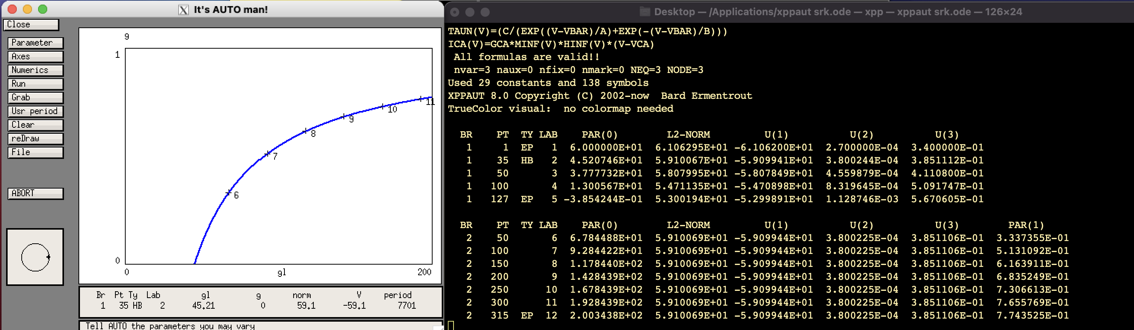

Bursting

Quiescent

SRK hopf bifurcation occurs at

45.20746 = gL\*(1-G)

G = 1-(45.20746/gL)

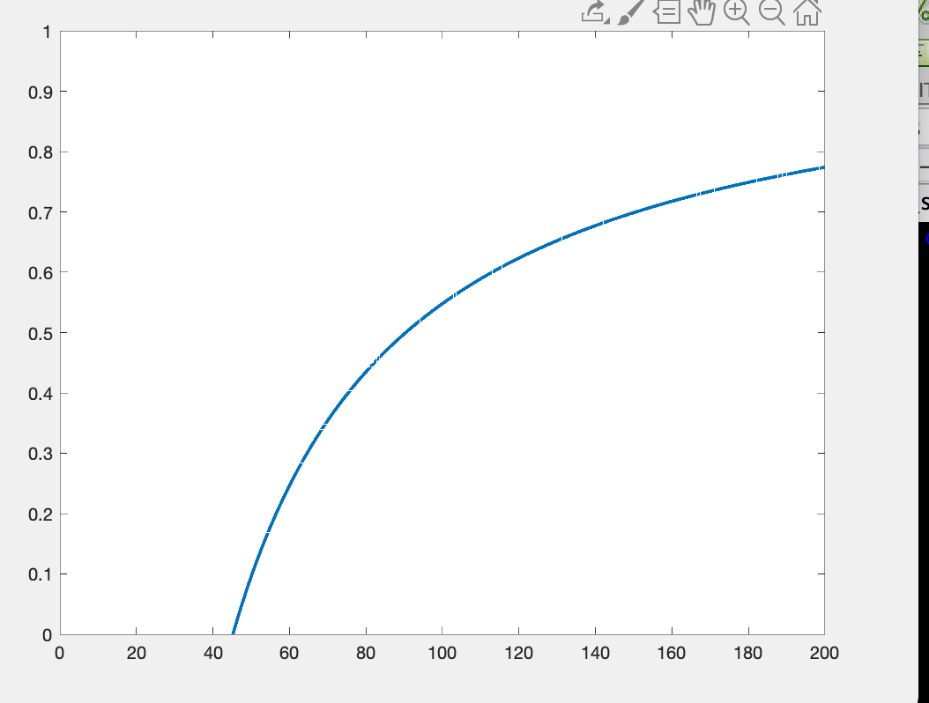

gL

G

Quiescent

Bursting

Steps:

1. Load fn.ode
2. Run fn.ode
3. Open Auto
4. Set Numerics – Nmax = 400, Ds = +0.02, Par Max=200
5. Run steady state
6. Grab Hopf bifurcation
7. Axes – two par, - change ymin=0, ymax = 2 (second param should be g)
8. Run two-param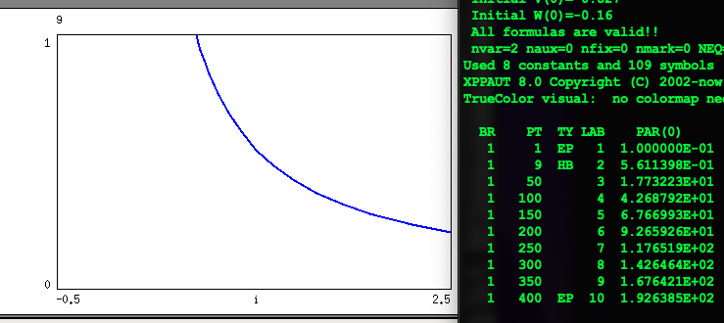

Spiking

Quiescent

G\*I = 0.561139

G = 0.561139/I