Description of software for BETACOOL program based on BOLIDE interface.

A.Smirnov, A.Sidorin, G.Trubnikov

Joint Institute for Nuclear Research

Dubna, 2004
Contents

Introduction | 3
1. Description of the BETACOOL interface based on BOLIDE system | 6
1.1. General description of the interface | 6
1.1.1. Interface files | 6
1.2. Windows of BETACOOL program | 7
1.2.1. Windows of the "beam" object, list of the beam parameters | 7
1.2.2. Windows of the "ring" object, list of the ring parameters | 15
1.2.2.1. Window Lattice Structure | 15
1.2.2.2. Window Ring | Parameters | 19
1.2.3. Windows of the "ECOOL" object, list of the cooler parameters | 22
1.2.3.1. Models of the cooler and ion beams | 22
1.2.3.2. Models of the electron beam | 23
1.2.3.3. Library of the friction force | 28
1.2.4. Menu item Effects. Library of the Effects | 30
1.2.4.1. Menu item Effects. CollisionPoint Effect. | 30
1.2.4.2. Menu item Effects. Internal Target Effect. | 33
1.2.4.3. Menu item Effects. Intrabeam Scattering Effect. | 34
1.2.4.4. Menu item Effects. RestGas Effect. | 36
1.2.4.5. Menu item Effects. Additional Heating Effect. | 37
1.2.4.6. Menu item Effects. Particle Losses Effect. | 37
1.2.5. Menu item Task. Procedures of BETACOOL program | 39
1.2.5.1. Calculation of emittance variation rates | 39
1.2.5.2 Num. algorithms of beam evolution and multi particle tracking | 41
1.2.5.3 Calculation of the beam r.m.s. dynamics | 41
1.2.5.4 Calculation of the Model Beam algorithm | 43
1.2.5.5 Calculation of the particle tracking | 44
1.3. Work with BETACOOL independently on interface. | 46
1.3.1. Format of the input files and launching the program. | 46
1.3.2. Format of the output files. | 48
2. Description of the source code | 49
2.1. Source files | 49
2.2. Structure of the source code | 50
2.3. Interface part of the source code | 51
2.4. Basic algorithms | 52

Introduction

The report describes the structure of software for calculation of ion beam parameters taking into account peculiarity of electron cooling, intrabeam scattering processes and beam interaction with internal target. The code was developed by JINR electron cooling group on the base of BETACOOL program [1 - 4]. The version of the program presented here calculates:
- evolution in time of r.m.s. ion beam parameters under a common action of a few heating or cooling effects which are described in terms of characteristic times of the beam r.m.s. parameter variation. This model presumes Gaussian distribution of the ions in all degrees of freedom.
- multi-particle simulation based on amplification of the heating and cooling effects action in accordance to a large step over time during dynamics simulation. Each effect acting on the ion beam distribution function is represented by the variation of the particle momentum components after revolution in the ring. These momentum variations are amplified by the turn number, which is used as a step for dynamics simulation
- direct tracking of particles along the ring circumference with arbitrary step using Molecular dynamics technique.

The software is divided in two independent parts: physical code, which is made using only standard C++ syntax and interface part, which is an executable program working under Windows environment (Fig. 1). Connection between two parts of the program is provided using three types of the files: input, output and file used for control of the calculation process. Such a structure on the one hand allows to use the program on PC, to control and analyse results during simulations. From the other hand the physical part of the program can be compiled for UNIX operation system and used for calculations independently on interface. The interface part in this case can be used for preparation of the input file and result visualisation after completion of the calculations.

The interface part of the software consists of executable file Bolide.exe, *.dfm files containing information about BETACOOL exterior and input files for post processing of the calculated data. Development of the BETACOOL exterior is possible without recompilation of the Bolide.exe file. Description of the BETACOOL exterior structure and manual for users are presented in chapter 1 of this report.

The physical part of the software consists of the executable file Betacool.exe compiled for Windows operation system and file of input parameters. For intrabeam scattering calculation one needs to use file of lattice parameters, for instance, MAD file.

The software also includes the total set of BETACOOL initial codes: *.cpp and *.h files, project files for C++ Builder 4 and for Microsoft Visual C++ 6. The source code of the physical part of the software consists of tree relatively separated parts:

- interface part, which supports the format of input and output files common with the Bolide system,
- library of base numerical algorithms including description of dimensional variables, templates of the program self counters, procedures for matrix algebra, algorithms of numerical solution of differential equations,
- physical codes describing objects of the program and procedures with them.

Structure of the BETACOOL program exterior corresponds to the structure of general objects in the source code, therefore main part of the object parameters is described in the chapter 1 of this report. Detailed description of the source code structure and manual for users are presented in the chapter 2.

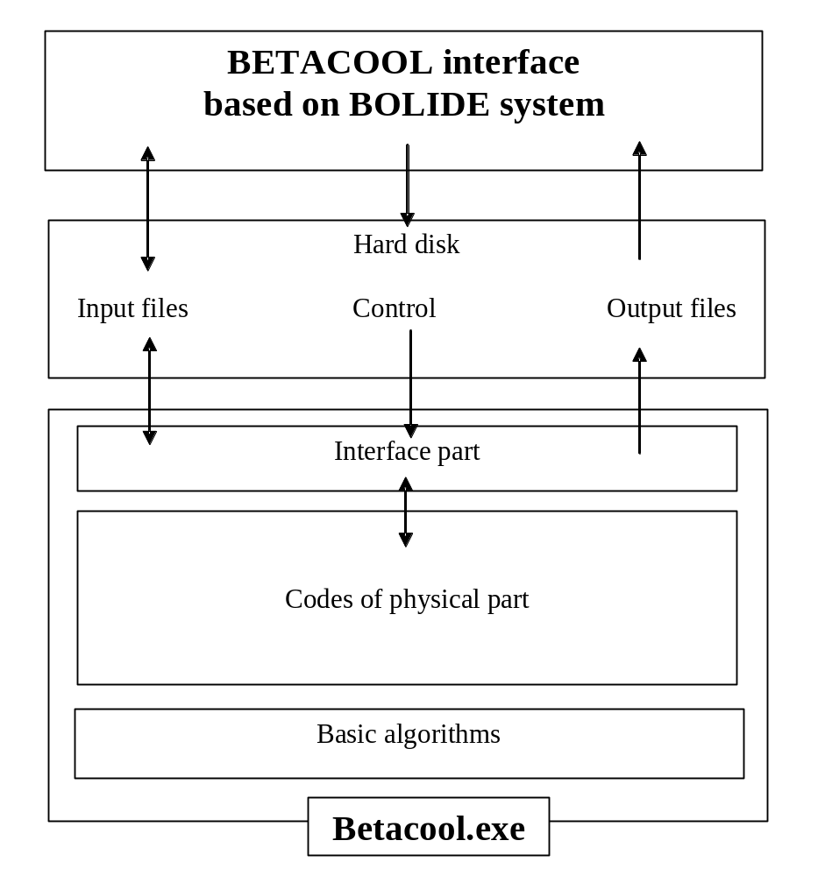
Fig.1. Structure of the software for electron cooling calculation.

The simplest way to start a work with BETACOOL program is the following:

- to save the Interface files, Betacool.exe file, file of input parameters (*.bld format) and, if necessary MAD file of the ring lattice structure into the same folder;
- to start Bolide.exe file, load the input file, edit it if necessary (with a specially developed BETACOOL notepad);
- to start BETACOOL program using one of the TBrowse components in the visual Windows of the Interface.
- BETACOOL program is working in the regime of Windows-32 application and stops the calculations after their completion, or can be stopped using corresponding Interface tool,
- during the calculation the Interface program automatically reads the results from output files and represents them in numerical or graphical format in corresponding Windows.

This chapter describes the structure of the BETACOOL program exterior for the case when working with the Interface. Structure of the exterior coincides with the structure of the input file and this description can be used as description of the input file format in the case when working without Interface. The structure and dimensions of all the variables are described also in constructors, OnGet and OnSet procedures of the BETACOOL classes in the source code of the program. For post-processing of the output BETACOOL files one can use arbitrary graphical editor. In the file BOLIDE.doc the format of the output files is presented. Description of dimensions of output parameters is not included into the files and can be obtain from the Interface, or from source codes of the program. In future new format of input file with descriptions will be developed.

1. A. Lavrentev, I.Meshkov “The computation of electron cooling process in a storage ring”, preprint JINR E9-96-347, 1996.
2. I .N.Meshkov, A.O.Sidorin, A.V.Smirnov, E.M.Syresin, G.V.Trubnikov, P.R.Zenkevich," SIMULATION OF ELECTRON COOLING PROCESS IN STORAGE RINGS USING BETACOOL PROGRAM" , proceedings of Beam Cooling and Related Topics, Bad Honnef, Germany, 2001.
3. Yu.Korotaev, I.Meshkov, A.Sidorin, A.Smirnov, E.Syresin, G.Trubnikov, Software for Beam Parameter Simulations with Electron Cooling, Dubna, 2003
4. http://lepta.jinr.ru
1. Description of the BETACOOL interface based on BOLIDE system

1.1. General description of the interface

1.1.1. Interface files

Interface part of BETACOOL program consists of the executable program “bolide.exe” and the following binary *.dfm files, which include information about the program exterior:

NN | File name | Window of BETACOOL program
1 | bolide1.dfm | Beam | Parameters
2 | Bolide2.dfm | Beam | Distribution
3 | Bolide3.dfm | Beam | Evolution
4 | Bolide7.dfm | Beam | Real space
5 | Bolide10.dfm | Effects | Collision point
6 | Bolide36.dfm | Effects | Internal target
7 | bolide42.dfm | Effects | IBS
8 | Bolide6.dfm | Effects | Rest Gas
9 | Bolide8.dfm | Effects | Additional Heating
10 | Bolide9.dfm | Effects | Particle Losses
11 | bolide4.dfm | Ring | Parameters
12 | bolide15.dfm | Ring | Lattice Structure
13 | bolide5.dfm | Task | Rates
14 | bolide21.dfm | Task | Algorithm
15 | bolide30.dfm | Ecool | Models
16 | bolide31.dfm | Ecool | Parameters
17 | bolide32.dfm | Ecool | Friction Force

The files are listed in accordance with menu items of Main window of BETACOOL program. Name of the *.dfm file is generated by BOLIDE automatically adding to the "bolide" word the number equal to "Row" parameter in Constructor of corresponding visual window. Thus if user develops the interface part adding new windows, each new window has to have unique value of the "Row" parameter.

To install interface part one needs to copy all the *.dfm files to the same folder with Bolide.exe file. Names and number of BETACOOL output files are described inside the program code (now there are 5 files of 3D plots *.sur and 17 files of 2D plots *.cur) and they are generated by the program and saved in the same folder with Betacool.exe file. For convenient work it is better to have interface files in the same folder with Betacool.exe.
1.2. Windows of BETACOOL program

1.2.1. Windows of the "beam" object, list of the beam parameters

Parameters of the global variable of class xBeam and results of calculation of the beam parameter evolution in time are collected in the Main Menu item Beam which includes submenu items Parameters, Distribution, Evolution, Real space.

The Window Parameters (Fig.2) includes 5 tab sheets: Emittance, Stability, Model Beam, Bunch, Characteristics. The Tab Sheet Emittance is used to define main beam parameters. When Model Beam Algorithm is used user must choose Emittance Definition. Here 4 types of emittance presentation are proposed: Root Mean Square (usual rms emittance – when 1 sigma of Gaussian distributed particles is presumed), Courant Snyder (when emittance is calculated as Courant Snyder invariant), Full Width on Half Maximum (emittance corresponded to particles inside full width on half maximum of distribution), Enclosed Percents (emittance occupied by the indicated percent of beam particles).

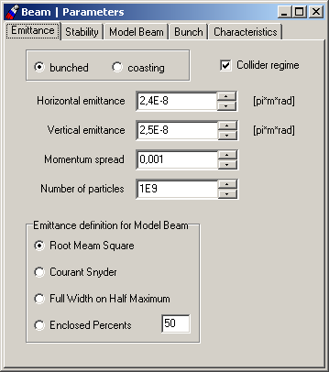
Fig.2. Tab Sheet Emittance of the menu item Beam | Parameters

The Tab Sheet Parameters (Fig. 2) includes the following input and output variables:
Variable caption | Unit | Variable in the program | Comment, Formula
Input
Radio group  "bunched – coasting" | - | Boolean variable  iBeam.bunched | bunched = true  for bunched beam,  bunched = false  for coasting beam
Check box  Collider regime | - | Boolean variable  iBeam.collider | if iBeam.collider = true,  calculates luminosity
Horizontal emittance | π⋅m⋅rad | r.m.s. horizontal emittance, ε_{x},  iBeam.Emit[0]
Vertical emittance | π⋅m⋅rad | r.m.s. vertical emittance, ε_{z},  iBeam.Emit[1]
Momentum spread | - | r.m.s momentum spread  Δp/p,  iBeam.Emit[2] | ε_{s} = (Δp/p)²  Used for calculation of the longitudinal emittance
Number of particles | - | N_{i}  iBeam.Emit[3]
Radio group  "Emittance definition for Model beam" | - | int iBeam.EmitDef | Used for Model Beam Algorithm:  0 - Root Mean Square  1 - Courant-Snyder invariant  2 – FWHM  3 – Enclosed Percent

The Tab Sheet Stability (Fig. 3) includes the following input and output variables:

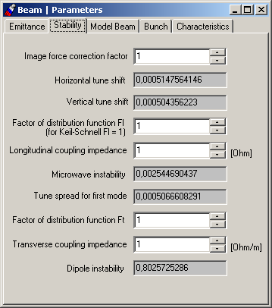
Fig. 3. Tab Sheet Stability of the menu item Beam | Parameters.

The Tab Sheet Stability includes the following input and output variables:

Variable lable | Unit | Variable in the program | Comment, Formula
Input
Image force correction factor | - | F_{sc}  iBeam.F_sc | Used for Lasslet tune shift calculation
Factor of distribution fanction Fl | - | F_{l}  iBeam.F_l | Used for microwave instability threshold calculation
Longitudinal coupling impedance | Ohm | addition to longitudinal space charge impedance  Z_{L,I} , iBeam.Z_l_i | Z_{L} = Z_{l,sc} + Z_{L,i}
Factor of distribution fanction Ft | - | F_{t}  iBeam.F_t | Used for dipole instability threshold calculation
Transverse coupling impedance | Ohm/m | addition to transverse space charge impedance  Z_{t,I} , iBeam.Z_t_i | Z_{t} = Z_{t,sc} + Z_{t,i}
Output
Horisontal tune shift | - | Horizontal Lasslet tune shift ΔQ_{x}  iBeam.D_Q_x | 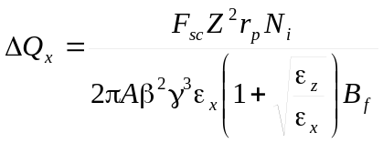
Vertical tune shift | - | Vertical Lasslet tune shift  ΔQ_{z}  iBeam.D_Q_z | 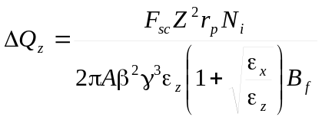
Microwave instability | - | Ratio between beam current and threshold current  iBeam.KS | 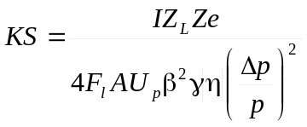  U_{p} = 938.2796 MeV
Tune spread for first mode | - | ΔQ₁  iBeam.S_Q | 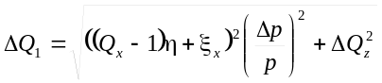
Dipole instability | - | Ratio between beam current and threshold current , iBeam.DM | 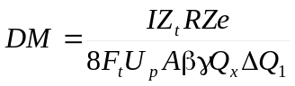

The Tab Sheet Model Beam includes beam parameters required for simulation by the task Task | Algorithm | Tracking (multi particle tracking) or Model Beam (dynamics of the test beam with Particle Number particles in accordance with chosen effects).

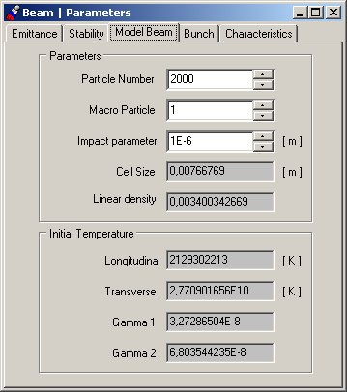
Fig. 4. Tab Sheet Model Beam of the menu item Beam | Parameters

The Tab Sheet Model Beam (Fig. 4) includes the following input and output variables:

Variable lable | Unit | Variable in the program | Comment, Formula
Input
Particle Number | - | N_{particle}  iBeam.Number | Number of particles in the test beam
MacroParticle |  | iBeam.Macro | Number of macroparticles
Impact parameter |  | iBeam.Impact | Impact parameter – needed for crystallization simulation
Output
Linear density | - | λ  iBeam.Lambda | 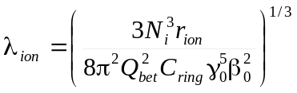
Longitudinal temperature | [ K ] | T||  iBeam.Tlong | T|| = m_{i}c² β² (Δp/p)²
Transverse temperature | [ K ] | T⊥  iBeam.Ttrans | 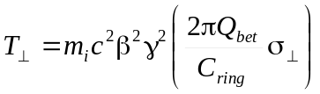
First criterion of ordering state | - | Γ₁  iBeam.Gamma1 | 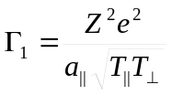
Second criterion of ordering state | - | Γ₂  iBeam.Gamma2 | 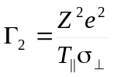

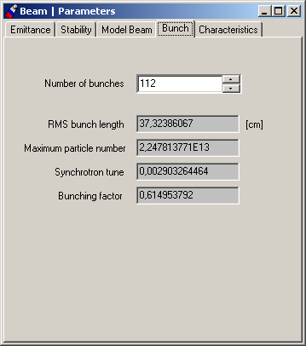
Fig. 5. Tab Sheet Bunch of the menu item Beam | Parameters

The Tab Sheet Bunch Parameters (Fig. 5) includes the following input and output variables:

Variable lable | Unit | Variable in the program | Comment, Formula
Input
Number of bunches | - | N_{b}  iBeam.N_b | Used for luminosity calculation
Output
R.m.s. bunch length | m | σ_{s}  iBeam.s | 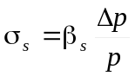, 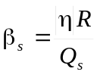
Maximum particle number | - | Particle number corresponding to zero syncrotron tune N_{max}  iBeam.N_max | 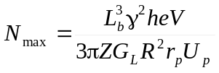  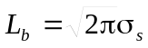
Synchrotron tune | - | Synchrotron tune value with tacking into account beam space charge Q_{s,N}  iBeam.Q_s | 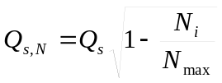
Bunching factor | - | B_{f}  iBeam.B_f | 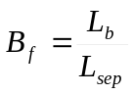  L_{sep} is the separatrix length

The Tab Sheet Characteristics includes beam parameters calculated when main parameters of the beam and ring are defined.

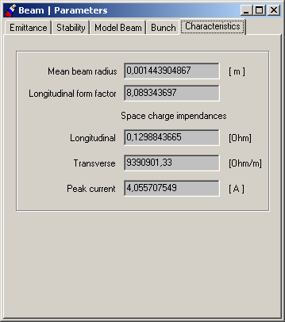
Fig. 6. Tab Sheet Characteristics of the menu item Beam | Parameters

This Tab Sheet (Fig. 6) includes the following input and output variables:

Mean beam radius | m | a  iBeam.a | Used for longitudinal form-factor calculation  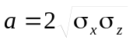
Longitudinal form factor |  | G_{L}  iBeam.G | 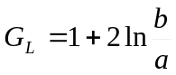  b is the mean radius of the vacuum chamber
Longitudinal | Ohm | Space charge longitudinal coupling impedance Z_{L,sc} , iBeam.Z_l_sc | 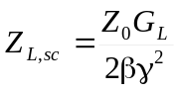  Z₀ = 377 Ohm
Transverse | Ohm/m | Space charge transverse coupling impedance Z_{t,sc}  iBeam.Z_t_sc | 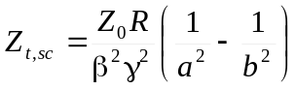  R is the ring mean radius
Peak current | A | Current of the coasting beam or peak current for the bunched beam, I  iBeam.I | 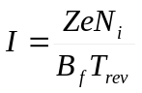  B_{f} is the bunching factor

The Window Beam | Evolution (Fig. 7) is used for visualization of the beam parameter time dependencies.
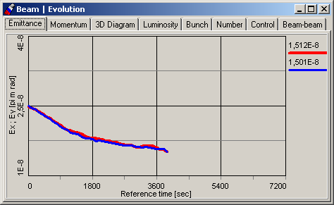
Fig. 7. Window of the Beam | Evolution menu item.

Tab Sheet Emittance contains 2D plot for output two curves: Ex2t.cur, Ey2t.cur - time dependencies of horizontal and vertical emittances. Tab Sheet Momentum contains 2D plot for output curve Dp2t.cur - time dependence of momentum spread. Tab Sheet 3D Diagram contains plot for output gamma2.cur and gamma3.cur – criterion Γ₂=π and the dependence (evolution) of the horizontal emittance on the momentum spread txy2t.cur. Tab Sheet Luminosity contains plot for output Lum2t.cur – luminosity time dependence. Tab Sheet Bunch contains plot for output Bunch2t.cur for time dependence of bunch length. Tab Sheet Number contains plot for output Num2t.cur – particle number time dependence. Tab Sheet Beam-beam contains plots for output kappax.cur and kappay.cur – both transverse beam-beam parameters time dependence.
The new useful feature of Betacool windows is TabSheet Control (Fig.8), which is added to every window that contains any plot.
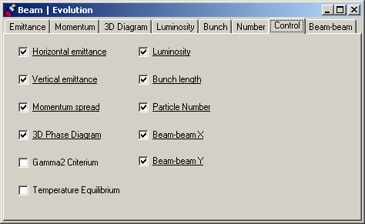
Fig. 8. Window of the Beam | Evolution|Control TabSheet.
This Tab Sheet allows user managing of the plots visualization. It contains list of all the plots of the current window which presented by Checkboxes. User must check plots which are needed to be redrawn on-line and (or) check off unnecessary plots. Such a scheme allows to manage CPU resource in order to fasten calculation time.

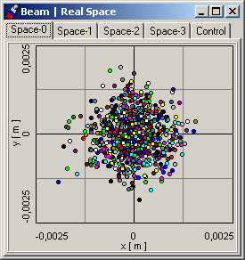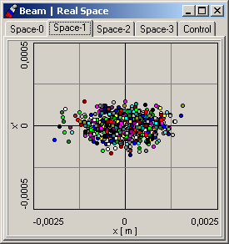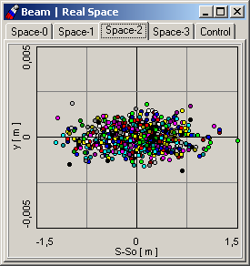
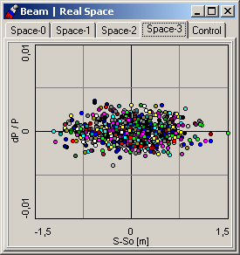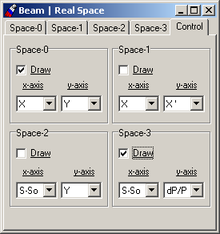
Fig. 9. Windows of the Beam | Real Space menu item.

The Window Beam | Real Space (Fig. 9) is used for visualization of the particle distribution in different planes during tracking procedure. Tab Sheet Control here is a manager of plots – user can choose which plot is active for on-line redrawing and what a coordinate plane will be represented on it (for example Y-X – transverse real space of particles, X’-X – horizontal phase space, Y-S – longitudinal real space etc).
The Window Beam | Distribution (Fig. 10) is used for visualization of the real particle distribution for test beam. Tab Sheet Coordinate – is the dependence of particle number (in percent) on momentum deviation (dist_sp.cur) and coordinate (dist_sx.cur and dist_sy.cur) normalized on corresponding rms parameter and particle number (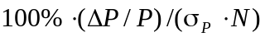). Tab Sheet Profile - is real particle distribution for every coordinate (analogue of previous plot) averaged on betatron or synchrotron oscillations (dist_ix.cur, dist_iy.cur, dist_ip.cur). Tab Sheet Emittance - is plot of all three particle invariants (dist_ex.cur, dist_ey.cur, dist_dp.cur)– actually it shows particle number (in percent) which occupies corresponding emittance (abscissa axis).
Tab Sheet Evolution – 3D plot for evolution of real particle distribution in time (evolution.sur).
Tab sheet Control – settings for plot on all Tab Sheets listed above. As on every plot window user can choose which plots he wants to be redrawn on-line. Group Box Coordinate, Profile correspond to first two Tab Sheets and defines: Sigma – is range in number of sigmas, Division – split number, normalized on emittance – choice of rms parameter for sigma to be normalized on . Group Box Evolution defines settings for 3D plot of particle distribution
deviation: Slices – number of steps in time scale, Step, sec – value of step in time.

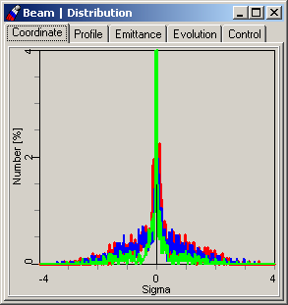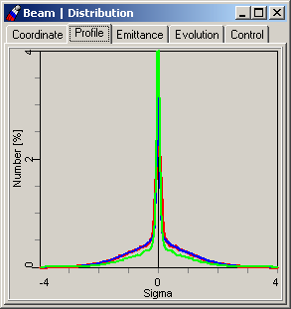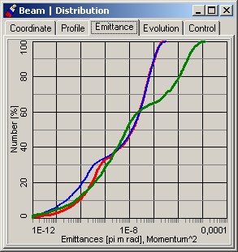
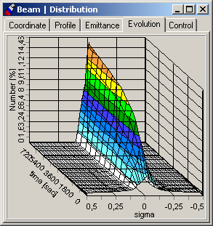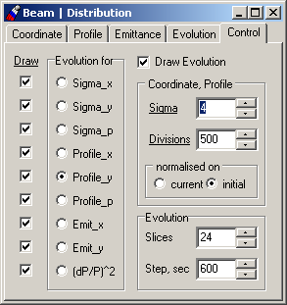
Fig. 10. Windows of the Beam | Distribution menu item.

1.2.2. Windows of the "ring" object, list of the ring parameters

Parameters of the global variable of class xRing and results of calculation of the ring mean parameters are collected in the Main Menu item Ring that includes submenu items Lattice Structure and Parameters.

1.2.2.1. Window Lattice Structure

Window Optics Structure (Fig 11) contains tab sheets Lattice Filename, Output MAD format, and three tab sheets connected to Lattices of optic structure and its transformation matrix: two of 2D plots beta functions and alfa functions, and Matrix.
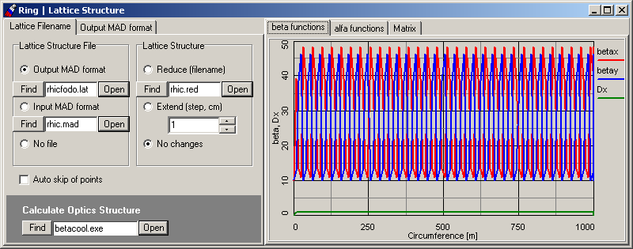
Fig. 11. Window of the Ring | Optic structure menu item. Tab sheet File names.

Tab sheet Lattice Filename is used to select and save in the input file the names of files containing information about ring optics structure. This Tab Sheet contains:
- Radio Group Lattice structure File with three possible positions: Output MAD format, Input MAD format, No file and three of TBrowse components. This Radio Group is used when user has a file with some lattice structure obtained from MAD program or collected in accordance with input MAD file standard. No file option is hosen when user does not need Lattice file.
- Radio Group Lattice Structure with three possible positions: Reduce (filename), Extend (step, cm), No changes. Here choice of active option depends on the definition made in described above Lattice structure File Radio Group.

For IBS calculations using Martini or Jei Wei models one needs to find appropriate lattice structure file, for example MAD output file. Button Find of the TBrowse component opens the file manager window. Button Open opens the file using internal text editor. The chosen file name is indicated in the edit window of the TBrowse component and saved in the input BATACOOL file. This name is used for initialization of the ring structure after start of the program. Validity of the file can be checked using TBrowse component Calculate Optics Structure.
Button Open of this TBrowse starts BETACOOL with the parameter /lattice. At this parameter BETACOOL read MAD output file, transform lattice parameters into internal format and save them into the files BetaX.cur, BetaY.cur, DispX.cur, AlfaX.cur, AlfaY.cur, DispX_.cur. During this procedure the program checks validity of the data in all positions of lattice structure file in accordance with the description tacking from the tab sheet Output MAD format (Fig. 12).

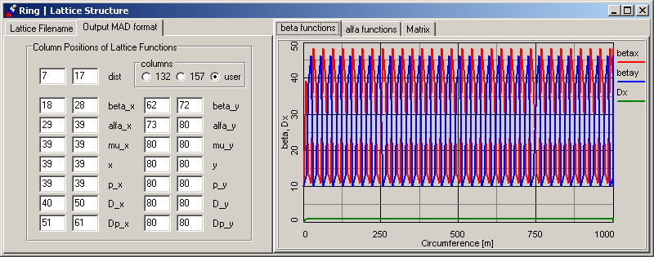
Fig. 12. Window of the Ring | Optic structure menu item. Tab sheet Output MAD format.

The Tab Sheet Output MAD format contains radio button columns which positions 132 and 157 correspond to the standard output MAD files with 132 or 157 columns correspondingly. In the case of nonstandard lattice file user can prepare its specification by himself. For this goal one needs to introduce initial and final columns in the string for all lattice functions. If user set the initial and final columns in zero value then these lattice functions will be equal zero. In the case of mistakes in the Lattice structure file specification BETACOOL generates corresponding message in the Betacool.war file.

Input MAD format – is used for choosing the input file name for multi particle tracking. BETACOOL program can read optics and lines from the standard input MAD file and translate to the optics structure of the storage ring. The result of translation is saved to file with same name as MAD input file and extension *.use. Now BETACOOL can translate the following elements from MAD file:
- DRIFT;
- SBEND (ANGLE – bend angle, E1 and E2 – edge angles);
- QUADRUPOLE (K1 – quadrupole gradient, TILT - rotation);
- SEXTUPOLE (K2 – sextupole gradient);
- RFCAVITY (FREQ – RF frequency, V – RF Voltage)
- SOLENOID (Ks – solenoid gradient);
- LINE;
- USE.
All the elements have obligatory parameter LENGTH
Electron cooling object can be added into the MAD file if any element has name XECOOL:

XECOOL: drift, l=2.1

Target object is included into the MAD file as zero-length element and should have name XTARGET:

XTARGET: marker, type=TARGET

Depending on the task, the BETACOOL program is a powerful instrument for processing with ring lattices and (or) transformation matrices of optics element. If user has a MAD input file with optics element consequence, there is an algorithm that provides a calculation of transformation matrix for whole ring, then the second step – is calculation of lattice parameters in the point S₀, and after tracking of lattice parameters takes place. If one has a lattice at the chosen point and matrix after, it is possible to calculate lattices after matrix, and so on and so force. For this procedure user has to choose Input MAD format radio button and to push Calculate Optics Structure. Passing time, calculated lattices will be visualized onto corresponded plots.
Reverse procedure is also provided – co called “reverse-tracking” – when one chooses the Output MAD format radio button – the consequence of transformation matrices for optical elements of the structure will be restored from the consequence of lattices.
If checkbox Auto skip of points is switched on then the following procedure takes place: when the number of points in any curve (here the curves with lattice parameters) is to be exceeded then because of the limited size of the curve with every next point inserted to the curve array one looses first point from the array. So if checkbox is ON, every second point in this array will be deleted and all left points will be suppressed, then at least a half of the curve array will be released for the expected calculated data. This procedure can be eternal - always when array is nearly to be overfilled, every second cell in it will be released.

Reduce(filename) – is useful option foreseen for large lattice (optics) structure. Here one must built a special file *.red with reduced structure of the ring. User has to leave only optical elements and corresponded which he wants to be taken into account for calculations and visualization. Here the following algorithm takes place: for the tracking using matrices the whole structure is taken into account. But necessary matrices will be build only in points selected by user (by multiplying of all the intermediate matrices between selected points). Then only these matrices will track the beam. And IBS effect will be calculated only in these points. Finally, only lattices in selected points will be plotted. So the calculation time may be sufficiently reduced.
Extend (step, cm) – this option is used only when Tracking algorithm is presumed and Molecular dynamics technique is used. Here the step over longitudinal coordinate is defined between points where transformation matrix is calculated. This choice is active when option Matrixes is switched on in Task | Algorithm | Tracking | Equations of motion window. The second necessary condition – is Input MAD format must be chosen in Lattice structure File Radio Group
Next Tab sheet Matrix (see Fig 13) is rather comfortable tool for the monitoring the transformation matrix of the whole ring or selected optic element. One can choose to monitor either a transformation matrix of the whole ring (Ring) or the selected element from optic structure (Optics) by choosing its number with Index counter. Here complete transformation matrix is visualized. There is an option to look at any part of numerical appearance of matrix elements, if it is introduced as complex one. One can choose the representation by switching Real | Imag | Abs | Arg radio buttons. Here edit window |1-Det| introduces the precision of calculated matrix determinant.

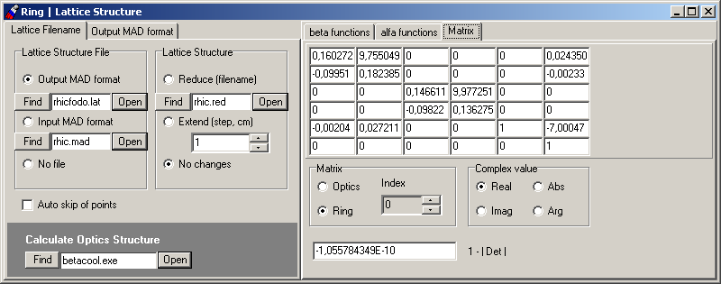

Fig. 13. Window of the Ring | Optic structure menu item. Tab sheet Matrix.

Here a useful table is presented for different modes of usage the Ring | Lattice Structure | Lattice Filename radio buttons for selected tasks (for details see description of Task | Algorithm):

Radio button  Task | Output MAD format | Input MAD format | No optics | Comments
RMS Dynamics | √ | √ | √* | * - in case when Piwinsky model of IBS calculation was chosen
Model Beam | √ | √ | √** | ** - if chosen No optics – user has to fill (type in) the ring transformation matrix
Tracking | ⎯ | √ | ⎯

1.2.2.2. Window Ring | Parameters

Window Parameters (Fig. 14 – 17) contains the tab sheets Ion kind, Lattice, Mean params, RF system.

The tab sheet Ion kind (Fig. 14) contains radio button Reference energy. Depending on chosen button one can input one of the following parameters for the reference particle:

Lorenz factor (Gamma),
Velocity in the speed of light units (Beta),
Kinetic energy (Kinetic) or
Momentum in GeV/c (Momentum).

Units of the particle kinetic energy can be determined using ComboBox near corresponding edit window. Only one parameter from this group can be chosen as input one, all others parameters are output.

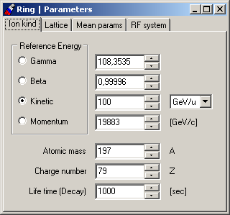
Fig. 14. Window of the Ring | Parameters menu item. Tab Sheet Ion kind.

Other parameters from this tab sheet are listed in the following table:
Variable lable | Unit | Variable in the program | Comment, Formula
Input
Atomic number | - | A,  iRing.A
Charge number | - | Z,  iRing.Z | For calculation of the ion life time due to the interaction with residual gas and internal target one supposes that the ions are completely stripped
Life time | sec | iRing.Tlife | used in Decay effect for the loss rate calculation
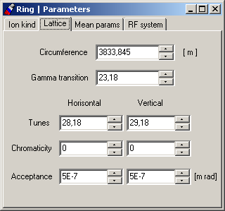
Fig.15. Window of the Ring | Parameters menu item. Tab Sheet Lattice.

The tab sheet Lattice (Fig. 15) includes the following input variables:

Variable lable | Unit | Variable in the program | Comment, Formula
Circumference | m | C,  iRing.Circ
Gamma transition | - | γ_{tr}  iRing.GammaTr | used for off momentum factor calculation
Tunes | - | Q_{x}, Q_{z}  iRing.TunesH,  iRing.TunesV
Chromatisity | - | ξ_{x}, ξ_{z}  iRing.HromatH ,  iRing.HromatV | used for tune spread calculation
Acceptance | π⋅m⋅rad | A_{x}, A_{z}  iRing.AcceptH ,  iRing.AcceptV | used for calculations of life time due to single scattering on big angles

The tab sheet Mean params (Fig. 16) includes the following output variables:
Variable caption | Unit | Variable in the program | Comment, Formula
Mean radius | m | R,  iRing.R_m | R = C/2π
Horizontal beta function | m | β_{x} ,  iRing.BetaH | β_{x} = R/Q_{x}
Vertical beta function | m | β_{z} ,  iRing.BetaV | β_{z} = R/Q_{z}
Dispersion | m | D,  iRing.Dispersion | D = β_{x}/Q_{x}
Revolution period | sec | T_{rev} ,  iRing.Trev | T_{rev} = C/βc
Off momentum factor | - | η,  iRing.Eta | 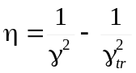
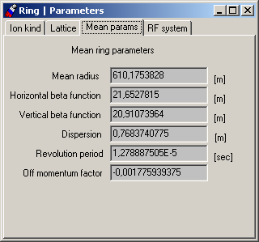
Fig. 16. Window of the Ring | Parameters menu item. Tab Sheet Mean params.

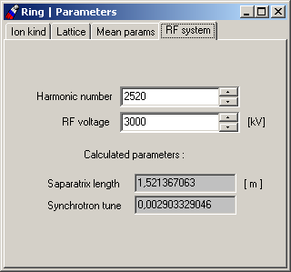
Fig. 17. Window of the Ring | Parameters menu item. Tab Sheet RF system.

The tab sheet RF system (Fig. 14) includes the following input and output variables:
Variable caption | Unit | Variable in the program | Comment, Formula
Input
Harmonic number | - | H,  iRing.h
RF voltage | kV | V  iRing.V
Output
Separatrix length | m | L_{sep}  iRing.L_s | L_{sep} = C/h
Synchrotron tune | - | Q_{s}  iRing.Q_s | 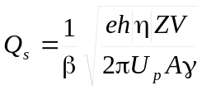

1.2.3. Windows of the "ECOOL" object, list of the cooler parameters

In this BETACOOL version electron cooling is treated as an Effect acting on the r.m.s. parameters of the ion distribution function and changing the ion number. Like other Effects (IBS, Additional Heating and so on) the electron cooling model returns heating and loss rates and, in principle, it is a part of the Effect library. Separate menu item ECOOL is used for electron cooling due to complicated structure of this Effect. To calculate the cooling rates user needs to determine:

- models of the cooler and ion beam;
- general parameters of the cooling section and model of the electron beam;
- formula for the friction force calculation from corresponding library.

To make the procedure clear these three steps are divided between three submenu items and can be done independently using corresponding windows.

1.2.3.1. Models of the cooler and ion beams

The tab sheet Cooler of the ECOOL | Model Window (Fig. 18) contains radio button Calculation model which provide the choice between calculations of the ion coordinates after crossing the cooling section in the frame of the Thin lens model and numerical integration of the ion motion equation. The numerical integration can be performed by two methods: Euler (Euler method) or 4-th order Runge Kutta (RK method). For the numerical integration one needs to determine the number of integration steps along the cooling section.

In the program the electron beam models are switched by variable iEcool.e_model which is equal:
iEcool.e_model = 1, for Thin Lens model;
iEcool.e_model = 2, for integration with Euler method;
iEcool.e_model = 3, for integration with Runge Kutta method.

The variable iEcool.integr_step corresponds to the integration step number for both numerical methods.
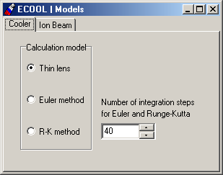
Fig. 18. Window of the ECOOL | Models menu item. Tab sheet Cooler.

The cooling rates can be calculated for r.m.s. particle or by averaging over the particle distribution function using Monte Carlo method. Choice between these possibilities is provided by radio button Calculation model of the tab sheet Ion beam of the ECOOL | Model Window (Fig. 19).

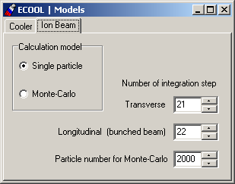
Fig. 19. Window of the ECOOL | Models menu item. Tab sheet Ion Beam.

In the program these models are switched by variable iEcool.i_model, which is equal to 1 for r.m.s. particle calculation and 2 for Monte Carlo calculation.

For r.m.s. particle the cooling rates are calculated by averaging over phases of betatron and synchrotron oscillations. Numbers of integration steps over the phases are input in corresponding edit windows. Corresponding variables in the program are iEcool.step_tr and iEcool.step_long.

For Monte Carlo method one needs to determine number of particles used for cooling rate calculation. In the program corresponding variable has a name iEcool.num_MC.

1.2.3.2. Models of the electron beam

General parameters of the cooling section are collected in the Window of the ECOOL | Parameters menu item. This Window contains the following tab sheets:

Cooler,
Geometry,
Lattice,
Gaussian bunch,
Gaussian cylinder.

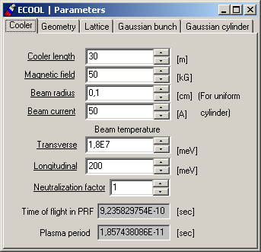
Fig. 20. Window of the ECOOL | Parameters menu item. Tab sheet Cooler.

The tab sheet Cooler (Fig. 20) includes the following input and output variables:

Variable caption | Unit | Variable in the program | Comment, Formula
Input
Cooler length | m | L_{cool} ,  iEbeam.CoLength
Magnetic field | kG | B,  iEbeam.F.mfield
Beam radius | Cm | a_{e} ,  iEbeam.bradius | These two parameters are used for calculation the electron beam density in the case when electron beam is treated as an cylinder with uniform density, plasma oscillation period is calculated using these values also
Beam current | A | I_{e} ,  iEbeam.bcurrent
Beam temperature  Transverse | meV | T⊥ ,  iEbeam.F.Ttemp_centre
Longitudinal | meV | T|| ,  iEbeam.F.Ltemp
Neutralization factor | - | η_{neutr} ,  iEbeam.Neutralization | has to be positive and less than 1, used only for uniform cylinder model
Output
Time of flight in PRF | sec | τ ,  iEbeam.F.tau | τ = L_{cool}/γβc
Plasma period | sec | T_{p,e} ,  iEbeam.F.T_plasma | 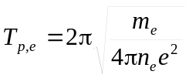  n_{e} is the electron density in PRF calculated for uniform cylinder model
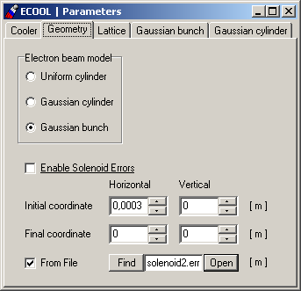
Fig. 21. Window of the ECOOL | Parameters menu item. Tab sheet Geometry.

The tab sheet Geometry (Fig. 21) includes radio button Electron beam model which provides a choice between three models of the electron beam. In the program the models are switched by variable i.Ebeam.GeoModel, which is equal to the following numbers:

Electron beam model | i.Ebeam.GeoModel value
DC cylindrical electron beam with uniform electron density | 1
DC electron beam with elliptic cross-section and Gaussian distribution in the transverse plane | 2
Electron bunch with elliptic cross-section and Gaussian distribution in all degrees of freedom | 3

CheckBox Enable Solenoid Errors is intended to take into account magnetic field errors in solenoids of cooling section. There are two possibilities of errors definition:
- with the edit windows Initial coord, Final coord which are intended to input the position of the electron beam orbit at the entrance and at the exit of the cooling section respectively to the ion equilibrium orbit in [cm]. Corresponding variables in the program are: iEbeam.x_0, iEbeam.y_0, iEbeam.x_f, iEbeam.y_f.
- to read magnetic field errors from the text file. This file contains three-tuples of coordinates [m] from which angle of the field line is calculated. User can choose file with TBrowse component

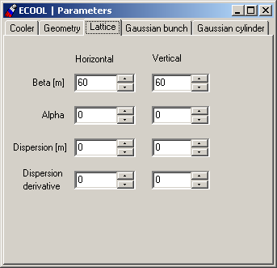
Fig. 22. Window of the ECOOL | Parameters menu item. Tab sheet Lattice.

The lattice parameters of the ring in the cooler position are input using tab sheet Lattice (Fig. 22). They are collected in the variable iEcool.ecool_lat of the xLattice class.

The tab sheet Gaussian bunch (Fig. 23) includes the following input and output variables:

Variable caption | Unit | Variable in the program | Comment, Formula
Input
Horizontal | cm | σ_{e,x} ,  iEbeam.sigma_x
Vertical | cm | σ_{e,z} ,  iEbeam.sigma_y
Longitudinal | cm | σ_{e,s} ,  iEbeam.sigma_s
Distance between electron and ion bunch centers | cm | iEbeam.dist
Number of electrons | - | N_{e} ,  iEbeam.Ne
Output
Peak current | A | I_{e} ,  iEbeam.Ieb | 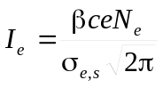

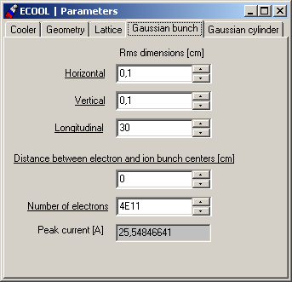
Fig. 23. Window of the ECOOL | Parameters menu item. Tab sheet Gaussian bunch.

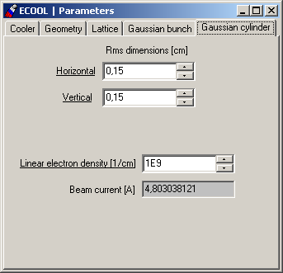
Fig. 24. Window of the ECOOL | Parameters menu item. Tab sheet Gaussian cylinder.

The tab sheet Gaussian cylinder (Fig. 24) includes the following input and output variables:

Variable caption | Unit |  | Variable in the program | Comment, Formula
Input
Horizontal | cm | σ_{e,x} ,  iEbeam.sigma_x_cil
Vertical | cm | σ_{e,z} ,  iEbeam.sigma_y_cil
Linear electron density | 1/cm | λ_{e} ,  iEbeam.Ne_cil
Output
Beam current | A |  | I_{e} ,  iEbeam.Ie_cil | 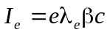

1.2.3.3. Library of the friction forces

The friction force components acting on the ion inside the electron beam can be calculated using different analytic formulae and, in principle, using results of numerical calculations. Choice between different presentation of the friction force is provided by radio button Model of the tab sheet Model of the ECOOL | Friction force menu item window (Fig. 25). Now in the program realized the following formulae:

Budker formula
Non-magnetized;
Derbenev-Skrinsky;
Parkhomchuk;
Tabulated
Linear.

The last one is the linear part of the Derbenev-Skrinsky formula and it is used for crystalline beam simulations.

In the program the friction force formulae are switched using variable iForce.Type which is equal to the following numbers:

Type of force presentation | iForce.Type value
Budker | 1
Non-magnetized | 2
Derbenev-Skrinsky | 3
Parkhomchuk | 4
Tabulated | 5
Linear | 6

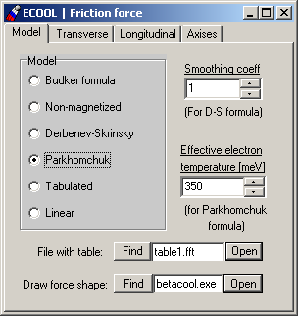
Fig. 25. Window of the ECOOL | Friction force menu item. Tab sheet Model.

If Tabulated model is chosen then user must point file with tabulated values of friction force component pre-calculated by another program.
Component TBrowse Draw force shape is used for visualization of the friction force dependence on ion velocity. Button Open of the TBrowse starts BETACOOL program with parameter /fr. At this parameter BETACOOL calculates and saves into the disk two 3D plots: FFtr.sur and FFlong.sur. The 3D plots are loaded and visualized into corresponding tab sheets Transverse and Longitudinal of the ECOOL | Friction force menu item window (see example of the friction force calculation in the Fig. 26).

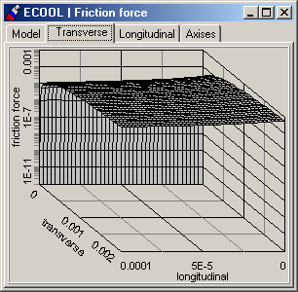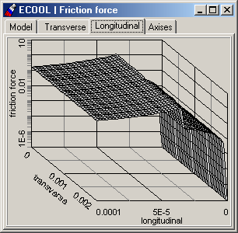
Fig. 26. Example of the friction force shape calculation.

The friction force is performed in [rad/turn] units, the velocity components are measured in [rad]. Velocity interval and number of divisions for the friction force calculation are put in the tab sheet Axises of the ECOOL | Friction force menu item Window (Fig. 27).
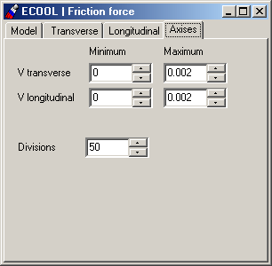
Fig. 27. Window of the ECOOL | Friction force menu item. Tab sheet Axises.

1.2.4. Menu item Effects. Library of the Effects

All the effects using in BETACOOL but Electron Cooling are collected in the menu item Effects including the following submenu items:

Collision Point
Internal Target
Intrabeam Scattering
Rest Gas
Additional Heating
Particle Losses.

1.2.4.1. Menu item Effects. CollisionPoint Effect.

Window of the Effects | Collision Point (Fig. 28) includes Toolkit for Luminosity and connected parameters calculation in the collision points. Here the choice of the Luminosity calculation model is provided and four Tab Sheets for the parameters definition: Parameters, Divisions, Luminosity, Beam-beam.
Model of luminosity calculation includes three types of model and is represented in the program code as int xColl::LuminosityModel variable. Algorithm in different models are following:
Local density – here luminosity is calculated for every particle of the model beam through the density of the head-on beam in the point of the particle position.
Coordinate ellipsoid – here luminosity is calculated for the elliptical layers inside the model beam through the density of the corresponding layer of the head-on beam. Density in the head-on beam is calculated through the particle coordinates.
Profile density – here luminosity is calculated for the spherical layers inside the model beam through the density of the corresponding layer of the head-on beam. Density in the head-on beam is calculated with the averaging over betatron oscillations.
CheckBox Real-time calculation is intended for the fast calculation of the luminosity dependence on the particles per division (see plot on the Luminosity Tab Sheet of the current window).

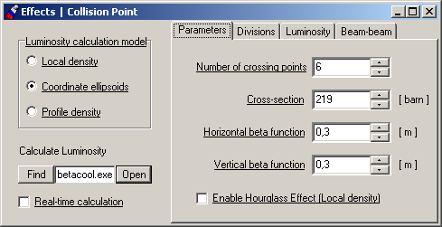
Fig. 28. Window of the Effects | Collision menu item. TabSheet Parameters

The Tab Sheet Parameters (Fig.28) is intended for the definition of the main characteristics of the collision point and includes next parameters needed for calculation:

Variable caption | Unit | Variable in the program | Comment, Formula
Input
Number of crossing points | - | int iColl.Points | Number of interaction (collision) points in the ring
Cross-section | barn | int iColl.Cross | Cross-sesction of the collision
Horizontal beta_function | m | β_{x} , Lattice.betax | Horizontal beta-function in the collision point
Vertical beta_function | m | β_{y} , Lattice.betay | Vertical beta-function in the collision point

CheckBox Enable Hourglass effect (Local density) – when checked and the model of the luminosity Local Density is chosen – takes into account the so-called hourglass effect in the collision point.

The Tab Sheet Divisions (Fig.29) is intended for the real-time luminosity calculation for the fast estimation of the luminosity vs number of particles. It includes next parameters needed for calculation:

Variable caption | Unit | Variable in the program | Comment, Formula
Input
Particles/Divisions | - | int iColl. Divisions | Number of particles in the unit division of density
from |  | int iColl.From | Start and final parameters, and step for the calculation
upto |  | Lattice.Upto | Start and final parameters, and step for the calculation
step |  | Lattice.Steps | Start and final parameters, and step for the calculation

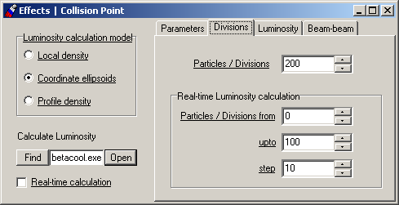
Fig. 29. Window of the Effects | Collision menu item. TabSheet Divisions

The Tab Sheet Luminosity (Fig. 30) contains plot with dependence of luminosity on particles-per-cell. It is necessary for making real-time fast estimation of the luminosity.

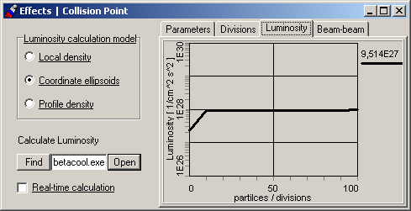
Fig. 30. Window of the Effects | Collision menu item. TabSheet Luminosity

The Tab Sheet Beam-beam (Fig. 31) is intended for the definition how beam-beam parameters (horizontal and vertical) will be calculated. These parameters are represented in the code and are calculated as a following:

Variable caption | Variable in the program | Comment, Formula
Beam–beam parameter | ξ_{x,y}  iColl.Kappa_x  iColl.Kappa_y | 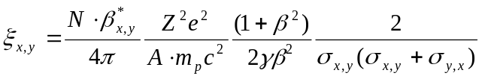
Choice for the Emittance for the beam-beam (which the σ_{x,y} are calculated via by) defines which emittance value will be taken for the calculation: usual RMS, FWHM value, or the emittance value occupied by pointed percent of particle number. Correspondingly the number of particles for the beam-beam formula will be recalculated and taken in accordance with the chosen emittance.
Evolution of the Luminosity and Beam-beam parameters in time is calculated and is visualized into the window Beam | Evolution Tab Sheets Luminosity and Beam-beam.

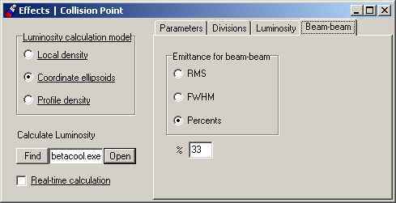
Fig. 31. Window of the Effects | Collision menu item. TabSheet Luminosity

1.2.4.2. Menu item Effects. Internal Target Effect.

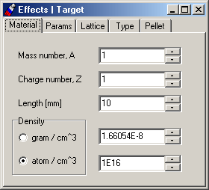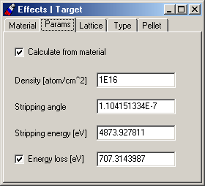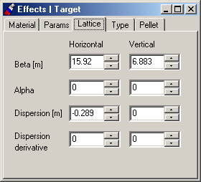
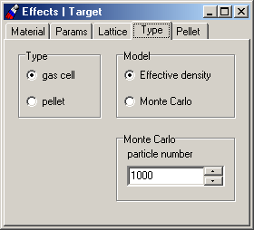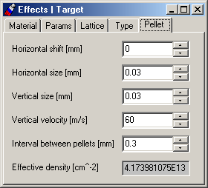
Fig. 32. Window of the Effects | Target menu item.

Window of the Effects | Target (Fig.32) includes five tab sheets: Material, Params, Lattice, Type and Pellet. Tab sheet Material defines Mass number and Charge number of the target atoms, Length and Density of the target. Tab sheet Material shows parameter of the target which can be calculated from material if check box Calculate from material is switch on. Check box Energy loss indicates the using of the energy loss value in the simulation. Tab sheet Lattice defines the lattice functions in the target position. Tab sheet Type is used for choosing of the target Type (gas jet or pellet) and simulation Model (Effective density or Monte Carlo). Tab Sheet Pellet describes parameters of the pellet target. More detail explanation of the target object is given in physical description of BETACOOL program.

1.2.4.3. Menu item Effects. Intrabeam Scattering Effect.

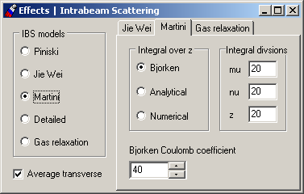
Fig. 33. Window of the Effects | IBS menu item.

Window of the Effects | IBS menu item (Fig. 33) includes radio group IBS models and three Tab Sheets for more detailed description and definition of the chosen calculation model.
Also it contains Check Box Average transverse rates. When it is checked (in the program variable iIBS.coupled is equal true) the both transverse growth rates are set to be equal half-sum of calculated horizontal and vertical rates.

Radio group IBS models provides a choice between analytical models of diffusion coefficient calculation. Piwinski model calculates the growth rates for smoothed ring structure (for mean beta functions and dispersion) and it does not require loading optics structure of the ring. Jie Wei and Martini models calculate the rates by averaging over the ring tacking into account dependence of the lattice parameters on longitudinal co-ordinate. These models require loading optics ring structure from output MAD file (or from another type file). The fourth model is Detailed IBS calculation, here for rates calculation this model needs mean beta functions and dispersion. But if dynamics algorithm chosen – one needs to load optics structure of the ring. The fifth model of IBS is Gas Relaxation – calculation of growth rates is provided using well known formula of characteristic times of gas relaxation from plasma physics. This model needs mean beta-functions and dispersion, which can be taken as pre-defined parameters or calculated from real lattices by averaging.

Jie Wei model calculates the growth rates analytically (without numerical evaluation of integrals). In the program the models are switched with variable iIBS.Model which is equal to 0 - for Piwinski, to 1 - for Jie Wei, to 2 - for Martini model, 3 for Detailed IBS calculation, and 4 – for the Gas Relaxation formula.

Martini model calculates integral over three variables. The radio button Martini integral over z (Fig. 33) provides a choice of method for calculation of the integral over z variable (Coulomb logarithm calculation). Bjorken model sets the value of this integral to some constant (40/D in the text of the program). Analytical model calculates the integral as a sum of a few first members of the expansion into series. The numerical model provides integration numerically. Edit windows step over mu, step over nu, step over z input number of integration steps over corresponding variable. Corresponding variables in the program are: iIBS.stepmu, iIBS.stepnu, iIBS.stepz. step over z is used for numerical model only. These models are switched with variable iIBS.Model2 in the program, which is equal to 0 for Bjorken, to 1 for Analytical and to 2 for numerical model.

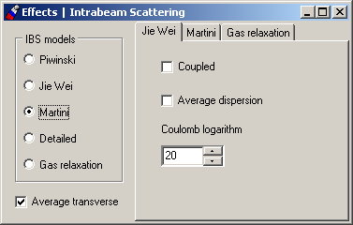
Fig. 34. Window of the Effects | IBS menu item. Jie Wei Model.

For the Jie Wei model (Fig. 34) there are two check boxes to choose some modifications in this model. For details see the BETACOOL description, section, dedicated to IBS modelling.
If check box Coupled is checked (in the program variable iIBS.coupledJie is equal true) then works case for beams which are stored at energies much higher then the transition energy. Due to coupling and injection conditions, the horizontal and vertical betatron amplitudes are about the same. Here in formulae for growth rates the value of transition energy will be taken instead of usual gamma factor.
If check box Average dispersion is checked (in the program variable iIBS.NoDispersion is equal true) together with Coupled Check Box this is a case when r.m.s. beam parameters (σ_{x} and σ_{p}) are related only by the average dispersion D_{p}. And the asymptotic configuration for form factor d can be reached (d ≈ 2n/(1+2n)).

For the Detailed model – there are no switches. The formula for longitudinal rate calculation is analytic and was obtained by A. Burov. It has two-dimensional integral inside. To define number of steps for those integrals following variables in the program are used: iIBS.stepmu, iIBS.stepnu. To change these values one has to use edit windows step over mu, step over nu on the Tab Sheet intended for Martini model.

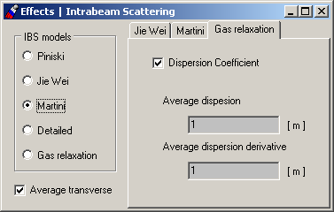
Fig. 35. Window of the Effects | IBS menu item. Gas Relaxation Model.

For the Gas Relaxation model (Fig. 35) there is a Tab Sheet with CheckBox Dispersion coefficient and two edit windows for output of calculated average dispersion and dispersion derivative of the investigated structure. When CheckBox Dispersion is switched on – then the numerical coefficient: 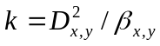 will be taken into account for gas relaxation formula calculation.

1.2.4.4. Menu item Effects. RestGas Effect.

Window of the Effects | Rest Gas (Fig. 36) includes a kit of parameters characterized vacuum composition in the ring. The list of following parameters on the Tab Sheet Vacuum composition is presented:
Mean vacuum chamber radius [cm] (this variable is presented in program code as iBeam.a variable);
Pressure [Torr] (variable iRestGas.Pressure in the program code);

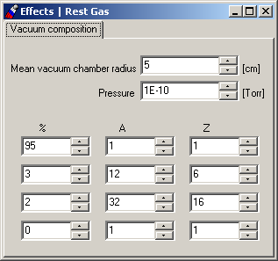
Fig. 36. Window of the Effects | RestGas menu item.

Four-component vacuum is presumed for now in the program. Below the above mentioned parameters the table of the vacuum components is situated. For every component provided the following kit of parameters: percentage of the component in a whole composition (%), Atomic number of the component (A) and Charge number correspondingly (Z). In the program these are variables: xMaterial iRestGas.Comp[].
Growth rates due to the scattering on the residual gas are calculated with the same mechanism to the internal target effect (for example gas-jet target). Accordingly to the residual gas pressure the effective density of the gas is calculated, then energy loss on scattering with Bethe-Bloch formulae, r.m.s. angles of ions after scattering on atoms of the residual gas, and emittance and momentum deviation are calculated consequently. After in accordance with the percentage of components the characteristic growth rates are obtained. More detailed information is given in physical description of BETACOOL program.

1.2.4.5. Menu item Effects. Additional Heating Effect.

Window of the Effects | Heating menu item (Fig. 37) includes two panels: Linear deviation and Diffusional deviation. Each panel has check box Active, the corresponding Boolean variables iHeat.linear and iHeat.diffusion are equal to true if checked. Emittance derivatives and diffusion coefficients are input into the arrays iHeat.Linear[3] and iHeat.Diffusion[3].

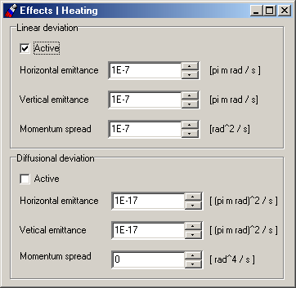
Fig. 37. Window of the Effects | Heating menu item.

1.2.4.6. Menu item Effects. Particle Losses Effect.

Window of the Effects | Heating menu item (Fig. 38) includes list of the effects and factors which lead to the particle losses in the storage ring. Here are two lists presented. The first one is for the Active Effects and it contains four factors which cause particle losses due to the active switched effects:
- Electron Capture in ECOOL
- Scattering on Rest Gas
- Internal Target
- Collision Point

All this effects lead to the decreasing of the particle number in the beam.
When the check Box Electron capture n ECOOL is checked the particle losses due to the recombination in the cooling section are tacking into account in the loss rate calculation. In this case the Boolean variable iEcool.Loss is equal true in the opposite case – false.
When Check Box Scattering on Rest Gas is checked the particle losses due to the scattering on residual gas are taking into account. In this case the Boolean variable iRestGas.Loss is equal true in the opposite case – false.
When Check Box Internal Target is checked the particle losses due to the scattering on the switched target are taking into account. In this case the Boolean variable iTarget.Loss is equal true in the opposite case – false.
When Check Box Collision Point is checked the particle losses due to the effects in the interaction point are taking into account. In this case the Boolean variable iColl.Loss is equal true in the opposite case – false.
The second list on the form contains factors which cause Additional Losses:
- Life time (Decay)
- Acceptance
- Separatrix Length

User can choose which effect is to be taken in calculations.
When Check Box Life time (Decay) is checked the particle losses due to the natural decay of the particles is taken into account. In this case the Boolean variable iLosses.Decay is equal true in the opposite case – false.
When Check Box Acceptance is checked the particle losses due to the aperture boundaries is taken into account. In this case the Boolean variable iLosses.Acceptance is equal true in the opposite case – false.
When Check Box Life time (Decay) is checked the particle losses due to the particles coming out of the separatrix is taken into account. In this case the Boolean variable iLosses.Separatrix is equal true in the opposite case – false.
GroupBox Generate new particle on distribution – allows to recover lost particle in the test beam. BETACOOL works with two arrays of particles (beams) – the first one (major) – it contains real number of particles. The second one – is test beam – it usually contains several thousands particles and is used for dynamics simulation in accordance with active effects. When particle is lost due to some factors we have to decrease number of particles in the major beam, but the number of particles in the test beam has to stay unchanged.
So this Group Box allows to make a choice how lost particles will be recovered in the test beam in accordance with defined distribution from the list: Gaussian, Real, or None.

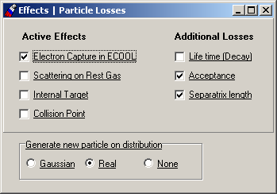
Fig. 38. Window of the Effects | Particle Losses menu item.

1.2.5. Menu item Task. Procedures of BETACOOL program

Input parameters for general procedures of the program are collected in the menu item Task, which includes submenu items Algorithm, Rates.

The window of submenu item Task | Algorithm is used to provide a beam tracking and beam parameters recalculation correspondingly to the chosen numerical model. TBrowse component of this window starts selected calculation process.

The window of submenu item Task | Rates collects input parameters for calculation of the sum of inverse characteristic times of emittance variation for all active effects. The TBrowse component of this Window is used for calculation the sum of the rate as a set of four numbers, or as three 3D plots.

1.2.5.1. Calculation of emittance variation rates

The Window of the Task | Rates menu item (Fig. 39) includes:

- the panel Active Effects including the check boxes for all effects determined in the program;
- four edit windows for representation of sum of the rates of corresponding beam parameter;
- the Check Boxes Draw Evolution of Rates, and Draw 3D Diagrams;
- TBrowse component Calculate Diagrams of Rates which starts the calculations;
- five tab sheets for representation of results in graphic format.

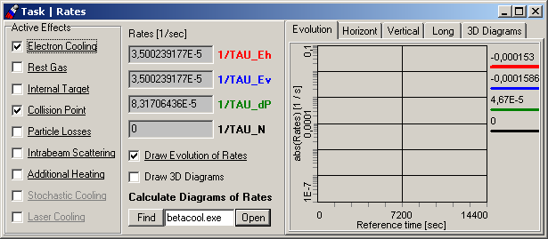
Fig. 39. Window of the Task | Dynamics menu item. Tab sheet Evolution.

All the Effect classes have the same parent class xEffect, which has a Boolean variable use. When the corresponding check box is checked this variable of the effect is true. All the variables Effect are put in the array using self counter system. The program calculates sum of the rates in cycle calculating the rates of the effects at use = true. In the current version of the program not a whole list of the effects from last version of BETACOOL is realized. The font color of effect name, which can be used in calculations now, is black. For effects under development the color is gray.

The check box Draw 3D Diagram determines the calculation procedure, which starts when push the button Open of the TBrowse Calculate Rates. If the check box is not checked the program calculates the sum of the rates at the beam emittance values determined in the window of the menu item Beam|Parameters, and represents them into corresponding edit windows. If the check box is ON the program calculates the sum of the rates as three 3D diagrams in the range of the beam emittances determined in the tab sheet 3D Diagrams (Fig. 40).

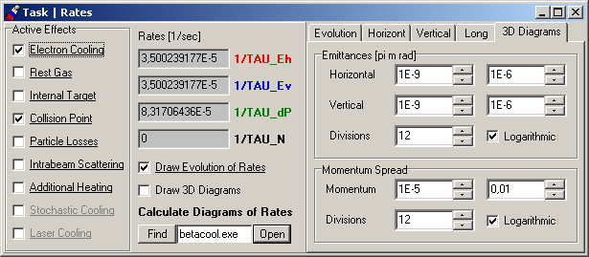
Fig. 40. Window of the Task | Rates menu item. Tab Sheet 3D Diagrams.

If the Check Box Draw Evolution of Rates is checked then evolution of the calculated rates (absolute value of the growth rates vs reference time) will be visualized onto plot on the Evolution Tab Sheet when pushed the button Open of the TBrowse Calculate Rates.
An example of 3D diagram of the sum of the rates is presented in the Fig. 41. The tab sheet Horizont contains 3D diagram of the sum of the rates of the horizontal emittance variation, Vertical – the vertical emittance variation, Long – the longitudinal one.

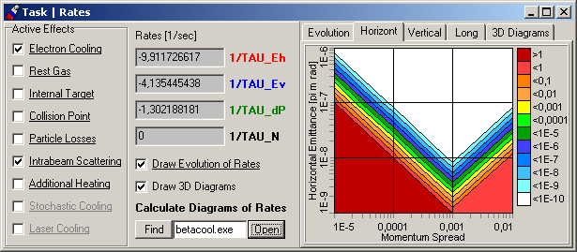
Fig. 41. Window of the Task | Rates menu item. Tab sheet Horizont.

1.2.5.2 Numerical algorithms of beam evolution and multi particle tracking

The Window of the Task | Algorithm menu item (Fig. 42) includes:
- Several Tab sheets for different algorithms: RMS Dynamics, Model Beam and Tracking - to input the calculation process parameters;
- special Tab sheets for calculated results output modes: Output, Points. Also there is a TBrowse component Run Algorithm which starts the calculations;
- Tab sheet Algorithm itself contains radio button to make a choice a calculation model: Dynamics, Model Beam, Tracking.

1.2.5.3 Calculation of the beam r.m.s. dynamics

RMS Dynamics – is original BETACOOL method for beam r.m.s. parameters dynamics (evolution of r.m.s. parameters). To launch this calculation method one beforehand must choose Ring Optics (lattice structure) – with help of Ring Optics window – user must switch on either Lattice structure file (MAD output) or MAD input file (see below a special table of modes to be switched). The result of knitting of the MAD lines to the continuous chain of optic elements, which will be used for r.m.s. parameters tracking one can see in *.use file. So the goal of the Dynamics algorithm is calculation of growth rates of beam r.m.s. parameters evolution.
Here one must use the TabSheet RMS Dynamics to change some necessary parameters. In case of this model selection program calculates the beam parameter evolution by Euler method at variable step (variable iDynnamics.Variation is true). At each step over time program checks all the beam emittance and if expected emittance variation is higher then determined in the edit window Max growth of the tab sheet RMS Dynamics, or expected emittance values after the step have a negative sign, the program divided the step value by the factor determined in the edit window Step multiplier. In the program this procedure is controlled by the variables iDynnamics.ratio, iDynnamics.ifmore and local Boolean variable negative of the procedure xDynamics::Dynamics(). Initial step of integration can be input from the panel and is controlled by variable iDynnamics.dt, Maximum step can also be input from the panel and is a variable iDynnamics.Maxtdt in the binary code.. On Figures an examples of these windows and Tab Sheet are presented.

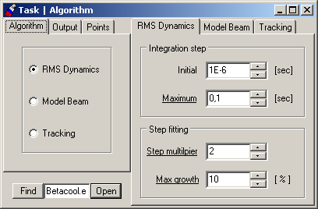
Fig. 42. Tab sheets of the Task | Algorithm| Algorithm menu item Window.

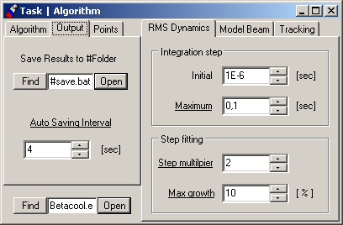
Fig. 43. Tab sheets of the Task | Algorithm| Output menu item Window.

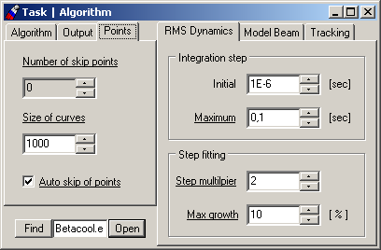
Fig. 44. Tab sheets of the Task | Algorithm| Points menu item Window.

The Tab Sheet Output (Fig 43) controls the process of data output. Edit window Save Results to #Folder determines the path to the folder where all the files with calculated results (curves, tables, etc) will be saved. The name of the folder will be identical to the name of the file of initial parameters (for example #rhic.bld). The batch file (save.bat) pointed in this edit window contains a list of files with curves and data which are intended to be saved.
Edit window Auto Saving Interval determines how frequently the program saves all calculated results to the indicated folder.
The Tab Sheet Points (Fig 44) controls the process of data output. Edit window Number of skip Point determines how many points of calculated curves will be skipped when saving to disc. Edit window Size of curves determines the size of curve (size of array of points) to be saved on disk.

Radio button  Task | MAD output file | MAD input file | No optics file | Comments
Dynamics | √ | √ | √* | * - in case when Piwinsky model of IBS calculation was chosen
Model Beam | √ | √ | √** | ** - if chosen No optics – user has to fill (type in) the ring transformation matrix
Tracking | ⎯ | √ | ⎯
Crosses of algorithm models and mode of Optics structure required.

1.2.5.4 Calculation of the Model Beam algorithm
This method of beam tracking through the optics structure is based on the algorithm, realized in program code Simcool made by V.Parkhomchuk. The basic scheme of the algorithm is the following:
- on the first stage a beam is generated with defined parameters;
- in the selected point of the ring in accordance to the current lattices so called “kicks” from active effects are calculated (coordinates and angles of every particle are changed correspondingly). In the earlier versions of the BETACOOL kicks for two effects only were calculated (electron cooling and IBS). The last version presumes calculation of the influence from any effect in the list as a kick
- obtained vector of coordinates is multiplied Turn step times by the transformation matrix of the whole ring;
- go to the first step;

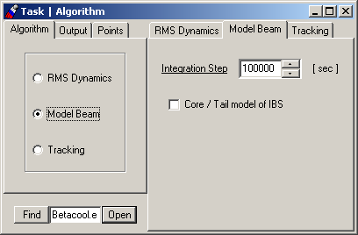
Fig. 45. Tab Sheet of the Task | Algorithm | Model Beam Window.

This algorithm has the parameter to be initialized from the Tab sheet Task | Algorithm | Model Beam Tab sheet (Fig. 45) - integration step. This parameter is step of the integration in seconds – this is itself the number of the beam turns, by other words – a number of acts of the ring transformation matrix to the vector of coordinate. In the program code this parameter is initialised with double iDynamics.IntegrationStep variable.
Check Box Core/Tail model of IBS if checked determines that effects of Core-Tail distribution for IBS is taken into account during the calculation.

1.2.5.5 Calculation of the particle tracking

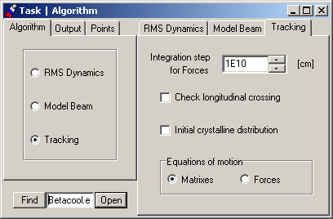
Fig. 46. Tab Sheets of the Task | Algorithm | Tracking Window.

This method of particle tacking over the optics structure is an eternal cycle of particles over the optics elements. All the elements are collected in a special array iRingOptics[n]. Every element has its own index. Every member of this array contains a kit of optic element parameters. The step of tracking is initialized from the Tab Sheet Tracking: Integration step for Forces [cm]. The number of element particle to “enter” is taken from the iRing.Index. Also there is a variable xTime.s0 that indicates the coordinate of particle inside the optics element. All the necessary parameters of the element (length, etc) are taken accordingly to the xRing.Index. New vector of coordinates is recalculated at every step in the presence of acting forces inside the element (right parts of the motion equations) with selected method of integration (Runge-Kutta of the 4th order, Simplectic integrator or Euler). For the IBS effect method of Molecular Dynamics is used.

The Window of the Task | Algorithm | Tracking Tab sheet (Fig. 46) includes also two Check Boxes:
- Check longitudinal crossing – if switched the number of crossings in the longitudinal direction will be checked. In the program code this parameter is initialised with bool iDynamics. CheckCrossing variable.
- Initial crystalline distribution – if switched then particles in the beam will generated as an ordered distribution. This option is used when crystalline beam dynamics is simulated. In the program code this parameter is initialised with bool iDynamics.Crystall variable.
And the Group Box Equations of motion which gives a choice what formalism will be used for the particle coordinate vector tracking – either via transformation Matrixes or integrating the vectors of Right Parts (Forces).

1.3. Work with BETACOOL independently on interface.

1.3.1. Format of the input files and launching the program.

The input file for the last version of BETACOOL is developed to use in a convenient way the program in cross-platform regime. For now the interface for Linux version is under development, that’s why the user friendly way to use BETACOOL is independent editing of the input file and a possibility to launch a program with pre-defined parameters and further investigation of the results with any Windows or Linux application.
The format of the input file is developed in such a way that it is easy to collect and edit it in any simple editor. All the parameters are provided with comments and structure of parameters list is connected to the program algorithm.
All the parameters (input and output) which are processing during calculation are kept in global array Data. The size of this array is set in accordance with the input file: number of rows corresponds to the maximal number value of the effect (object) or the tag of the Form or Panel with the maximal number (if interface is used). Number of columns in the row corresponds to the number of parameters of the processed effect (object).
This array is generated in accordance to the mentioned numbers and every cell is filled with input parameters.
All the objects and effects in program which have parameters to be input from the form include functions int OnGet(), int OnSet() and int OnRun() as obligatory part of the structure.
Function OnGet() accordingly to the effect(object) tag reads necessary parameters from the corresponded rows. Here is the example of the input file is presented:

[row=1] Beam | Parameters | Emittance
2.4e-08= Horizontal emittance, pi*m*rad
2.5e-08= Vertical emittance, pi*m*rad
0.001= Momentum spread
1000000000= Number of particles
0= bunched(0) / coasting(1)
1= Collider regime (0/1)
0.001443904867= Mean beam radius, m
8.089343697= Longitudinal form factor
0.1298843665= Longitudinal space charge impendances, Ohm
9390901.33= Transverse space charge impendances, Ohm/m
4.055707549= Peak current, A
0= Emittance definition: RMS(0),CS(1),FWHM(2),%(3)
100= Divisions for FWHM
50; Percents

[row=2] Beam | Parameters | M.D.
2000= Particle per Cell
1= Macro Particle
1e-06= Impact parametr, m
0.00766769= Cell size, m
0.003400342669= Linear density
2129302213= Initial longitudinal temperature, K
2.770901656e+10= Initial transverse temperature, K
3.27286504e-08; Gamma1
Parameter [row= ] is corresponded to the Form or Panel tag and simultaneously number of Row in the Data array. On the next strings of the input file the list of parameters is presented. The value is separated from the comments with “=”. The last parameter of the effect (object) (means the last column in the row) has to have a marker “;” after equaling.
In this way is easy to understand that values (necessary parameters themselves) can be separated from the comments with “]”, “=” or “;” markers.
After all the parameters are filled in accordance with the input file and are redrawn in edit windows if the interface is used, for some pre-calculation or on-line update the function OnSet() is used. It makes some intermediate calculations and update Data array cells and edit windows on interface.
Another one very useful feature which BETACOOL gives is OnRun() function. All the parameters which have underlined labels in interface can be changed while program executes and all the procedures will re-calculate with on-line changed parameters. Effects or objects which need such a possibility must have a function OnRun()inside its own class.
To activate this function user must edit necessary parameter and push the button with yellow clock on the main window of the interface (see Fig. 47). Changed parameters will be saved to the file, file will be reloaded and calculation process will be continued with new parameters.

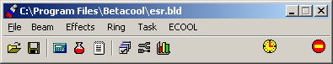
Fig. 47. Main window of the BETACOOL program

To stop the program with correct cleaning the OS memory it is advised to use red button Stop on the main window. In this case a special file-marker will be created in the current directory and as soon as program will find it then it immediately will shutdown with correct saving all the calculated results.

The BETACOOL program can be started independently on interface program. For this purpose one needs to input in the command line the following:

<path>\betacool.exe <inputfilename> /<parameter>

The program analyses only the first letter in the parameter name. The parameter can be equal to the following letters:

Parameter | Executable procedure, output files of simulation
a | iDynamics. Algorithms () - calls one of the indicated simulation model.  Ex2t.cur  Ey2t.cur  Dp2t.cur  Num2t.cur  Lum2t.cur  Th2t.cur  Tv2t.cur  Tp2t.cur  Tn2t.cur
l | iDynamics.Lattice() – used for check a validity of MAD output file  output files:  BetaX.cur,  BetaY.cur,  DispX.cur,  AlfaX.cur,  AlfaY.cur,  DispX_.cur.
r | iDynamics.Rates() – calculates growthrates of the rms beam parameters in accordavce with active effects.  RateEh.sur  RateEv.sur  RatedP.sur
f | iDynamics.FFTest() – used for visualisation of the friction force shape  output files:  FFtr.sur  FFlong.sur

1.3.2. Format of the output files.

The files *.cur as a rule contain time dependencies of the beam parameters. Example of the *.cur file format:

0 0.0003849600109
18 0.0003703453546
36 0.0003563822554
54 0.0003430464386
72 0.0003303146755
90 0.0003094731154
99 0.0002900512001
108 0.0002719605886
117 0.0002551191811

The first column of the files with beam parameter time dependencies contains the current time in [sec], second column – values of corresponding variable. The columns are divided by tabulator symbol. Strings are finished by the end of line symbol.

The files *.sur contain functions of two variables. Example of *.sur file:

0 0.000333333 0.000666666 0.001
0 -0 -0 -0 -0
0.000333333 2.98404e-12 2.98364e-12 2.98243e-12 2.9804e-12
0.000666666 2.16460e-12 2.16452e-12 2.16426e-12 2.1638e-12
0.001 1.01881e-12 1.01879e-12 1.01873e-12 1.01864e-12

First element in the first string of the file is empty. Other elements in the first string contain the value of first variable. The elements of the first column contain the values of second variable. Corresponding value of the function are placed at the cross of the string and column. Numbers in the string are divided by tabulator symbol. Strings are finished by the end of line symbol.

2. Description of the source code

This chapter describes the structure of BETACOOL initial codes, that includes *.cpp and *.h files, project files for C++ Builder 4 and for Microsoft Visual C++ 6. The code structure was developed in the way, which simplifies understanding the structure of the objects and provides the tools for fast modification and development of the base physical models of the program. Text of the code includes comments to all general variables of the program inside the header files and comments to calculation algorithm steps inside the *.cpp files. Dimensions of all dimensional variables used in the program are declared in the text of the code. General input and output variables of the program are described in the chapter 1 and their dimensions and physical sense can be verified using BOLIDE interface of the program. By this way we tried to make the source code and the software as a whole in the form of a self-documented system. Any case overview of the code structure is necessary for understanding a way of connection between its functional parts. From the other hand, the code fragments presented here are aimed to be initial manual for user how to develop the code in parallel with development of the program exterior described in the chapter 1.

2.1. Source files

The source code consists of

- Betacool.cpp file, which contains main procedure of the program,

- and following units:

doubleu.cpp
datau.cpp
bolideu.cpp
xbeam.cpp
xdistributor.cpp
xdraw.cpp
xdynamic.cpp
xebeam.cpp
xecool.cpp
xeffect.cpp
xforce.cpp
xibs.cpp
xlibrary.cpp
xoptics.cpp
xrestgas.cpp
xring.cpp
xrunge.cpp
xtarget.cpp

with corresponding header files;

file xbeam.inc

- two header files:

BTempinc.h
BTemplat.h

with the BOLIDE Self Pointer Templates;

- header file

StdAfh.h

generated by Microsoft Visual C++.

To compile the program by Borland C++ Builder 4 the project file Betacool.bpr is used.

Betacool.dsk, generated by Borland C++ Builder 4, with saved desktop of the interface

To compile the program by Microsoft Visual C++ 6 the working space file Betacool.dsw and project file Betacool.dsp are used.

2.2. Structure of the source code

The structure of the source code can be shared between three functional parts and its structure is illustrated on the Fig. 48.
The source code consists of:
- interface part, which supports the format of input and output files common with the BOLIDE system,
- library of base numerical algorithms including description of dimensional variables, templates of the program self counters, procedures for matrix algebra, algorithms of numerical solution of differential equations,
- physical codes described objects of the program and procedures with them.

The interface part of the code and library of algorithms were developed and tested independently on physical part of the program. They are aimed to give user the tools for development of the physical part of the code. Correspondingly, modification of the physical code of the program, if it is necessary to improve models of investigated processes, can be done without any changes of the interface part. Therefore here we give only brief description of the interface and algorithm parts of the code and describe the physical code in more details.
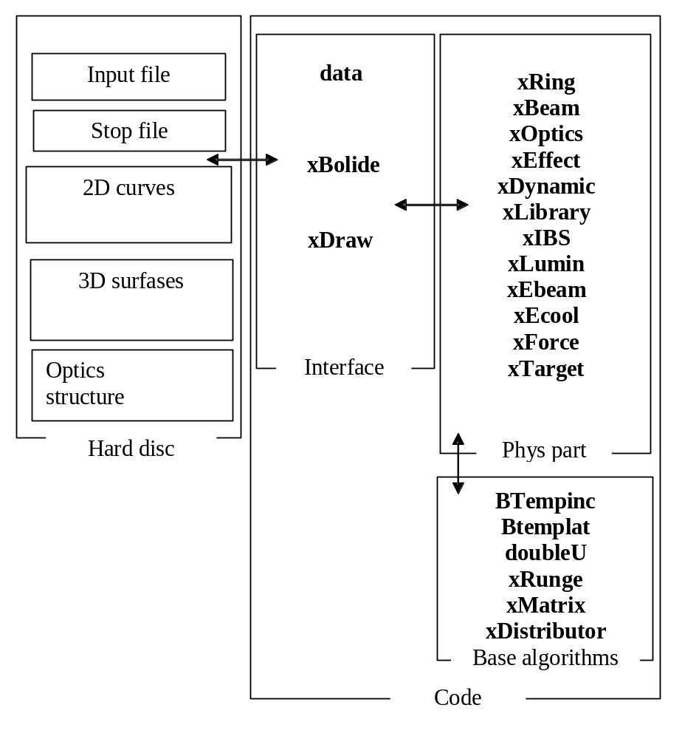
Fig. 48. Schematics of the code structure.

2.3. Interface part of the source code

Interface part of the code provides a work with file structure on a hard disk and it is described in the files datau.cpp, datau.h, bolideu.cpp, bolideu.h, xdraw.cpp, xdraw.h.

Class xData described in the files bolideu.cpp, bolideu.h is the parent class for all general objects of the code. This class includes two-dimensional array of the BData class, which provides loading and saving to disk the input file of the program. This array has variable column number in the rows and variable row number and is described in the files data.cpp, data.h. Structure of this array corresponds to the structure of input file. In the program global variable xData Data is declared and all objects of the program get the values of their variables from the elements of the global array. Output variables are put into the corresponding elements of the global array. The array Data is generated dynamically during reading of an input file.

All the names of output curves and surfaces of the program are collected in the object xDraw, where they are associated with the corresponding names of output files. Interface part described in the files bolideu.cpp, bolideu.h saves the calculated curves and surfaces into corresponding files. The data writing to the disk is repeating periodically in accordance with corresponding parameters in the input file.

2.4. Basic algorithms

Basic algorithms used by physical part of the code includes:
- algorithm of work with Self pointers in the program (files BTempinc.h, Btemplat.h),
- description of the class of dimensional variables (files doubleu.cpp, doubleu.h),
- procedures for numerical solution of systems of differential equations (files xrunge.cpp, xrunge.h),
-templates and classes of dimensional vector and matrix releasing the matrix algebra (matrixu.cpp, matrixu.h),
- generator of the array of 6D dimensional vectors in accordance with given distribution function (xdistributor.cpp, xdistributor.h).

The Self Pointers algorithm is the base of calculation of the sum of the rates for active effects of the task. Brief description of the algorithm is given in the chapter 2.5.3.

The hierarchy of classes for the description of dimensional variables described in the files doubleu.h, doubleu.cpp. The dimensional calculations in the program are based on (second, Quloumn, meter) system of units. Dimensional variable in the code has five parameters: value, powers of base units and coefficient for recalculation the value to the units of the variable. All the standard operations with the dimensional variable and elementary functions are overloaded. Appropriation and comparison operators include the checking of dimension equality (CheckUnits and CheckZero functions), which prompt the user in case of errors. To increase the calculation speed of the program after completion of the debug process user can switch off the checking of dimensions. For this case one has to comment first line in doubleU.h file:

#define PoWeRs // Do comment this line to speed up calculation and recompile the program.

The files xrunge.cpp, xrunge.h, matrixu.cpp, matrixu.h describe the standard mathematical algorithms for dimensional variables. Description of mathematical methods used in the object xDistributor is given in the part of report dedicated to the basic physical models of the software.

