64036_Assignment1

Durgaprasad Gandi

2023-09-29

library("knitr")

# Summary of the Carseats dataset:

library(ISLR) #loads the ISLR library  
summary(Carseats)

## Sales CompPrice Income Advertising   
## Min. : 0.000 Min. : 77 Min. : 21.00 Min. : 0.000   
## 1st Qu.: 5.390 1st Qu.:115 1st Qu.: 42.75 1st Qu.: 0.000   
## Median : 7.490 Median :125 Median : 69.00 Median : 5.000   
## Mean : 7.496 Mean :125 Mean : 68.66 Mean : 6.635   
## 3rd Qu.: 9.320 3rd Qu.:135 3rd Qu.: 91.00 3rd Qu.:12.000   
## Max. :16.270 Max. :175 Max. :120.00 Max. :29.000   
## Population Price ShelveLoc Age Education   
## Min. : 10.0 Min. : 24.0 Bad : 96 Min. :25.00 Min. :10.0   
## 1st Qu.:139.0 1st Qu.:100.0 Good : 85 1st Qu.:39.75 1st Qu.:12.0   
## Median :272.0 Median :117.0 Medium:219 Median :54.50 Median :14.0   
## Mean :264.8 Mean :115.8 Mean :53.32 Mean :13.9   
## 3rd Qu.:398.5 3rd Qu.:131.0 3rd Qu.:66.00 3rd Qu.:16.0   
## Max. :509.0 Max. :191.0 Max. :80.00 Max. :18.0   
## Urban US   
## No :118 No :142   
## Yes:282 Yes:258   
##   
##   
##   
##

# Number of (observations)rows in Carseats dataset:

number_rows <- nrow(Carseats) #To get number of rows in the dataset.  
print(number_rows)

## [1] 400

***We get 400 observations in a Carseats dataset***

# Maximum value of the advertising attribute:

Advertising_Max <-max(Carseats$Advertising) #max is used to get maximum value of dataset.  
print(Advertising_Max)

## [1] 29

# Calculating the inter quartile of price attribute:

iqr_price <-IQR(Carseats$Price) #IQR is function to get inter quartile range.  
print(iqr_price)

## [1] 31

***The value of IQR is 31***

# Plotting of Price against Sales:

plot_SP<- plot(Carseats$Price,  
Carseats$Sales,  
xlab="Price", # on x axis we take Price as label.  
ylab="Sales") #on y axis we take Sales as label.

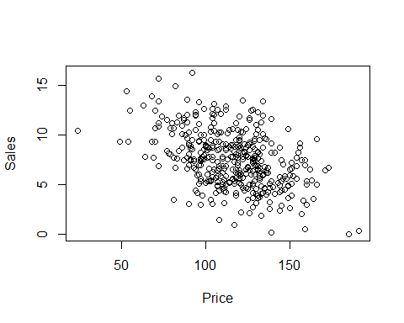

print(plot_SP)

## NULL

# Correlation of Price and Sales:

cor_cooeft <- cor(Carseats$Price, Carseats$Sales) #$ indicates respective column of dataset.  
print(cor_cooeft)

## [1] -0.4449507

***As the value is -0.4449 i.e the relation between Price and Sales is negative which indicates Weak relation***