**Scenario**:

In the booming world, I focused on Customer Relationship management. The CRM system created for TechBoost Innovations, a start-up in the technology industry, is intended to improve customer connections, expedite project management, foster creativity, and adapt to the always changing tech environment. Modules for managing customer profiles, project optimization, tracking the technology stack, capturing innovative ideas, and adaptable data formats to accommodate evolving requirements are all included in this all-inclusive CRM. CRM is strategically important because it guarantees customized client interaction, efficient project processes, continuous improvement, and adaptability to the rapidly evolving technology landscape inside the company.

**Description**:

The CRM system was created especially to take use of real-time sensor data, track vehicle movements, and account for the changing nature of logistics operations for UrbanTransit Logistics, a firm that specializes in autonomous vehicle fleet management for urban logistics. The tracking of maintenance tasks, managing telemetry data, dynamic route optimization, and attending to customer preferences are given top priority by this CRM system. It tackles the challenges of effectively overseeing autonomous car fleets in the dynamic urban logistics environment, emphasizing real-time analytics and flexibility in response to changing circumstances.

**Data Requirements**:

The CRM system developed for TechBoost Innovations is tailored to meet the unique data requirements of the technology and innovation sector. It includes detailed client profiles with identifiers, names, contact information, and a thorough communication history. Project details encompass distinct project identifiers, client affiliations, milestones, and development stages. The technological stack module incorporates project identifiers, utilized technologies, and version specifics. Innovation ideas are systematically monitored with clear idea identifiers, descriptions, and feasibility analyses. The CRM system is adept at handling flexible data structures, ensuring adaptability to the evolving needs of the tech industry. This data-intensive framework facilitates personalized client engagements, streamlined project management, and a dedicated focus on innovation amid the dynamic technology landscape.

**Why Non-Relational Database**:

The best option for TechBoost Innovations Customer Relationship Management (CRM) system is a non-relational database, namely MongoDB, considering the constantly evolving and dynamic nature of the technology and innovation industry. Given how quickly the industry is evolving, a flexible, schema-less database is essential, and MongoDB is excellent at handling unstructured and semi-structured data. It’s ability to smoothly include a wide range of data, from client profiles and project specifics to technology stacks and innovative concepts, makes it an excellent fit for the CRM's complex data needs. The database's capacity for horizontal scaling and its versatility in handling a wide range of data types make it an ideal fit for the IT industry's erratic expansion and changing requirements. Additionally, MongoDB's ability to work with rapid and iterative development processes guarantees quick adaptations to evolving data models, ensuring maximum performance when managing project workflows and client connections.

**Preference of Document DB Over Other Types**:

A document database, more especially MongoDB, is the perfect NoSQL database solution for TechBoost Innovations Customer Relationship Management (CRM) system. The rationale behind this choice stems from the necessity of flexibility and adaptability in the technology and innovation industry to manage a wide range of dynamic data structures. Document databases have a schema-less design that aligns with the changing nature of customer profiles, project details, technology stacks, and innovation concepts. They are adept at handling unstructured and semi-structured data. The CRM system at TechBoost Innovations can accommodate a variety of requirements thanks to the document-oriented approach, which makes it possible to store and retrieve complex data structures with efficiency.

**Justification:**

MongoDB was chosen as the document database for TechBoost Innovations CRM system due to its established reputation, wide user base, and strong community support. The schema-less structure of MongoDB complements the dynamic CRM data and offers flexibility for different kinds of information. Its scalability guarantees effective management of swift expansion, and a complex query language makes complex data analysis possible. When compared to other document databases on the market, MongoDB is the clear choice for meeting the complicated needs of the tech and innovation sector because of its geographic capabilities and seamless integration across varied tech stacks.

**Cost and characteristics:**

MongoDB was selected by TechBoost Innovations for its CRM system based on a combination of commercial and technical factors. skillfully terms of business, MongoDB's affordability, wide industry acceptability, and user-friendly features fit nicely with the many user needs and budgetary restraints found in the fast-paced technology industry. From a technical standpoint, MongoDB excels at managing unstructured data, providing horizontal scalability for expansion, and enabling sophisticated data analysis with strong query capability. MongoDB is the recommended choice because it is not only powerful but also optimal in addressing the many and changing needs of the CRM system. Its geographic capabilities and smooth connection with various tech stacks further solidify this opinion.

**Prototypes:**

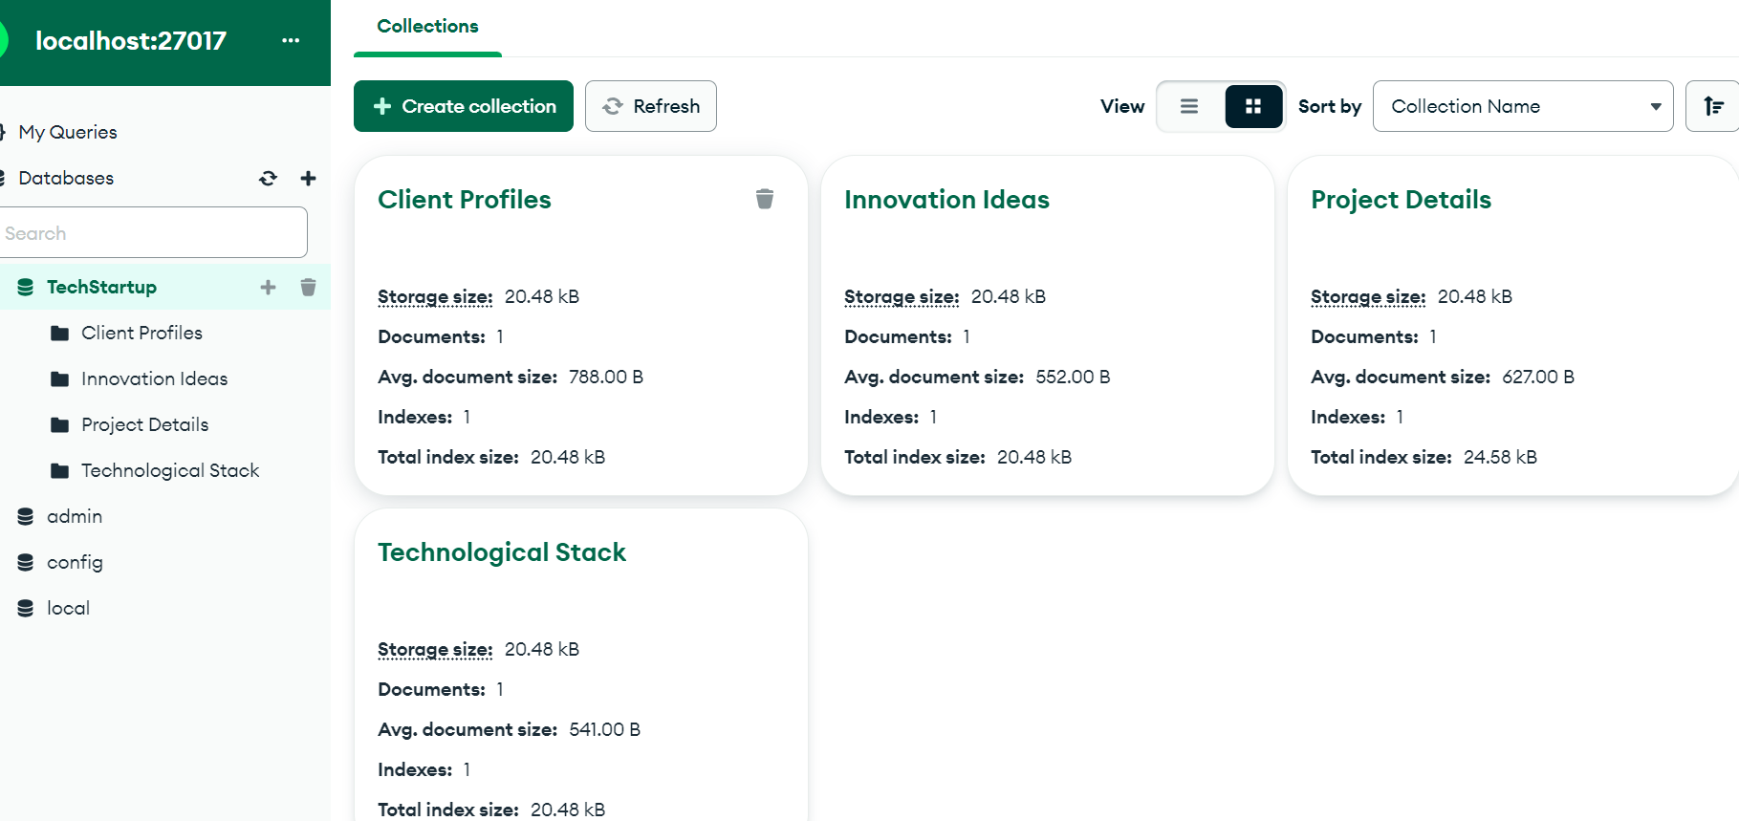

The Above Picture describes the creation of a new database in Mongodb where there will be a connection to connect . After that we need to add the Collections to the database.

**Client Profile**:

**Overview**:

A crucial source of important client data is the Client Profiles Collection. A different clientId allows each client to be uniquely identifiable, making tracking easier. Important information is kept in the name attribute, which holds the client's complete name, while the contact Information attribute holds the client's address. The correspondence history field is an array that contains entries with dates and thorough descriptions of every contact that has ever taken place. It is used to carefully document the history of communications with the client. This guarantees a thorough and detailed history of interactions with the client.

**Project Details**:

**Overview**:

The Screenshots above describes about the Clients and their individual projects that are connected through the Collection for Project Details. Every document in this collection is identified by a unique project identifier called a projectId. The project and a specific client from the Client Profiles Collection are connected via the clientId attribute. The milestones listed in this collection shed light on significant turning points in the project's history and the developmentStages field groups together several stages, such as front-end, back-end, and testing development. A thorough portrayal of the major developments and events of any project is ensured by this organized structure.

**Innovation Ideas**:  
  
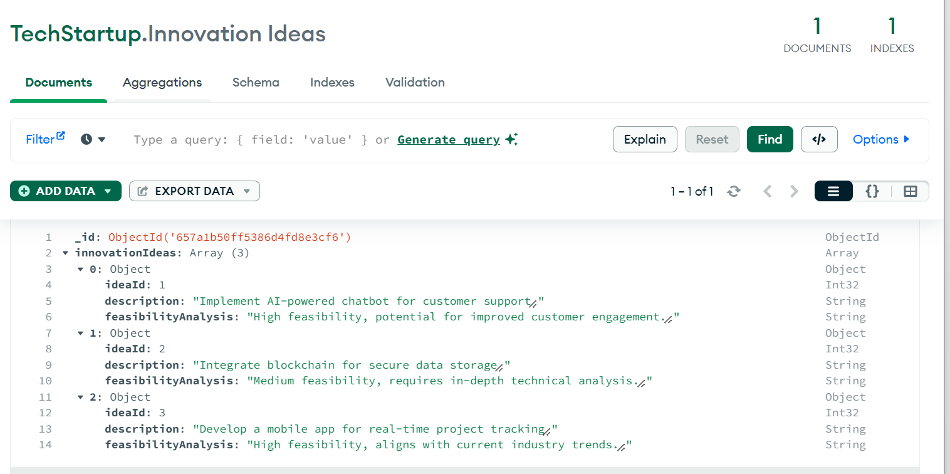

**Overview**:

At TechBoost Innovations, the Innovation Ideas Collection serves as a hub for fostering creativity. Each innovative concept is uniquely identified by an ideaId. The essence of every concept is captured in the description attribute, and its feasibility analysis field assesses how feasible it is to implement the idea. This compilation serves as a clearinghouse for brainstorming and idea evaluation, fostering an environment of continuous improvement and forward-thinking inside the company.

**Technological Stack:**

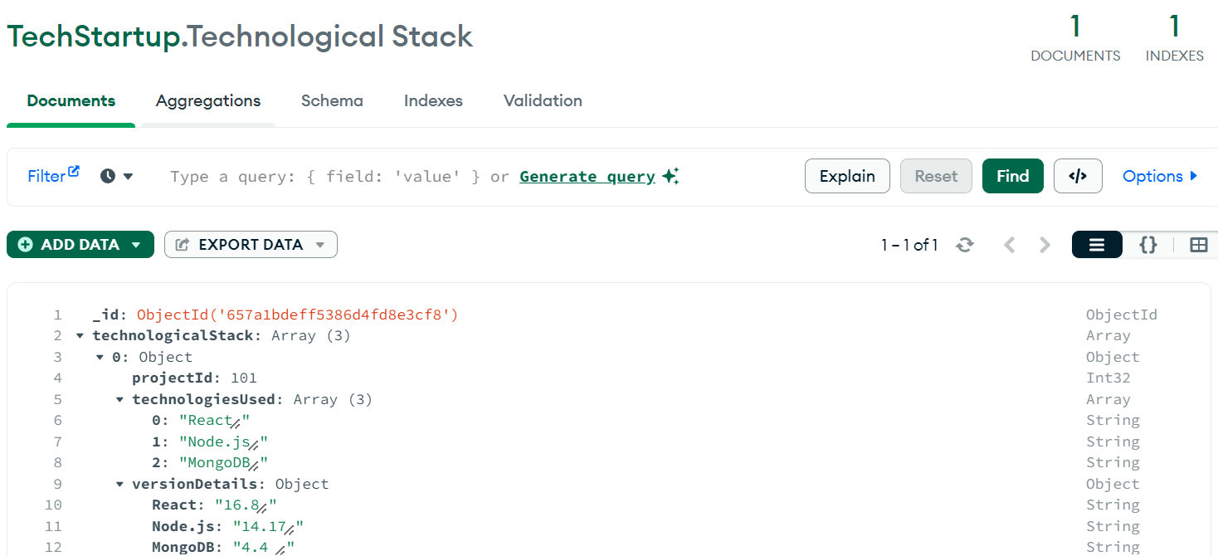

**Overview**:

The Technological Stack Collection plays a crucial role in monitoring the technologies utilized in each project. It establishes connections between projects and the technologies employed. The projectId acts as a reference, linking entries to their respective projects. The technologiesUsed attribute, presented as an array, enumerates the applied technologies, and the versionDetails field supplies version-specific details for each technology, guaranteeing a thorough documentation of the technological stack.

**Conclusion:**

In summary, the Customer Relationship Management (CRM) system crafted for TechBoost Innovations is a comprehensive solution tailored to meet the distinct challenges and dynamic nature of the technology and innovation sector. The pivotal collections—Client Profiles, Project Details, Technological Stack, and Innovation Ideas—form a robust framework for enhancing client interactions, streamlining project workflows, fostering innovation, and accommodating evolving data needs.

The selection of MongoDB as a non-relational document database is justified by its flexibility, scalability, and adept handling of unstructured and semi-structured data. MongoDB's schema-less design seamlessly aligns with the ever-changing nature of CRM data in the technology sector, making it an ideal fit for TechBoost Innovations' CRM system.

The prototypes outline a systematic process for creating and linking collections within MongoDB, highlighting the significance of each collection in capturing and organizing vital data. The detailed explanations of Client Profiles, Project Details, Innovation Ideas, and Technological Stack collections offer a lucid comprehension of how the CRM system effectively manages diverse information.

Overall, the CRM system stands as a strategic tool for TechBoost Innovations, fostering personalized client engagements, efficient project management, and a culture of continual improvement. Leveraging MongoDB as the underlying database ensures adaptability to the swift and ever-evolving landscape of the technology industry, positioning it as a valuable asset for TechBoost Innovations in its pursuit of excellence in client relationships and innovation.

**References:**

[**https://www.couchbase.com/blog/relational-to-nosql-crm-application-data-visibility/**](https://www.couchbase.com/blog/relational-to-nosql-crm-application-data-visibility/)

[**https://www.talend.com/resources/what-is-crm-database/**](https://www.talend.com/resources/what-is-crm-database/)

[**https://www.mongodb.com/solutions/use-cases**](https://www.mongodb.com/solutions/use-cases)

[**https://www.mongodb.com/blog/post/use-mongodb-atlas-make-crm-more-efficient**](https://www.mongodb.com/blog/post/use-mongodb-atlas-make-crm-more-efficient)

[**https://link.springer.com/article/10.1007/s11365-022-00800-x**](https://link.springer.com/article/10.1007/s11365-022-00800-x)

[**http://ijbssnet.com/journals/Vol.%202_No._10;_June_2011/18.pdf**](http://ijbssnet.com/journals/Vol.%202_No._10;_June_2011/18.pdf)