Integrating a Checkmarx scan with Bamboo on Linux

Prerequisite:

* Java must be installed on the CI-Server ,
* JAVA_HOME environment variable should be set
* Java.exe should be in the PATH environment variable

Note: For Checkmarx to integrate with a Bamboo project, the Bamboo project name must not contain spaces or special characters.

The steps to configure a scan from Bamboo are the following:

1. Decompress the attached file CxConsole_CI.zip on the Continuous Integration Server. The contents of the folder should be:

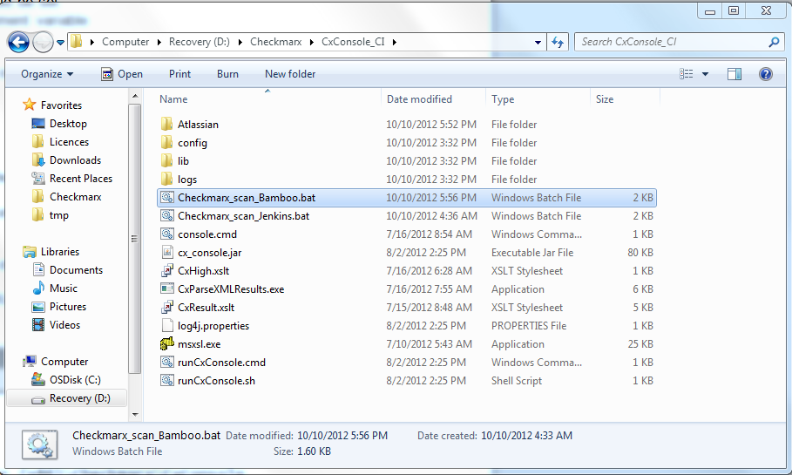

1. Edit the values of the below parameters in the Checkmarx_scan_Bamboo.sh script:

CX_CONSOLE_PATH is the location when you unzipped the CxConsole package

USERNAME is your Checkmarx user account

PASS is your Checkmarx password

CHECKMARX_HOST is the name or ip address of the Checkmarx Server

PRESET is the Checkmarx preset of the scan

JOB_NAME is the name of the Checkmarx project. Please note that CxServer\SP\Company\USERS\%JOB_NAME% should resemble the full name of your project. If you have defined companies or teams in your Checkmarx system, please edit them accordingly in the script file.

1. Define a dedicated Stage and a Job in the stage that the will launch the Checkmarx_scan_Bamboo.sh scrip. For example, create a “Security scan” stage (see below)

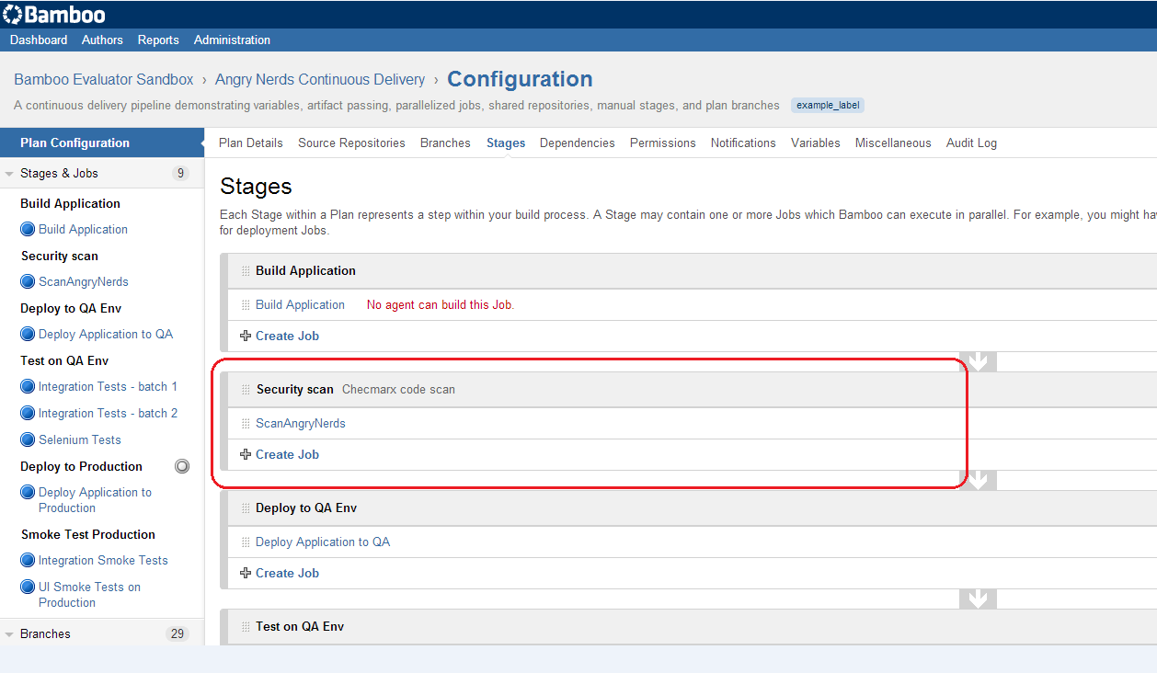

And in it, create a Job:

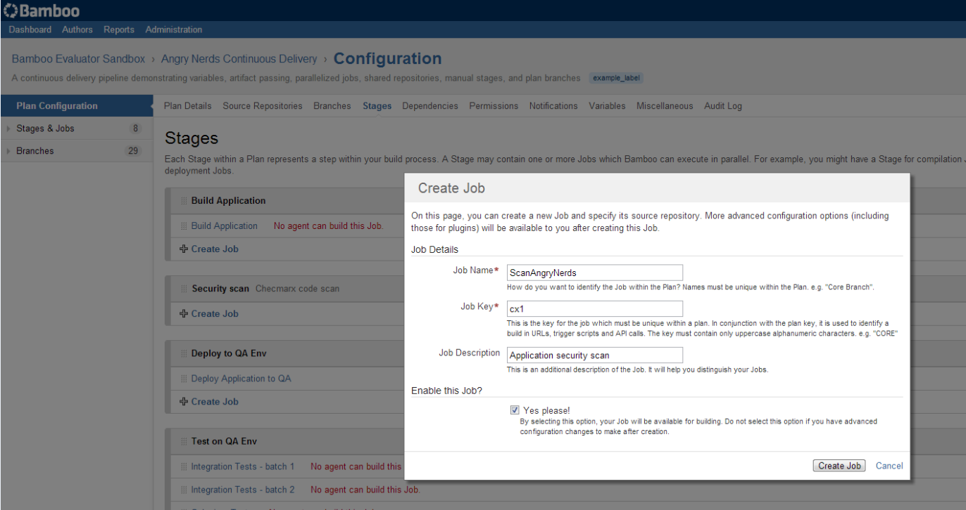

1. On the Job screen, choose the “Tasks” tab and press “Add task” to create the task that will launch the batch file, choose “Command” type.

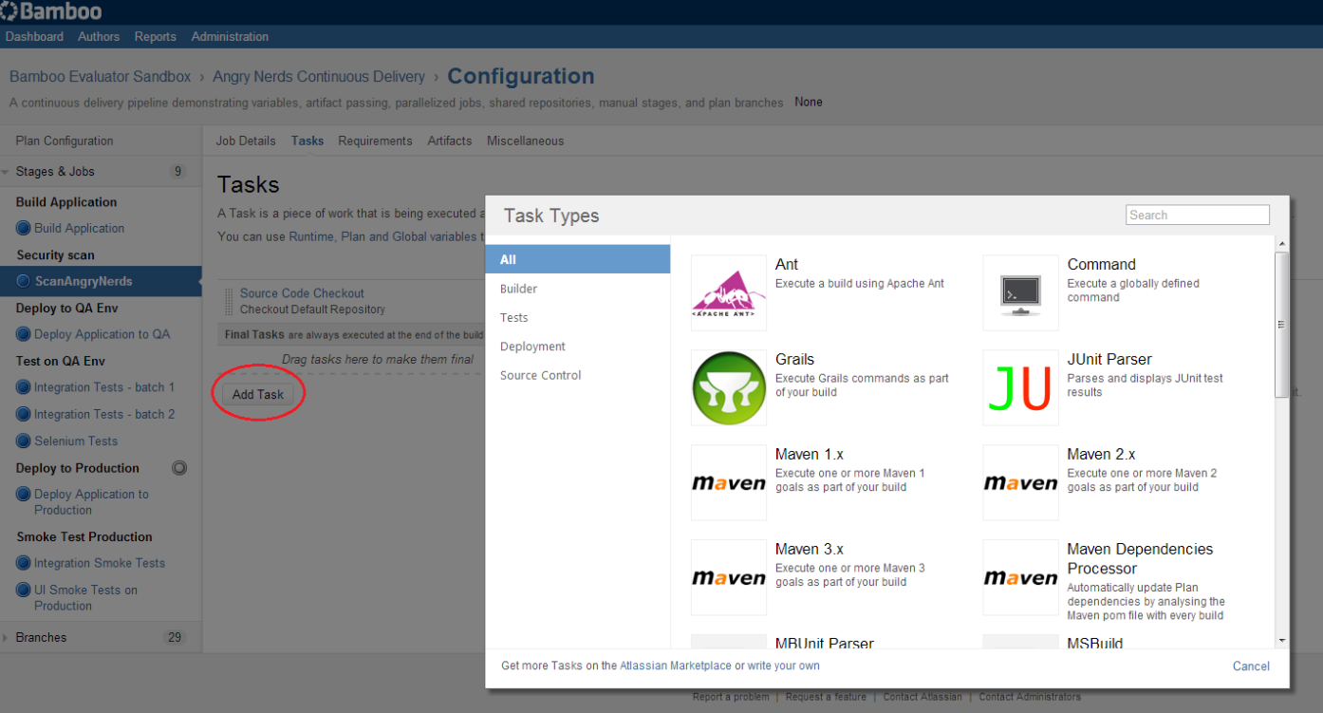

5) Press the “Add new Executable” button, and in the below screen, enter the full path to the scritp. In our example: D:\Checkmarx\CxConsole_CI\Checkmarx_scan_Bamboo.sh

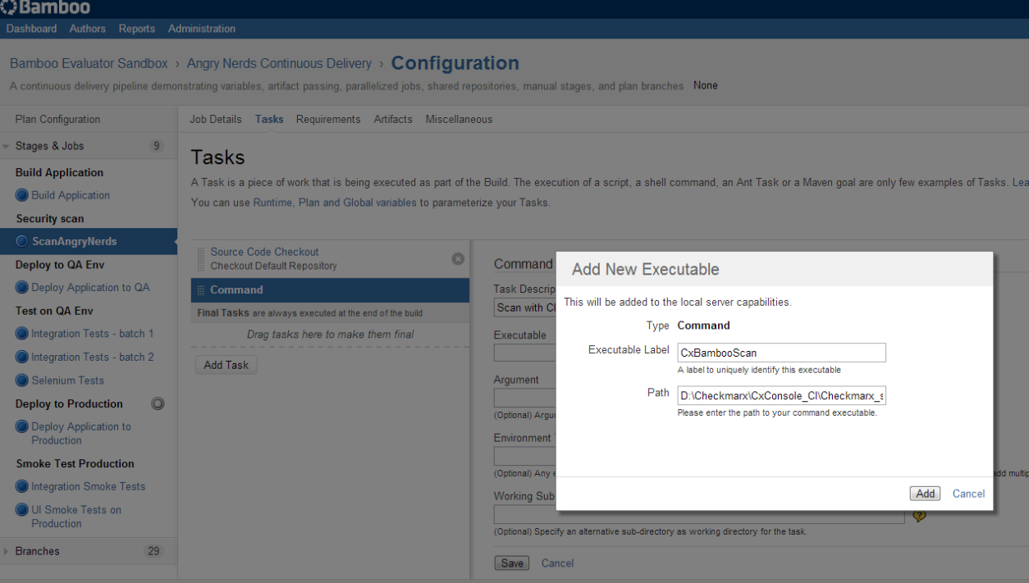

6) In the below screen, edit the “Environment Variables”:

JOB_NAME=${bamboo.buildPlanName} WORKSPACE=${bamboo.build.working.directory}

Please ignore the Argument section.

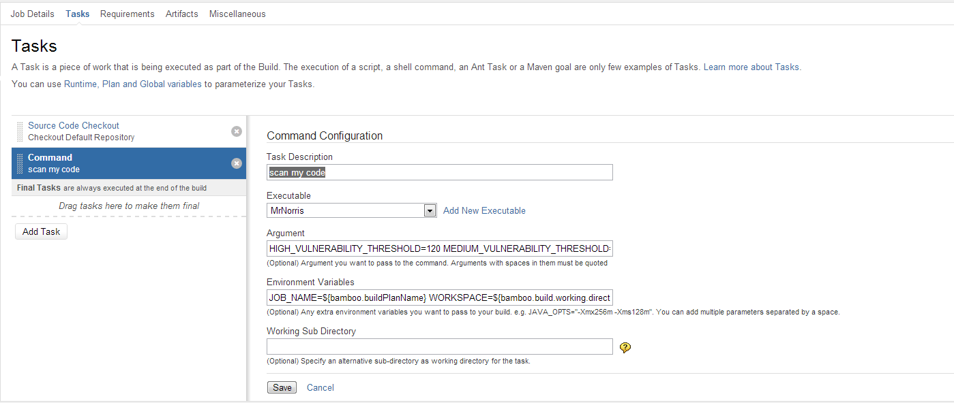

7) On the new created Job screen, choose the “Artifacts” tab and press “Create definition” and enter the below values. Name: CxReports Copy Pattern: *CXresults.*

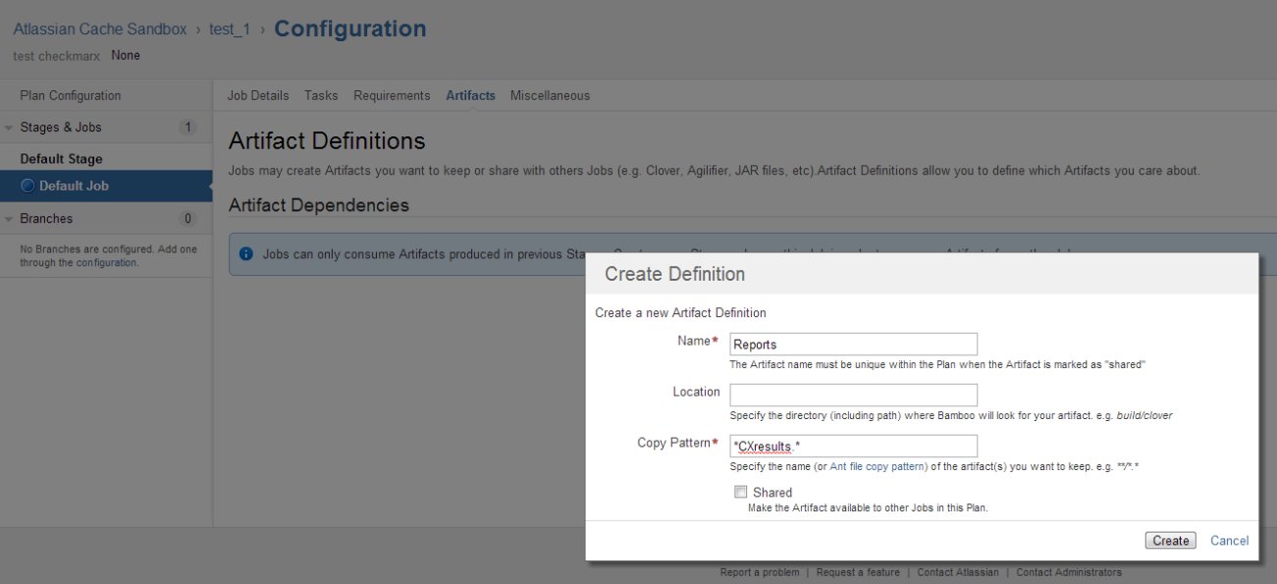

8) That’s it! You’re now ready to run the project.

The results of the scan will be accessible from the “Artifacts” section.

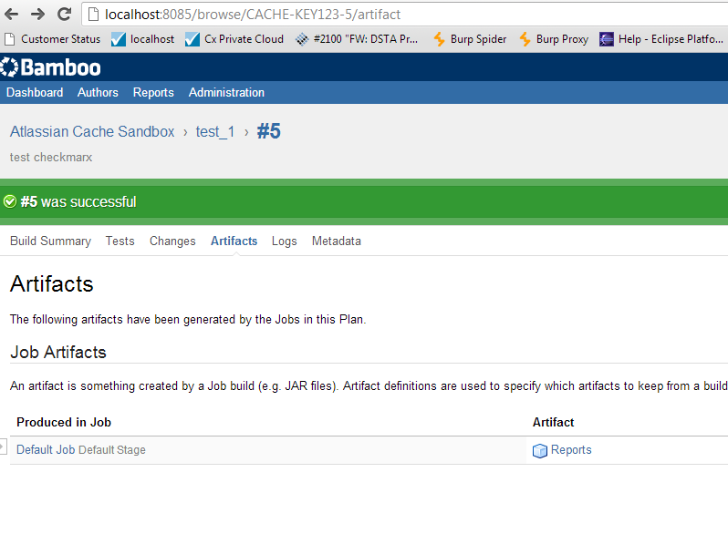

And should look something like this: