# Salesforce commerce cloud design for Caesar’s Itinerary builder.

Desired experience:

Customer books room/stay at Caesars’s palace hotel. After stay is booked, we want to offer options for activities that guests can do during their stay e.g. Entertainment Shows, Pool, Cabana, Restaurants etc. Guest will pick and choose activities build itinerary and complete the transaction to book ticket or make reservation for selected activities.

Technical design within Salesforce commerce cloud:

Data model.

1] All events like entertainment shows, other events that have date time slots and availability will need to be setup as master/variation type skus.

Example:

Master product : ComedyShow, variation attributes: EventDate, EventTime

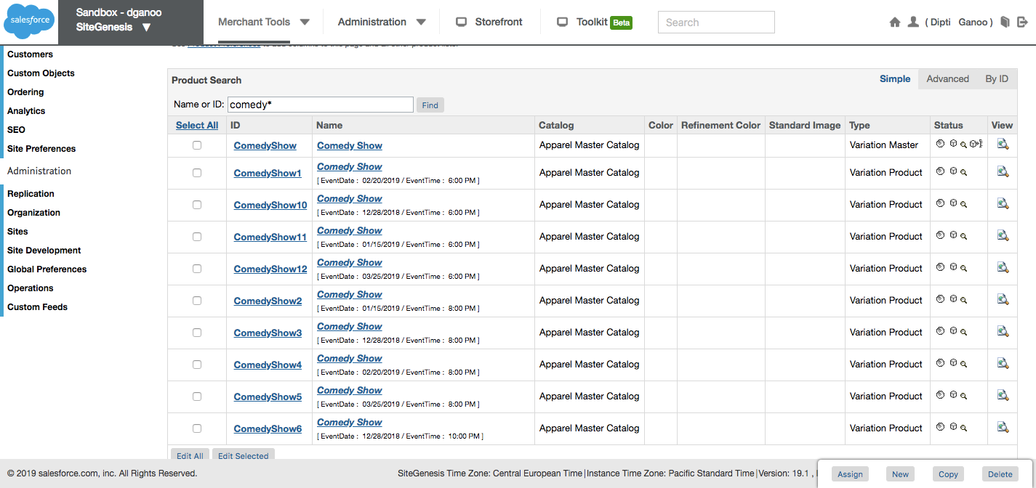

Product Detail page will present the options to select date and time for events like it would do for size and color for apparel products.

Pricing:

For selected event, if it is a show then pricing will be fetched from Ticketmaster. For other events like Pool or Cabana where pricing is not applicable it will be set to $0 and not visible to customer.

TicketMaster pricing and calls:

Ticketmaster has apis to get pricing and availability. These apis can be cached.

Pricing for an event depends on seat selected, type of event and possible many other factors that are decided by Caesars as per their business requirements. Pricing is managed by Caesar’s directly within TicketMaster. Ticket prices are based on seats selected by customer.

Due to possible complexity for pricing, we will most likely retrieve pricing using real time api calls to ticketmaster.

Inventory Availability:

For shows, seat availability/inventory availability can be fetched from ticketmaster using api. Since Caesar sells tickets from multiple channels like boxoffice, it is not possible to have a inventory allocated to web channel. So it might not be practical to be able to manage inventory list on SFCC like regular storefront would do.

Checkout flow for SFCC.

When itinerary will be built by consumer, it will be saved as Cart construct within SFCC. This is mainly because we need to set price on lineitem within itinerary and basket lineitem has api setPrice that lets you set external price explicitly (e.g. pricing retrieved from ticketmaster can be set on cart items like event booking seats). Also base code for other functions like set tax (if needed) apply promotion , check prices and validations is based on cart/basket object so it will be beneficial to use it.

For selecting seats for show using Ticketmster, we might not have seat selection interface in phase1. For phase 1 we will call ticketmaster api to get best available seats and pricing. Based on this, pricing of items within basket will be set and custom attributes will be set holding other information line seat numbers, venue etc.

Checkout process will be comprised of

1]Cart step,

This step will be integrated to start/create cart within ticketmaster. Hold seats when customer proceeds to checkout.

2] login step (as per current understanding login is must to save the itinerary for customer),

This step will be integrated with Caesar’s single sign on.

3] Billing and Payment

This step will tied with Caesar’s payment integration.

On successful auth, it will call respective vendor’s api for items within itinerary e.g. For shows -Ticketmaster, for pool – Pool reservation service, Restaurant -Open table etc. via Tibco (ESB)

-If one of the reservation fails order should still go thru? with messaging to customer? Define customer experience here.

4] Order confirmation.