Introduction to Computing for the Social Sciences
Exercise Sheet for Session 07

Prof. Dr. David Garcia

Exercise 1: selectionsort
a) Consider the following array: [1, 2, 10, 4, 3, 7, 9, 11]
Show how selection sort reorders the array. Indicate each state of the array in temporal sequence, marking what entries are compared and/or swapped in each state of the array.

b) Explain the advantages and disadvantages of selection sort compared to repeated minimum search.

Exercise 2: mergesort

a) Using the same array as in exercise 1, show how merge sort would sort it.

b) What is the advantage of mergesort compared to selection sort? Explain the reasoning behind your answer.

Exercise 3: more sorting algorithms

Consider the pseudocode of Bubblesort
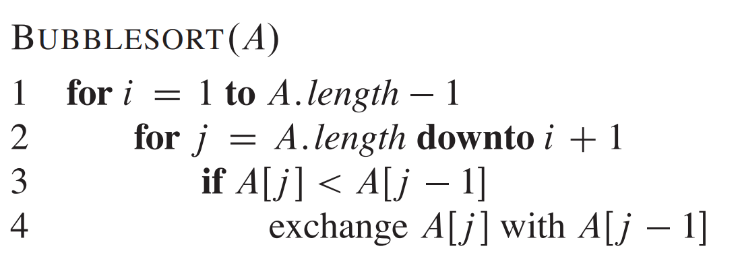

a) show how it sorts the same array as in exercise 1

b) is it a stable sorting algorithm? Why?

