Introduction to Computing for the Social Sciences
Exercise Sheet for Session 10

Prof. Dr. David Garcia

Exercise 1: Finite-State Automata

Consider the following Finite-State Automaton.
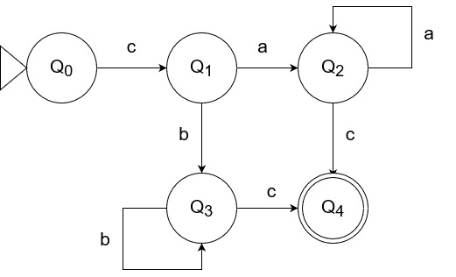

a) A finite state automaton is defined by the 5-tuple (Q, Σ, δ, q₀, X). For the automaton depicted in the figure above describe what each element in the 5-tuple consists of.

b) Which of the following input sequences are accepted by the above finite state automaton? Show the sequence of states of the automaton that justify your answer

i) caaac

ii) cbbbbbbc

c) What language is accepted by the finite state automaton depicted above? [Hint: You don’t have to give a formal definition, it is enough to describe the language in your own words.]

d) Is the finite-state automaton above a non-deterministic finite state automaton? Explain your answer

e) Design a Deterministic Finite State Automaton that recognizes strings that contain the substring ICSS in an alphabet composed of {I, C, S, X}. Show a diagram with its states and transitions.

Exercise 2: Turing Machines
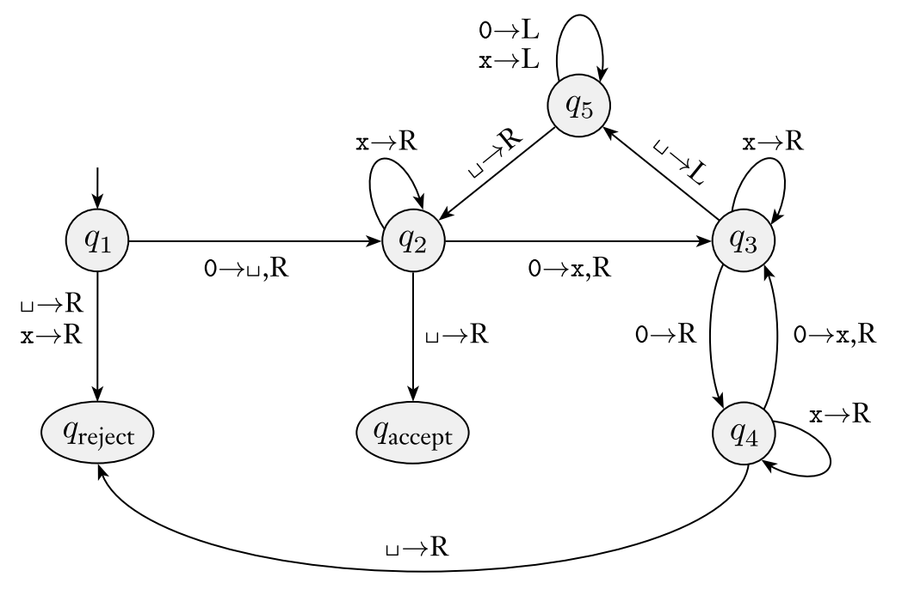
Consider the Turing Machine defined by M = (Q, Σ, Γ, δ, q₁, q_{accept}, q_{reject}), where:
Q = {q₁, q₂, q₃, q₄, q₅, q_{accept}, q_{reject}}
Σ = {0}
Γ = {0, x, _ }
δ is depicted in the figure
q₁, is the start state
q_{accept}, is the accept state
q_{reject} is the reject state

a) Show how the Turing Machine processes the string 0000

b) Show how the Turing Machine processes the string 000

c) Describe in your own words what language is recognized by the Turing Machine

Exercise 3: Computability

A k-clique is a fully connected graph of k vertices (i.e. there is an edge between each pair of vertices). Consider the CLIQUE problem, which is the decision problem of determining wether a graph G contains a k-clique of a given size k. The example below (Sipser, 2012) is a graph that contains a 5-clique but not a 6-clique.
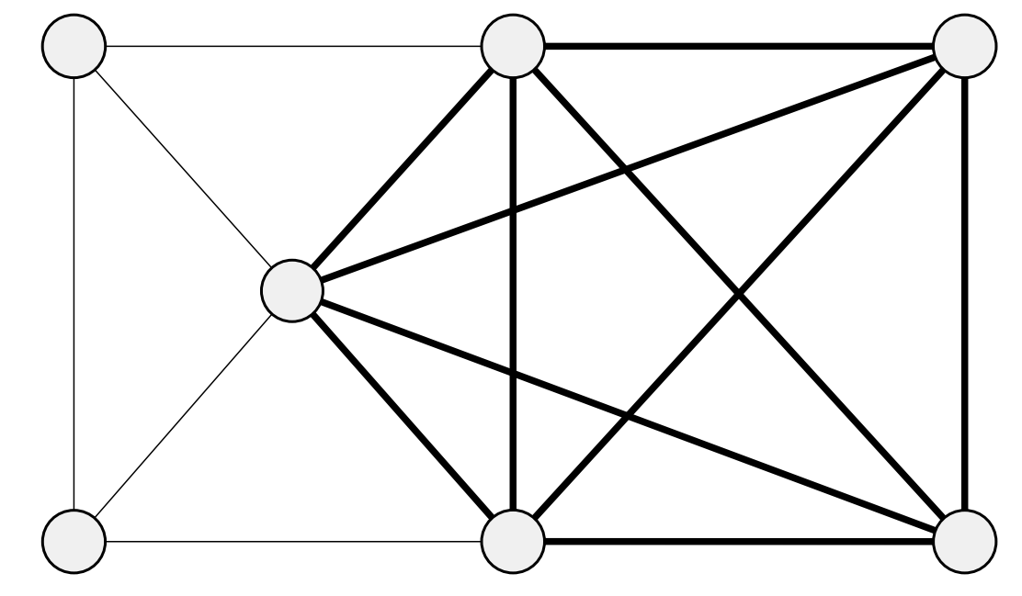

a) Write the pseudocode of an algorithm to verify that a given solution c is a proof that a given graph G contains a k-clique of a given size k.

b) Based on your algorithm above, what can you say of the complexity classes that the CLIQUE problem belongs to?

