Q2:

I created project from kanban named MILESTONE 1 from software development

then created the column named ready for QA

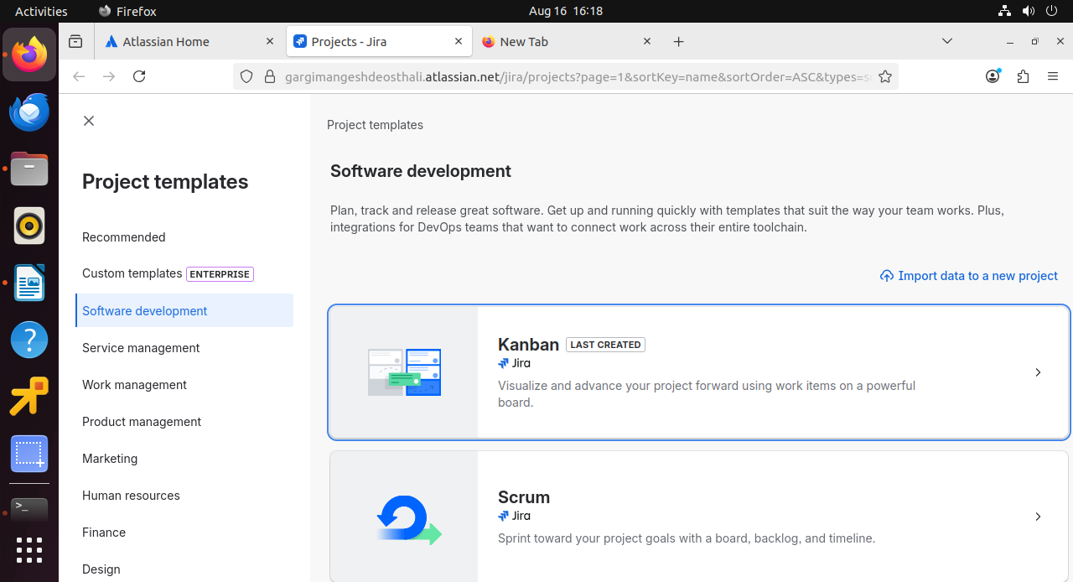

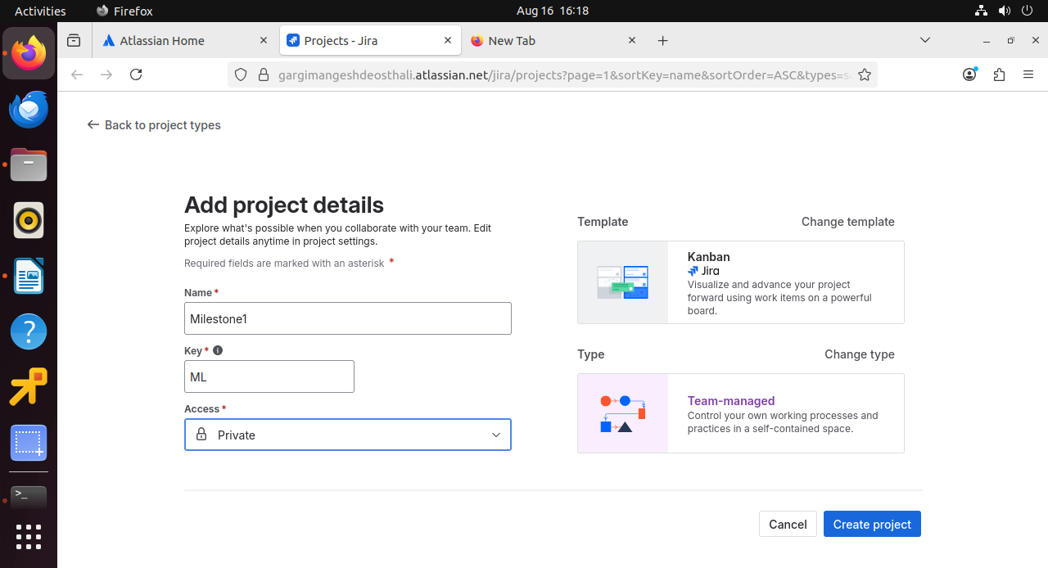

Then i have entered in MILESTONE1 project setting

selected Automation then create the rule from scratch

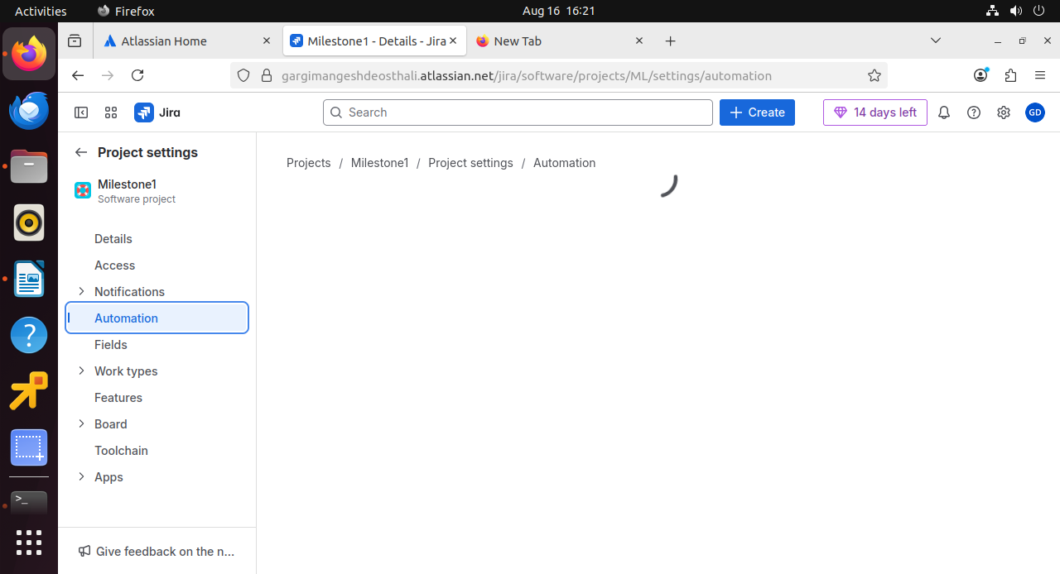

Selected trigger as work item transition

status from in progress to ready for QA

then given issue condition : task

Assigned the work item to me itself as [gargimangeshdeosthali@gmail.com](mailto:gargimangeshdeosthali@gmail.com)

Then i send email to qa lead and [gargimangeshdeosthali@gmail.com](mailto:gargimangeshdeosthali@gmail.com)

rule is completed the work is assigned to QA lead .

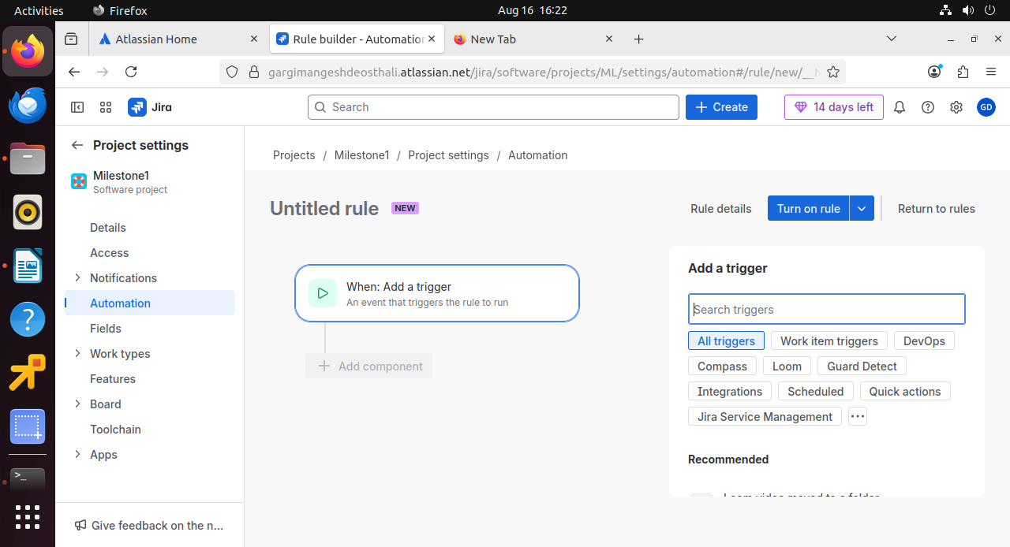

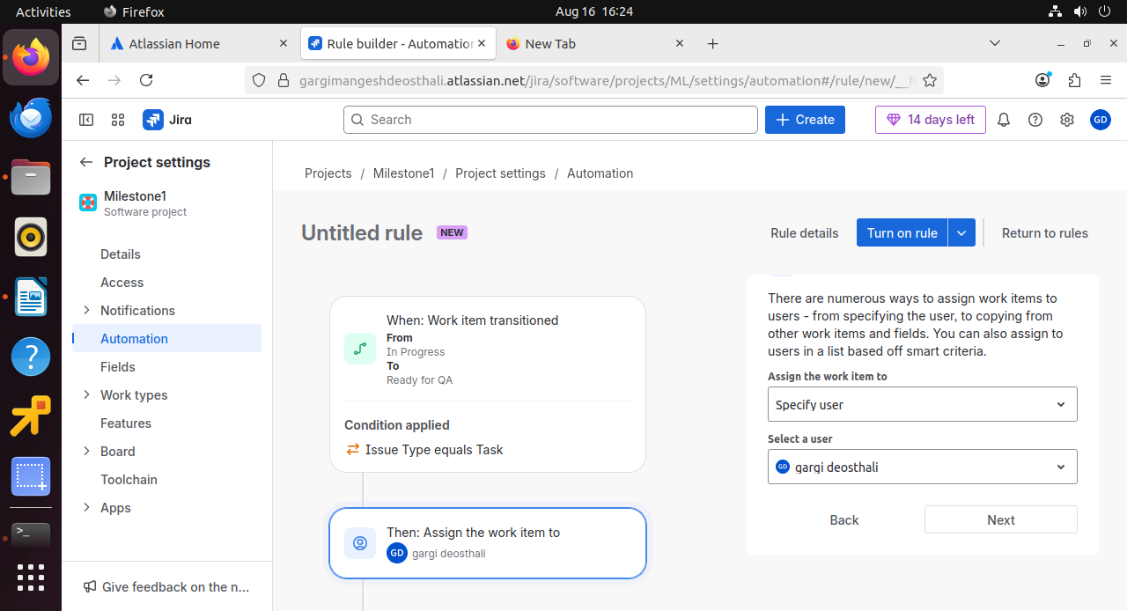

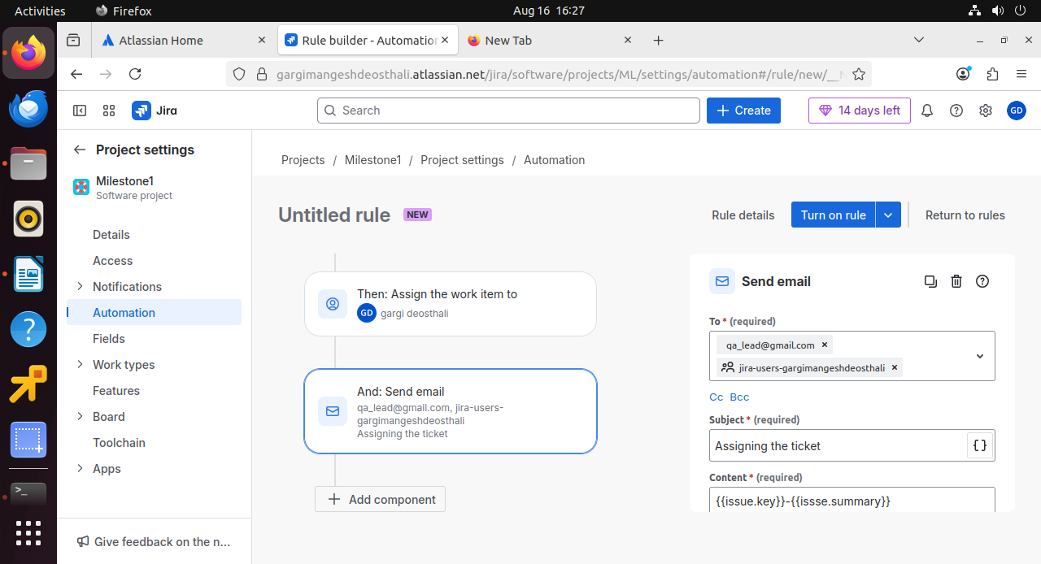

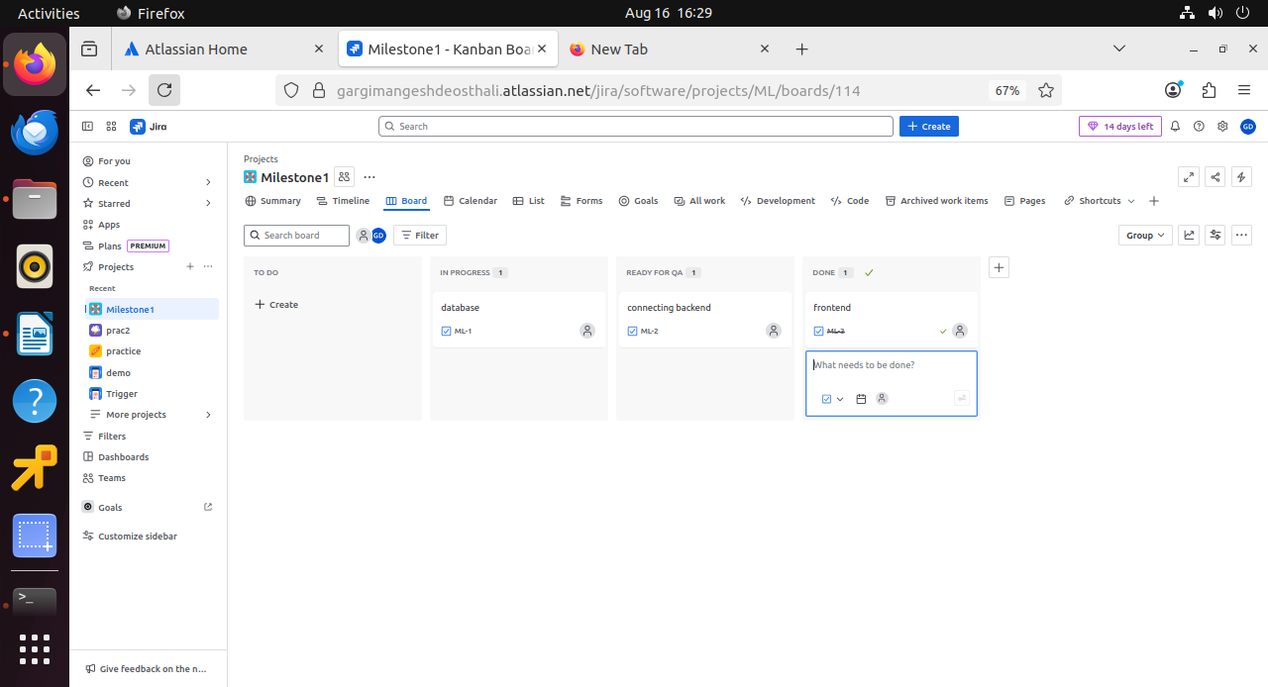

I have written the task and changed the status to ready for QA

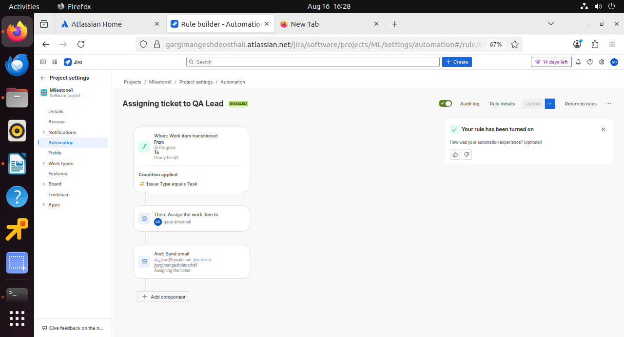

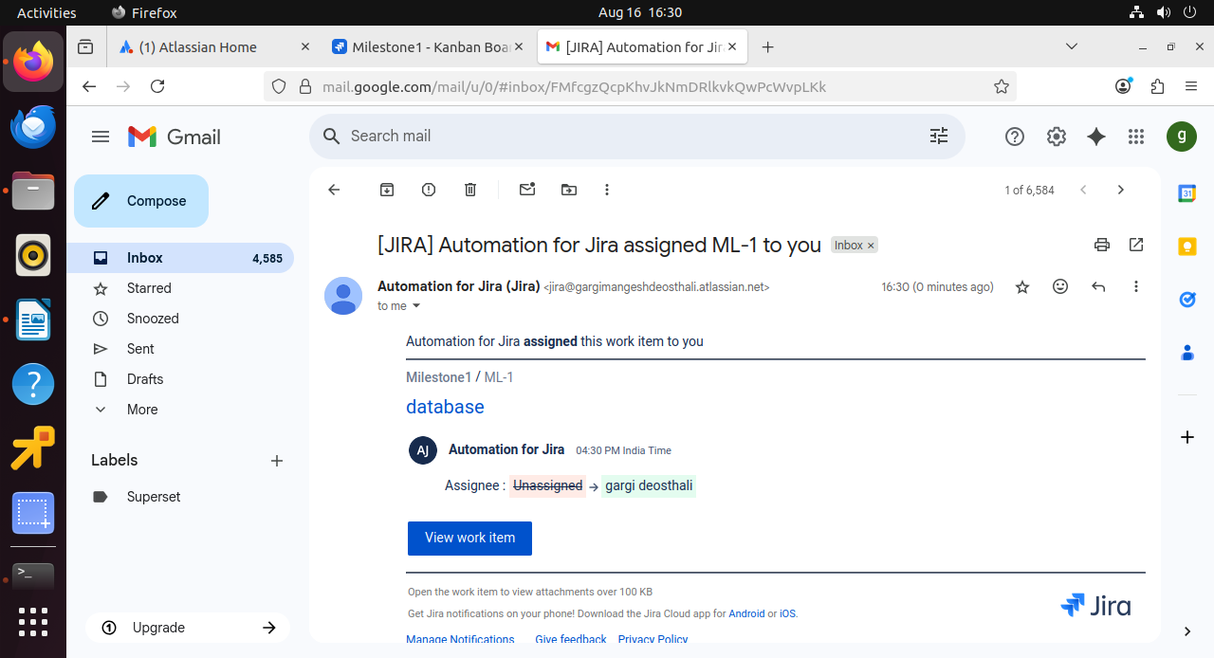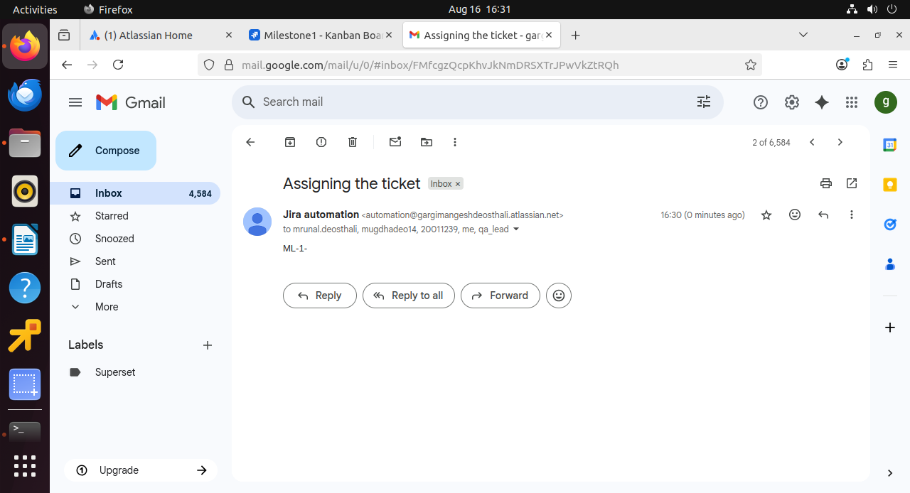

This mails shows that assigning is successful.