Q2: Answer:

step 1: sudo su

step 2: apt update

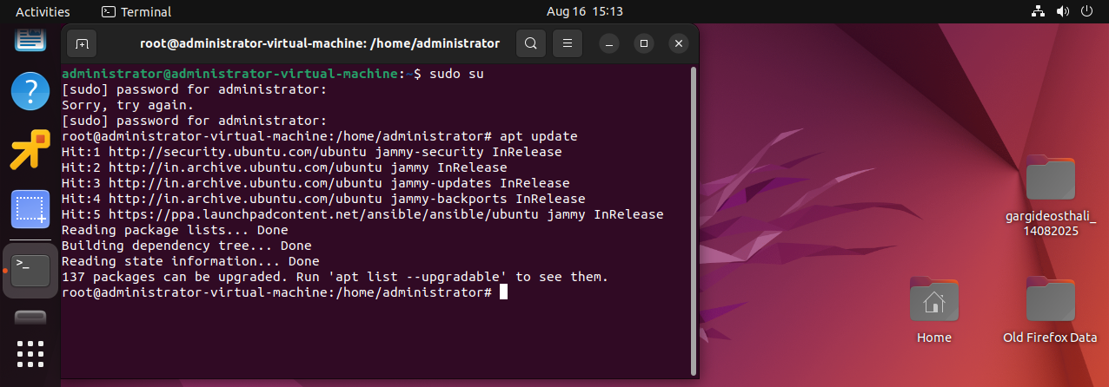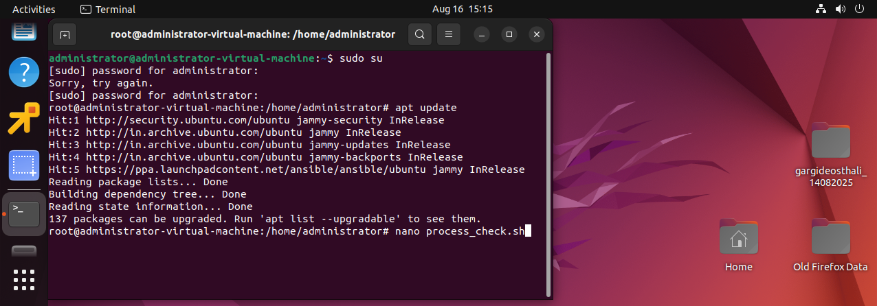

step 3: nano process_check.sh

this will create script file named process_check

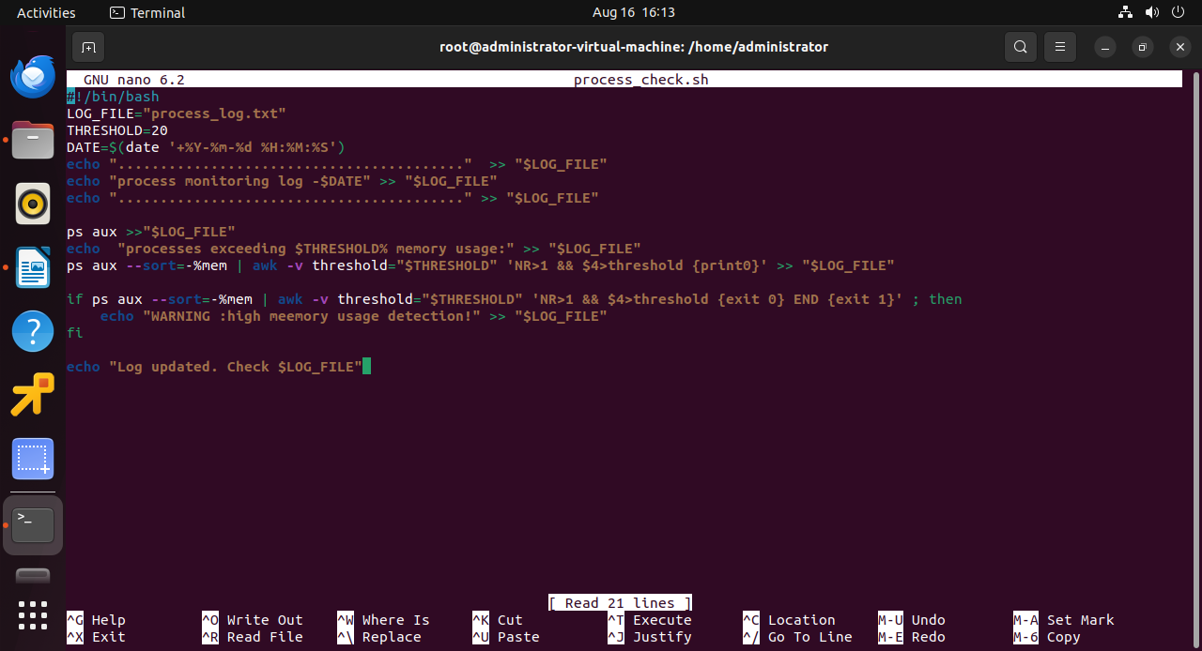

now i have written the script in process_check.sh

#!/bin/bash

LOG_FILE="process_log.txt"

THRESHOLD=20

DATE=$(date '+%Y-%m-%d %H:%M:%S')

echo "........................................." >> "$LOG_FILE"

echo "process monitoring log -$DATE" >> "$LOG_FILE"

echo "........................................." >> "$LOG_FILE"

ps aux >>"$LOG_FILE"

echo "processes exceeding $THRESHOLD% memory usage:" >> "$LOG_FILE"

ps aux --sort=-%mem | awk -v threshold="$THRESHOLD" 'NR>1 && $4>threshold {print0}' >> "$LOG_FILE"

if ps aux --sort=-%mem | awk -v threshold="$THRESHOLD" 'NR>1 && $4>threshold {exit 0} END {exit 1}' ; then

echo "WARNING :high meemory usage detection!" >> "$LOG_FILE"

fi

echo "Log updated. Check $LOG_FILE"

EXPLANATION OF THIS SCRIPT:

INSERT i

LOG_FILE is a log file i have created

set threshold as 20

date = it is showing me the date and time

echo will print

ps aux is used to show running processes in LOG_FILE

(ps aux --sort=-%mem | awk -v threshold="$THRESHOLD" 'NR>1 && $4>threshold {print0}' >> "$LOG_FILE") this will showprocess above threshold .

And the last i have given warning if it is exceeded

then echo means showing process completed in LOG_FILE.

ctrl+x+y+enter

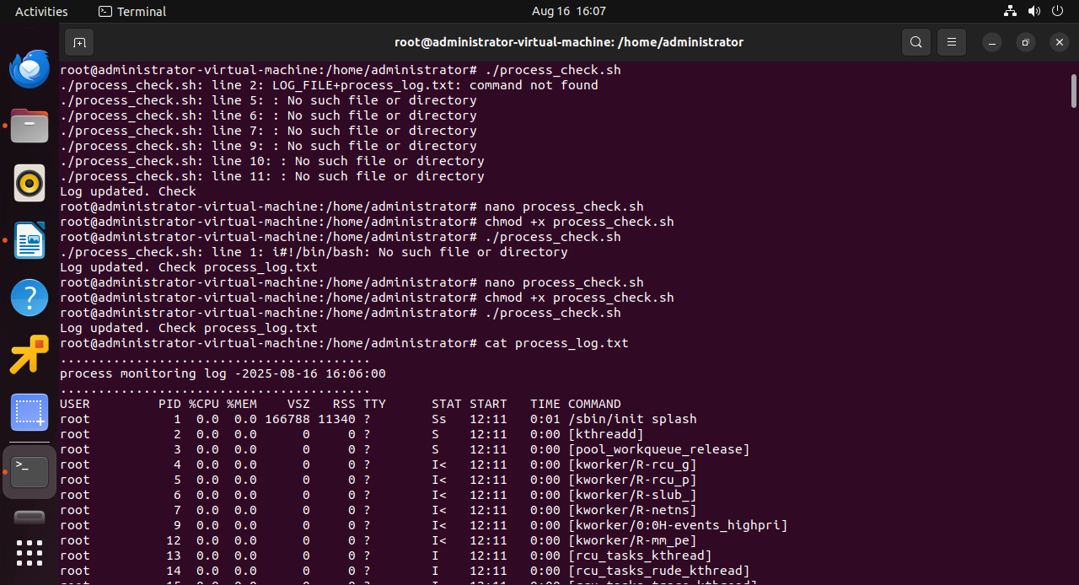

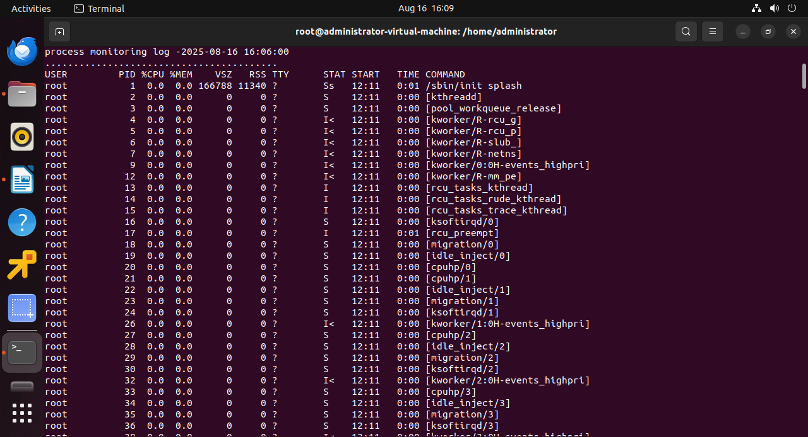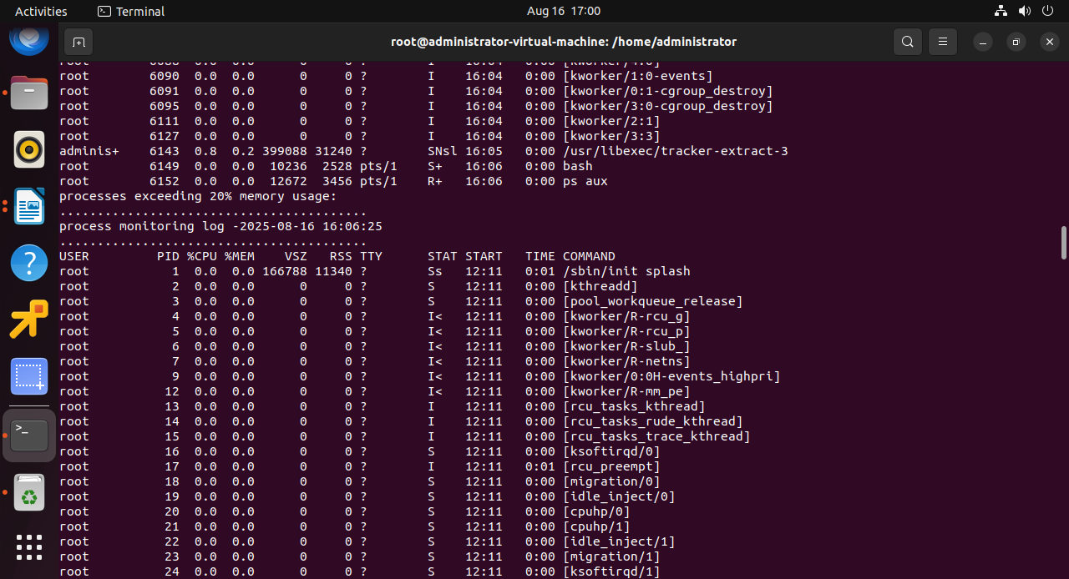

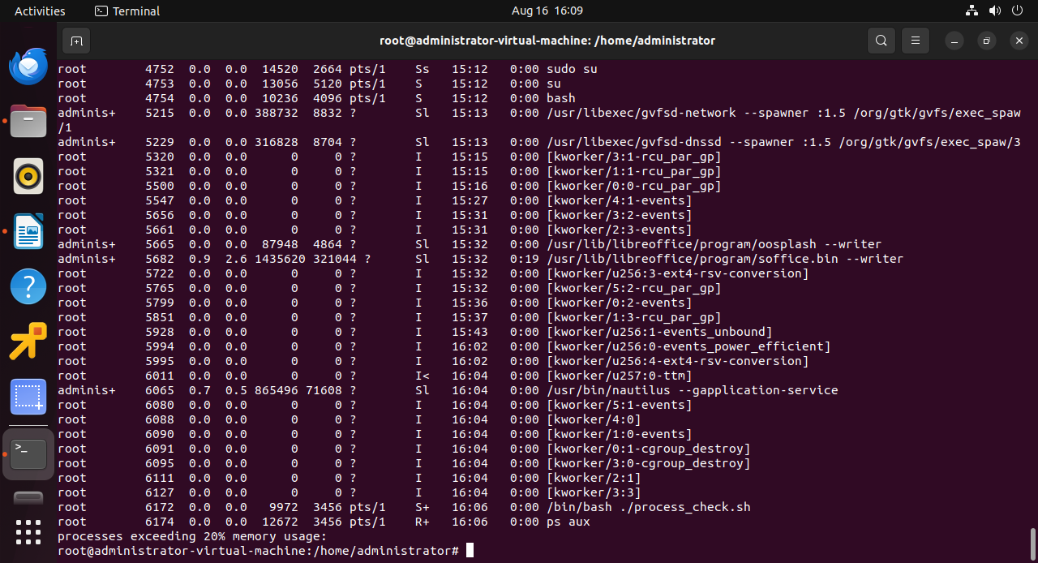

then i have written chmod +x process_check.sh

this will give permission

then

./process_check.sh – which will be executable file

cat process_log.txt

will show process

Successfully done!