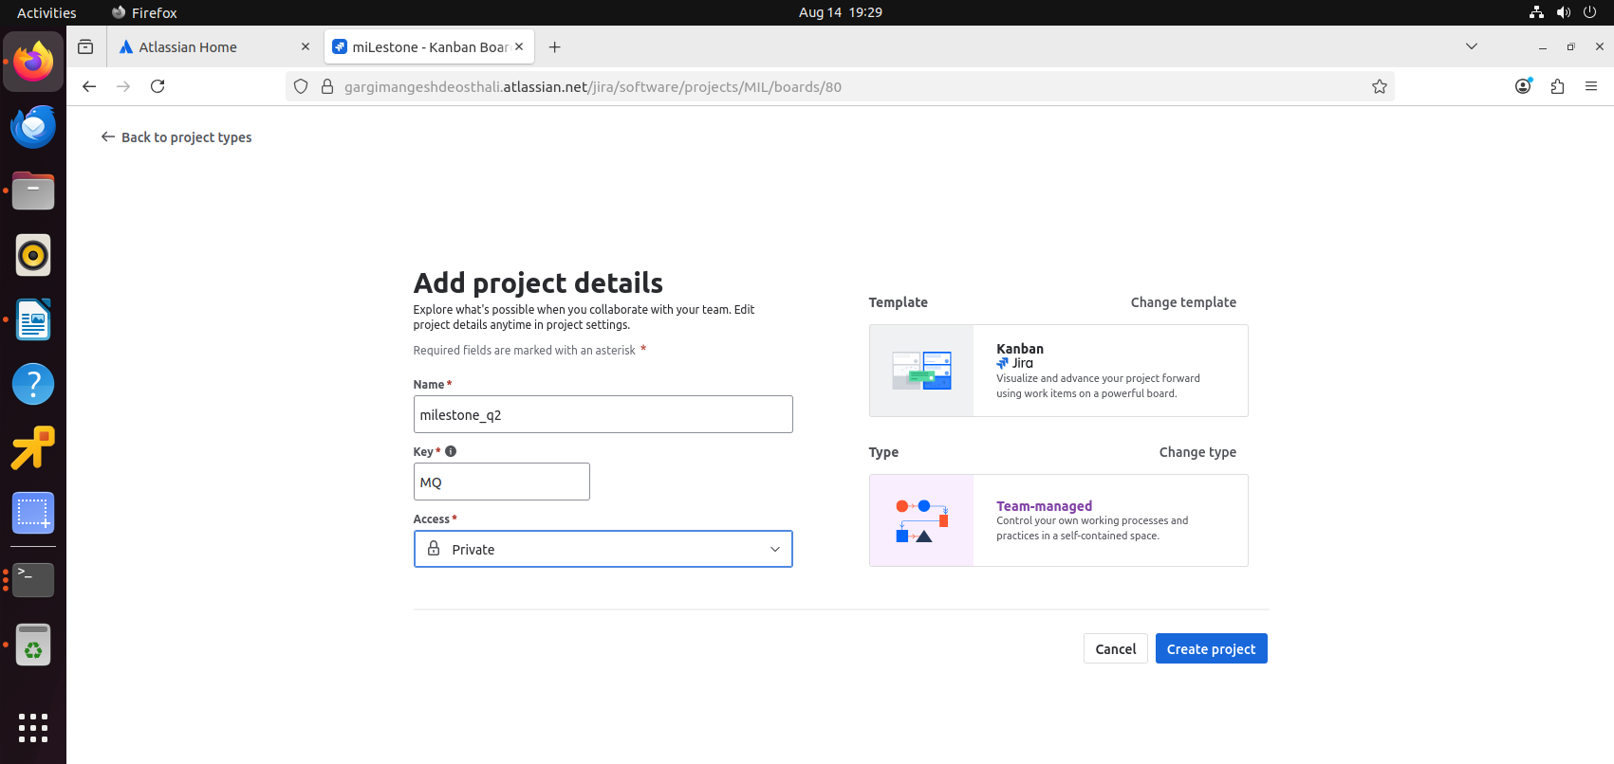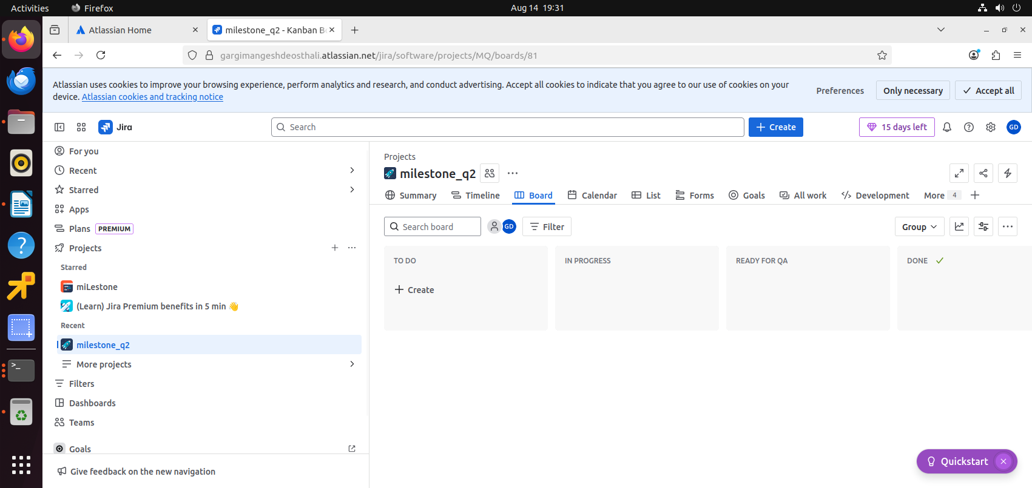

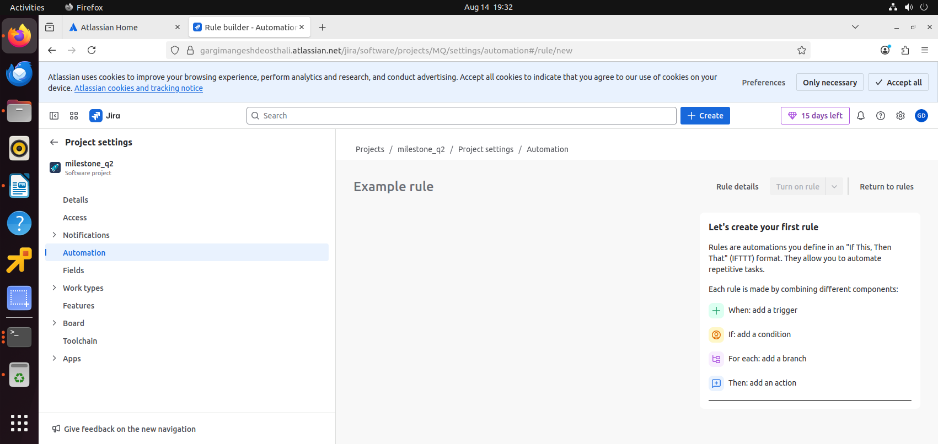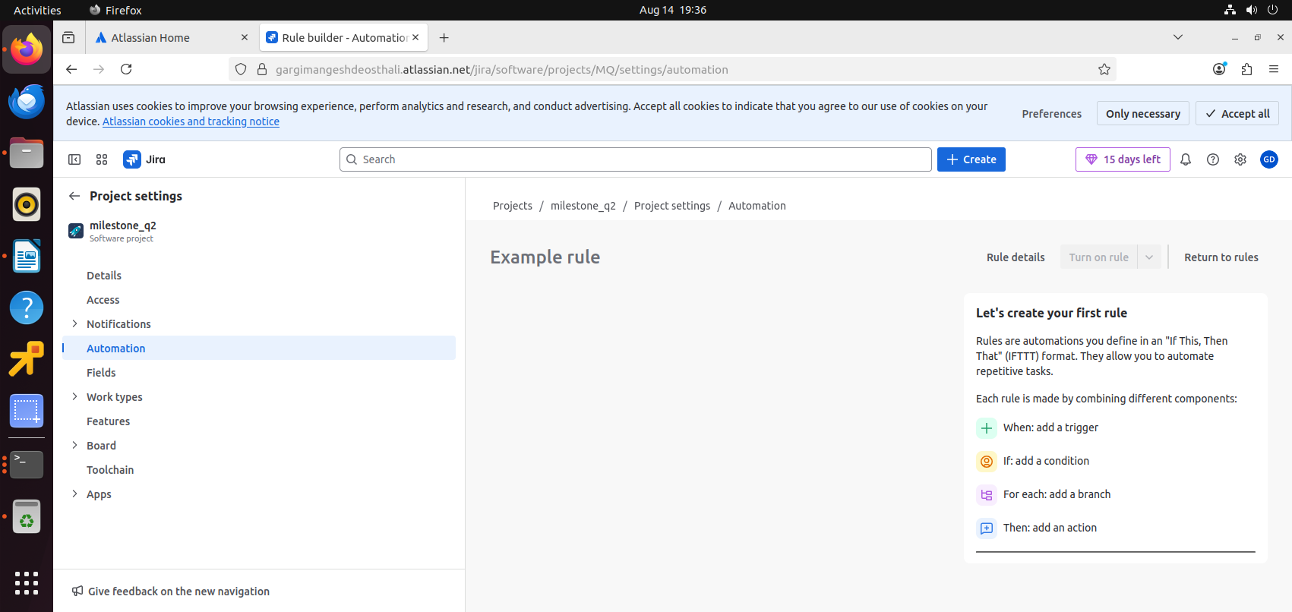

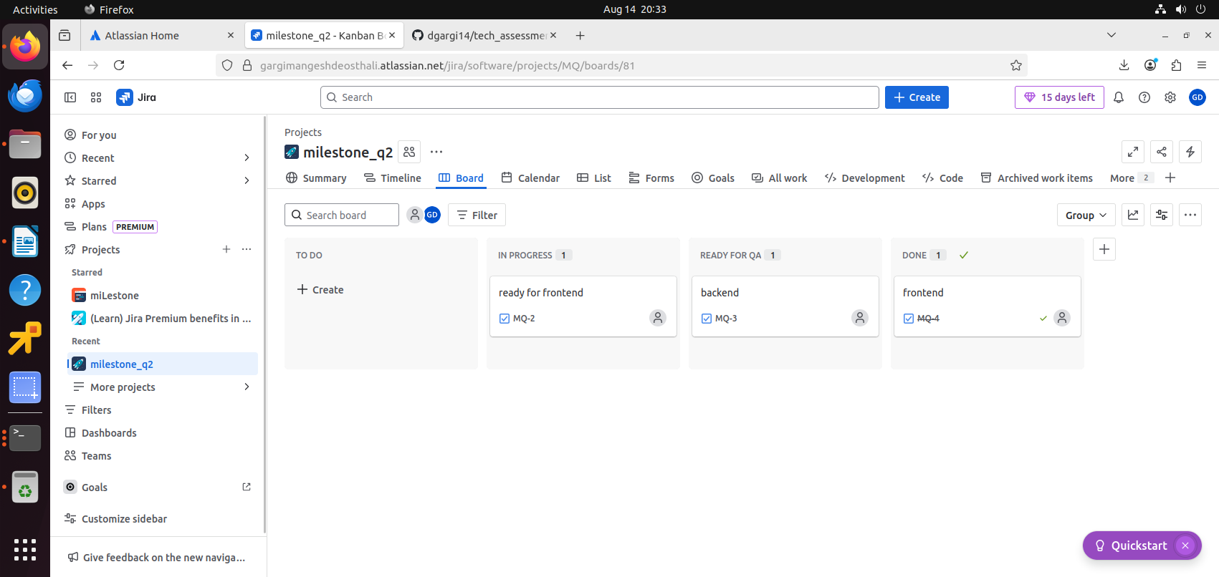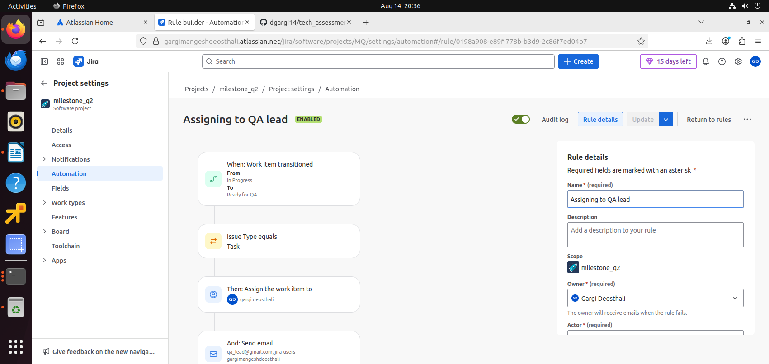

1. created kanban from software development

2.project created

3.1 column addes ad reeady for qa

4.project setting

5.automation

6.trigger- issue transitioned

7. status from in progess to ready for qa

8.condition added as issue type is equal to task

9.assigned one user as me.

10.send email to qa lead

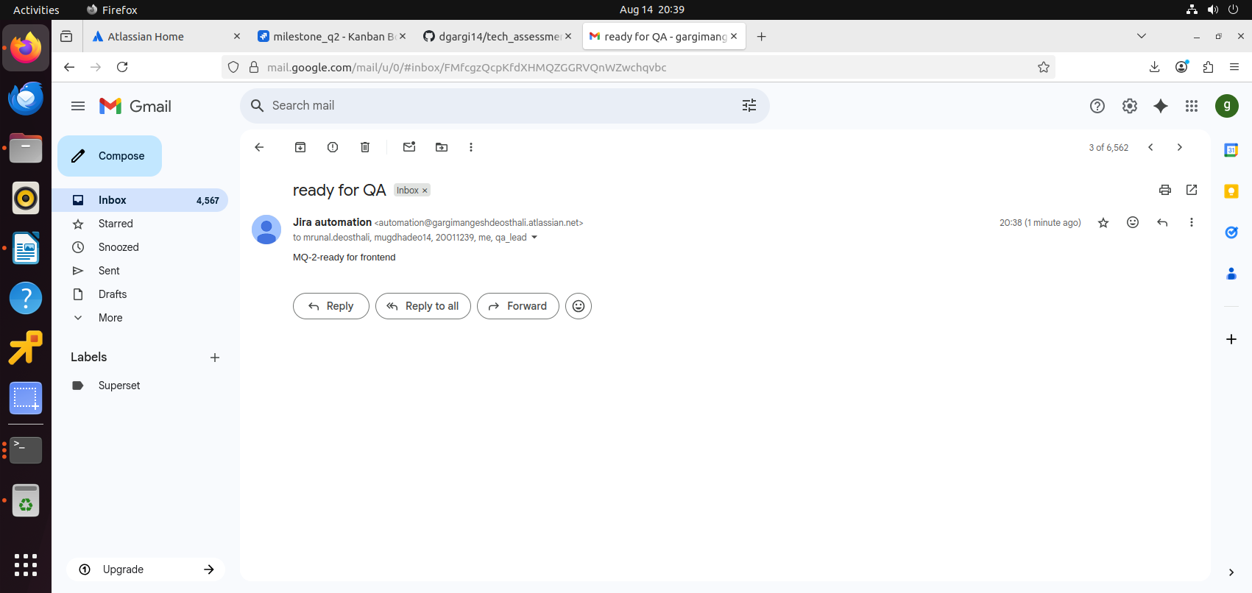i have received email on my gmail acc.