question 1:

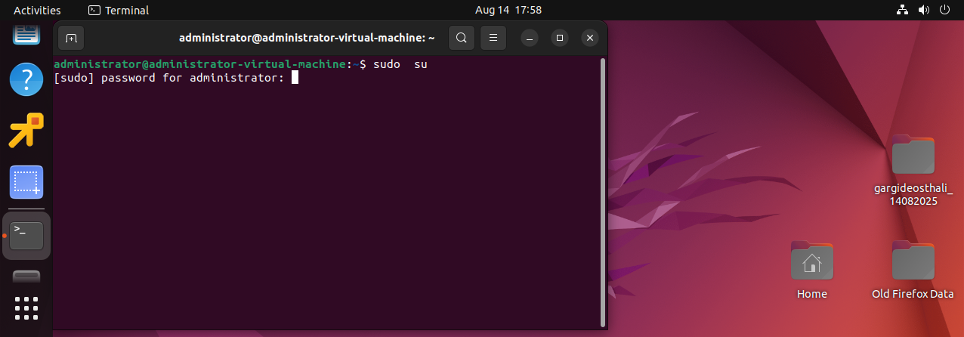

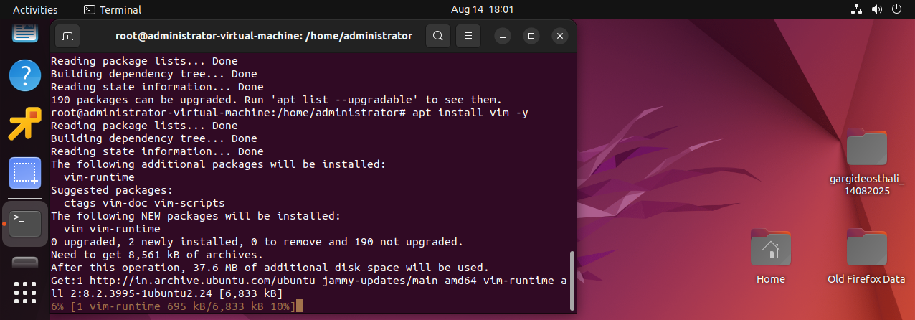

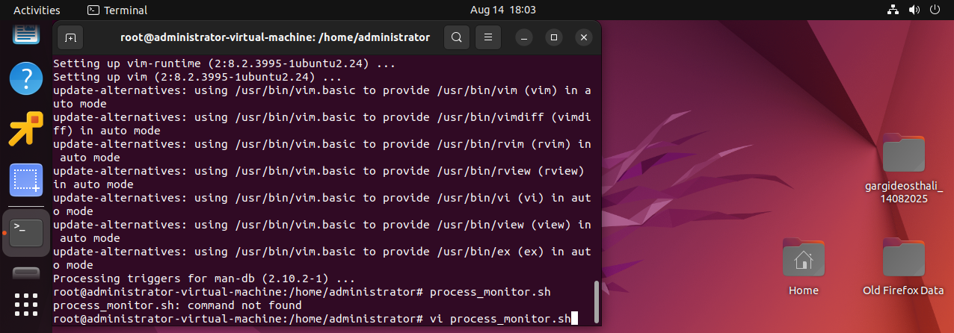

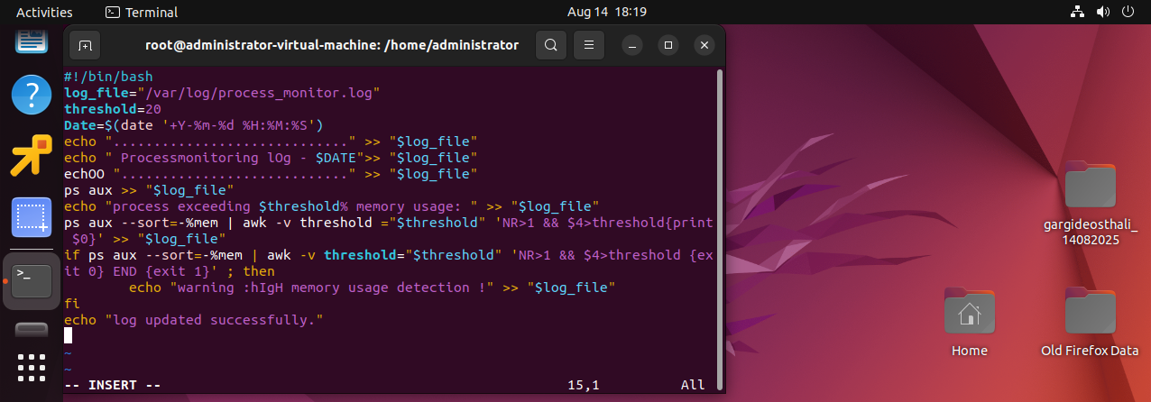

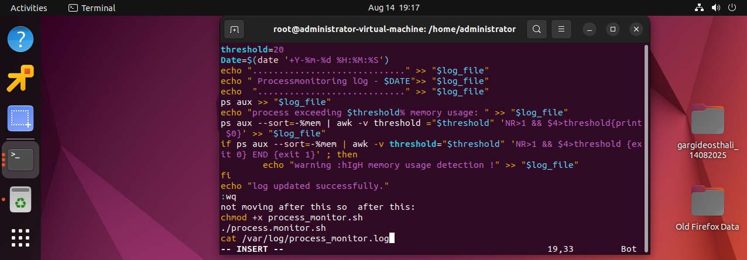

sudo su

sudo apt update

apt install vim -y

vi process_monitor_sh

insert i

!/bin/bash

log_file="/var/log/process_monitor.log"

threshold=20

Date=$(date '+Y-%m-%d %H:%M:%S')

echo "............................." >> "$log_file"

echo " Processmonitoring lOg - $DATE">> "$log_file"

echo "............................" >> "$log_file"

ps aux >> "$log_file"

echo "process exceeding $threshold% memory usage: " >> "$log_file"

ps aux --sort=-%mem | awk -v threshold ="$threshold" 'NR>1 && $4>threshold{print $0}' >> "$log_file"

if ps aux --sort=-%mem | awk -v threshold="$threshold" 'NR>1 && $4>threshold {exit 0} END {exit 1}' ; then

echo "warning :hIgH memory usage detection !" >> "$log_file"

fi

echo "log updated successfully."

esc:wq

but esc is not working o after this things are not working.

not moving after this so after this steps:

chmod +x process_monitor.sh

./process.monitor.sh

cat /var/log/process_monitor.log

all this processes will show output and also tell memory and threshold.

Because of esc and ctrl too not working was not able to show output.