Crop Analysis Q3 2013

Danielle Garshott

Jan 23rd, 2019

Class 05 Graphics and plots with R This is some narative text that I can style **bold** and *italic* and add links to [webpages]

# Section 2A: line plot   
  
weight <- read.table("bimm143_05_rstats/weight_chart.txt", header = TRUE)  
plot(weight, pch = 15, cex = 1.5, type = "o", col = "blue", lwd = 2, ylim = c(2,10), xlab = "Age (months)", ylab = "Weight (kg)", main = "Baby Weight")

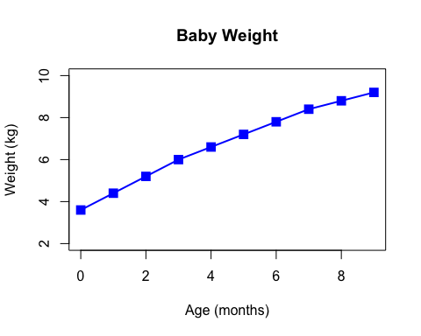

# Section 2B: bar plots  
# \t encodes a tab character   
# mar (first-up, second-right, third-down, fourth-left)  
counts <- read.table("bimm143_05_rstats/feature_counts.txt", header = TRUE, sep = "\t")  
barplot(counts$Count, horiz=TRUE, names.arg = counts$Feature, las=2, main="Number of Features", xlim= c(0,80000))

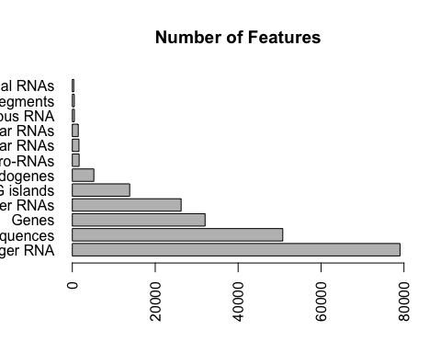

par(mar=c(5,10,4,2))  
barplot(counts$Count, horiz=TRUE, names.arg = counts$Feature, las=2, main="Number of Features", xlim= c(0,80000), col = "RED")

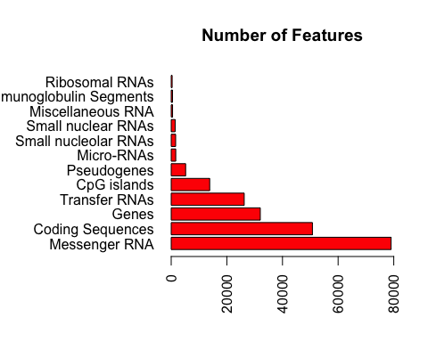

# Section 2C: Histograms  
  
B <- c(rnorm(10000), rnorm(10000)+4)  
hist(B, breaks=80)

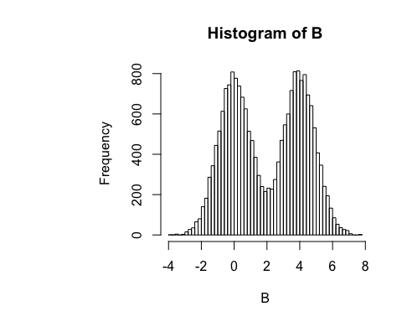

# Section 3A: Proving color vectors  
  
mf <- read.table("bimm143_05_rstats/male_female_counts.txt", header=TRUE, sep="\t")  
mfc <- read.delim("bimm143_05_rstats/male_female_counts.txt")  
barplot(mf$Count, names.arg = mf$Sample, ylim = c(0,20), las=2, col = rainbow(nrow(mf)))

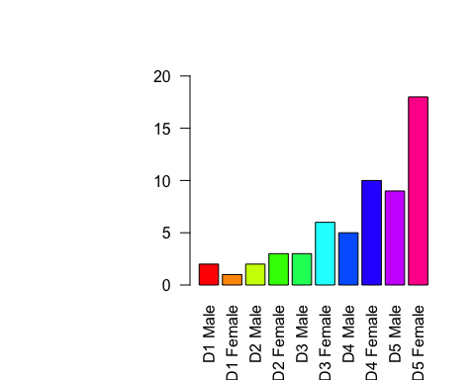

# Section 3B: Coloring by value  
  
  
express <- read.delim("bimm143_05_rstats/up_down_expression.txt", header = TRUE)  
View(express)  
# how many genes  
nrow(express)

## [1] 5196

table(express$State)

##   
## down unchanging up   
## 72 4997 127

plot(express$Condition1, express$Condition2, col=express$State)

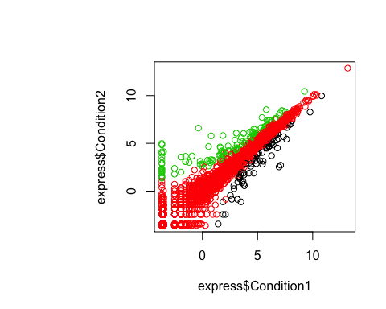

palette()

## [1] "black" "red" "green3" "blue" "cyan" "magenta" "yellow"   
## [8] "gray"

levels(express$State)

## [1] "down" "unchanging" "up"

palette(c("red", "gray", "blue"))  
plot(express$Condition1, express$Condition2, col=express$State, xlab = "Expression Condition 1", ylab = "Expression Condition 2")

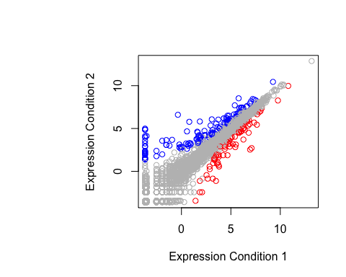

# Section 3C: Dynamic use of color