

Lanka Nippon Biztech Institute

**JUSTICEHIRE**

**(Lawyer Hiring System)**

Final Database Report

**Database Systems**

Name : K D G A Kahanda

Index Number : UGC0223040

Batch : SE02

**ER Diagram**

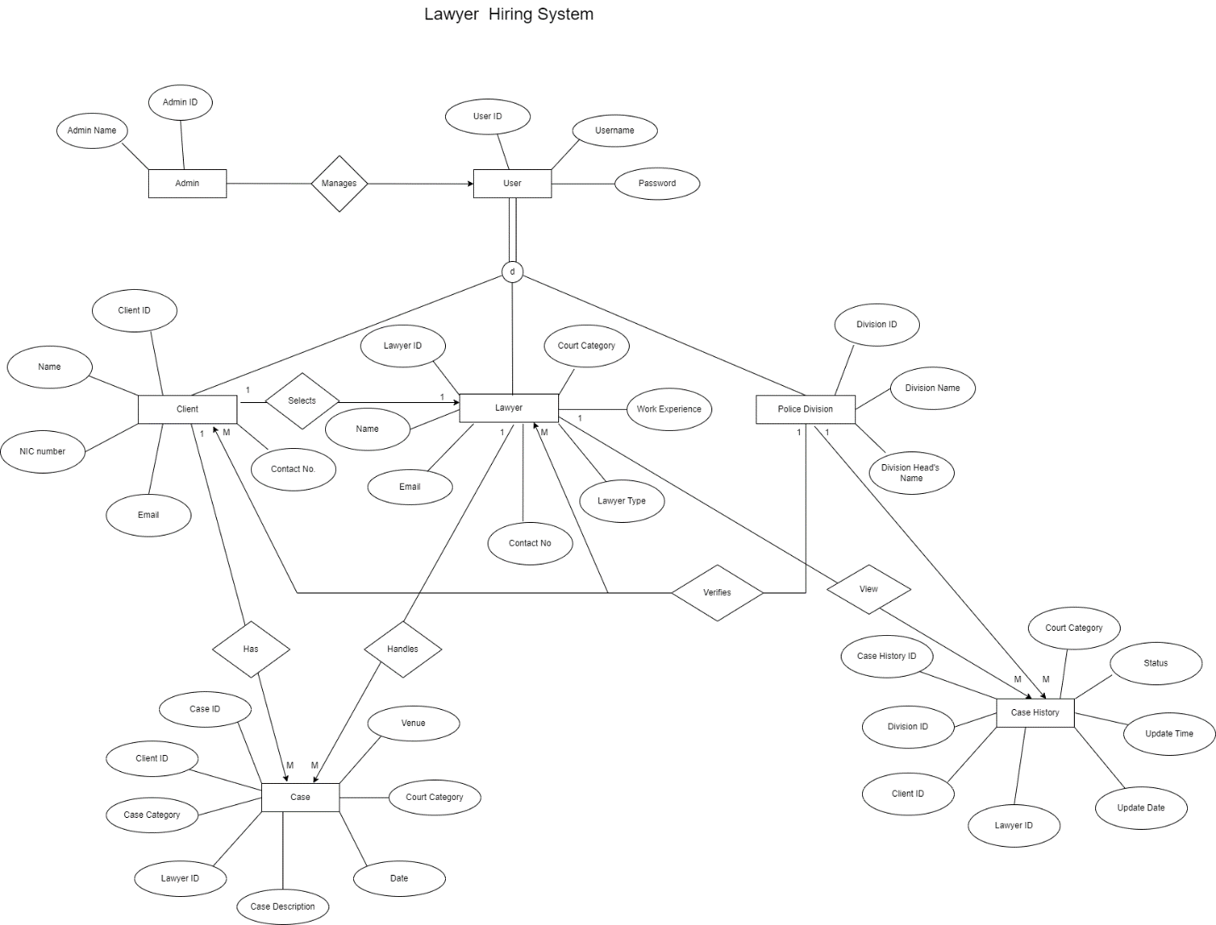

**Included Tables**

**Client Table**

CREATE TABLE Clients (

clientID varchar(20) PRIMARY KEY,

clientName VARCHAR(100),

nic varchar(50),

email varchar(100)

);

INSERT INTO Clients (clientID, clientName, nic, email) VALUES

('C001', 'Chathura',20033872245 , 'chathura@gmail.com'),

('C002', 'Dulen',20033874646 , 'dulen@gmail.com'),

('C003', 'Sandil',20033878465 , 'muhandiram@gmail.com'),

('C004', 'Chameera',20033873465 , 'chathuranga@gmail.com');

SELECT * FROM Clients;

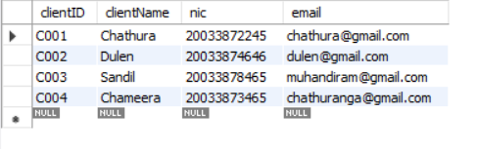

**Lawyer Table**

CREATE TABLE Lawyers (

lawyerID varchar(20) PRIMARY KEY,

lawyerName VARCHAR(100),

lawyerType varchar(50),

contact long,

email varchar(100),

workExp varchar (20),

courtcategory varchar(20)

);

INSERT INTO Lawyers VALUES

('L001','Saman','Criminal',0715346642,'saman@gmail.com','5 Years','High Court'),

('L002', 'Dilshan','Divorce',0701586543, 'dilshan@gmail.com', '2 Years','Magistrates'),

('L003', 'Gavin','Land',0712185376, 'dgavink12@gmail.com', '4 years','District');

SELECT * FROM Lawyers;

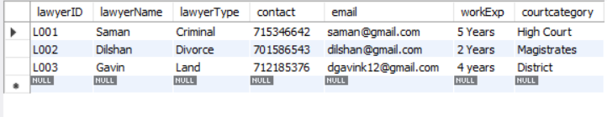

**Police Table**

CREATE TABLE Police (

divisionID varchar(20) PRIMARY KEY,

divisionName VARCHAR(100),

divHeadName varchar(50)

);

INSERT INTO Police VALUES

('P100','Kottawa', 'ASP Nimal Jayathilake'),

('P101', 'Maharagama','ASP Suneth Hettiarachchi'),

('P102','Homagama', 'ASP Pubudu Gimhana');

SELECT * FROM Police;

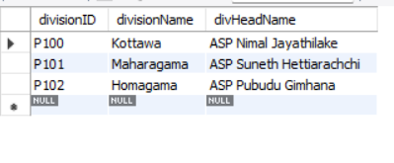

**Case Table**

CREATE TABLE Courtcase (

caseID VARCHAR(20) PRIMARY KEY,

clientID VARCHAR(20),

lawyerID VARCHAR(20),

caseCategory VARCHAR(100),

courtcategory VARCHAR(20),

caseDescription VARCHAR(50),

venue VARCHAR(20),

caseDate DATE,

FOREIGN KEY (clientID) REFERENCES Clients(clientID),

FOREIGN KEY (lawyerID) REFERENCES Lawyers(lawyerID),

FOREIGN KEY(courtcategory) REFERENCES Lawyers(courtcategory)

);

INSERT INTO Courtcase VALUES

('CA001', 'C002','L001', 'Criminal','High Court', 'des', 'Courtroom 3A-Colombo High Court', '2024-09-12' ),

('CA002', 'C003', 'L002', 'Civil', 'Supreme Court', 'description', 'Courtroom 4B-Colombo Supreme Court', '2024-10-05'),

('CA003', 'C004', 'L003', 'Family', 'District Court', 'details', 'Courtroom 5C-Colombo District Court', '2024-11-01');

SELECT * FROM Courtcase;

**Case History Table**

CREATE TABLE caseHistory (

chID VARCHAR(20) PRIMARY KEY,

clientID VARCHAR(20),

lawyerID VARCHAR(20),

divisionID VARCHAR(20),

courtcategory VARCHAR(20),

hisStatus VARCHAR(20),

updDateandTime datetime,

FOREIGN KEY (clientID) REFERENCES Clients(clientID),

FOREIGN KEY (lawyerID) REFERENCES Lawyers(lawyerID),

FOREIGN KEY(courtcategory) REFERENCES Lawyers(courtcategory),

FOREIGN KEY(divisionID) REFERENCES Police(divisionID)

);

INSERT INTO caseHistory (chID, clientID, lawyerID, divisionID, courtcategory, hisStatus, updDateandTime)

VALUES ('CH001', 'C002', 'L001', 'P001', 'Criminal', 'Closed', '2023-08-16 14:30:00'),

('CH002', 'C003', 'L002', 'P002', 'Civil', 'Open', '2024-01-10 09:15:00'),

('CH003', 'C004', 'L003', 'P003', 'Family', 'In Progress', '2024-03-22 11:45:00'),

('CH004', 'C003', 'L001', 'P002', 'Criminal', 'Closed', '2023-03-19 16:30:00');

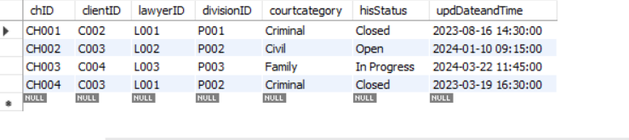SELECT* FROM caseHistory;

**SQL QUERIES**

1. **List Cases with Lawyer and Client Names**

SELECT Courtcase.caseID, Courtcase.caseDescription, Lawyers.lawyerName, Clients.clientName

FROM Courtcase

INNER JOIN Lawyers ON Courtcase.lawyerID = Lawyers.lawyerID

INNER JOIN Clients ON Courtcase.clientID = Clients.clientID;

1. **Count the Number of Cases per Lawyer**

SELECT lawyerID, COUNT(caseID) AS numberOfCases

FROM Courtcase

GROUP BY lawyerID

ORDER BY numberOfCases DESC;

1. **Cases with the Most Recent Update**

SELECT chID, clientID, lawyerID, divisionID, courtcategory, hisStatus, updDateandTime

FROM caseHistory

WHERE updDateandTime = (SELECT MAX(updDateandTime) FROM caseHistory);

1. **List Cases and Their Associated Lawyers**

SELECT Courtcase.caseID, Courtcase.caseDescription, Lawyers.lawyerName, Courtcase.caseDate

FROM Courtcase

JOIN Lawyers ON Courtcase.lawyerID = Lawyers.lawyerID

WHERE Courtcase.caseDate > '2024-01-01'

ORDER BY Courtcase.caseDate;

1. **Case History Status Summary**

SELECT hisStatus, COUNT(chID) AS statusCount

FROM caseHistory

GROUP BY hisStatus

HAVING COUNT(chID) > 1;

