Question 1
Question 1 was completed in the python file submitted.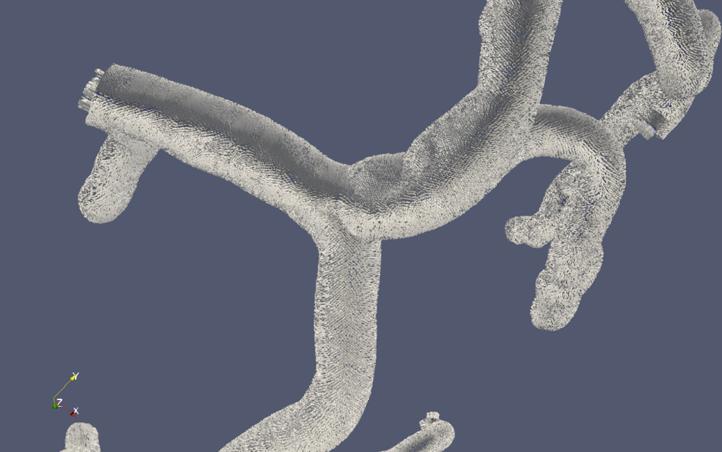

Question 2

Part 1
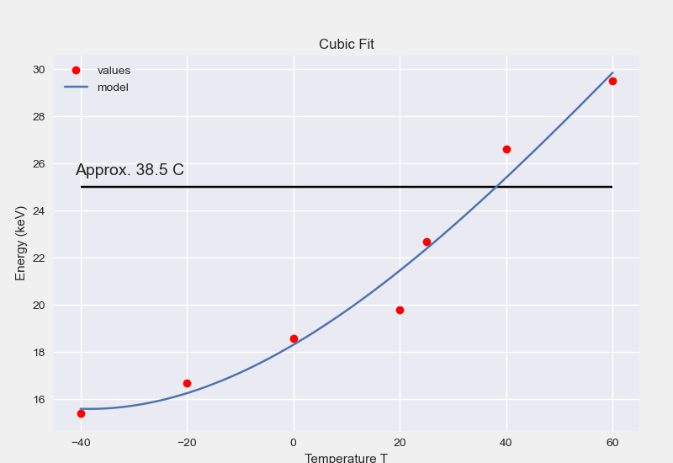

When we interpolate the value at room temperature, we get 38.5 C.

Part 2
We can write our matrix values according to the following form:

$$Ax=b$$
Where A:
$$A= \left(\begin{matrix}1 & -40 \\ ⋮ & ⋮ \\ 1 & 60\end{matrix}\right), x=\left(\begin{matrix}α \\ β\end{matrix}\right), b= \left(\begin{matrix}15.4 \\ ⋮ \\ 29.5\end{matrix}\right)$$

We can pre-multiply our matrix with A’:

$${(A}^{T}A)x=A^{T}b$$

We can can calculate ${(A}^{T}A)$
$$\left(\begin{matrix}7 & 85 \\ 85 & 8225\end{matrix}\right)$$

We can then $A^{T}b$ get a 2x1 matrix:
$$\left(\begin{aligned}149.3 \\ 2847.5\end{aligned}\right)$$

We take the ${\left(A^{T}A\right)}^{-1}$ to both sides:

$${\left(A^{T}A\right)}^{-1}{(A}^{T}A)x={{\left(A^{T}A\right)}^{-1}A}^{T}b$$
$$Ix= {{\left(A^{T}A\right)}^{-1}A}^{T}b$$
Or
$$x= {{\left(A^{T}A\right)}^{-1}A}^{T}b$$

Which gives us the final answer for x:$$x= \left(\begin{matrix}19.582 \\ 0.14383\end{matrix}\right)$$

The interpolated value was the same, 21.464434

Part 3
When we check with the following code from numpy:

A = np.array([-40, -20, 0, 20, 25, 40, 60])
b = np.array([15.4, 16.7, 18.6, 19.8, 22.7, 26.6, 29.5])

linearfit = np.polyfit(temp, energy, 1)
linearfit

we get the output:

array([ 0.14383317, 19.58202582])

confirming our results by hand.

