**A Cat, a Parrot, and a Bag of Seed**

In this problem we have a man who needs to get 2 animals (a cat and a parrot) and a bag of seed across a river. He does not have much room on his boat so he can only take one animal or the bag of seed across at a time. We are given the constraint that the cat cannot be alone with the parrot and the parrot cannot be alone with the seed. The overall goal is to get all 3 things to the other side of the river while abiding by these constraints.

Here are the 7 steps that the man should follow to accomplish his goal.

1. Take the bird across the river
2. Return
3. Take the cat across the river
4. Return to the other side bringing the bird back
5. Leave the bird and take the seed across the river
6. Return
7. Take the bird across the river

This solution will always work. Our constraints tell us what cannot be together, but they do not say the cat and the seed will not be together, therefore we begin by taking the bird across. We then return empty and pick up the cat, leaving the seed. We take the cat to the other side where we have to pick up the bird that cannot stay with the cat. We return with our parrot, leaving the cat alone, to pick up our seed. We swap out the parrot for the seed and take the seed to where the cat is, bringing them together once more. We leave them alone because this allowed by our constraints and go get the parrot. Finally, we will bring the parrot to the side where the cat and the seed are. Following these seven simple steps we can be sure that the given problem is solved and there is no fear of the cat eating the bird or the bird eating the parrot.

**Socks in the Dark**

Here we are given a problem where we have 20 socks of varying colors in a drawer, but it is dark so you cannot see which socks you are grabbing. We are given 2 sub-problems: first, we need just one matching pair of socks and next we need one pair of matching socks of each color. There are 2 solutions to each problem.

Using Figure A (made with Google Draw and attached onto the next page) I found the preferred solution to each problem. For the first sub-problem we only need to grab four socks. Grabbing less than that could result grabbing one sock from each A, B, and C. grabbing four socks guarantees that we will grab at least two of one color sock.

For the second sub-problem we must grab at least one pair of each color sock. Because of this constraint we must grab at least 18 socks. Grabbing any less could result in grabbing all of A and B but one or none of C.

The shared solution to these problems is grabbing all of the socks. This method will give us the ability to take all of the socks into the light and simply pick out which socks we need. Hopefully, they’re washed!

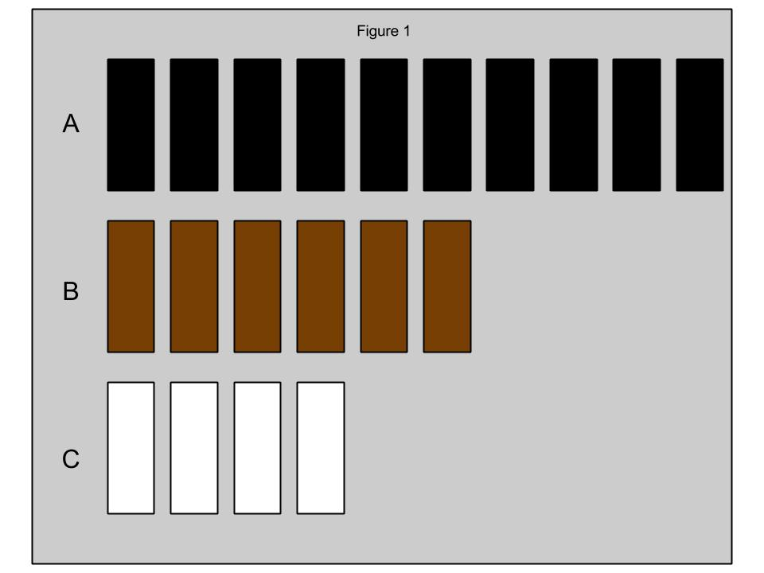

**Predicting Fingers**

In this final problem we have a girl who is counting on her fingers. The solution is as simple as understanding a pattern. The little girl has a special way of counting so I replicated the method of counting on my own hand. We have 3 sub-goals: finding which finger she will stop on at 10, at 100, and at 1000.

To begin finding the solution I counted to ten in the same way the little girl did, stopping on my pointer finger. I then counted to 100 following the pattern and ended on my ring finger (second sub-goal). I had two realizations when doing this. First, I realized that I only ever stopped on my pointer finger and my ring finger; also, there is a pattern on every multiple of ten. The pattern goes:

Pointer finger, ring finger, ring finger, pointer finger, pointer finger, ring finger, ring finger, etc.

Counting to 300 by my new method I found that on every multiple of 100 there is a new pattern:

Ring finger, pointer finger, ring finger, pointer finger, etc.

Finally, I used my last pattern to solve for my last sub-goal. I counted to 1000 using this pattern and found that, when going by the little girl’s counting method, the number 1000 will be represented by the pointer finger.