FABRICATION BRIEF
Custom Photobooth Enclosure
Option B — Wing-Fin Tower with Integrated Lighting

Document type: Fabrication specification and request for quotation
Version: 2.1 — Final
Date: May 2025

This document contains the full specification for a custom aluminium photobooth enclosure. It is intended as a fabrication brief for sheet metal fabricators. Please read all sections before quoting. All dimensions are in millimetres (mm) unless otherwise stated.

2D TECHNICAL DRAWINGS
For fabricator reference. DXF/CAD drawings to be supplied separately as the cutting instructions. These sketches show the design intent and relative positions of all components.
DRAWING 1 — FRONT VIEW
Tower with fins deployed · heights from floor · key cutouts labelled
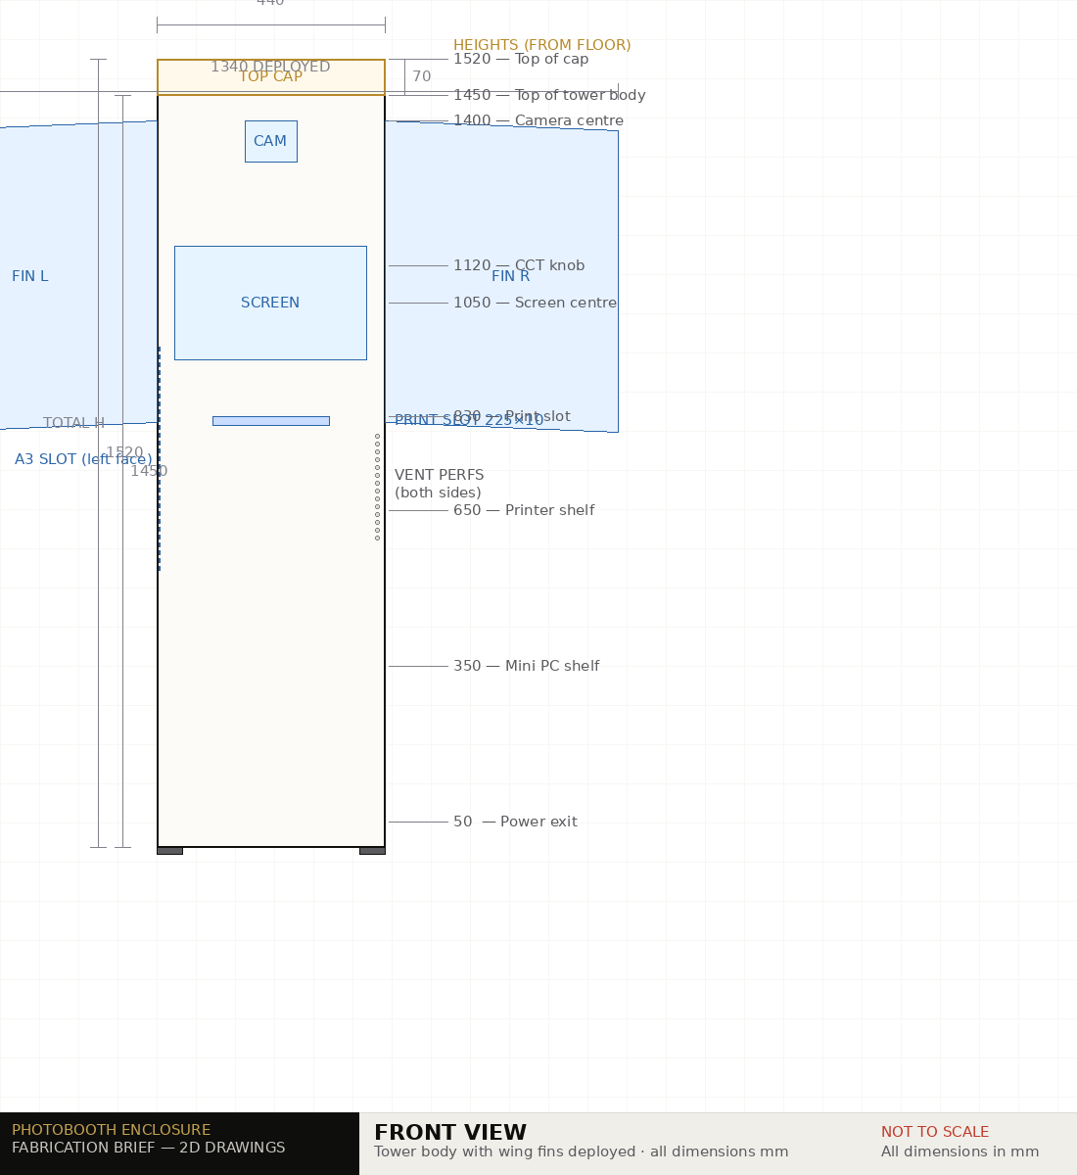

DRAWING 2 — SIDE VIEW (RIGHT)
Internal layout visible · operator panel and knobs on right face · rear door on right edge
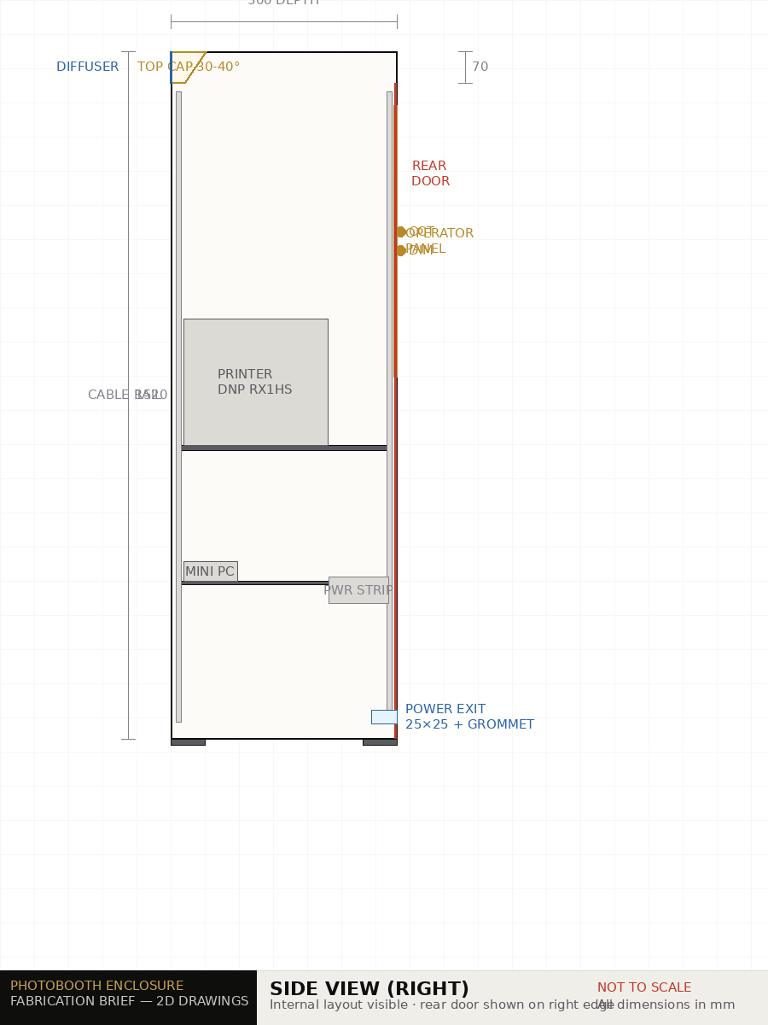

DRAWING 3 — TOP-DOWN PLAN VIEW
Fins deployed at 30–35° · internal components for reference only · front = guest-facing side
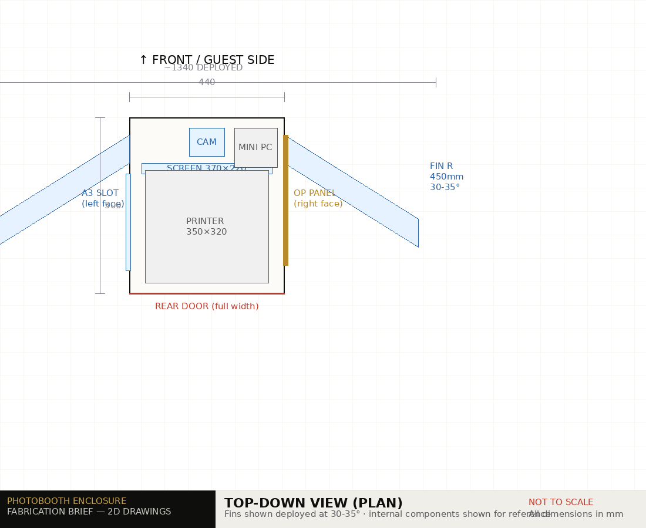

DRAWING 4 — CUTOUT DETAIL SHEET
Key apertures at varying scales · see Section 3 specification table for exact dimensions and tolerances
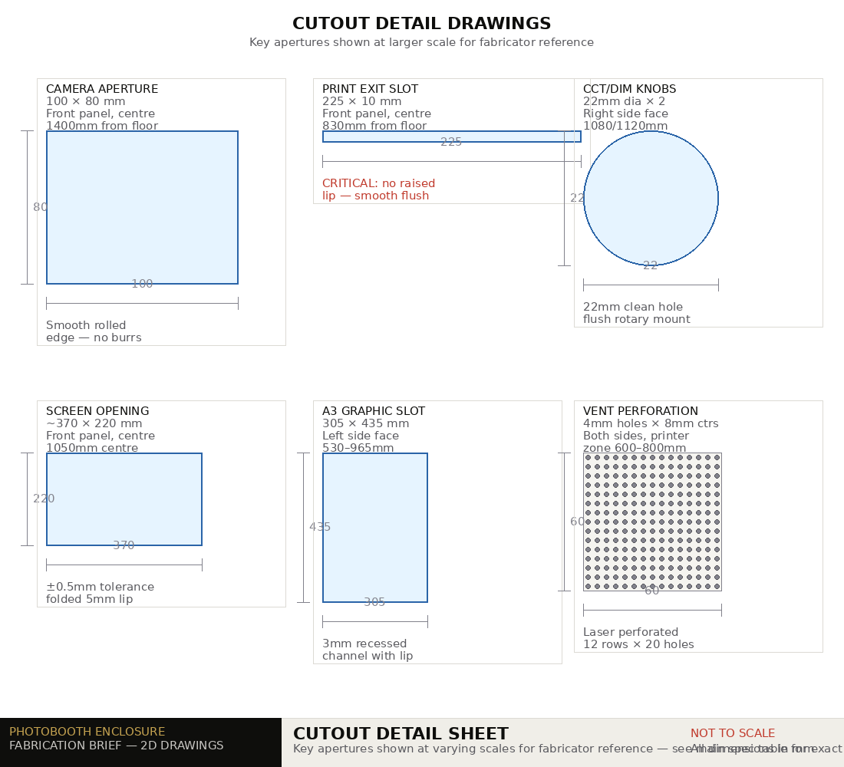

1. PROJECT OVERVIEW
We are commissioning a custom freestanding photobooth enclosure for commercial event use. The enclosure must house a camera, touchscreen monitor, dye-sublimation printer, mini PC, lighting panels, and all associated cabling in a single self-contained tower unit. The design must be robust enough for repeated assembly and disassembly at events, transport in a commercial van, and operation in Singapore's indoor climate.

Scope of work
- Tower body fabrication — 1.5mm aluminium sheet, all panels
- Wing fin fabrication — 2 fins, hinged, with angle stop tabs
- Top strip light mounting cap — welded cap on tower crown
- All cutouts, apertures, perforations and slots per specification
- Powder coating — full enclosure including fins and cap, one RAL colour (TBC)
- Laser engraving of logo panel (if selected)

IMPORTANT: A bare-metal fit-check assembly is required before any powder coating or finishing. Client will attend to verify all component positions before final finishing is approved.

2. OVERALL DIMENSIONS
Tower body
Parameter | Dimension | Notes
Overall height — tower body | 1450 mm | Excludes top strip light cap
Overall height — with top cap | 1520 mm | Includes 70mm cap on crown
Overall width | 440 mm | Tower column only, excluding fins when deployed
Overall depth | 500 mm | Front face to rear face
Deployed width (tower + both fins) | 1340 mm | Fins extend 450mm each side
Packed width (fins folded flat) | 440 mm | Fits flat in Toyota Hiace (1620mm bay)
Wall thickness | 1.5 mm | All panels — aluminium alloy 5052 or equivalent

Top strip light cap
Parameter | Dimension | Notes
Cap width | 440 mm | Full tower width — sits flush on tower crown
Cap height | 70 mm | Adds 70mm to tower height
Cap depth | 80 mm | Angled 30–40° forward and downward toward subjects
Front face opening | 420 × 52 mm | For frosted polycarbonate diffuser strip — press-fit
Power cable pass-through | 20 × 20 mm | Rear of cap into tower interior. Fit rubber grommet.

Wing fins (×2)
Parameter | Dimension | Notes
Fin width (each) | 450 mm | Extension from tower face
Fin height (each) | 600 mm | Spans camera and screen zone — main lighting area
Fin depth (each) | 80 mm | Must accommodate LED panel (40mm) + 20mm air gap + diffuser
Hinge type | Full-length piano hinge, 180° | Stainless steel. Full-length preferred over point hinges.
Deployed angle | 30–35° inward toward subject | Welded steel stop tab inside hinge — confirmed at fit-check
Fin front face | Open — diffuser panel slot | Frosted PC sheet press-fit or screwed
Fin rear ventilation | 6× 8mm holes | LED heat dissipation
Cable pass-through at hinge | 2× 15mm diameter holes | Power + control signal for LED panels

3. CUTOUT AND APERTURE SPECIFICATIONS
All cutouts are on the FRONT face unless otherwise specified. Dimensions are opening size. Fabricator to add appropriate edge treatment (folded lip or smooth rolled edge) per cutout type.

Cutout / Feature | Opening size (mm) | Panel | Height from floor | Edge treatment | Notes
Camera aperture | 100 × 80 | Front | 1400 mm centre | Smooth rolled edge | Canon R50 lens ~65mm dia. Circular or rectangular — confirm with client.
Touchscreen opening | ~370 × 220 | Front | 1050 mm centre | Folded 5mm lip inward | ASUS VT169HE — frameless monitor. Measure actual bezel before cutting. +5mm clearance all sides.
Print exit slot | 225 × 10 | Front | 830 mm from floor | Smooth rolled edge — NO sharp lip | DNP DS-RX1HS strip exit. Critical: no raised lip that could snag prints.
Operator side panel | 140 × 600 | Right side face | 800–1400 mm | Full hinge + magnetic flush latch | Push-to-open, no visible handle. Mini PC shelf accessible behind panel.
CCT knob aperture (×2) | 22mm diameter | Right side face | ~1100 mm | Clean circular hole, rolled edge | Stacked vertically, 40mm centre-to-centre. Flush-mount rotary encoder holes.
A3 graphic insert slot | 305 × 435 | Left side face | 530–965 mm | 3mm recessed channel with lip | Client branding inserts slide in from top. Lip depth 3mm to retain card.
Rear access door | Full height × full depth | Rear face | Full height | Full-length hinge + magnetic latch | Full-height hinged panel. Push-to-open. No external handle.
Ventilation perforations | 4mm holes, 8mm centres — 12 rows × 20 holes | Both side faces, printer zone | 600–800 mm | Clean laser perforation | Printer heat dissipation. Laser-perforated for premium appearance.
Power cable exit | 25 × 25 | Rear base | 50mm from floor | Rubber grommet fitted | Single IEC mains cable exits here to venue power.
Top cap — diffuser opening | 420 × 52 | Front face of top cap | 1470–1520 mm | Folded 3mm lip for PC sheet | Frosted polycarbonate diffuser press-fits into this opening.
Top cap — cable pass-through | 20 × 20 | Rear of cap into tower | At cap base | Rubber grommet | TL60 tube light AC cable routes from cap into internal power strip.
Fin cable pass-throughs (×2 per fin) | 15mm diameter | At hinge edge of each fin | Centred in fin height | Rubber grommet both sides | Power + CCT/dim control signals route through hinge into tower.

4. INTERNAL STRUCTURE REQUIREMENTS
The following internal brackets and shelves are to be fabricated and welded as part of the tower body. All shelf positions are measured from floor level to the top surface of the shelf.

Internal element | Dimensions | Height | Load | Notes
Printer shelf | 380 × 420 mm | 650 mm | 15 kg | DNP DS-RX1HS: 32×35×28cm. Shelf must be fully enclosed on 3 sides to prevent lateral movement. Rubber vibration mounts to be fitted by client post-delivery.
Mini PC shelf | 200 × 200 mm | 350 mm | 1 kg | Beelink Mini S12 Pro: 123×112×44mm. Accessible via operator side panel.
Internal cable management rails | Full tower height | — | — | 2× vertical aluminium channel rails, 20×10mm, one on each side wall interior. Cable velcro tie anchor points at 150mm intervals.
Internal power strip bracket | 400 × 60 mm | 300 mm | 1 kg | Slim 4-gang power strip mounted on dedicated bracket. One IEC cable exits at base. Client to mount power strip post-delivery.
Camera mount thread insert | 1/4-20 UNC threaded insert | 1400 mm (front panel interior) | 2.5 kg | Weld or press-fit a 1/4-20 threaded brass insert into the front panel interior at camera aperture height. Client mounts camera directly to this thread.
VESA monitor mount points | 75×75mm VESA pattern, 4× M4 threaded inserts | Screen zone — 1050mm centre | 4 kg | Standard 75×75mm VESA pattern to match ASUS VT169HE. Client bolts VESA bracket to these points.

5. MATERIAL SPECIFICATION
Item | Specified material | Thickness | Grade / spec
Tower body panels | Aluminium sheet | 1.5 mm | Alloy 5052-H32 or 6061-T6 equivalent
Wing fin panels | Aluminium sheet | 1.5 mm | Same grade as tower body — coat together
Top strip light cap | Aluminium sheet | 1.5 mm | Same grade — coat together
Piano hinges (×2) | Stainless steel | Full-length | 304 stainless, full-length, 180° rotation
Hinge angle stop tabs | Mild steel weld-on tab | 5 mm | Welded inside hinge mechanism. Confirm exact angle at fit-check.
Levelling feet (×4) | Heavy-duty rubber | Adjustable 15–25mm | M8 thread stem, 50mm rubber pad, locking nut
Magnetic latches | Neodymium flush latch | As required | Minimum 5kg pull force. Rear door + operator panel + top cap if applicable.

6. SURFACE FINISH SPECIFICATION
Item | Finish | Specification | Notes
Powder coat — all surfaces | Matte or gloss (TBC) | RAL colour TBC by client | Full enclosure including both fins and top cap coated in same batch for colour consistency.
Laser-engraved logo panel | Contrast infill (TBC) | Logo artwork to be supplied by client as vector EPS/AI file | One panel only. Confirm panel location with client before engraving.
All exposed aluminium edges | Deburr and smooth | No sharp edges anywhere | Critical — booth is operated by members of the public. All edges to be safe to touch.
Internal surfaces | No finish required | Clean metal acceptable | Internal surfaces not visible in use.

Powder coat colour: RAL number to be confirmed by client at time of order. Fabricator to provide a physical powder coat swatch panel in the selected RAL colour for client approval before coating commences.

7. COMPONENT POSITION REFERENCE MAP
Heights below are measured from the finished floor level to the centre of each component or feature. These are design targets — exact positions to be confirmed during the bare-metal fit-check.

Component / Feature | Height from floor (centre) | Panel | Notes
Top strip light cap (crown) | 1485–1520 mm | Top of tower | 2× Godox TL60 tubes seated inside. Angled 30–40° downward.
Camera aperture centre | 1400 mm | Front | Camera mounts on 1/4-20 insert at this height. Slight upward angle — flattering for groups.
CCT control knob (upper) | 1120 mm | Right side | Recessed flush. Controls colour temperature of both fin LED panels.
Dimmer control knob (lower) | 1080 mm | Right side | Recessed flush. Controls brightness of both fin LED panels.
Touchscreen centre | 1050 mm | Front | ASUS VT169HE 15.6" — comfortable tapping height for adult guests.
Operator side panel (top) | 1400 mm | Right side | 60cm tall panel from 800–1400mm. Exposes mini PC shelf.
Operator side panel (bottom) | 800 mm | Right side | Push-to-open magnetic latch.
A3 graphic insert slot (top) | 965 mm | Left side | A3 card slides in from top opening.
A3 graphic insert slot (bottom) | 530 mm | Left side
Print exit slot centre | 830 mm | Front | DNP strip exits here. Must align precisely with printer output position.
Printer shelf top surface | 650 mm | Interior | DNP printer (28cm tall) sits on shelf — top of printer at ~930mm.
Ventilation perforations zone | 600–800 mm | Both sides | Printer heat zone.
Mini PC shelf | 350 mm | Interior, right side | Accessible via operator side panel.
Power cable exit (centre) | 50 mm | Rear base | Single IEC cable to venue mains.
Levelling feet | 0 mm | Base corners | 4× adjustable rubber feet.

8. FABRICATION PROCESS REQUIREMENTS
Required process steps
- CNC laser cutting of all panels from approved DXF/DWG drawings
- CNC press brake bending to achieve all folded edges and panel angles
- TIG welding of all structural joins, shelf brackets, and internal rails
- Fit piano hinges to both fins — position and secure angle stop tabs (angle confirmed at fit-check)
- Bare-metal fit-check assembly — client attends to mount all equipment and verify positions
- Deburr all edges — smooth all cut edges to safe-to-touch finish
- Pre-treatment — chemical clean and etch before powder coat
- Powder coating of full enclosure — all panels, both fins, top cap — in one batch, client-approved RAL colour
- Laser engraving of logo panel (if selected) — before or after powder coat per fabricator recommendation

The bare-metal fit-check (Step 5) is mandatory. No powder coating or finishing is to commence until the client has physically mounted all equipment and provided written sign-off on component positions.

Quality requirements
- All welded joins must be continuous, clean, and ground flush on visible exterior surfaces
- All cutouts and apertures to be within ±1.0mm of specified dimensions
- Touchscreen opening tolerance is critical — ±0.5mm on width and height
- Print exit slot must be smooth with no raised edges — DNP prints are 0.25mm thick and will catch on any lip
- Powder coat finish must be uniform, bubble-free, and free from runs across all surfaces
- Finished unit must stand square and stable on all 4 levelling feet on a flat surface

9. EQUIPMENT REFERENCE — ITEMS HOUSED IN ENCLOSURE
Fabricator to use these dimensions when sizing internal compartments and cutouts. Client will provide physical units for the bare-metal fit-check.

Equipment | Model | Dimensions (W×D×H mm) | Weight | Mounting
Dye-sublimation printer | DNP DS-RX1HS | 350 × 320 × 280 | 14 kg | Sits on printer shelf. Rubber vibration mounts.
Touchscreen monitor | ASUS VT169HE 15.6" | ~370 × 25 × 230 (bezel) | 2.2 kg | VESA 75×75mm bolted to front panel interior.
Mini PC | Beelink Mini S12 Pro | 123 × 112 × 44 | 0.5 kg | Sits on mini PC shelf. Accessible via operator panel.
LED panels — fins (×2) | Viltrox VL-60B | ~300 × 40 × 200 | 0.8 kg each | Bolted to fin interior rear face.
Top fill light (×2 tubes) | Godox TL60 RGB | 750 × 48mm dia. | 0.4 kg each | Seated in top cap housing. Secured with mounting clip.
Portable WiFi router | TP-Link M7650 | 113 × 67 × 16 | 0.13 kg | Rests inside tower on mini PC shelf area or adhered with velcro.

10. REQUEST FOR QUOTATION
Please provide a written quotation covering the following items. Quote each line item separately to allow comparison.

Item | Description | Qty | Unit price | Total
1 | Tower body — laser cut, bend, weld, all internal brackets and shelves | 1
2 | Wing fin shells — laser cut, bent, with ventilation holes (excludes hinges) | 2
3 | Piano hinges, full-length, stainless — fitted to fins with angle stop tabs | 2
4 | Top strip light cap — welded to tower crown, angled 30–40° forward | 1
5 | Rear access door — full-height, hinged, magnetic flush latch | 1
6 | Operator side access panel — 140×600mm, right side, magnetic flush latch | 1
7 | A3 graphic insert slot — recessed channel, left side | 1
8 | Levelling feet — heavy duty adjustable rubber, M8 stem | 4
9 | Powder coating — full enclosure, fins, and cap, one RAL colour | 1 lot
10 | Laser engraving — logo on one panel (artwork supplied by client) | 1
11 | Pre-treatment (chemical clean and etch before powder coat) | 1 lot
 | TOTAL

Please also advise: (1) Lead time from drawing approval to delivery, (2) Whether a powder coat swatch can be provided for colour approval, (3) Whether bare-metal fit-check is chargeable, and (4) Delivery / collection options.

11. IMPORTANT NOTES FOR FABRICATOR
- CAD drawings (DXF/DWG format) will be provided separately. This document is the brief; the DXF files are the cutting instructions. If there is any discrepancy between this brief and the DXF files, please contact the client before proceeding.
- The print exit slot is safety-critical. The DNP DS-RX1HS photo printer produces prints that exit at low speed. Any raised lip, burr, or sharp edge at the print exit will damage prints. This slot must be smooth and flush, with a gently rounded leading edge.
- The piano hinge stop tab angle (30–35°) is to be confirmed at the bare-metal fit-check — not pre-set during initial fabrication. The fabricator should leave the stop tab unwelded until the client has confirmed the exact deployed angle during fit-check.
- The touchscreen monitor (ASUS VT169HE) is a frameless design. The physical bezel dimensions should be measured from the actual unit before the screen opening is cut. Client will provide the physical unit at the fit-check or send measured dimensions in advance.
- All magnetic latches are to be flush-mounted with no visible external hardware. The enclosure exterior must be clean and uncluttered — no visible handles, hinges, or latches on the front or sides.
- Transport consideration: the enclosure will be transported in a Toyota Hiace cargo van (bay width 1620mm). The packed width of the tower with fins folded is 440mm — this must be verified during fit-check.
- Ventilation is not optional. The DNP dye-sublimation printer generates significant heat during continuous use. The perforated panels on the printer zone sides must not be filled, blocked, or reduced in count.

Client sign-off
Please sign and date to confirm receipt of this brief and agree to the bare-metal fit-check requirement before finishing.

Fabricator name: _____________________________________________
Contact person: _____________________________________________
Quote reference: _____________________________________________
Signature: _____________________________________________
Date: _____________________________________________

