- 

- The University of Hong Kong

- School of Computing and Data Science

- COMP7705
- Project Report
- Intelligent Multi-Agent System for Enterprise
- Operations

- Submitted in partial fulfillment of the requirements for the admission to the degree of Master of Science in Computer Science
- By

- Lin Chuanbin ()
- Huang Siyuan (3036656087)
- Xia Xin (3036660375)
- Zhang Zhaoming ()
- Yao Jiacheng ()

- Mentor: Huang Chao
- Date of submission: 17/06/2026

- Content
- Abstract I
- Declaration II
- Acknowledgments III
- Chapter 1: Introduction 1
- 1.1 Background and Motivation 1
- 1.2 Problem Statement 2
- 1.3 Project Objectives 2
- 1.4 Scope and Limitations 3
- 1.5 Report Organization 4
- Chapter 2: Literature Review 5
- 2.1 LLMs in Enterprise Applications 5
- 2.2 Multi-Agent Systems and Orchestration 5
- 2.3 Code Generation and Text-to-SQL 6
- 2.4 RAG 7
- 2.5 Tool-Augmented Language Models 8
- 2.6 Data Security and Local Deployment 8
- Chapter 3: Requirements Analysis 10
- 3.1 Banking Industry Context 10
- 3.2 Functional Requirements 10
- 3.3 Non-Functional Requirements 12
- 3.4 Use Case Analysis 14
- Chapter 4: System Architecture Design 18
- 4.1 Five-Layer Architecture Overview 18
- 4.2 Frontend Architecture 20
- 4.3 Backend Microservice Architecture 23
- 4.5 Data Layer Architecture 29
- 4.6 Technology Stack Rationale 31
- Chapter 5: Core Agent Implementation 34
- 5.1 Tool Agent Implementation 34
- 5.2 Code Agent Implementation 45
- 5.3 RAG Agent Implementation 55
- Chapter 6: System Integration and Deployment 60
- 6.1 User Center and RBAC 60
- 6.2 Task Center and Orchestration 61
- 6.3 WebSocket Real-Time Communication 62
- 6.4 Containerized Deployment 63
- Chapter 7: Discussion 65
- 7.1 Challenges and Resolutions 65
- 7.2 Comparison with Existing Solutions 66
- 7.3 Project Limitations 66
- Chapter 8: Conclusion and Future Work 67
- 8.1 Summary of Achievements 67
- 8.2 Future Work 67
- References 69
- Appendix B: API Documentation (Selected Endpoints) 73
- Appendix C: User Manual (Summary) 76
- Declaration of Individual Contributions 78

Abstract
- Large language models (LLMs) are developing rapidly, they are opening up new paths for Enterprise Digital Transformation. However, when applying them in some specific areas, such as banks, huge challenges are needed to be solved. For example, programming code can be wrong, errors happen in some cases, tools may not work well. Also, we depend on outside application programming interfaces (APIs) which brings extra risks. To solve these issues, this article proposes a system and implementation method specifically designed for digital transformation of banks.
- The system has three agents. A Code Agent turns natural language questions into executable queries by using a Python‑based LLM service and a multi‑level SQL whitelist filter. A Retrieval‑Augmented Generation (RAG) Agent fetches policies and knowledge by using Milvus vector indexing and vLLM text generation. A Tool Agent automatically handles everyday business tasks, such as spotting schedule conflicts, booking meeting rooms, and calculating routes. These three agents are all managed by a DeepSeek‑based module, which understands what the user wants from a central point.
- The platform has an access control system based on roles. This system is called RBAC. It gives different levels of security permissions. It also keeps data separate by department. The platform runs on a five‑layer microservices architecture. The architecture is built with Spring Boot, Vue 3, and Docker containers.

Declaration
This report is our own original work. We completed it independently. It has not been submitted before for academic qualification requirements at the University of Hong Kong or any other institution. All outside sources we cited and help we received have been properly noted in the references. For a detailed description of what each team member contributed, please see the section titled "Statement of Individual Contributions" at the end of the report.

Acknowledgments
We thank our supervisor, Dr. Huang. He gave us guidance, encouragement, and insightful advice throughout the project. His expertise and support helped shape the direction of our work. They also made the work better. We also thank the School of Computing and Data Science at the University of Hong Kong. It provided the academic environment and facilities. These strongly supported our research. Finally, we thank our families and friends. They supported us during the hard phases of developing and writing the project.

Chapter 1: Introduction

1.1 Background and Motivation
LLMs are built on transformer architectures. They are trained on large sets of text and have pushed artificial intelligence forward. These systems can understand almost every language, create runnable programming code, and solve reasoning problems. By 2026, banks and financial firms are using AI more and more. They use AI to handle routine work task, help with decision-making and provide automated services for clients.
But using LLMs in business banking brings problems that go beyond just linking up the tech. First, SQL that is made by the model for database queries is not always reliable. The code often has mistakes in the way it is written, or the meaning does not match the data. This happens when the SQL runs on complex financial data structures. Second, these models often give wrong answers. This happens when a request is not clear. Or when it asks about things that belong to a very specific business field. Also, letting AI agents call functions on their own is still not reliable for real-world use. They must correctly understand what the user wants. Then they must start the right inside tool, like a room-booking system or a calendar. This kind of self-acting call is not yet safe to use in live production.
The most serious problem comes from the common industry practice. Many firms rely on outside LLM APIs, like those from big cloud providers. This brings up data safety issues and legal control problems. Secret company plans, private trading methods, and customer data are examples of sensitive inside information. Such data could be leaked while being sent. Or it could be stored and used in ways not allowed. This kind of indirect leak breaks the safety controls. These controls are demanded by rules like Basel III, GDPR, and many national bank security standards.
The current work is driven by several linked problems. These are technical precision, keeping domain knowledge correct, stable tool calling, and data control. So, a single multi-agent AI system is clearly needed. This system must use the strengths of LLMs. It must run fully on-site. It must be secure and built to business-grade level. It must be made for the working needs of banking.

1.2 Problem Statement
The present work are facing four major challenges.
Code generation accuracy. Database queries are used in everyday bank work. For example, they are used to get customer data and to file reports required by rules. Natural-language interfaces can make data access easier. But current tools that turn text into SQL often make mistakes. They fail to correctly map the tables, columns, and joins referenced in a user's question to the underlying database schema. They also do not work well on the very standard data structures that are common in financial systems.
Knowledge retrieval. Answers to procedural and policy questions must be verifiable. They must be backed by citations. This is important for bank employees. Finance is a field where rules must be followed carefully. Standard LLMs sometimes give answers that sound good but are factually wrong. This is not acceptable in such a setting. The models do not have access to the latest internal records. They also do not see the rules that are specific to this sector.
Enterprise Tool Integration. Daily bank work uses many tools, including room booking, calendar syncing, and route planning. An AI system must correctly understand user requests. It must find the right tool to call, carry out the action, pull out the correct details to do this and also handle errors and recover from them.
Data Sovereignty And Access Control. Beyond the risks from outside APIs, banking settings need strict access levels. Different departments handle documents with different security clearances. The rules also require that every sensitive action is recorded in a complete audit log. Any AI system that sends data through outside points takes on too much compliance risk. So, the system must be set up fully on-site. It must have identity and access governance built in.

1.3 Project Objectives
This work presents a multi-agent AI framework, built on an on-premise infrastructure and designed for banking operations, to address the challenges described above. The specific objectives are as follows:
Code Agent. The Code Agent is a component that turns natural language into SQL. It connects to a Python-based LLM inference server to generate queries. A five-tier whitelist filtering mechanism makes sure the queries run safely and correctly. This mechanism covers operation categories, prohibited terms, permitted tables, allowed columns, and complexity thresholds. Metadata from the MySQL information_schema is cached in Redis. This provides context for checking. It also helps to understand the database structure better.
RAG. RAG combines Milvus-based vector retrieval with vLLM-based inference. It gives accurate answers. These answers are backed by references. They are for banking policy and procedural questions. Organizational documents go through a workflow. This workflow splits and embeds them. It allows fine-grained retrieval of relevant content. This goes beyond simple whole-document matching. It also enforces access restrictions based on clearance. These restrictions apply to the returned results.
Tool Agent. Tool Agent is a module that calls business tools. It supports conference-room inquiry and reservation. It also detects conflicts. For conflict detection, it uses Redis sorted sets. The key pattern is tool:schedule:{userId}. This allows fast checking of time overlaps. It also does route planning with map drawing. This uses the Amap Open API. It has a multi-level backup for geocoding. An intent routing engine based on DeepSeek LLM coordinates all tool functions. It does this by understanding user queries. It pulls out the needed parameters.
System Integration. It builds an end-to-end platform. The platform includes authentication secured by JWT. It has a three-level RBAC model. The roles are Administrator, Department Admin, and End-User. It separates data by department. It uses clearance grades. Grade 1 is Public. Grade 2 is Internal. Grade 3 is Confidential. It has document oversight. This oversight includes human-in-the-loop escalation. It has a notification service. It gives live task progress updates using WebSocket. It is deployed with containers through Docker Compose. The system follows a microservice architecture with five tiers. This provides modularity and enterprise-grade security.

1.4 Scope and Limitations
This project covers the design, implementation, and evaluation of the multi-agent platform described above. The intended users are banking personnel. The platform provides three main functions. It generates SQL for data retrieval. It answers policy-related queries. It invokes business tools. These tools include room booking, calendar coordination, and route planning. The system is deployed on a single organization's on-premises servers. It uses role-based access control, or RBAC, to manage multiple users.
But there are still several limits. First, the Code Agent supports only MySQL SQL and relational table structures. It does not work with other database systems or NoSQL interfaces. Second, the RAG Agent's knowledge base relies on the internal records that are brought in. It depends on how complete and well-formatted those records are. Third, the Tool Agent has an AI intent routing part. This part relies on the DeepSeek API. The API needs outside network access for some AI functions.

1.5 Report Organization
The rest of this report is arranged like this. Chapter 2 looks at past work on LLM use in business settings, systems with many agents, turning text into SQL, RAG methods, language models with added tools, and related privacy and safety issues. Chapter 3 looks at the functional and non-functional needs of the system, and the limits on them. Chapter 9 gives a short summary of the key findings and points out what can be done next.

Chapter 2: Literature Review

2.1 LLMs in Enterprise Applications
- Transformer-based LLMs have changed AI research and its uses. Vaswani and others (2017)[9] introduced the transformer architecture. Since then, this field gain a rapid progress, large models, like GPT-4, Claude, DeepSeek has come out. These models perferms very well in understanding natural languages and inference tasks. Its core relies on self attention mechanism, which can capture semantic associations within the scope of long texts. Through this, coherent text will be generated.
- In some specificated organizions, LLMs are used to automatically manage knowledge intensive works, including report writing, document abstract generating, programming code making, specificated field questions answering and complex work flow managing. But if the company use ready-made models, they may face lots of problems. Bender et al. (2021) [11] call these models "Random Parrot". They believe that models can only learn statistical laws from training data, with no really understanding ability. So they may output seemingly reasonable answers, which is wrong actually. In regulated industries like bank, this is worrying because it may led to legal penalties and economic losses.
- Financial services industry has a strick attitude on using AI. Banks must meet the regulation commands. They need to standardize data confidentiality, transaction aduit, and explanatory automate decision. The Basel Committee on Banking Supervision has issued guidelines on AI in the financial industry, requiring transparency, resilience testing, and manual supervision of model outputs.

2.2 Multi-Agent Systems and Orchestration
- Multi agent systems (MAS) originated from research focus on distributed artificial intelligence. Early systems used rule-based agents, which had fixed interaction rules. As LLMs are becoming more and more popular, a new architecture design based on intelligent agents has emerged. Under this architecture, each agent relies on language models to complete reasoning, planning, and interactive communication between agents.
- Wu et al. (2023) proposed AutoGen [4]. This platform allows different LLM-driven agents to communicate, and work together to solve complex questions. AutoGen has a dynamic conversation machanism, which can allocate each agent a role, so that subtasks can be transferred and peer review can be used to optimize outputs. But this frame is unpredictable and its output may not be reliable, which is unbearable in commercial scenarios. On the opposite, Hong et al. (2024)[5] proposed MetaGPT. This frame embeds Standard Operating Procedures (SOPs) into a multi-agent collaboration system, drawing inspiration from the working mode of factory assembly lines. Virtual roles such as product managers, system architects, development engineers, and testers are set up, and agents collaborate through the transfer of standardized intermediate results.

2.3 Code Generation and Text-to-SQL
- Converting natural language questions into executable SQL statements has been a major challenge in the field of natural language processing for over 20 years. The early solution adopted a rule-based approach, relying on manually constructed grammar rules and domain specific knowledge systems. This type of method is effective in narrow domain scenarios, but it is difficult to adapt to diverse database structures.
- The emergence of the Spider dataset is an important development in this field. Yu et al. (2018) [1] constructed this dataset. Spider is a cross domain large-scale test set that includes 10181 query examples from 138 domains and 200 databases. Its core is used to test the model's ability to handle unfamiliar database architectures. This demand is highly compatible with the banking industry scenario: financial databases will be frequently updated due to new product launches, regulatory reporting requirements, and market data changes.

2.4 RAG
- RAG fixed a weakness in LLM. LLM relies on the static knowledge stored in its parameters. This knowledge often leads to factual errors. Lewis et al. (2020) [8] first described RAG. The RAG design has added a step of obtaining information from external sources. This step retrieves relevant paragraphs from the knowledge base. It provides model evidence for generating answers.
- A typical RAG workflow has three phases. Phase one is indexing. In indexing, source materials are split into segments. These segments are turned into vector embeddings. This uses a pre-trained encoder. Phase two is retrieval. In retrieval, the user query is encoded in the same space. The most semantically similar segments are retrieved. This retrieval uses approximate nearest-neighbor search. Phase three is generation. In generation, the retrieved content and the original query are fed into the LLM. The LLM then produces the final output. This design separates language ability from where facts are stored. So, responses can draw on current data that is specific to the organization.
- In banking, RAG is useful. This is because regulatory rules, internal policies, and product documents are kept in large text stores. These stores are updated often. They cannot be put into model weights. Pipitone and Alami (2024) proposed LegalBench-RAG [2]. This is a benchmark for testing RAG systems in legal and financial settings. It puts more weight on clause-level precision than on document-level recall.

2.5 Tool-Augmented Model
- LLMs have a limit. They cannot interact with outside systems or data stores. Tool-augmented language models fix this problem. They let LLMs call APIs, query databases, and run computing tasks. The ReAct paradigm (Reasoning + Acting) was introduced by Yao et al. (2023) [10]. It showed that mixing reasoning steps with actions allows LLMs to use outside tools for tasks that need real-time data, arithmetic, and interacting with the environment.
- In corporate settings, tool use goes beyond general web search. It includes utilities that are specific to the organization. These utilities include calendar management, resource reservations, internal data queries, and process automation. The reliability of these tool calls is an important measure of performance. This reliability matters especially for three things: figuring out the user's intent, pulling out the right parameters, and recovering from faults. In conversational AI, occasional errors may be okay. But in business tool use, mistakes have immediate operational effects. Examples of such mistakes are booking the wrong room or missing a scheduling conflict.

2.6 Data Security and Local Deployment
- Security and data sovereignty are central concerns when companies adopt AI systems. The common practice is to access LLMs through cloud APIs. In this practice, user queries and context data are sent to outside endpoints. This is done for inference. This practice conflicts with data governance policies. These policies are enforced in regulated sectors. As Karras et al. (2025) noted, sensitive information in prompt payloads may be logged by providers. It may also be repurposed for model retraining. Or it may be leaked through inversion techniques.
- In banking, the Hong Kong Monetary Authority (HKMA) requires that customer information be protected through appropriate safeguards and that institutions retain control over data access and processing. Similar requirements are imposed by the GDPR, mainland China's Personal Information Protection Law (PIPL), and various national banking security regulations. Together, these frameworks require that confidential financial data be processed within controlled environments that support complete auditability, a requirement that is incompatible with routing such data through third-party services.
- Deploying on-site brings a real challenge. This challenge is the computing cost of running LLM inference. Kwon et al. (2023) [7] came up with a solution. They proposed PagedAttention and the vLLM framework. These reduce GPU memory bottlenecks. They do this through a memory management plan. This plan is based on how an operating system handles virtual memory.

Chapter 3: Requirements Analysis

3.1 Banking Industry Context
System Requirements come from how banks work. Banks and financial firms handle complex information settings. These settings have four main features. First, they have large relational data stores. These stores hold client profiles, transaction logs, product lists, and compliance reports. Second, they keep large sets of policy documents, rule handbooks, and procedure guides. These are updated often to match new legal needs. They are organized by department. Each has a different security level. Third, daily admin tasks involve resource scheduling. This includes booking meeting rooms, managing staff calendars, and planning travel. These tasks take up a lot of staff time. Fourth, security and compliance needs demand tight control over data access and handling. This includes role-based permissions, separating data by department, and clearance-escalation processes that can be audited.
A study of stakeholders finds five main user groups. Business analysts need to query databases without deep SQL knowledge. Compliance officers need to quickly find relevant regulatory clauses with verifiable references. Administrative staff coordinate meetings and schedules across the organization. Departmental administrators manage team membership, document access rights, and approval workflows in their units. System administrators handle platform configuration, manage user permissions, and allocate resources.

3.2 Functional Requirements
The platform's functional requirements are arranged by microservice. They show the features that were built. These features are checked against the codebase.
FR1 – User Authentication and RBAC. The system supports registration. Usernames must be in email format. It uses BCrypt to hash passwords. It uses JWT for authentication without server-side sessions. Each JWT carries the user ID (sub). It also carries the roles list (roles[]) and the permissions list (permissions[]). Three roles are supported. ROLE_ADMIN has full privileges. It can manage users, resources, and departments. ROLE_DEPT_ADMIN is limited to departmental tasks. ROLE_USER has basic access. The Gateway has a filter called JwtAuthGlobalFilter. It checks tokens for all endpoints that are not whitelisted. It then forwards user context to downstream services. It does this through custom headers. These headers are X-User-Name, X-User-Roles, and X-User-Permissions.
FR2 – Department Management. FA department structure with different levels is supported. It has six units: Credit, Compliance, Asset Management, Retail Banking, Investment Banking, and Risk Control. Department administrators can view the member list in their unit. They can browse unassigned users. They can add new members. They can remove existing ones. Users can be assigned to departments with a security clearance level. Level 1 is Public. Level 2 is Internal. Level 3 is Confidential. Newly registered users start at Level 1 by default.
FR3 – Document Management with Security Clearance. Organizational documents are stored in the sys_document table. The table has fields for title, markdown content, a department link, and a security level. The department field is called dept_id. It can be empty for global documents. The security level is a number from 1 to 3. Access is decided by a rule with several conditions. The rule is checked at query time. A document is accessible if two things are true. Its dept_id must match the user's department, or be empty. Its security level must not be higher than the user's clearance. Documents that do not meet both conditions are still returned. They are marked as not accessible. They show an "Access Restricted" message. They are not left out. This supports the Human-in-the-Loop escalation workflow.
FR4 – Notification System. The notification subsystem handles multiple types. They are stored in the sys_notification table. One type is CHAT. This is for general messaging. Its status flow is: 0 means Unread, and it moves to 1, which means Read. Another type is RAG_APPLY. This is for document access escalation requests. Its status flow is: 2 means Pending. It can change to 3, which means Approved, or to 4, which means Denied. Another type is SQL_AUDIT. This sends alerts on suspicious SQL statements. The alert includes a JSON payload. The payload holds the query and timestamps. The frontend shows a badge with the unread count. This count is checked every 10 seconds. The frontend also provides a three-column message center. It displays messages in different ways for each type.
FR5 – Code Agent. Natural-language queries are accepted through three endpoints. POST /code/query does generation and execution. POST /code/generate gives a preview only. POST /code/execute runs execution after human-in-the-loop review. The Python LLM inference server listens on port 8090. It receives a question in JSON format. It returns the generated SQL. A five-stage SqlValidationService checks the SQL. It restricts operations to SELECT only. It uses a blacklist to block forbidden keywords. It checks a whitelist of table names from information_schema. It checks a whitelist of column names. It enforces complexity limits. No more than 3 tables are allowed. No more than 10 conditions are allowed. Metadata is pulled from information_schema. It is cached as JSON in Redis. The key is code_agent:metadata:tables. The TTL is 3600 seconds. A scheduled task refreshes the cache every 30 minutes. An initial load happens when the application starts.
FR6 – RAG. RAG accepts natural-language policy questions. It searches a Milvus database for text pieces with a similar meaning. It generates responses with source citations. It respects document security clearance levels during retrieval. Note that this agent is under active development. Its foundational infrastructure is in place.
FR7 – Tool Agent. There is a single AI execution endpoint. It is POST /tool/execute. It accepts ToolRequest objects. These objects contain a toolType field, a parameters map, and a natural language field. The DeepSeek Service classifies the input into one of three intents. The intents are ROUTE_PLAN, MEETING_QUERY, and SCHEDULE_CHECK. It also extracts structured parameters. There are dedicated endpoints for specific tasks. One endpoint handles meeting-room query and booking. Another endpoint handles schedule-conflict detection. It uses Redis sorted sets. The sets are keyed as tool:schedule:{userId}. Another endpoint handles route planning with map visualization. It uses the Amap Open API. It includes multi-level geocoding fallback.
FR8 – Admin Resource Management. Users with the ROLE_ADMIN role can use two controllers. One is the MeetingRoomAdminController. It handles CRUD at /tool/admin/meeting-rooms. The other is the MeetingScheduleAdminController. It handles CRUD at /tool/admin/schedules. All admin endpoints check for the ROLE_ADMIN role. They look for it in the X-User-Roles header. Resource management applies several rules. The room name and floor are required. Capacity must be greater than zero. Start time must be before end time. The booker's name is required.

3.3 Non-Functional Requirements
NFR1 – Data Sovereignty. All core data tasks run inside our own Docker setup. These tasks include AI model runs, finding documents and database work. They all happen in a Docker environment on our own machines. External calls (the DeepSeek LLM endpoint at maas-api.cn-huabei-1.xf-yun.com and the Amap geocoding/routing API at restapi.amap.com) transmit only the minimum required parameters (prompts and coordinates), with no payload logging or retention by third-party providers. All external API keys are stored in environment variables, with development fallback defaults.
NFR2 – Performance. The system should meet these latency targets: (a) Code Agent SQL generation ≤3 s; (b) Tool Agent meeting-room and schedule queries ≤500 ms; (c) route-planning responses ≤2 s (limited by the Amap API round-trip); (d) WebSocket progress updates ≤200 ms; and (e) initial page load ≤3 s.
NFR3 – Security. All API traffic must be encrypted with HTTPS/TLS (and WSS for WebSocket connections). User passwords are hashed with BCrypt (strength factor 10). JWT tokens have configurable expiry (default 24 h) and are signed with HMAC-SHA. Method-level authorization is enforced by Spring Security's @PreAuthorize annotations. SQL injection is prevented through the use of PreparedStatement. MyBatis-Plus supports logical deletion. It uses the @TableLogic annotation for this. This works for all entities. It keeps the data for audit purposes.
NFR4 – Reliability and Availability.The platform is designed to be up 99.5% of the time during business hours. The system can keep working at a reduced level when some services fail. When the DeepSeek or Amap services cannot be reached, the Tool Agent uses mock data. If the Code Agent's inference server is not available, the system returns error messages. All task failures are logged. They include details like user ID, request payload, and stack trace. This is used for analysis after an incident.
NFR5 – Maintainability. The architecture follows microservice principles. It keeps different responsibilities separate. Each service provides RESTful APIs. These are documented in Appendix B. A Result<T> wrapper is used for responses. It has code, message, and data. This gives consistent error handling across the whole stack. MyBatis-Plus provides type-safe CRUD operations. It automatically maps underscores to camelCase. It supports logical deletion. It also logs SQL for debugging.
NFR6 – Deployability. The system is deployed with one Docker Compose command. The MySQL container starts on its own. It uses a file from docker/init/agent_platform_backup_utf8.sql. This file creates all 11 tables with seed data. Service URIs are set through environment variables. Examples are USER_SERVICE_URI, TOOL_SERVICE_URI, and CODE_SERVICE_URI. The default for development is localhost. Health-check probes test if a service is ready. They run before dependent containers start.

3.4 Use Case Analysis
Use case analysis was done. It captured how users interact with the multi-agent platform. Detailed use case diagrams were made for each agent module. This was done during the design phase. Figure 1 shows the use cases for the Tool Agent module. Three main actors interact with the system. The first group is end users. They have the role ROLE_USER. They can book meeting rooms, check schedule conflicts and plan routes. The second group is administrators. They have the role ROLE_ADMIN. They can also manage meeting room and schedule resources. Besides, they can use dedicated admin controllers to do this. There are also two external system actors. One is the DeepSeek LLM. It classifies what the user wants and pulls out parameters from natural language requests. The other is the Amap API. It converts addresses into coordinate snd can also calculates routes.

Figure 1: Tool Agent Use Case Diagram — Meeting Room, Schedule Conflict, and Route Planning
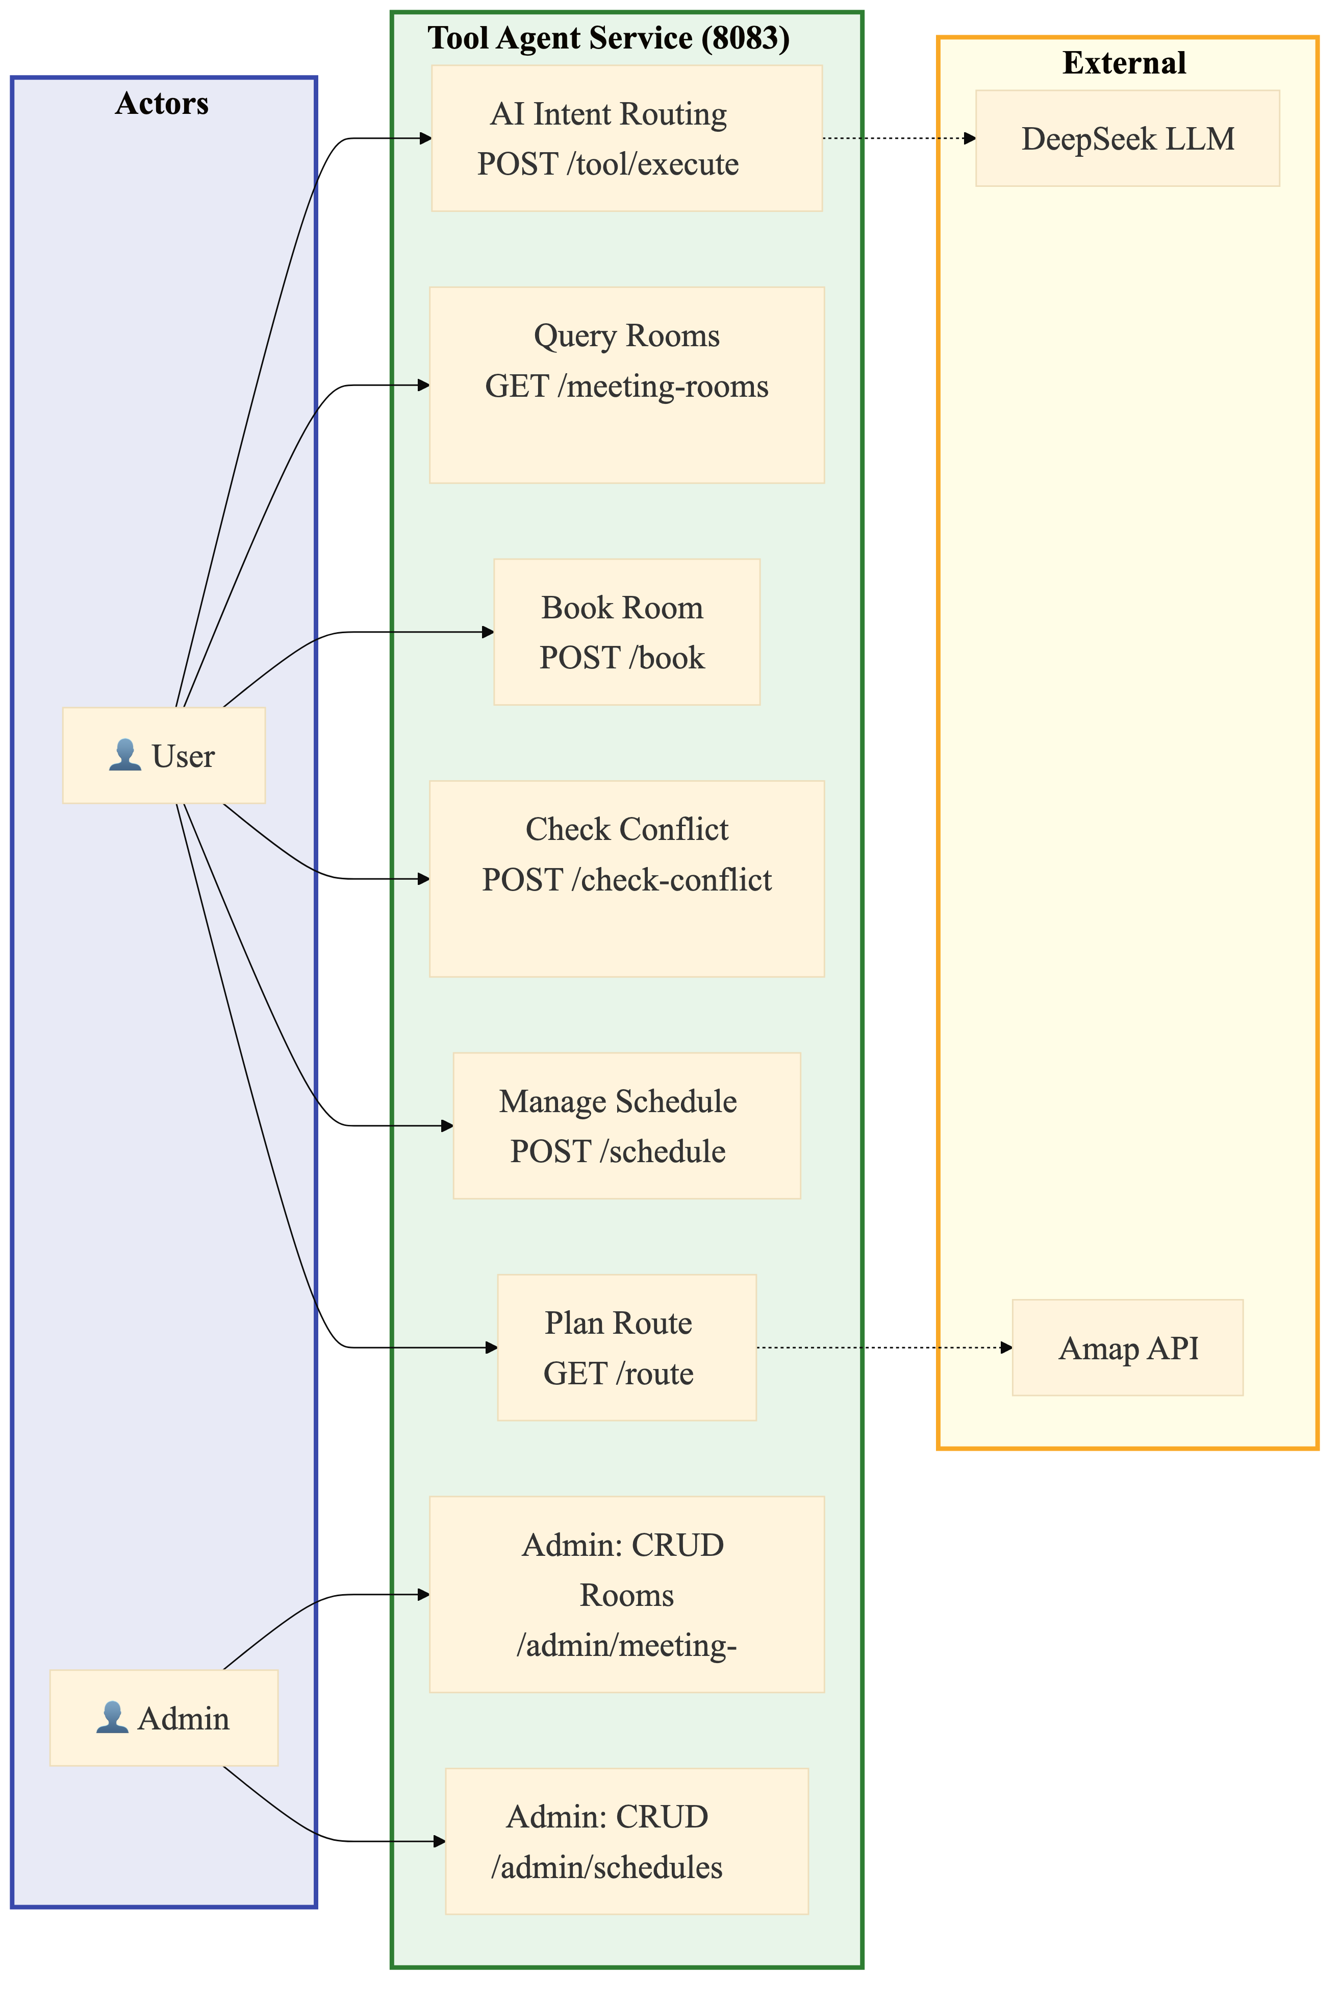
There are three agent modules. Their use cases are as following.
UC1 – Generate SQL from Natural Language (Code Agent). A business analyst types a natural language request. An example is: "Show me all customers who opened accounts in Q1 2026 with balances exceeding HKD 500,000." The CodeAgentController receives the request at the endpoint POST /code/query. It sends the question to the Python LLM inference server on port 8090. The server returns the generated SQL. The five-layer SqlValidationService then checks the SQL. After it passes, the SQL is run through JdbcTemplate with a PreparedStatement. The system returns the result in table form. The result includes column names, row data, and execution time.
UC2 – Policy Compliance Query (RAG Agent). A compliance officer asks a question. For example: "What are the latest KYC requirements for corporate account opening?" The system encodes the query. It retrieves the top-k most similar document chunks from the Milvus vector store. These chunks are filtered by the user's department and clearance level. The system passes these chunks as context to the LLM. It returns an answer with citations. The citations point to the specific policy documents and sections used.
UC3 – Meeting Room Booking (Tool Agent). An administrative staff member types a request into the AI Assistant panel. The request is: "Book a meeting room on the 3rd floor for 10 people tomorrow morning at 10 AM." The frontend opens a WebSocket connection. It sends the query. It displays progress. The DeepSeekService classifies the request as MEETING_QUERY. It extracts the parameters. The parameters are floor 3, capacity 10, and time tomorrow 10:00 AM. The result is sent to the MeetingAgent component. MeetingAgent queries MySQL for rooms that match. It checks the floor and capacity, and then cross-references Redis for time availability. The available options are displayed.
UC4 – Schedule Conflict Detection (Tool Agent). A user enters a request: "Check if Zhang and Li are free next Tuesday 2-4 PM." The AI identifies the user's intent and then extracts the attendees’ names and time range. The ScheduleAgent component calls API and sends the attendee list. The ToolController will checks each attendee's schedule. The response shows if conflicts exist, identifies the conflicting users and gives the conflict type with suggested alternatives.
UC5 – Document Access Escalation (User Center). A Credit Department staff member has clearance Level 1. They try to access a Level-3 confidential risk evaluation document. The method SysDocumentServiceImpl.listDocumentsForUser() checks the access rule. The document’s department matches the user's department. But the user's clearance level is 1. This is lower than the document's clearance which is 3. So the document is not accessible. The user can then submit an escalation request, which will create a notification. The notification status starts as Pending and goes to a department administrator for review. The status can be changed to Approved. The approval creates a record that can be audited. Then the user can access the document.

Chapter 4: System Architecture Design

4.1 Five-Layer Architecture Overview
This platform adopts a five-layer architecture with high cohesion and low coupling, implementing one-way dependencies between layers: data is transmitted downwards via RESTful APIs, and long-lived connections are established upwards via WebSockets to proactively push events. This meets the requirements of banking systems for "modularity," "testability," and "independent scalability."
The five-layer structure described above is shown in the diagram below.
Figure 2: Five-Layer Logical System Architecture — Web, Gateway, Business Service, AI Service, and Data Layers
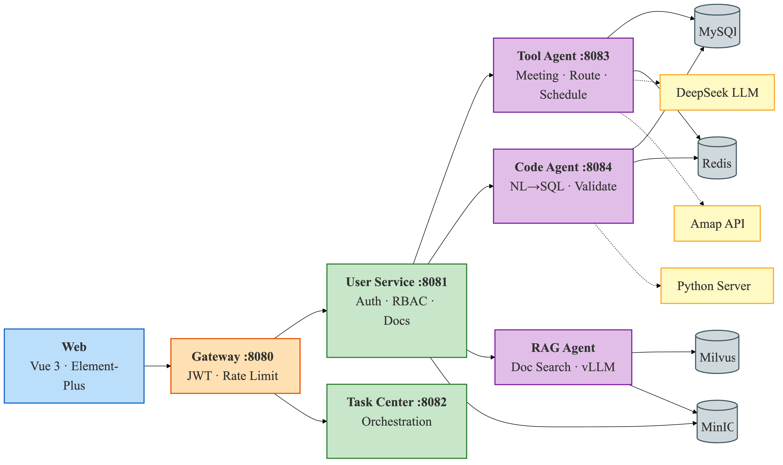
The five layers, from top to bottom, are as follows:
Layer 1 – Web Presentation Layer. This is the front end of the architecture, using Vue 3 SPA, responsible for user interaction, result display (tables/maps/charts), and real-time progress push notifications. It supports Simplified Chinese, Traditional Chinese, and English language switching.
Layer 2 – the gateway layer. As the system's sole entry point, the gateway layer is responsible for request routing and identity verification. Confidentiality is paramount in banking systems; requests not on the whitelist must be verified using JWT. Upon successful verification, the user's identity and permissions information are extracted and passed to downstream services.
Layer 3 – Business Service Layer. This layer includes user services and a task center. User services handle registration and login, JWT issuance, and role-based access control; the task center handles cross-agent request scheduling and status management.
Layer 4 – AI Service Layer. The AI layer deploys three dedicated agents: the Code Agent handles code generation and security verification before SQL execution; the Tool Agent handles enterprise tool requests, using a large model for intent recognition and parameter extraction; and the RAG Agent combines vector retrieval and generation models to provide policy Q&A with cited sources.
The fifth layer – the data layer. This is the lowest layer of the platform. We adhere to the principle of adapting to local conditions, using MySQL as the single data source to persistently store user, permission, organizational structure, document, and meeting room data; Redis is responsible for caching hot data (such as table structure metadata and schedule conflict detection); Milvus 2.3+ is deployed independently to handle document vectorization storage and semantic retrieval, providing the RAG Agent with similarity search capabilities.
The request lifecycle shown in Figure 3 varies significantly depending on the ingress type. We assume all external traffic first flows into the gateway layer. JWT authentication and rate limiting policies are strictly implemented upfront—the legitimacy of the request and the access rate are determined before routing decisions are made (otherwise, network security issues could easily arise). Only traffic that passes through this filtering layer is allowed to proceed downstream.

Figure 3: Data Flow Architecture — End-to-End Request Processing Across System Layers
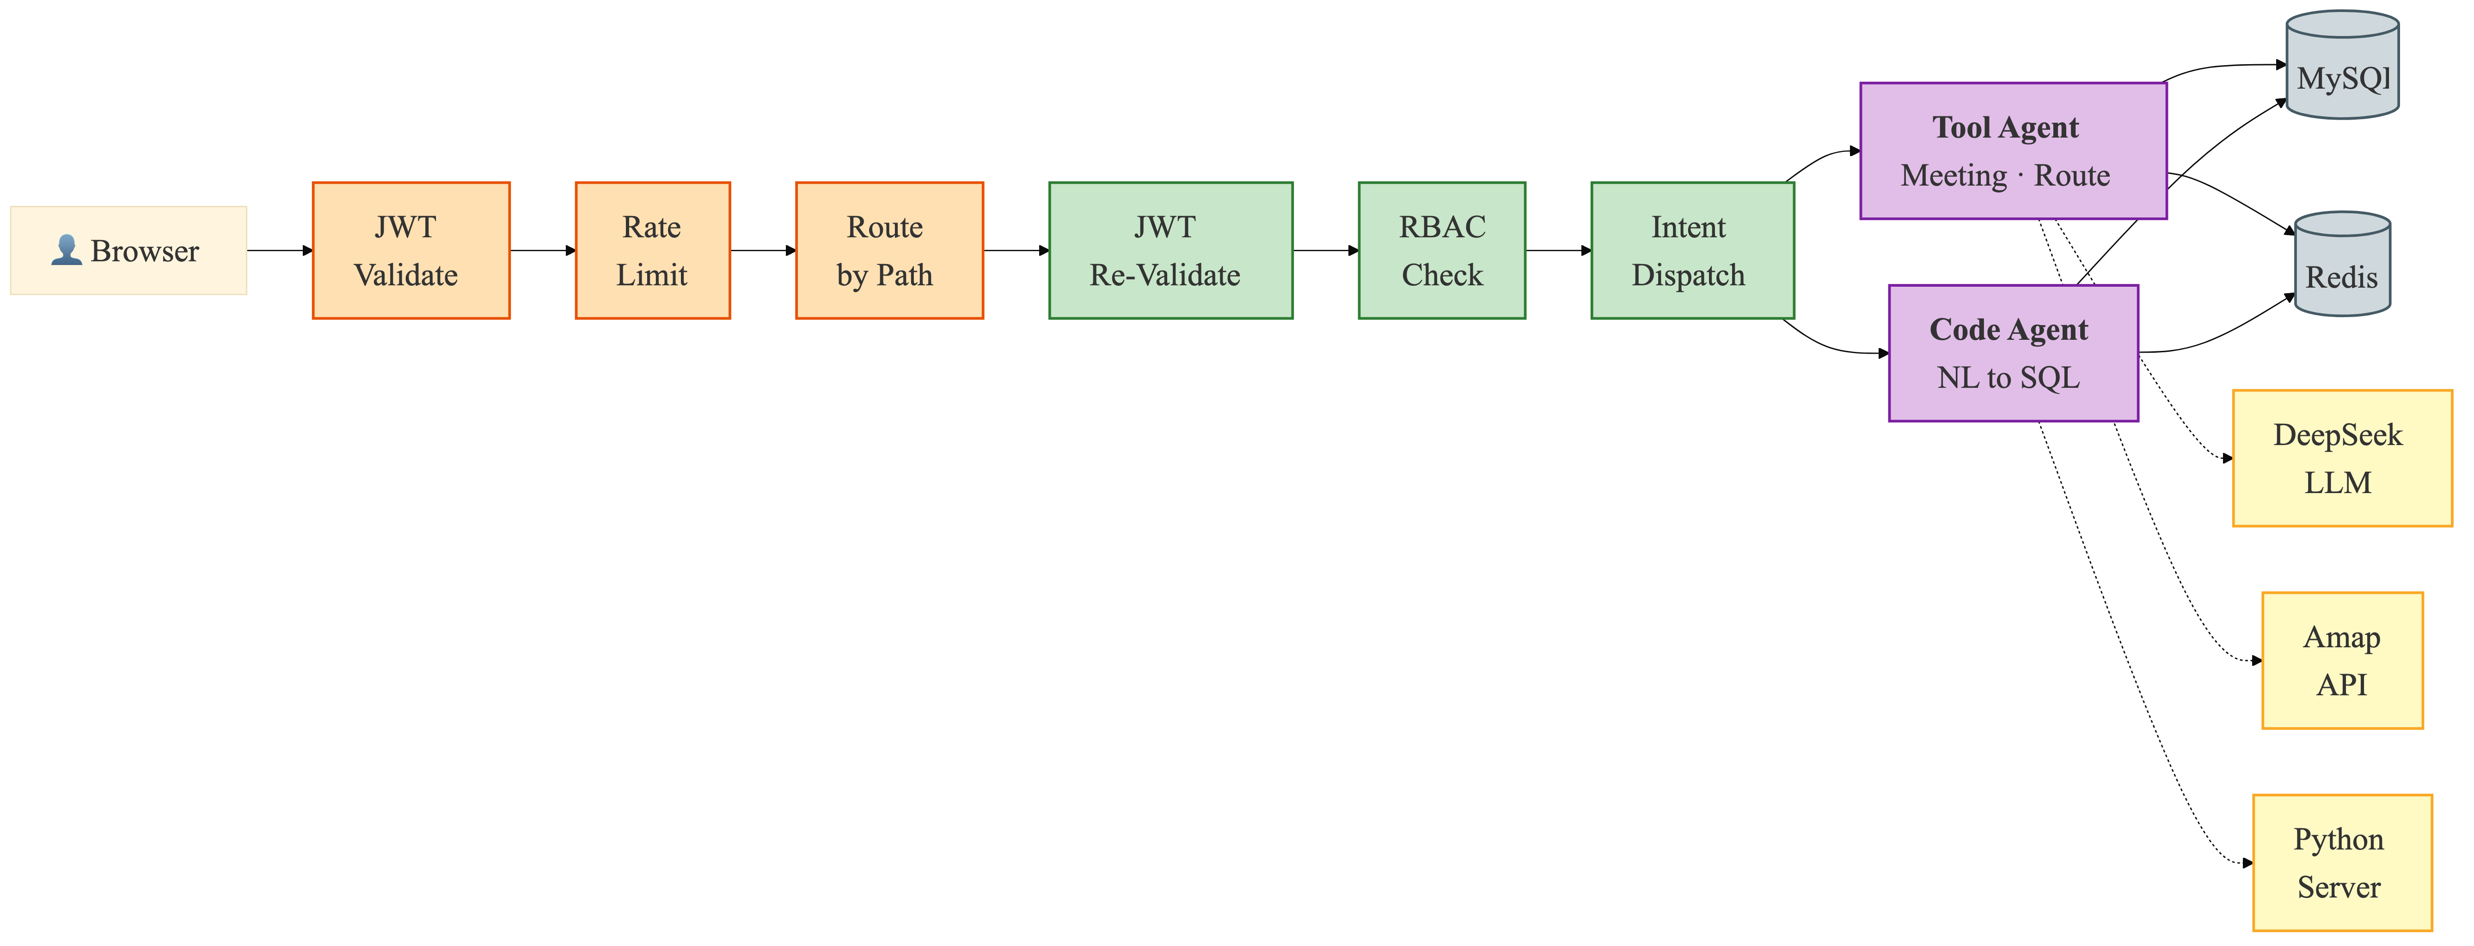

In the Tool agent section, the natural language query (POST /tool/execute) processing path introduces an additional semantic layer. Requests don't directly reach the business logic; instead, they are first sent to DeepSeek for intent "translation"—the model needs to understand whether the user wants to book a meeting room, check a schedule, or plan a route. Only after the intent is clear is the request routed to the corresponding domain module. Meanwhile, the code generation path (POST /code/query) follows a completely different pipeline. The service layer delegates the task to the backend Python inference server. After the SQL is returned, it undergoes a five-layer security check before the Jdbc Template is finally allowed to execute into the database. This link is significantly longer and more likely to become a bottleneck.
The asynchronous task state synchronization mechanism differs from the conventional front-end polling mode. This platform relies on the Web Socket long connection maintained by the gateway proxy to actively push the proxy execution progress to the client, thereby achieving real-time visualization without increasing the request frequency (which will hardly generate any additional latency).

4.2 Frontend Architecture
This project's front-end is based on Vue 3 technology stack, and actual development utilized Composition API and TypeScript. The motivation for introducing TypeScript was straightforward: we wanted to catch type errors during compilation phase, reducing runtime exceptions caused by type mismatches. The logic reuse mechanism provided by Composition API was used simultaneously in Tool, Code, RAG interfaces, and management backend—the same set of interaction logic did not need to be implemented repeatedly, thus significantly reducing maintenance cost. We believe that terminal devices used in banking environment is quite complex (desktops, laptops, tablets, and mobile phones are all used, meaning that responsive layout is not an added feature, but a fundamental constraint that must be met.
Route management is handled uniformly by Vue Router, divided into public routes and authenticated routes based on access permissions. Navigation guards intercept requests before route switching, preventing unauthorized requests from entering protected pages. AuthLayout handles the login and registration pages, featuring a slide-in animation during page transitions. MainLayout is the main framework after authentication, with a left sidebar that supports both expanded and collapsed states. When expanded, its 230 pixels wide, and when collapsed, its only 56pixels wide, just enough to accommodate a function icon. The main framework is divided into three areas: agent services (tools, code, RAG) for regular users, a management panel accessible only to ROLE_ADMIN, and system settings. Language switching supports Simplified Chinese, Traditional Chinese, and English(meeting the requirements of Hong Kong banks) .Unread message counts is obtained by polling the /user/notification/unread-count interface every 10 seconds and displayed as badges. The user avatar dropdown menu includes a personal information entry and a logout function.
For state management, we chose Pinia and split it into two Store based on their responsibilities. The userStore is responsible for maintaining login state. JWT tokens is persistently stored in localStorage. userInfo records user roles, permissions, departments, and security levels. External call layers interact with it through the login, logout, and getUserInfo methods. The taskStore tracks the agent task lifecycle. The Task structure includes fields for id, type (code/rag/tool), status (pending/running/completed/failed), progress (0–100), result, and createTime. Status changes are handled through addTask and updateTask.
HTTP requests are uniformly encapsulated in utils/request.ts. The Axios instance is pre-configured with basic URLs and interceptors. Server-side response are uniformly packaged into a Result structure with the fields code, msg, and data. This structure is convenient for front-end response processing. WebSocket communication is handled within utils/websocket.ts, using the wsClient singleton pattern to manage the connection lifecycle. It automatically reconnects after a connection interruption, attempting a maximum of 3 times with a 2-second interval (otherwise, interaction latency would increase. Messages are handled according to four event categories: open, message, close, and error.
Map rendering is handled by the MapContainer.vue component. This component dynamically injects the Amap JS API v2.0, carrying the API key and security code. The map expands from the starting coordinates, with the route drawn as an indigo (#4f46e5) polyline, 6 pixel wide. Custom icons in green and red are used for the start and end points respectively (we've compared them, and color differences improve visibility). The easeOutQuad easing function is used for navigation transitions, making highlight transitions smoother. Full-screen loading feedback is implemented by AgentThinking.vue, with a Sparkles icon placed in center of the screen and a carousel displaying the thinking state text below, the content sourced from a configurable array. The progress bar uses a gradient design, and the progress value will never reach 100% during the loading process. It will fill up instantly when the task is actually completed. This detail is to avoid the user feeling that they are "stuck in the last little segment".
Table 1 summarizes the frontend technology stack.
Table 1: Frontend Technology Stack Specifications
Component | Technology | Utility & Responsibility
View Layer | Vue 3 + TypeScript | Composition API with strict type safety
State Management | Pinia | userStore (JWT persistence), taskStore (task lifecycle)
UI Components | Element-Plus | Enterprise forms, tables, dialogs, navigation elements
Visualization | ECharts 5 | Rendering of data charts and SQL execution result analytics
Build Tool | Vite 4 | Sub-second HMR during development, Rollup-based production bundling
HTTP Client | Axios + Interceptors | JWT auto-attach, 401 auto-logout, unified error handling
Real-Time | WebSocket Client | Singleton with auto-reconnect (3 attempts, 2s delay)
Internationalization | Vue I18n | zh-CN, zh-TW, en locales with Element Plus sync
Map Visualization | Amap JS API v2.0 | Dynamic SDK loading, route polyline, custom markers

4.3 Backend Microservice Architecture
The backend consists of independent Spring Boot micro service, each handling a specific business capability and communicating through the Gateway layer. This decomposition allows independent development, testing, deployment, and scaling of each service, while the Gateway provides a single API entry point for the frontend.
Gateway Service (port 8080). Built on Spring Cloud Gateway 3.1.9, this service provides dynamic routing based on URL path predicates. The JwtAuthGlobalFilter (a GlobalFilter with order=-100)validates JWT tokens on all non whitelisted requests using the io.jsonwebtoken library with HMAC-SHA signing. On successful validation, it extracts the username (subject), roles, and permissions from the token claims and forwards them to downstream services through custom headers (X-User-Name, X-User Roles, X-User-Permissions). The SecurityConfig uses reactive Web Flux security with CSRF disabled; authentication is handled by the GlobalFilter rather than Spring Security at the Gateway level.
User Service (port 8081). This is the largest backend service, covering the complete user lifecycle. Spring Security 6.x is configured with stateless session management, CSRF disabled, and a JwtAuthenticationFilter (extending OncePerRequestFilter) that validates the JWT from the Authorization header and populates the SecurityContextHolder for @PreAuthorize enforcement. The service exposes five controller groups: AuthController (login, register, token refresh), UserController (profile, user listing, role assignment), DepartmentController (department membership and clearance management), DocumentController (document access with security clearance), and NotificationController (messaging and escalation requests). The JwtUtil class generates tokens with username, roles, and permissions claims, configurable expiration (default 86400000 ms = 24 hours, through the JWT_EXPIRATION environment variable), and HMAC-SHA signing with a configurable secret (JWT_SECRET environment variable).
Tool Agent Service (port 8083). The most developed AI service, it implements the Tool Agent with two controller groups. The ToolController (/tool/*) exposes 11 endpoints for end-user tool operations including the unified AI execution endpoint, meeting room query and booking, schedule conflict detection, and route planning. The MeetingRoomAdminController and MeetingScheduleAdminController handle administrative CRUD operations. Business logic is organized in service classes (ToolServiceImpl, MeetingRoomServiceImpl, MeetingScheduleServiceImpl) following the Spring service pattern with MyBatis-Plus mappers for database access.
Code Agent Service (port 8084). Implements the NL2SQL pipeline. The OnnxCodeGenerationService (enabled through the code-agent.onnx.enabled=true property) is the sole CodeGenerationService implementation, using java.net.http.HttpClient to POST natural language questions to a Python LLM inference server at the configured URL (default http://localhost:8090/infer). The service applies a five-stage SQL validation before execution through JdbcTemplate. The MetadataCacheManager triggers initial cache loading on ApplicationReadyEvent and schedules refreshes every 30 minutes through @Scheduled(fixedRate=1800000).
Task Service (port 8082). Currently scaffolded with a basic POM configuration and TaskApplication main class. In the current architecture, task orchestration is distributed between the Gateway (request routing) and the individual agent services; centralized orchestration in this service is planned for a subsequent development iteration.
Table 2 summarizes the backend services.
Table 2: Backend Service Ecosystem and Technical Orchestration
Component | Technology | Utility & Responsibility
Gateway Layer | Spring Cloud Gateway 3.1.9 | Dynamic routing, JWT validation, IP rate limiting, WebSocket proxy
Business Logic | Spring Boot 3.x + MyBatis-Plus | Service orchestration, type-safe CRUD, logical deletion (@TableLogic)
Security Framework | Spring Security 6.x + JWT | Stateless authentication, RBAC with @PreAuthorize, BCrypt password hashing
Caching Layer | Spring Data Redis | Session caching, rate limit counters, metadata cache (code_agent:metadata:tables)
AI Integration (Tool) | DeepSeek API (HTTPS) | Intent routing (MEETING_QUERY/SCHEDULE_CHECK/ROUTE_PLAN), parameter extraction, route translation
Inference Engine | Python FastAPI (port 8090) | LLM-based SQL generation from natural language questions via /infer endpoint
RAG Agent | Spring Boot 3.x (port 8085) | Document Q&A, vector retrieval, source citation, access workflow
Embedding Worker | Python FastAPI (rag-worker) | bge-m3 embedding generation, Markdown chunking
Document Parsing | Apache Tika | Multi-format document parsing for RAG ingestion pipeline
Vector Retrieval | Milvus Java SDK 2.3+ | Semantic ANN search for RAG document retrieval
Object Storage | MinIO | Document file storage (PDF/DOCX/PPT), Milvus backend
Email Service | Resend API | Email verification code delivery, three-tier rate limiting
Map Services | Amap API (HTTPS) | Geocoding (multi-level fallback), direction calculation, polyline coordinate parsing

Data security is paramount in banking systems. Therefore, our platform's security design does not rely on a single line of defense, but rather incorporates defense in depth across all layers. Each layer has independent verification mechanisms, ensuring that even if one layer is breached, the overall system will not be directly compromised.
Figure 4 shows the complete user authentication flow in three stages, including the email verification code mechanism that supports both registration and code-based login.

Figure 4: JWT Authentication and Email Verification Flow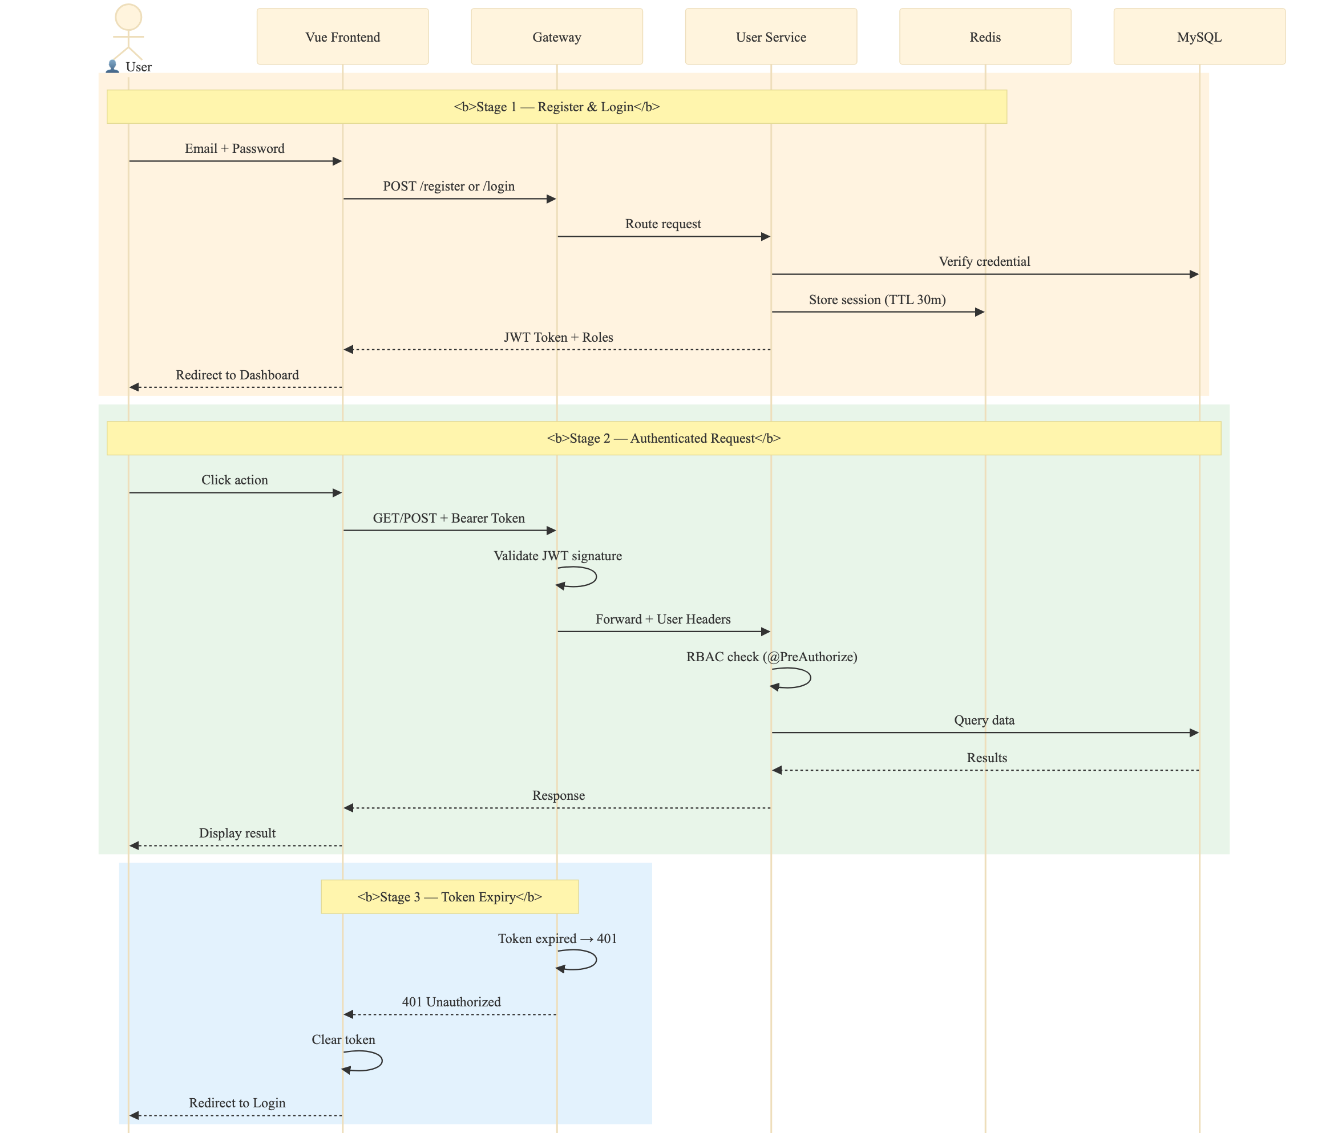
The login process begins with an email verification code. After the user submits their email address on the front end, the request reaches the user service section. The service first checks the 60-second rate limit key for that email address in Redis. If the limit is not exceeded, a 6-digit random code is generated, written to Redis with a 5-minute TTL, and then sent as an HTML email via QQ Mail's SMTP (port 465, SSL encryption). The front end starts a 60-second countdown after successful sending to prevent duplicate requests. This verification infrastructure covers both registration and CAPTCHA login scenarios, avoiding redundant construction.
Specifically, the registration process requires the user to submit their email address, verification code, and password. The backend retrieves the verification code from Redis and compares it. If successful, the password is encrypted using a one-way hash using BCrypt, written to the `sys_user` table, and assigned the `ROLE_USER` role. Login provides a dual-channel approach: password mode compare the BCrypt hash value; CAPTCHA mode directly verifies the 6-digit code in Redis. If either of the two modes passes, the system reads the user's roles and permissions, issues a JWT valid for 24 hours using HMAC-SHA256, and store the active session in Redis in the form of session:active:{username} (default 30-minute TTL). Finally, the token and basic user information are returned to the frontend.
In subsequent requests, the frontend automatically appends a Bearer Token via an Axios interceptor. the gateway layer's JwtAuthGlobalFilter is responsible for signature verification, checking the validity period, and confirming the session's validity in Redis. Once confirmed, it writes the username, roles, and permissions into the X-User-Name, X-User-Roles, and X-User-Permissions request headers respectively, and then forwards the request to downstream microservice. Each microservice independently performs a second signature verification upon receiving the request, populating the parsed roles and permissions into the SecurityContextHolder, thus supporting method-level @PreAuthorize annotation control. It's worth noting that we've implemented a usage expiration period: each normal request triggers a sliding renewal of the Redis session (except for message polling), preventing users from being suddenly kicked out during use. If the token is invalid or expired, the gateway directly returns a 401 error, the frontend clear the local session, and redirects to the login page.
The CAPTCHA itself is also heavily reinforced: the 6-digit random number only lasts for 5 minutes and is immediately deleted from Redis after successful verification, ensuring single-use semantics; a 60-second rate limit effectively suppresses brute-force enumeration and email bombing; our CAPTCHAs are never stored in the database, and no query interfaces are exposed. Communication with the mail server uses SSL encryption to reduce the risk of man-in-the-middle attacks.
We adopted RBAC for our permission design, but only implemented a coarse-grained division of roles into three tiers—this "coarseness" was intentional. Different banks have vastly different organizational structures, and overly granular role division would be difficult to adapt to. Therefore, we decided to first build an extensible framework and then refine it according to specific organizations. ROLE_ADMIN corresponds to the system administrator, the highest-level account on the entire platform (corresponding to bank executives). Almost all management endpoints are open to them: user and role lifecycle management, department creation and maintenance, allocation of operational resources such as meeting rooms and schedules, and configuration of global parameters. ROLE_DEPT_ADMIN is positioned at the department level (corresponding to bank department managers). Their permissions are consciously narrowed, only covering member management and document maintenance within their own department. Operations such as viewing department members, adding or removing personnel, and browsing users not yet assigned to departments is encapsulated in DeptAdminController for them to call, but cross-departmental data is invisible to them—this isolation is implemented directly at the data query layer. ROLE_USER is geared towards ordinary end-users (or general employees), with permissions leaning more towards "usage" than "management." Its main system interface consists of daily operations of the tool's intelligent agent (meeting room booking, schedule lookup, route planning), Q&A interactions between the code and the RAG intelligent agent, access to confidential and anonymized documents, and a personal message center.
Table 3: Pseudocode — listDocumentsForUser() Multi-Factor Document Access Rule
- FUNCTION listDocumentsForUser(userId, userDeptId, userClearance)
- documents = queryAllDocuments()
- result = []
- FOR EACH doc IN documents:
- // Multi-factor access rule: a document is visible if...
- IF doc.dept_id IS NULL THEN
- // Global document — accessible to all users
- doc.accessible = TRUE
- ELSE IF doc.dept_id = userDeptId
- AND doc.security_level ≤ userClearance THEN
- // Same department with sufficient clearance
- doc.accessible = TRUE
- ELSE
- // Access denied — user may submit escalation request
- doc.accessible = FALSE
- doc.escalationType = "RAG_APPLY"
- // Manager can approve (Pending → Approved) or deny (Pending → Denied)
- END IF
- result.add(doc)
- END FOR
- RETURN result
- END FUNCTION
The unified exit point for external communication is the REST API, all using HTTPS, with the TLS version locked at 1.3. WebSocket is forcibly upgraded to WSS in the production environment; this switch is configured directly at the gateway layer, without relying on the front-end code to determine it. Internal calls between our services are actually quite simple—microservices within the Docker bridged network can use regular HTTP. Network isolation already limits the exposure surface, so there's no need to add the overhead of a TLS handshake for internal communication. API keys for external services, such as DeepSeek's model call keys and Gaode's map service keys, are all injected into the containers via environment variables; no sensitive strings are left in the code or image. For data persistence, we enabled logical deletion in MyBatis-Plus, adding the @TableLogic annotation to entity. The deletion operation only changes the status bit, and the record remains in the database. (This is mainly to balance audit traceability and query cleanliness: regular queries will automatically filter out records marked for deletion, active data will not be disturbed, and historical records are always available.)

4.5 Data Layer Architecture
For the data persistence layer, we adopted a multi-engine heterogeneous architecture. The main reason for not using a single database were the significant difference in storage requirements for different types of data: relational records require transactional consistency, vector embeddings require high-dimensional approximate search, and cached data demands extremely high read/write throughput. (Forcing all these loads into a single database would inevitably lead to performance bottlenecks). Of course, a multi-engine architecture also means more effort from the operations team, but we considered this a worthwhile trade-off.
All relational data resides on MySQL 8.0. We agreed on the database name agent_platform, character set utf8mb4, and collation utf8mb4_unicode_ci—while general_ci is more faster, it causes garbled characters for homographs in Chinese, Japanese, and Korean, so we opted for unicode_ci as a precaution. The database ultimately consist of 11 tables, but this is the result after two reconstructions; the first version only had 7, with the permissions section being a later addition.
The user and permission management uses five tables: sys_user stores account information, passwords are hashed using BCrypt, and it's linked to sys_department as foreign key, also recording security level and logical deletion status; sys_role predefines three system roles; sys_permission defines six fine-grained permissions; and sys_user_role and sys_role_permission separate the many-to-many relationships. The organizational structure uses only one table, sys_department, containing basic information for all six departments. The knowledge management domain uses two tables: sys_document stores document titles, Markdown text, department, and security level 1-3; sys_notification records message type, status, payload, and sender/receiver IDs. Facility management also uses two tables: meeting_room manages meeting room names, floors, capacity, and facility configurations; meeting_schedule associates meeting rooms with room_id and records the booking person, start and end times, and status.
During system initialization, we added a batch of seed data: four meeting rooms, five users with different roles and security levels, six departments, six permissions, a complete role allocation relationship, 11 documents covering three security levels, and three sample notifications corresponding to RAG_APPLY, SQL_AUDIT, and BUG_REPORT respectively (this part will be adjusted later according to the specific circumstances of each bank, as each bank's situation is different).
Cache and high-frequency operational data are handled by Redis 5.0+. Session tokens are stored in memory with configurable TTLs; atomic counting also rely on Redis when the gateway layer performs IP-level token bucket rate limiting. Additionally, the database metadata—that is, the JSON serialized TableMetadata object—is cached with the key code_agent:metadata:tables, with a TTL of 3600 seconds, refreshed every 30 minutes by a scheduled task, representing a trade-off between performance and freshness.
Redis is also used for the tool's intelligent agent's schedule conflict detection. The key format is tool:schedule:{userId. We store the meeting timestamps as scores using an ordered set. For overlapping queries, we use ZRANGEBYSCORE for range queries, with a complexity of O(logN), which is much faster than scanning the entire table. A key detail is that we use dual writes for schedule creation. While Redis is fast, it lacks persistence, so MySQL remains the authoritative data source, with Redis only accelerating queries. Cancellation operations are performed synchronously on both sides, ensuring eventual consistency.
Semantic retrieval for RAG agents requires vector support, so we separately introduced Milvus 2.3+. During the selection process, we considered several vector engines, and Milvus, with its relatively mature distributed scaling and native vector support, aligned well with our expectations. After document slicing, the bge-small-zh model encodes the data into high-dimensional floating-point vectors, which are then written to the Milvus collection. We chose IVF_FLAT for the index—while it slightly reduces precision compared to brute-force search, the improvement in query speed is considerable. Combined with partition-based ANN retrieval, latency and recall are generally within acceptable ranges. The embedding dimension follows the model configuration and requires no additional adjustment.
Going forward, we plan to add a security post-filter to the RAG retrieval pipeline. The raw vector results returned by Milvus will not be directly passed through; instead, they will be secondarily filtered based on the user's department and security level. This way, the access control model used in relational documents can be directly reused for vector retrieval, eliminating the need for a separate permission system.
Table 4 summarizes the data storage strategy.
Table 4: Multi-Modal Data Storage Strategy and Layered Access Patterns
Category | Engine | Primary Data Types | Access Pattern
Operational Layer | MySQL 8.0 | Users, roles, departments, documents, meeting rooms, schedules, notifications | Transactional, ACID-compliant read/write
Caching Layer | Redis 5.0+ | Session tokens, rate limit counters, metadata cache (hash), schedule conflicts (sorted sets) | High-concurrency, sub-millisecond reads
Object Storage | MinIO | PDF, DOCX, PPT files; Milvus backend objects | Document upload/download, RAG source document storage
Vector Layer | Milvus 2.3+ | Document chunk embeddings (bge-small-zh), source metadata | Semantic approximate nearest neighbor search

4.6 Technology Stack Rationale
After discussion, the technology stack of our system was determined based on four main principles: First, it should be able to be deployed locally to reduce reliance on external cloud services (because banking systems have strong requirements for data security); second, it should be validated in a production environment and have an active community to ensure compatibility and ease of use; third, it should match the team's existing Java and Python technical skills; and finally, it should support routine business operations (user management, meeting room booking, document storage) as well as meet the needs of the times and handle AI-related computationally intensive tasks (such as large model inference, vector retrieval, and map API integration）
Specifically, the system's backend framework uses Java + Spring Boot. This choice was primarily based on its mature enterprise-level ecosystem. A strong typing system effectively reduces implicit errors at the interface level in multi-user collaborations; MyBatis-Plus provide type-safe CRUD encapsulation, logical deletion, and automatic camelCase mapping, reducing boilerplate code in the data access layer. Spring Security, combined with `@PreAuthorize`, allows method-level access control to be declaratively embedded in business code, eliminating the need for manual validation in each interface.
Our gateway is Spring Cloud Gateway, rather than a traditional Servlet solution. (One issue with Servlets is that containers default to a blocking "one thread, one request" model. As the gateway acts as the traffic entry point, the number of concurrent connections is far higher than that of ordinary business services, causing the thread pool to expand rapidly.) Spring Cloud Gateway, on the other hand, is a reactive architecture based on Project Reactor and Netty, offering higher concurrency throughput in routing, forwarding, and filtering chain processing, while also having low integration costs with the Spring ecosystem.
The AI inference service ultimately chose Python + FastAPI, deployed on port 8090. Python's dominant position in the machine learning toolchain is unlikely to be replaced in the short term (compared to Java, which we also use), and FastAPI's native asynchronous support and automatically generated OpenAPI documentation also reduce the workload of interface maintenance. The intent routing for the tool agent is handled by the DeepSeek API, which calls maas-api.cn-huabei-1.xf-yun.com/v2 via HTTPS. The model version is xopdeepseekv32. Its JSON output format, deterministic performance at low temperatures (0.3), and ability to understand Chinese semantics basically meet the accuracy requirements for intent classification.
We settled on Vue 3 with TypeScript after weighing several options. While the team’s front-end skill levels were uneven, Vue 3’s learning curve proved less steep than alternatives, which mattered given our tight timeline. The Composition API, in particular, gave us the flexibility we needed: the tool agent’s chat interface, the code agent’s SQL preview panel, and the RAG agent’s Q&A flow each carried distinct state requirements, and Vue’s reactivity model handled these without excessive boilerplate. For i18n, Vue I18n covered Simplified Chinese, Traditional Chinese, and English（three variants that a Hong Kong banking platform realistically needs).
Containerization via Docker and Docker Compose was our choice for environment parity. MySQL, Redis, and Milvus all run as containers, which eliminates the "it works on my machine" problem. The Java services use multi-stage builds: Maven compiles and packages the application, and we ship a slim JRE-based runtime image. The resulting image size is smaller than a full JDK deployment, which helps during CI/CD transfers.

Chapter 5: Core Agent Implementation
This chapter covers the three agent modules that form the platform’s intelligence layer—tool agent, code agent, and RAG agent. Each section discusses internal architecture, key algorithms, and data flow, with references to the actual source code where relevant.

5.1 Tool Agent Implementation
This agent runs within a separate tool-agent service (Spring Boot, port 8083), providing three capabilities: meeting room management, schedule conflict detection, and route planning. Technically, business data uses a REST API, time-range queries rely on Redis ordered sets, and natural language interaction utilizes DeepSeek LLM for intent recognition.

5.1.1 Architecture and AI Intent Routing
The tool agent employs a dual-path design at the interaction layer: one side retains programmatic calls, while the other open a natural language entry point.
Programmatic calls use a separate REST endpoint, where the frontend or third-party system directly passes type parameters, making the logic straightforward. Natural language interactions are uniformly routed to `POST /tool/execute`, with the request body being a `ToolRequest` DTO containing `toolType, parameter mappings, and the `naturalLanguage` field. Upon receiving the request, the Service layer dispatches it according to `toolType`: `MEETING_QUERY` go to `handleMeetingQuery()`, `SCHEDULE_CHECK` goes to `handleScheduleCheck()`, `ROUTE_PLAN` goes to `handleRoutePlan()`, and for AI/NLP types, it's handled by `handleAiIntent()` for complete intent understanding.
We separate the natural language entry point from the programmatic entry point, rather than using AI routing for everything, primarily for cost considerations. DeepSeek's token consumption and response latency are not low; if a deterministic operation like "finding a meeting room" also goes through an LLM (Local Language Management) process, the cost-effectiveness would be too low. Therefore, only requests with ambiguous semantics that cannot be directly mapped to a tool type will trigger `handleAiIntent()`.
We ultimately adopted the iFlytek MaaS (Model as a Service) platform, which provide an interface compatible with the OpenAI Chat Completions format. Therefore, the underlying HTTP client can directly reuse the existing OpenAI SDK without additional encapsulation. Of course, if a provider needs to be switched later, simply changing an environment variable will allow switching to the official endpoint or other compatible platforms without modifying the code. (Because this is not currently a mature production environment. If there are future needs, it can be switched to a local LLM based on the bank's requirements, thus eliminating the need to separate the natural language entry point and the programmatic entry point, and the configuration is also very simple.)

Figure 5: Tool Agent Task Sequence — DeepSeek AI Intent Routing to Specialized Handlers
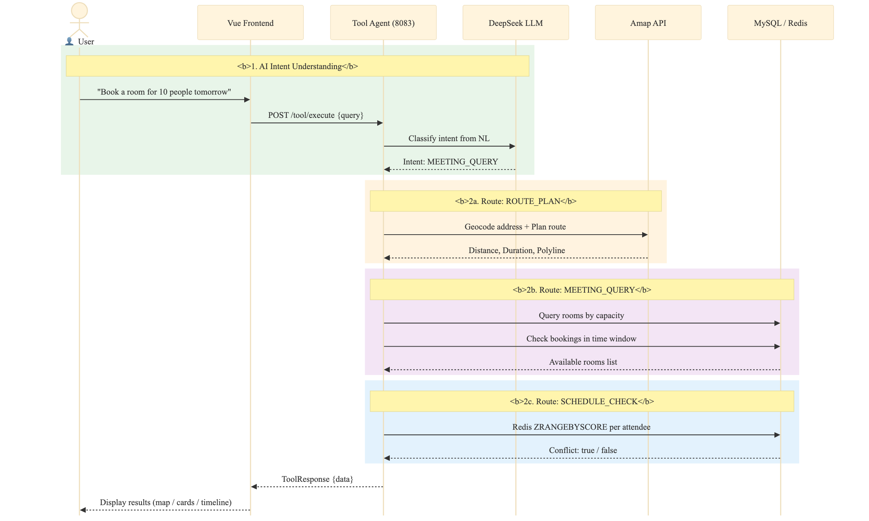
Table 5-6 shows the AI intent routing pipeline where DeepSeek classifies user input into three intent types and dispatches to the corresponding handler, with a mock fallback on API failure.
Table 5: Pseudocode — handleAiIntent() AI Intent Classification and Routing
FUNCTION handleAiIntent(userInput: String): HandlerResult
systemPrompt = PromptBuilder.create()
.defineIntent("ROUTE_PLAN",
params = ["from", "to", "mode"],
description = "Route planning request")
.defineIntent("MEETING_QUERY",
params = ["date", "capacity", "equipment"],
description = "Meeting room search")
.defineIntent("SCHEDULE_CHECK",
params = ["timeRange", "attendees"],
description = "Schedule conflict detection")
.build()
response = deepSeekService.chat(
system = systemPrompt,
user = userInput,
format = "json_object",
temp = 0.3,
maxTok = 2048
)
intent = response.intentType
params = response.parameters
SWITCH intent:
CASE "ROUTE_PLAN":
RETURN routeHandler.handle(params.from, params.to, params.mode)
CASE "MEETING_QUERY":
RETURN meetingHandler.handle(params.date, params.capacity, params.equipment)
CASE "SCHEDULE_CHECK":
RETURN scheduleHandler.handle(params.timeRange, params.attendees)
DEFAULT:
THROW UnknownIntentException(intent)
END SWITCH
END FUNCTION
Table 6: Pseudocode — DeepSeekService.chat() LLM API Call with Fallback
FUNCTION chat(system, user, format, temperature, maxTokens): DeepSeekResponse
requestBody = {
model: config.deepseek.model,
messages: [
{role: "system", content: system},
{role: "user", content: user}
],
response_format: {type: format},
temperature: temperature,
max_tokens: maxTokens
}
TRY
httpResponse = httpClient.send(
method: POST,
url: config.deepseek.baseUrl + "/chat/completions",
headers: {
"Authorization": "Bearer " + config.deepseek.apiKey,
"Content-Type": "application/json"
},
body: toJSON(requestBody),
timeout: 60s
)
rawJson = httpResponse.choices[0].message.content
parsed = objectMapper.readValue(rawJson, DeepSeekResponse)
RETURN parsed // {intentType, parameters}
CATCH Exception e:
log.error("DeepSeek API call failed", e)
RETURN fallbackMock() // demo data, source = "mock"
END TRY
END FUNCTION
The DeepSeek API configuration in application.yml uses environment variables with development defaults: AI_DEEPSEEK_API_KEY, AI_DEEPSEEK_BASE_URL (defaulting to https://maas-api.cn-huabei-1.xf-yun.com/v2), and AI_DEEPSEEK_MODEL (defaulting to xopdeepseekv32). A timeout of 6000 ms is set. The API key and base URL point to the Xunfei MaaS (Model as a Service) platform, which provides OpenAI-compatible chat completions API access to the DeepSeek model family. This design let the Tool Agent use LLM capabilities for natural language understanding while supporting alternative LLM providers through configuration changes.

5.1.2 Meeting Room Management
For meeting room management, due to varying user permissions, we designed two sets of interfaces base on user permissions and functions:
The first set is for regular users. Regular users has a simple request: "Check if there are any available rooms for this time slot." Therefore, our ToolController only includes a single GET request: /tool/meeting-rooms. The parameters are simplified: startTime and endTime are optional; if not specified, the default time are the current time up to two hours later—this range was determined based on actual usage and covers most scenarios of finding meeting rooms on short notice, saving the front-end from having to construct complete timestamps every time. The time format is standardized as yyyy-MM-dd HH:mm:ss, directly bound to LocalDateTime using @DateTimeFormat, avoiding formatting issues when writing a custom parser. The returned results include a list of rooms and their availability status; if a room is already occupied, the next available booking time slot is also included, allowing users to quickly decide whether to wait or find another room.
The second set, the management side, uses a completely different logic (although the system administrator and department administrators maintain consistency). Because the Admin class needs to maintain room metadata, operations such as querying all, creating, modifying, and deleting rooms is handled separately under the AdminController, which enforces the ROLE_ADMIN parameter. The validation rules stipulates that roomName and floor cannot be empty, and capacity must be greater than zero. These validations may seem trivial, but if they aren't strictly enforced here, and the frontend passes in an empty name or a negative capacity, the subsequent booking logic will execute based on this problematic data. The cost of subsequent troubleshooting are far higher than directly intercepting it at the entry point.
Table 7: Pseudocode — queryRoomsWithStatus() Three-Phase Room Availability Algorithm
FUNCTION queryRoomsWithStatus(startTime, endTime, minCapacity): List<Map>
// ═══ Phase 1: Query all active meeting rooms ═══
query = new LambdaQueryWrapper<MeetingRoom>()
.eq(MeetingRoom::status, 1)
IF minCapacity ≠ NULL THEN
query.ge(MeetingRoom::capacity, minCapacity)
END IF
rooms = meetingRoomMapper.selectList(query)

// ═══ Phase 2: Find booked room IDs in time range ═══
overlapping = bookingMapper.selectList(
new LambdaQueryWrapper<MeetingSchedule>()
.lt(MeetingSchedule::startTime, endTime)
.gt(MeetingSchedule::endTime, startTime)
)
bookedRoomIds = {b.roomId | b ∈ overlapping}

// ═══ Phase 3: Assemble availability response ═══
result = []
FOR EACH room IN rooms:
available = room.id ∉ bookedRoomIds
equipment = split(room.facilities, ",")
result.add({
id: toString(room.id),
name: room.roomName,
capacity: room.capacity,
location: room.building + ", Floor " + room.floor,
equipment: equipment,
available: available,
statusText: IF available THEN "Available" ELSE "Booked",
nextBooking: findNextBooking(room.id, startTime)
})
END FOR
RETURN result
END FUNCTION
Table 8: Pseudocode — bookRoom() Atomic Conflict Check-and-Insert
FUNCTION bookRoom(roomId, startTime, endTime, booker, title): Long
// Step 1 — Atomic conflict check
conflicts = scheduleMapper.selectCount(
new LambdaQueryWrapper<MeetingSchedule>()
.eq(MeetingSchedule::roomId, roomId)
.lt(MeetingSchedule::startTime, endTime)
.gt(MeetingSchedule::endTime, startTime)
)
IF conflicts > 0 THEN
RETURN FALSE // room already booked in this window
END IF
// Step 2 — Insert new booking
schedule = new MeetingSchedule()
schedule.roomId = roomId
schedule.startTime = startTime
schedule.endTime = endTime
schedule.booker = booker
schedule.title = title
schedule.status = 1
scheduleMapper.insert(schedule)
RETURN schedule.id
END FUNCTION

FUNCTION getSchedulesForUsers(userIds, startTime, endTime): List<Schedule>
RETURN scheduleMapper.selectList(
new LambdaQueryWrapper<MeetingSchedule>()
.in(MeetingSchedule::booker, userIds)
.ge(MeetingSchedule::startTime, startTime)
.le(MeetingSchedule::endTime, endTime)
)
END FUNCTION
The MeetingRoom entity (@TableName("meeting_room")) maps to the database table with fields: id (Long, @TableId auto-increment), roomName (String), building (String, e.g., "Building A"), floor (String, e.g., "3", stored as VARCHAR to accommodate non-numeric floor identifiers), capacity (Integer), facilities (String, comma-separated list, e.g., "Projector,Whiteboard"), status (Integer, 1=active), createTime, updateTime (LocalDateTime), and deleted (logical deletion flag). Four rooms are seeded: Room 301 (Building A, Floor 3, 10 people, Projector+Whiteboard), Room 302 (Building A, Floor 3, 20 people, Projector+Video Conference), Room 201 (Building A, Floor 2, 8 people, Whiteboard), and Room 501 Large (Building B, Floor 5, 50 people, Projector+Audio+Video Conference).
Table 9 lists the Tool Agent REST API endpoints implemented in ToolController.
Table 9: Tool Agent REST API Endpoints
Method | Endpoint | Key Parameters | Description
POST | /tool/execute | toolType, naturalLanguage, parameters | Unified AI execution — DeepSeek LLM classifies intent and routes to handler
GET | /tool/meeting-rooms | startTime, endTime, capacity | Query rooms with time-based availability status and capacity filter
POST | /tool/meeting-room/book | roomId, booker, startTime, endTime, topic | Atomic check-then-insert room booking with conflict verification
POST | /tool/check-conflict | attendees[], startTime, endTime | Check schedule conflicts by attendee list via Redis ZRANGEBYSCORE
POST | /tool/schedule/create | userId, eventName, startTime, endTime | Create personal schedule (dual-write: MySQL room_id=0 + Redis sorted set)
POST | /tool/schedule/add | userId, eventId, startTime, endTime | Add schedule entry to Redis sorted set only
POST | /tool/schedule/remove | userId, eventId | Remove schedule entry from Redis sorted set by eventId prefix match
GET | /tool/schedules | date, users[] | Query schedules for specified users on a given date from MySQL
GET | /tool/my-schedules | X-User-Name header | Get authenticated user's bookings and personal schedules with room details
DELETE | /tool/my-schedule/{id} | X-User-Name header, path id | Cancel schedule: set status=0 in MySQL, remove from Redis if personal
GET | /tool/route | from, to, mode (default driving) | Plan route via Amap API with multi-level geocoding fallback and map data

5.1.3 Schedule Conflict Detection
Schedule conflict detection uses a dual-layer architecture: MySQL is the persistent store for all schedule data, while Redis serves as a fast query cache for temporal overlap detection. The ScheduleServiceImpl (implementing the ScheduleService interface) handles all Redis operations through a RedisTemplate<String, String> with the key prefix "tool:schedule:".
Figure 6 shows the schedule conflict detection algorithm.
Figure 6: Schedule Conflict Detection — Redis Sorted Set-Based Temporal Overlap Algorithm
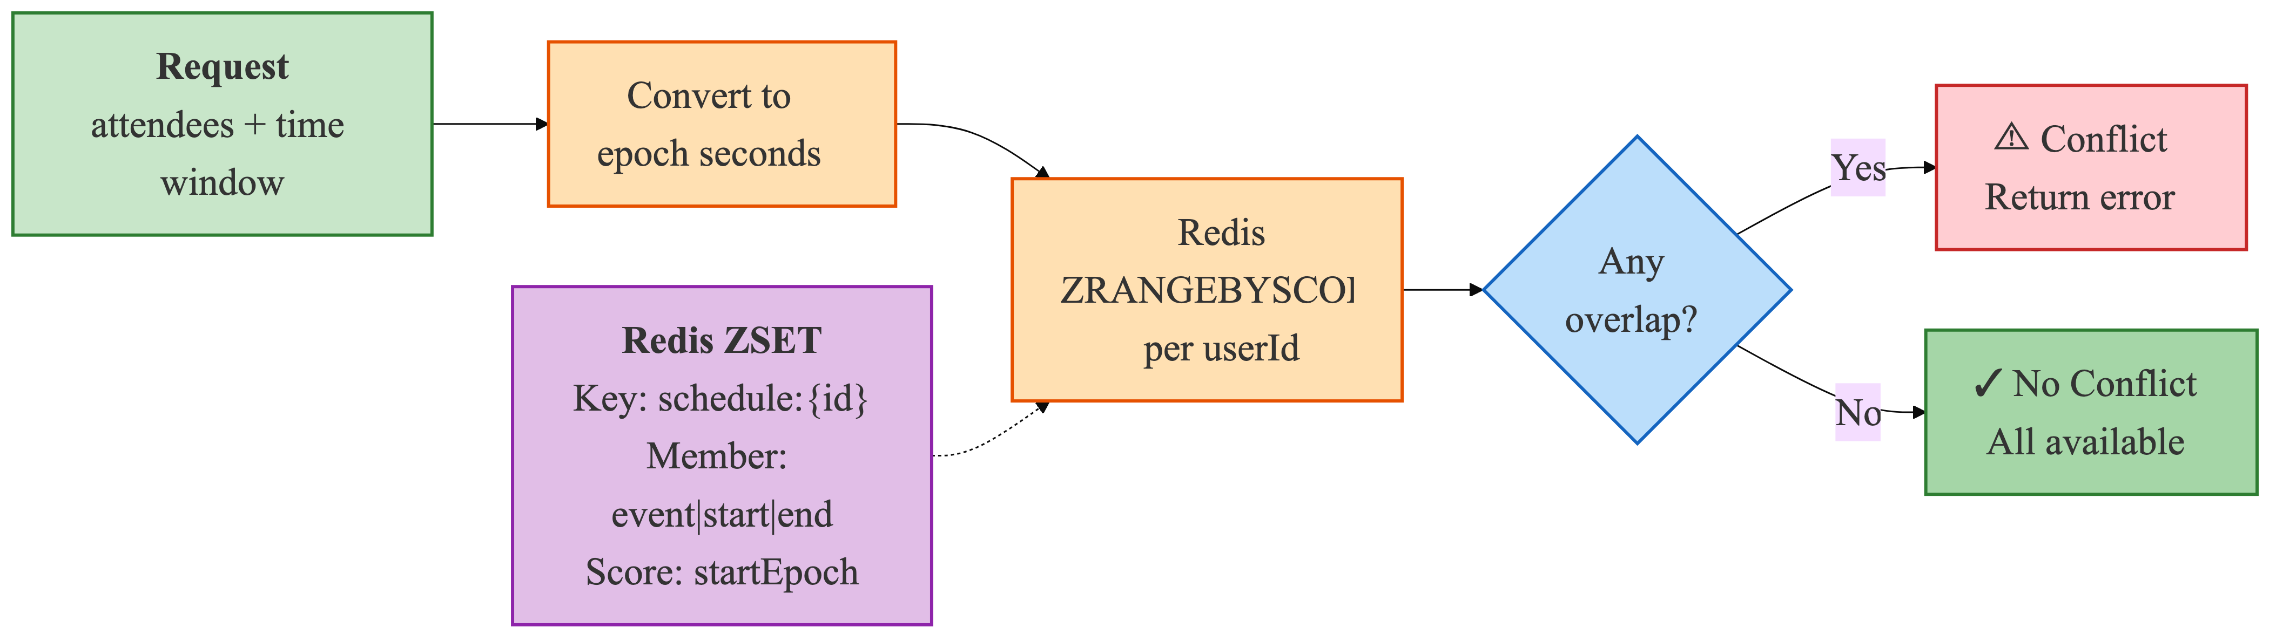
Each user's schedules are stored in a Redis sorted set at key tool:schedule:{userId}. Schedule entries are encoded as members with the format "{eventId}|{startEpoch}|{endEpoch}", where startEpoch and endEpoch are Unix timestamps computed with ZoneOffset.ofHours(8) for the Asia/Shanghai timezone. The member's score is set to startEpoch, which supports range queries. The checkConflict(userId, startTime, endTime) method converts the query time window to epoch seconds and runs ZRANGEBYSCORE on the user's schedule key, retrieving all members whose scores (start times) fall within the query range [startEpoch, endEpoch]. If the returned set is non-empty, a conflict exists and the method returns true. Since entries are scored by their start time, this query identifies all events that begin during the proposed time window.
Table 10–12 shows the schedule management subsystem including Redis sorted-set operations for temporal conflict detection, attendee-based conflict checking, and the MySQL-Redis dual-write consistency pattern.
Table 10: Pseudocode — Redis Sorted Set Schedule Operations (add / remove / checkConflicts)
FUNCTION addSchedule(userId, eventId, startTime, endTime)
key = "tool:schedule:" + userId
startTs = toEpochMillis(startTime)
endTs = toEpochMillis(endTime)
member = eventId + ":" + startTs + ":" + endTs
redisTemplate.opsForZSet().add(key, member, startTs)
END FUNCTION

FUNCTION removeSchedule(userId, eventId)
key = "tool:schedule:" + userId
members = redisTemplate.opsForZSet().range(key, 0, -1)
FOR EACH member IN members:
IF member.startsWith(eventId + ":") THEN
redisTemplate.opsForZSet().remove(key, member)
BREAK
END IF
END FOR
END FUNCTION

FUNCTION checkConflicts(userId, startTime, endTime): List<String>
key = "tool:schedule:" + userId
startTs = toEpochMillis(startTime)
endTs = toEpochMillis(endTime)
// Query schedules whose start time falls within window
overlapping = redisTemplate.opsForZSet()
.rangeByScore(key, startTs, endTs)
conflicts = []
FOR EACH member IN overlapping:
[evtId, memStartTs, memEndTs] = split(member, ":")
IF parseLong(memStartTs) < endTs THEN
conflicts.add(evtId)
END IF
END FOR
RETURN conflicts
END FUNCTION

Table 11: Pseudocode — POST /tool/check-conflict Attendee-Based Conflict Workflow
ENDPOINT POST /tool/check-conflict
Request: {attendees: String[], startTime: String, endTime: String}
Response: {hasConflict: Boolean, conflictUser: String?}

FUNCTION checkConflict(attendees, startTime, endTime): ConflictResult
FOR EACH userId IN attendees:
conflicts = scheduleService.checkConflicts(userId, startTime, endTime)
IF conflicts IS NOT EMPTY THEN
// Early exit — return first conflict found
RETURN {
hasConflict: TRUE,
conflictUser: userId,
conflicts: conflicts
}
END IF
END FOR
RETURN {hasConflict: FALSE, conflictUser: NULL}
END FUNCTION
Table 12: Pseudocode — Schedule Dual-Write Pattern (MySQL + Redis Consistency)
// ═══ Schedule Creation (dual-write) ═══
ENDPOINT POST /tool/schedule/create
FUNCTION createSchedule(request): ScheduleResponse
// Write 1 — Persist to MySQL
schedule = meetingRoomService.addPersonalSchedule({
roomId: 0, // personal schedule convention
booker: request.booker,
startTime: request.startTime,
endTime: request.endTime,
title: request.title,
status: 1
})
// Write 2 — Cache to Redis for fast conflict queries
eventId = "event_" + schedule.id
scheduleService.addSchedule(request.booker, eventId,
request.startTime, request.endTime)
RETURN {scheduleId: schedule.id, eventId: eventId}
END FUNCTION

// ═══ Schedule Cancellation (dual-delete) ═══
ENDPOINT POST /tool/schedule/cancel
FUNCTION cancelSchedule(scheduleId): void
// Step 1 — Soft delete from MySQL (preserves audit trail)
scheduleMapper.update(null,
new LambdaUpdateWrapper<MeetingSchedule>()
.eq(MeetingSchedule::id, scheduleId)
.set(MeetingSchedule::status, 0)
.set(MeetingSchedule::updateTime, now())
)
// Step 2 — Remove from Redis cache
scheduleService.removeSchedule(currentUser, "event_" + scheduleId)
END FUNCTION

5.1.4 Route Planning
The route planning feature integrates the Amap Open API through the AmapService class, which provides geocoding, route calculation, and map data for visualization. The GET /tool/route endpoint accepts from, to, and mode (default "driving") query parameters, and returns a route result that includes formatted distance, duration, traffic status, toll information, step-by-step navigation instructions, and polyline coordinate arrays for map rendering.

Figure 7: Route Planning Map Visualization — Interactive Map with Route Polyline and Navigation Steps
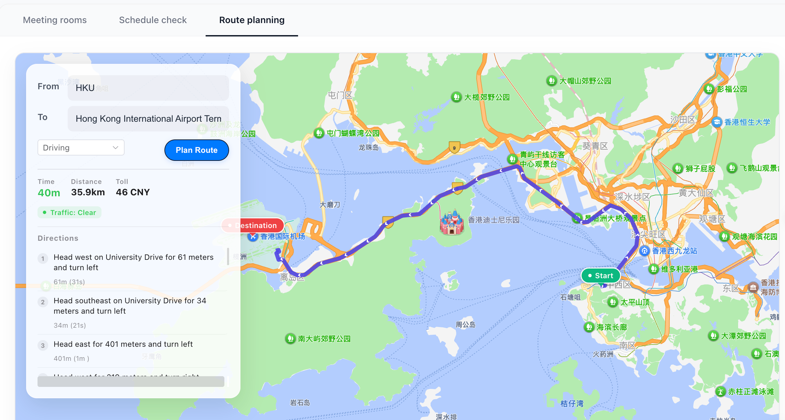
Table 13: Route Planning Three-Stage Geocoding and Navigation Pipeline
Stage | Method | API Endpoint | Input | Output | Fallback
1 – Geocoding | geocodeWithFallback() | GET restapi.amap.com/v3/geocode/geo | Address string | Location (lng,lat) | POI text search → Prepend "北京" + retry
2 – Route Calc | planDrivingRoute() | GET restapi.amap.com/v3/direction/driving | Origin + Dest coords, strategy (0–4) | Distance, duration, polyline steps | N/A — returns error to caller
3 – Enrichment | parseRouteResult() | — (local processing) | Amap JSON response | Formatted text + coordinate arrays | N/A — keeps raw values on parse error
Table 14 shows the route geocoding pipeline with a three-level fallback strategy and LLM-based translation of navigation instructions.
Table 14: Pseudocode — geocodeWithFallback() Multi-Level Address Resolution
FUNCTION geocodeWithFallback(address: String): Location
TRY
response = httpGet(restapi.amap.com/v3/geocode/geo,
{key: apiKey, address: URL_ENCODE(address)})
IF response.geocodes IS NOT EMPTY THEN
RETURN parseLocation(response.geocodes[0].location)
END IF
CATCH: // fall through
TRY
// Fallback 1 — POI text search
response = httpGet(restapi.amap.com/v3/place/text,
{key: apiKey, keywords: URL_ENCODE(address), offset: 1})
IF response.pois IS NOT EMPTY THEN
RETURN parseLocation(response.pois[0].location)
END IF
CATCH: // fall through
// Fallback 2 — Prepend "北京" and retry geocoding
RETURN geocodeWithFallback("北京" + address)
END FUNCTION

FUNCTION translateRouteToEnglish(routeData): RouteData
fields = extractChineseFields(routeData) // trafficStatus, toll, steps
TRY
translated = deepSeekService.chat(
system = "Translate to English, keep JSON structure",
user = toJSON(fields),
format = "json_object")
RETURN replaceUnits(translated)
// e.g., "公里" → "km"
CATCH:
RETURN routeData // keep original Chinese
END TRY
END FUNCTION
On the frontend, the MapContainer.vue component loads the Amap JS API v2.0 SDK through script injection with the API key and security code. The component creates a map instance with zoom level 12, centered on the start point or default Hong Kong coordinates [114.137, 22.283]. Route rendering draws an indigo polyline (#4f46e5, 6 px weight) with a custom green "Start" marker and a red "End" marker. If the Amap API is unavailable, the ToolController.planRoute() endpoint catches the exception and returns mock data with estimated distance, duration, and simplified step instructions, so the feature remains usable without external API connectivity.

5.2 Code Agent Implementation
The Code Agent lets users generate executable SQL queries from natural language descriptions, connecting business users' domain expertise with the SQL knowledge needed for direct database interaction. The implementation sends natural language questions to a Python LLM inference server (port 8090) through HTTP, validates the generated SQL through a five-stage validation pipeline, and executes the query. The service runs on port 8084, with endpoints at /code/* routed through the Gateway from /api/code/**.

5.2.1 Architecture Overview
Table 15 shows the four-stage pipeline of Code Agent.
Table 15: Code Agent Four-Stage Natural Language to SQL Pipeline
Stage | Service Class | Key Operation | Security Mechanism
1 – Metadata  Extraction | MetadataCacheService | Query information_schema for table/column definitions;  Cache as JSON in Redis (key: code_agent:metadata:tables) | Provides whitelists (table names, column names)  to the validation layer
2 – SQL  Generation | OnnxCodeGenerationService | HTTP POST {question} → Python LLM inference  server (port 8090); receives {sql, method} | N/A — generation only;  output is untrusted at this stage
3 – SQL  Validation | SqlValidationService | Five-layer defense-in-depth pipeline:  ① operation type ② forbidden keywords  ③ table whitelist ④ column whitelist  ⑤ complexity limits | Blocks: non-SELECT, DDL/DML keywords,  unrecognized tables/columns,  overly complex queries
4 – SQL  Execution | SqlExecutionService | Re-validate (defense in depth) →  execute via JdbcTemplate with PreparedStatement | Parameterized queries prevent injection;  read-only connection enforced
The CodeAgentController exposes six endpoints: POST /code/query (one-shot generate and execute, returns FullResult with SQL, columns, rows, elapsedMs), POST /code/generate (preview only, generates SQL without validation or execution, returns CodeGenerationResponse), POST /code/execute (runs a pre-validated SQL string from the request body, used for HITL-reviewed execution), POST /code/metadata/refresh (triggers an immediate metadata cache refresh, returns the table count and cache status), POST /code/metadata/tables (returns the cached table metadata with column details, useful for debugging), and POST /code/metadata/test-connection (verifies that the Python inference server is reachable at the configured URL). The frontend at /app/code implements a three-step workflow: natural language input with quick template tags, SQL review in a dark-themed code editor with model name and "SELECT only" indicator, and query results display with a data table, execution stats, and CSV export.
Figure 8 shows the Code Agent use case diagram. Business analysts interact with the system by submitting natural language queries through the three-step frontend interface. The system processes requests through the four-stage pipeline, returning formatted query results or validation failure messages. A schema explorer sidebar displays available database tables from the metadata cache, with a "Sync Schema" button to trigger a cache refresh.
Figure 8: Code Agent Use Case Diagram — Natural Language to Safe SQL Execution
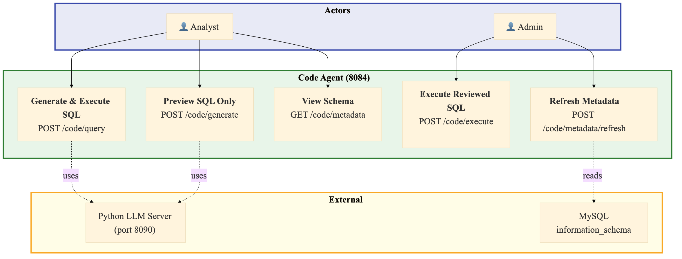
The use case covers schema-aware query generation, five-layer security validation, JdbcTemplate-based execution, and result presentation with export capabilities.

5.2.2 Python LLM Inference Server Integration
Table 16 shows the SQL generation HTTP proxy that forwards natural language questions to the Python LLM inference server and parses the returned SQL.
Table 16: Pseudocode — OnnxCodeGenerationService HTTP Proxy to Python Inference Server
// @Service, @ConditionalOnProperty(code-agent.onnx.enabled=true)
// Acts as HTTP proxy (NOT direct ONNX Runtime inference)
FUNCTION generateSQL(question: String): CodeGenerationResponse
payload = {question: question}
TRY
httpResponse = httpClient.send(
method: POST,
url: config.serverUrl, // default: http://localhost:8090/infer
headers: {"Content-Type": "application/json"},
body: toJSON(payload),
connectTimeout: 10s,
responseTimeout: 60s
)
responseBody = objectMapper.readTree(httpResponse.body)
sql = responseBody.get("sql").asText()
method = responseBody.get("method").asText() // e.g., "LLM" or "T5"
IF sql IS BLANK THEN
RETURN failure("Generated SQL is empty")
END IF
RETURN success(sql, method)
CATCH Exception e:
log.error("SQL generation failed", e)
RETURN failure(e.message)
END TRY
END FUNCTION

// Design note: Any LLM serving framework can back port 8090
// as long as it accepts {question} → returns {sql, method}.
// Reference: Python inference server at data/infer_server.py
// hosts fine-tuned T5 model (data/fine-tuned-t5-banking/).

5.2.3 Five-Layer SQL Whitelist Validation
The SqlValidationService uses a defense-in-depth validation pipeline with five sequential layers, each of which can reject SQL that violates its security rule. The validation is configurable through CodeAgentProperties.WhitelistConfig, so that security administrators can adjust each layer to their requirements.
Figure 9 shows the pipeline from natural language input to safe SQL execution. The five validation layers run in sequence.

Figure 9: SQL Generation and Five-Layer Validation Pipeline
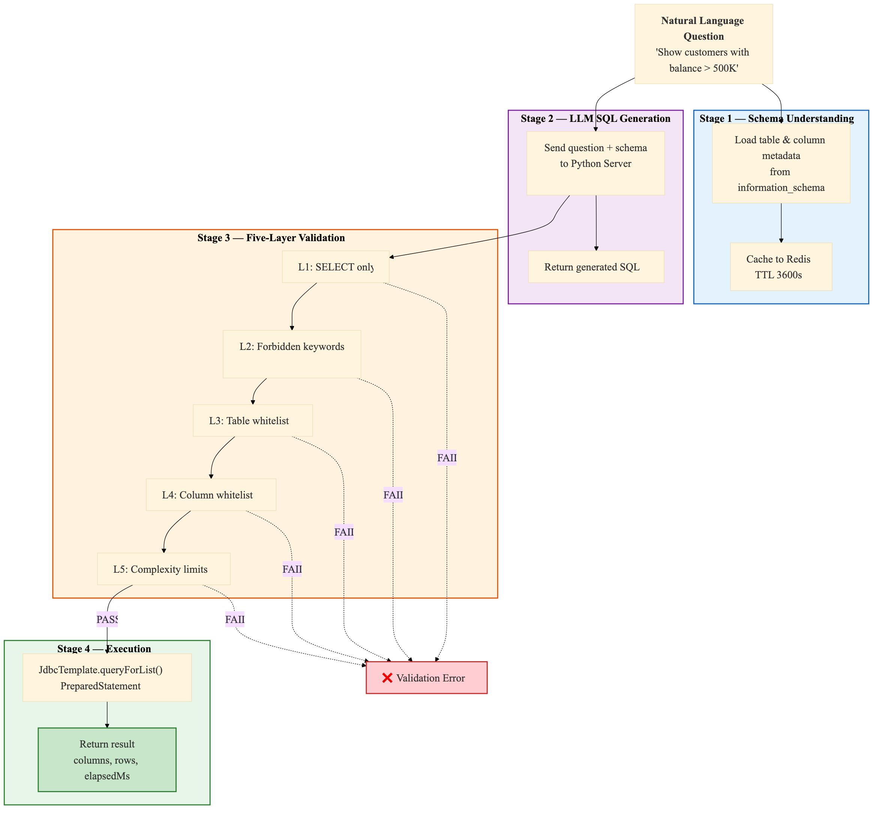
Table 17–21 shows the five-layer SQL whitelist validation pipeline: operation type restriction, forbidden keyword blacklist, table name whitelist, column name whitelist, and query complexity limits.
Table 17: Pseudocode — validateOperation() SQL Operation Type Check (Layer 1)
FUNCTION validateOperation(sql: String): ValidationResult
normalized = collapseWhitespace(sql).trim().uppercase()
allowedOps = config.getAllowedOperations() // default: ["SELECT"]
FOR EACH op IN allowedOps:
IF normalized.startsWith(op) THEN
RETURN PASS
END IF
END FOR
RETURN FAIL("Only SELECT operations are permitted")
END FUNCTION
Table 18: Pseudocode — validateForbiddenKeywords() Keyword Blacklist Scan (Layer 2)
FUNCTION validateForbiddenKeywords(sql: String): ValidationResult
upperSQL = sql.uppercase()
// Default blacklist: DROP, DELETE, INSERT, UPDATE, ALTER,
// TRUNCATE, CREATE, EXEC, EXECUTE, UNION, INTO,
// LOAD_FILE, OUTFILE, DUMPFILE
FOR EACH keyword IN config.getForbiddenKeywords():
pattern = "\\b" + keyword + "\\b" // word-boundary regex
IF pattern IS FOUND IN upperSQL THEN
RETURN FAIL("Forbidden keyword detected: " + keyword)
END IF
END FOR
RETURN PASS
END FUNCTION
Table 19: Pseudocode — validateTableNames() Table Whitelist Verification (Layer 3)
FUNCTION validateTableNames(sql: String): ValidationResult
allowedTables = metadataCacheService.getAllowedTableNames()
IF allowedTables IS EMPTY THEN
log.warn("Metadata cache empty — skipping table whitelist")
RETURN PASS // skip when Redis/metadata unavailable
END IF
// Extract table references from FROM and JOIN clauses
pattern = "\\b(?:FROM|JOIN)\\s+`?(\\w+)" // case-insensitive
extracted = findAllMatches(pattern, sql)
FOR EACH tableName IN extracted:
IF tableName ∉ allowedTables THEN
RETURN FAIL(
"Table not allowed: " + tableName
+ ". Allowed: " + allowedTables)
END IF
END FOR
RETURN PASS
END FUNCTION
Table 20: Pseudocode — validateColumnNames() Column Whitelist Verification (Layer 4)
FUNCTION validateColumnNames(sql: String): ValidationResult
// Skip for SELECT * or SELECT COUNT(*) queries
IF sql CONTAINS "SELECT *" OR sql CONTAINS "SELECT COUNT(*)" THEN
RETURN PASS
END IF
allowedColumns = metadataCacheService.getAllowedColumns()
IF allowedColumns IS EMPTY THEN
log.warn("Metadata cache empty — skipping column whitelist")
RETURN PASS // skip when metadata unavailable
END IF
// Extract column spec between SELECT and FROM
match = regex("SELECT\\s+(.+?)\\s+FROM", sql, CASE_INSENSITIVE)
IF match NOT FOUND THEN
RETURN PASS // cannot parse, allow through
END IF
columnsPart = match.group(1)
FOR EACH colSpec IN split(columnsPart, ","):
colRef = extractColumnReference(colSpec)
// Support both table.column and bare column
IF colRef IS qualified (t.col) THEN
IF colRef ∉ allowedColumns[colRef.table] THEN
RETURN FAIL("Column not allowed: " + colRef)
END IF
ELSE
found = ANY table IN allowedColumns
WHERE colRef ∈ allowedColumns[table]
IF NOT found THEN
RETURN FAIL("Column not allowed: " + colRef)
END IF
END IF
END FOR
RETURN PASS
END FUNCTION
Table 21: Pseudocode — validateComplexity() Query Complexity Limits (Layer 5)
FUNCTION validateComplexity(sql: String): ValidationResult
// Count table references
tableCount = countMatches("\\b(?:FROM|JOIN)\\s+`?(\\w+)", sql)
maxTables = config.getMaxTablesPerQuery() // default: 3
IF tableCount > maxTables THEN
RETURN FAIL(
"Too many tables: " + tableCount + " (max: " + maxTables + ")")
END IF
// Count conditions (AND/OR + 1 for base condition)
conditionCount = 1
+ countMatches("\\bAND\\b", sql)
+ countMatches("\\bOR\\b", sql)
maxConditions = config.getMaxConditions() // default: 10
IF conditionCount > maxConditions THEN
RETURN FAIL(
"Too many conditions: " + conditionCount + " (max: " + maxConditions + ")")
END IF
RETURN PASS
END FUNCTION
Table 22 summarizes the five validation layers with their default configurations.
Table 22: SQL Whitelist Validation Rules (Five-Layer Defense)
Layer | Check | Default Configuration | Action on Violation
1. Operation | SQL must start with allowed operation | ["SELECT"] only | Block execution, return error with permitted operations
2. Keywords | Word-boundary regex blacklist scan | DROP, DELETE, INSERT, UPDATE, ALTER, TRUNCATE, CREATE, EXEC, EXECUTE, UNION, INTO, LOAD_FILE, OUTFILE, DUMPFILE | Block execution, identify forbidden keyword
3. Table Names | FROM/JOIN tables vs. information_schema | All BASE TABLEs in agent_platform database | Block execution, show allowed table set
4. Column Names | SELECT columns vs. table column definitions | Per referenced table from metadata cache; skip on empty cache | Block execution, identify invalid column
5. Complexity | Table count + condition count | Max 3 tables, max 10 conditions (AND/OR count + 1) | Block execution, show actual vs. max counts

5.2.4 Metadata Caching and Execution
Table 23–25 shows the schema metadata cache loading from information_schema to Redis, the cache lifecycle management with scheduled refresh, and thedefense-in-depth SQL execution flow.
Table 23: Pseudocode — refreshAllMetadata() Schema Metadata Cache Loading
FUNCTION refreshAllMetadata(): Map<String, TableMetadata>
conn = dataSource.getConnection()
database = config.getDatabaseName()
// Query 1 — All BASE TABLE names
tables = conn.query(
"SELECT TABLE_NAME FROM information_schema.TABLES
WHERE TABLE_SCHEMA = ? AND TABLE_TYPE = 'BASE TABLE'",
database)
metadataMap = {}
FOR EACH tableName IN tables:
// Query 2 — Column metadata
columns = conn.query(
"SELECT COLUMN_NAME, DATA_TYPE, IS_NULLABLE,
COLUMN_COMMENT, COLUMN_KEY
FROM information_schema.COLUMNS
WHERE TABLE_SCHEMA = ? AND TABLE_NAME = ?
ORDER BY ORDINAL_POSITION",
database, tableName)
// Query 3 — Table comment
comment = conn.querySingle(
"SELECT TABLE_COMMENT FROM information_schema.TABLES
WHERE TABLE_SCHEMA = ? AND TABLE_NAME = ?",
database, tableName)
metadataMap[tableName] = {
columns: columns,
comment: comment
}
END FOR
conn.close()
// Serialize and cache to Redis
json = objectMapper.writeValueAsString(metadataMap)
redisTemplate.opsForHash().put(
"code_agent:metadata", "tables", json)
redisTemplate.expire(
"code_agent:metadata", config.getCacheTtl()) // default: 3600s
RETURN metadataMap
END FUNCTION

Table 24: Pseudocode — MetadataCacheManager Cache Lifecycle Management
// @Component — manages metadata cache lifecycle

// ═══ Startup — initial cache load ═══
@EventListener(ApplicationReadyEvent)
FUNCTION onApplicationReady():
TRY
metadataCacheService.refreshAllMetadata()
log.info("Metadata cache loaded successfully")
CATCH Exception e:
log.warn("Database not ready. Manually refresh via:")
log.warn(" POST /api/code/metadata/refresh")
END TRY
END FUNCTION

// ═══ Periodic refresh — every 30 minutes ═══
@Scheduled(fixedRate = 1800000)
FUNCTION scheduledRefresh():
TRY
metadataCacheService.refreshAllMetadata()
CATCH Exception e:
log.error("Scheduled metadata refresh failed", e)
END TRY
END FUNCTION

// ═══ Fallback — direct query when Redis unavailable ═══
FUNCTION getAllTableMetadata(): Map<String, TableMetadata>
TRY
cached = redisTemplate.opsForHash()
.get("code_agent:metadata", "tables")
IF cached NOT NULL THEN
RETURN deserializeJSON(cached)
END IF
CATCH: // Redis unavailable — fall through
// Direct DB query as fallback
RETURN refreshAllMetadata()
END FUNCTION

Table 25: Pseudocode — SqlExecutionService Defense-in-Depth SQL Execution
FUNCTION execute(sql: String): QueryResult
// Defense in depth — re-validate even if called from trusted pipeline
validation = sqlValidationService.validate(sql)
IF validation IS NOT PASS THEN
RETURN failure(validation.errorMessage)
END IF
// Execute via PreparedStatement (JdbcTemplate handles this)
TRY
rows = jdbcTemplate.queryForList(sql)
RETURN success({
columns: extractColumnNames(rows),
data: rows,
rowCount: rows.size(),
elapsedMs: measureElapsed()
})
CATCH DataAccessException e:
RETURN failure("Query execution failed: " + e.message)
END TRY
END FUNCTION

FUNCTION generateAndExecute(question, generationService): FullResult
genResult = generationService.generateSQL(question)
IF genResult IS FAILURE THEN
RETURN FullResult.failure(genResult.error)
END IF
execResult = execute(genResult.sql)
RETURN FullResult({
success: execResult.success,
sql: genResult.sql,
inferenceMethod: genResult.method,
columns: execResult.columns,
rows: execResult.data,
rowCount: execResult.rowCount,
elapsedMs: execResult.elapsedMs
})
END FUNCTION
The test dataset (banking_data.sql) provides three core tables for evaluation and demonstration: bank_customer (5 rows with customer_no, name, id_card, phone, risk_level LOW/MEDIUM/HIGH, status), bank_account (7 rows with account_no, customer_id FK, account_type SAVINGS/CHECKING/FIXED, balance in CNY, currency), and bank_transaction (10 rows with txn_no, account_id FK, txn_type DEPOSIT/WITHDRAW/TRANSFER_IN/TRANSFER_OUT, amount, transaction_time, with dates spanning January–March 2026). An additional extension dataset (hr_loan_data.sql) provides three more tables (bank_department with 5 departments, bank_employee with 10 employees across all departments with salaries 7,500–25,000, bank_loan with 6 loans totaling 3,680,000 in principal) reserved for future model coverage expansion beyond the current inference scope.

5.3 RAG Agent Implementation

5.3.1 RAG-agent Microservice Architecture
The RAG agent microservice runs on port 8085 and is integrated into Spring Cloud Gateway via the new /api/rag/** route. The Gateway's JwtAuthGlobalFilter validates the JWT token and forwards the X-User-Name, X-User-Roles, and X-User-Permissions headers to the RAG proxy, enabling the RAG service to operate within the existing security framework. It orchestrates the RAG pipeline: receiving user questions, identifying the user, computing the set of documents the user can access based on department and clearance, querying Milvus for relevant chunks, calling the LLM to generate answers from retrieved context, and returning the answer with citations.

5.3.2 Data Structure Design.
The existing sys_document table remains the document master table, storing title, content, dept_id, and security_level. Three additional tables support the RAG pipeline. rag_document_chunk stores chunk information: document_id (FK to sys_document), chunk_index (ordinal position within the document), chunk_content (the text segment), content_hash (for change detection), and embedding_status (SUCCESS/ERROR/NO_RESULTS). rag_document_chunk_vector stores embedding vectors associated with each chunk for Milvus cross-referencing. rag_index_task tracks index construction jobs, supporting full-index rebuild (REBUILD_ALL) and single-document refresh (REBUILD_SINGLE), with task status (PENDING/RUNNING/COMPLETED/FAILED), progress tracking, and error logging.

5.3.3 Milvus Vector Database Integration.
Milvus is used as the vector database. Docker Compose is extended with Milvus Standalone and its dependencies (etcd for metadata coordination, MinIO for object storage). On startup, rag-agent initializes the Milvus collection (named rag_document_chunks) with the configured embedding dimension (default 768 for bge-base-en-v1.5). Collection parameters including index type, nlist/nprobe for IVF, and M/efConstruction for HNSW are configured through environment variables.

5.3.4 Document Chunking Strategy.
Documents are processed with a structure-aware chunking strategy. Documents are first split by Markdown headings and paragraph boundaries to preserve document hierarchy. When a paragraph exceeds the target length, it is further split by token or character count. Each chunk contains about 500 tokens with a 50-token overlap between consecutive chunks to maintain context. The chunking pipeline registers an update listener on the sys_document table: when a document's content changes, the system re-chunks the affected document without rebuilding the entire index.

5.3.5 Embedding Generation.
Both document chunks and user questions need to be embedded into a shared vector space. The EmbeddingService interface defines embed(text) and embedBatch(texts) methods, and its implementation can support local embedding workers (preferred for stability and data sovereignty) or a remote embedding API. This model is also used for document indexing as well as query encoding, so vector space alignment is consistent.

5.3.6 Permission Security Filtering.
Permission filtering ensures that the retrieved answers will never disclose the content of document beyond the user's authorized scope. The platform's applies the existing access control model at multiple layers. When a query request is received, the system computes the set of document IDs that the user is entitled to access based on the user’s department and clearance level. This allowedDocumentIds set is passed as a filtering predicate to the Milvus search. The documents that are blocked due to permission filtering are recorded in the API response in the form of blockedDocuments for transparency.

5.3.7 Semantic Retrieval Flow.
The retrieval flow first encodes the user's question with the same embedding model as the document indexing. Milvus performs an ANN (Approximate Nearest Neighbor) search within the allowedDocumentIds scope, retrieving the topK most similar chunks. The search expression includes the user's department and clearance as filter predicates, so no chunks from inaccessible documents are ever returned. Future extensions may introduce hybrid search (combining vector similarity with BM25 keyword retrieval) and a cross-encoder reranker for better ranking precision on regulatory or legal queries.

5.3.8 LLM Answer Generation with Citations.
The LLM (configured through RAG_LLM_API_KEY, RAG_LLM_BASE_URL, RAG_LLM_MODEL) is invoked by rag-agent to generate responses. The topK retrieved chunks are assembled into a structured prompt including the following instructions: (1) Answer only based on the provided context and don’t fabricate information; (2) Provide specific references to the document, section, and chunk from which each claim is drawn; (3) Explicitly state the situation when the context doesn’t contain sufficient information. This approach ensures that each answer is verifiable against source documents, thereby reducing the hallucination risk of general-purpose chatbots.

5.3.9 RAG API Endpoints.
The RAG agent maps the RESTful API endpoints, and all endpoints are protected by Gateway-level JWT authentication. The POST /rag/query is the core Q&A endpoint, accepting {question, topK} and returning {answer, citations[], permissionFiltered, blockedDocuments[], traceId, retrievalTimeMs, generationTimeMs}. The POST /rag/index/rebuild (ROLE_ADMIN only) triggers full knowledge base re-indexing. The POST /rag/index/document/{id} rebuilds the index for a single document. The GET /rag/health returns service status including Milvus connectivity, embedding model availability, LLM API status, and index statistics information.

5.3.10 Task Service Integration.
The RAG capability has been integrated into the task-service, replacing the placeholder response ("RAG Agent is currently offline") with actual rag-agent calls. When a RAG-type task is submitted, the task-service will call the RAG agent's POST /rag/query endpoint and push the execution progress through WebSocket: 20% (checking permissions and computing document scope), 40% (performing vector retrieval), 70% (generating answer with LLM), and 100% (complete). The RAG response will be saved in task_record.output, enabling the Task Center and Copilot to use the same RAG capability through the existing orchestration framework.

5.3.11 Frontend RAG Workbench.
The current /app/rag page includes: a question input area with loading states; an answer display section; a citation panel listing each referenced document with title, chunk snippet, similarity score, security level badge, and clickable document link; and a permission filter indicator showing the count of blocked documents with expandable details. The Copilot intent routing is updated to redirect RAG intents to /app/rag?query=xxx, in order that users can enter policy or document questions through the Copilot and arrive at the RAG Q&A flow, and their questions have been pre-filled.

5.3.12 Document-RAG Index Synchronization.
A synchronization mechanism ensures that the document library remains in sync with the RAG index. The initial version provides an admin-accessible "Rebuild Index" button on the RAG workbench. This button could be triggered via POST /rag/index/rebuild for manual full knowledge base reconstruction. The incremental synchronization includes: document creation triggers single-document indexing through POST /rag/index/document/{id}; document updates re-process only the affected document; document deletion removes all chunk records and corresponding vectors. The content hash comparison feature enables change detection: only re-processing the chunks whose content_hash differs from the stored value avoids unnecessary embedding costs.

5.3.13 Docker Deployment Configuration.
Docker Compose is extended with new services: rag-agent (Spring Boot on port 8085), Milvus Standalone, etcd (Milvus metadata coordination), MinIO (Milvus object storage) as well as optionally rag-worker (local embedding model server). New environment variables include: RAG_SERVICE_URI, MILVUS_HOST, MILVUS_PORT, RAG_EMBEDDING_PROVIDER, RAG_EMBEDDING_MODEL, RAG_EMBEDDING_DIM, RAG_LLM_API_KEY, RAG_LLM_BASE_URL, RAG_LLM_MODEL, RAG_MILVUS_COLLECTION, RAG_MILVUS_INDEX_TYPE, and RAG_TOP_K. The services include dependency ordering so that Milvus and its dependencies start before rag-agent. The goal is a single docker compose up --build -d command that brings the complete platform online.

5.3.14 Technical Challenges and Testing Strategy.
(1) Permission security: RAG retrieval must not leak document content through answers. Defense in depth with pre-retrieval filtering, in-query Milvus predicates, and post-retrieval re-verification prevents single-point filter failures.
(2) MySQL-Milvus consistency: document updates, deletions, and re-indexing require coordinated cleanup of old chunks and vectors; content_hash-based change detection reduces unnecessary re-processing.
(3) Embedding quality: retrieval accuracy depends on embedding model quality for Chinese financial texts.
(4) LLM hallucination: citations and source verification mitigate factual errors.
(5) Performance: ANN search latency, embedding batch throughput, and LLM response time must meet service targets under concurrent load.
Testing covers: admin access to high-clearance documents; standard users restricted to same-department and clearance-allowed documents; low-clearance users blocked from confidential documents; RAG_APPLY approval enabling temporary access; index refresh after document updates; graceful error handling when Milvus or LLM is unavailable; and frontend display of answers, citations, similarity scores, and permission indicators.

Chapter 6: System Integration and Deployment

6.1 User Center and RBAC
- The user center (user service, port 8081) integrates identity management, access control, department-level data isolation, as well as cross-cutting notification and document services. Table 26 shows the dual-mode authentication process, including JWT issuance, gateway-level token verification, and sliding window session renewal.
Table 26: Pseudocode — Dual-Mode Login and JWT Session Management
// ═══ Dual-Mode Login ═══
ENDPOINT POST /user/login → {username, password, code?}
FUNCTION login(username, password, code): AuthResult
IF code IS PROVIDED THEN
// Mode 1 — Email verification code login
storedCode = redis.get("email:code:" + username)
IF storedCode IS NULL OR storedCode ≠ code THEN
THROW InvalidCodeException()
END IF
redis.delete("email:code:" + username) // single-use
ELSE
// Mode 2 — Password login with BCrypt verification
user = userMapper.selectByUsername(username)
IF user IS NULL OR NOT BCrypt.matches(password, user.password) THEN
THROW BadCredentialsException()
END IF
END IF
roles = roleMapper.selectByUserId(user.id)
perms = permissionMapper.selectByRoles(roles)
token = jwtService.generate({
sub: username,
roles: roles,
perms: perms,
deptId: user.deptId,
clearLv: user.clearanceLevel,
exp: now() + 24h
})
redis.set("session:active:" + username, token, {ttl: 30min})
RETURN {token, username, roles, permissions, realName}
END FUNCTION

// ═══ Gateway JWT Validation (JwtAuthGlobalFilter, order = -100) ═══
FUNCTION filter(exchange, chain):
IF requestPath IN whitelist THEN // /login, /register, /send-code
RETURN chain.filter(exchange)
END IF
token = extractBearerToken(request)
claims = jwtService.validateAndParse(token)
session = redis.get("session:active:" + claims.sub)
IF session IS NULL THEN THROW SessionExpiredException()
// Inject downstream headers
request.mutateHeader("X-User-Name", claims.sub)
request.mutateHeader("X-User-Roles", join(claims.roles))
request.mutateHeader("X-User-Permissions", join(claims.perms))
// Sliding-window renewal (exclude polling endpoints)
IF NOT requestPath.contains("/notification/unread-count") THEN
redis.expire("session:active:" + claims.sub, 30min)
END IF
RETURN chain.filter(exchange)
END FUNCTION
Access Control. Three roles (ROLE_ADMIN, ROLE_DEPT_ADMIN, ROLE_USER) and six granular permissions are used to control access to all protected endpoints. The six departments (Credit Department, Compliance Department, Asset Management Department, Retail Banking Department, Investment Banking Department, Risk Control Department) are defined in the sys_department table and support hierarchical parent ID associations. Document visibility is restricted by three-level permission levels (1 = public, 2 = internal, 3 = confidential): Global documents are visible to everyone; department-specific documents must match the corresponding dept_id and have sufficient permissions to view. If a user is outside the document scope, they cannot access the document and can submit an RAG_APPLY upgrade request through the notification system, which takes effect immediately upon approval. The notification subsystem supports four types: CHAT (unread to read), RAG_APPLY, SQL_AUDIT (pending approval/rejection), and BUG_REPORT (submitted by users).

6.2 Task Center and Orchestration
The task center sends requests to the agent, tracks the execution progress and returns the results. The orchestration function is distributed between the gateway (static routing) and each agent service; the task service (port 8082) is built for future centralized design. The routing table of the gateway maps path predicates to corresponding services: /api/user/** and /api/admin/** map to user-service:8081, /api/tool/** maps to tool-agent:8083, and /api/code/** maps to code-agent:8084. Rate limiting uses an IP-based token bucket mechanism. The task state machine enforces atomic transitions (INIT → RUNNING → SUCCESS or FAIL), and each transition records the timestamp. The front-end task storage (Pinia) tracks tasks through the addTask and updateTask operations. All errors are recorded with the user ID, request load, and stack trace information.

6.3 WebSocket Real-Time Communication
Long-running AI tasks need progress streaming beyond HTTP request-response. The platform uses WebSocket connections to push task progress from backend to frontend.
Figure 10 shows the WebSocket task progress architecture, illustrating how long-running AI task progress is pushed from the backend TaskProgressWebSocketHandler to the frontend in real time via WebSocket connections.
Table 27 shows the WebSocket-based task progress streaming mechanism with step-by-step JSON push and frontend rendering.
Table 27: Pseudocode — TaskProgressWebSocketHandler Real-Time Progress Streaming
// ═══ Backend: TaskProgressWebSocketHandler ═══
// Registered at /tool/ws via WebSocketConfig

CLASS TaskProgressWebSocketHandler EXTENDS TextWebSocketHandler:
sessions = ConcurrentHashMap<String, WebSocketSession>()

FUNCTION afterConnectionEstablished(session):
taskId = extractQueryParam(session.uri, "taskId")
sessions.put(taskId, session)
executor.submit(() → simulateProgress(taskId, session))
END FUNCTION

FUNCTION simulateProgress(taskId, session):
FOR step IN [1..5]:
sleep(500ms)
progress = {taskId: taskId, step: step, total: 5,
message: "Processing step " + step + "/5"}
session.sendMessage(new TextMessage(toJSON(progress)))
END FOR
sessions.remove(taskId)
END FUNCTION
END CLASS

// ═══ Frontend: WebSocket Client ═══
// Singleton at utils/websocket.ts
FUNCTION connectWebSocket(taskId):
ws = new WebSocket(BASE_WS_URL + "/tool/ws?taskId=" + taskId)
ws.onmessage = (event) → {
progress = JSON.parse(event.data)
agentThinking.updateSteps(progress)
IF progress.step = progress.total THEN
fetchTaskResult(taskId) // via AgentThinking.vue
END IF
}
END FUNCTION

// Gateway proxy: /ws/** → tool-agent:8083/tool/ws
// JWT passed as query parameter; upgrade requests whitelisted in JwtAuthGlobalFilter

6.4 Containerized Deployment
Figure 11 shows the Docker Compose service topology, illustrating how each service (Gateway, four backend microservices, frontend, MySQL, Redis, and optionally Milvus with etcd and MinIO) runs in an independent container within the platform's containerized deployment.
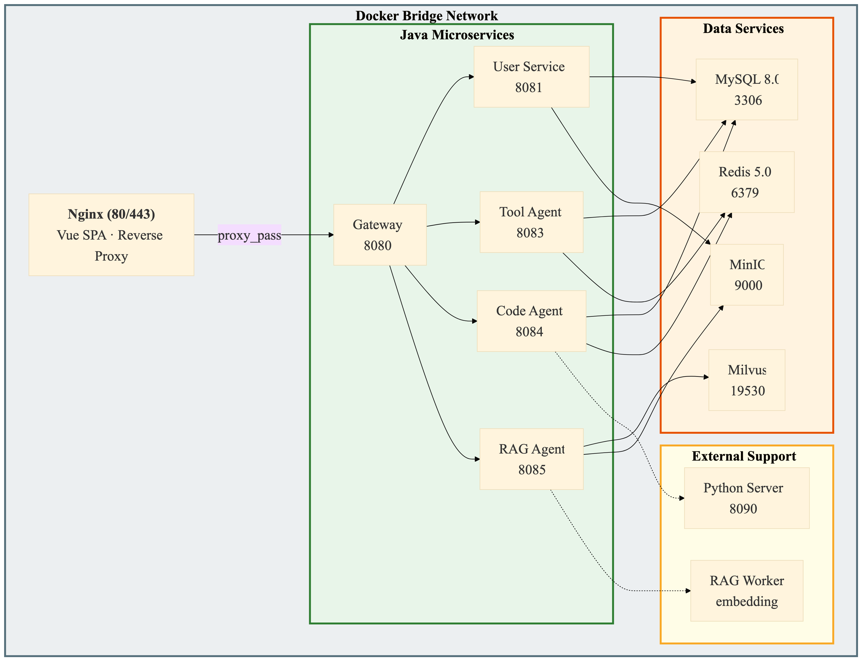
Figure 11: Docker Compose Service Topology

The platform is deployed through Docker Compose. Each service (Gateway, four backend services, frontend, MySQL, Redis, and optionally Milvus with etcd and MinIO) runs in an independent container on an internal bridge network, using service names as DNS hostnames. The Java service uses a multi-stage Dockerfile (Maven build, OpenJDK 17 JRE runtime); the Vue front-end is built in the Node.js stage and serves as an API proxy through Nginx. Only Nginx maps external ports; all backend services communicate internally through the gateway. The startup sequence is controlled by `depends_on` and health checks (mysqladmin ping, redis-cli ping), and the initialization file for MySQL is docker/init/agent_platform_backup_utf8.sql. The Compose file for the production environment adds resource limits and restart policies. All configurations are managed externally through environment variables. The deployment process is to first execute `docker compose build`, and then execute `docker compose up -d`.

Chapter 7: Discussion

7.1 Challenges and Resolutions
Frontend-Backend API Contract Alignment. During early integration, mismatches between the Vue 3 frontend's expected API response structures and the Spring Boot backend's actual response formats caused several integration failures. It was resolved through a standardized Result<T> wrapper (code, message, data fields) adopted across all microservices, and thorough documentation of request and response DTOs.
LLM API Integration for AI Intent Routing. The Tool Agent relies on the DeepSeek LLM for natural language intent classification, requiring prompt engineering to produce consistent, machine-parseable outputs. The system prompt instructs the model to classify user requests into one of three intent types (ROUTE_PLAN, MEETING_ROOM, SCHEDULE_CHECK) and extract structured parameters. Through repeated optimization, the classification accuracy rate has been improved from the initially inconsistent results to a reliable level suitable for production applications.
Amap API Multi-Level Geocoding Fallback. When conducting the initial test of the informal address description, if there is a failure in geocoding, a multi-level rollback strategy needs to be adopted. AmapService now attempts to perform geocoding using increasingly wider search ranges. When it fails to obtain precise coordinates, it gradually rolls back from specific address matching to city-level and regional-level searches.
Five-Layer SQL Validation Design. Designing a whitelist verification system requires striking a balance between security and availability. An overly strict validator will prevent legitimate analysis queries, while an overly lenient one will expose the database to injection attacks and unauthorized access risks. Through a five-layer architecture (operation type, disabled keywords, whitelist declaration, column whitelist, complexity restrictions), and by configuring adjustable rules for different deployment environments, it provides flexibility while maintaining a layered defense.
ONNX Model Optimization Path. Initially, it was planned to directly use ONNX Runtime for inference. However, this plan was eventually postponed and instead, a Python inference server based on HTTP was adopted. This decision was mainly driven by the complexity of ONNX model conversion required by the target large language model (LLM), the need for rapid iteration during the development process, and the richer support of the Python ecosystem for LLM inference. The HTTP proxy architecture enables the backend and the inference components to develop independently.

7.2 Comparison with Existing Solutions
Compared with cloud-based LLM API services, our platform achieves data sovereignty by performing local processing and controlling the external API calls that involve the minimum amount of data. Only user interactive natural language queries will be sent to the DeepSeek API for intent routing; all other data, including database content, documents, and user information, are retained in the local Docker environment.
Compared with general multi-agent frameworks such as AutoGen and MetaGPT, our platform abandons the flexibility of dynamically allocating agent roles and temporary conversations. Instead, it adopts the predictability, auditability and deterministic routing required in a banking environment. The static gateway routing table and explicit RBAC rules provide clear audit logs.
Compared with independent RAG solutions, our integrated architecture enables unified access to three complementary AI capabilities (code generation, knowledge retrieval, and enterprise tool invocation) through a single platform, and provides consistent identity authentication, authorization, and user experience. The RBAC system with department-level isolation and HITL workflow can meet the access control and compliance requirements of regulated industries, which is often lacking in the multi-agent prototypes in the academic field.

7.3 Project Limitations
Several limitations of the current implementation should be noted. The Code agent's Python HTTP server approach adds network latency and requires a separate Python process; local ONNX Runtime inference could eliminate this overhead. The RAG agent module has been fully designed but awaits complete deployment. The WebSocket progress tracking uses simulated steps for demonstration purposes; integration with actual agent execution progress is needed. Production readiness requires further hardening. The platform has not undergone formal security penetration testing, and load testing has been conducted with limited concurrent users. Quantitative performance metrics are based on a limited test dataset from the development stage and formal evaluation with larger sample sizes and diverse query types is needed.

Chapter 8: Conclusion and Future Work

8.1 Summary of Achievements
This project presents a multi-agent AI platform for banking digital transformation. It addresses issues such as code generation accuracy, domain knowledge reliability, tool invocation robustness, and data sovereignty through an on-premise deployment model. This platform integrates three specialized agents with a unified user center, RBAC system, and containerized infrastructure.
The Code agent implements a natural-language-to-SQL pipeline backed by a Python LLM inference server, combined with a five-layer SQL whitelist validation mechanism enforcing operation-type restrictions, forbidden-keyword filtering, table and column whitelists, and complexity limits. The RAG agent provides document-based question answering with Milvus vector retrieval and source citation, integrated with the existing permission system to ensure that retrieved answers respect department and clearance boundaries. The Tool agent delivers meeting room management with atomic booking, schedule conflict detection through Redis sorted sets, and route planning through Amap API integration, all accessible through a unified AI intent routing interface powered by the DeepSeek LLM.
The system integration layer provides JWT-based authentication with dual-mode login (password and email verification code), three-tier RBAC with department-level data isolation, HITL document access upgrade, and WebSocket-based real-time task progress streaming. All services are containerized and deployed through Docker Compose to ensure consistency of deployment.

8.2 Future Work
Several directions for future work have been determined. The implementation of the RAG agent should be completed by deploying the RAG agent microservice (port 8085) with Gateway routing, creating supporting database tables, and implementing the document chunking, embedding generation, and Milvus indexing pipeline. Direct integration of ONNX Runtime would replace the HTTP-based Python inference server, using the local JVM inference method, thereby eliminating network latency and the dependency on independent Python processes. The WebSocket progress tracking should be upgraded from simulated steps to real-time tracking of the actual execution progress through the Task Center. Dynamic multi-agent orchestration could evolve from static Gateway routing to workflow composition for complex cross-agent requests. Reinforcement of the production environment should include Prometheus metrics, Grafana dashboards, distributed tracing, centralized logging, and formal security testing. The Code agent should be extended to support more SQL syntax as well as domain-specific fine-tuning through LoRA, enabling banking institutions to adapt models to their internal terminology.

References
[1] T. Yu, R. Zhang, K. Yang, M. Yasunaga, D. Wang, Z. Li, J. Ma, I. Li, Q. Yao, S. Roman, Z. Zhang, and D. Radev, "Spider: A Large-Scale Human-Labeled Dataset for Complex and Cross-Domain Semantic Parsing and Text-to-SQL Task," in Proceedings of the 2018 Conference on Empirical Methods in Natural Language Processing (EMNLP), Brussels, Belgium, Oct.–Nov. 2018, pp. 3911–3921. doi: 10.18653/v1/D18-1425.
[2] N. Pipitone and G. H. Alami, "LegalBench-RAG: A Benchmark for Retrieval-Augmented Generation in the Legal Domain," arXiv preprint arXiv:2408.10343, 2024.
[3] N. Guha, J. Nyarko, D. E. Ho, C. Ré, A. Chilton, A. Narayana, A. Choksi, et al., "LegalBench: A Collaboratively Built Benchmark for Measuring Legal Reasoning in Large Language Models," arXiv preprint arXiv:2308.11462, 2023.
[4] Q. Wu, G. Bansal, J. Zhang, Y. Wu, B. Li, E. Zhu, L. Jiang, X. Zhang, S. Zhang, J. Liu, A. H. Awadallah, R. W. White, D. Burger, and C. Wang, "AutoGen: Enabling Next-Gen LLM Applications via Multi-Agent Conversation," arXiv preprint arXiv:2308.08155, 2023.
[5] S. Hong, M. Zhuge, J. Chen, X. Zheng, Y. Cheng, C. Zhang, J. Wang, Z. Wang, S. K. S. Lin, Z. Liu, J. Liu, J. Zhang, Y. Lin, and W. Fan, "MetaGPT: Meta Programming for A Multi-Agent Collaborative Framework," arXiv preprint arXiv:2308.00352, 2024.
[6] A. Karras, L. Theodorakopoulos, C. Karras, A. Theodoropoulou, I. Kalliampakou, and G. Kalogeratos, "LLMs for Cybersecurity in the Big Data Era: A Comprehensive Review of Applications, Challenges, and Future Directions," Information, vol. 16, no. 11, p. 957, Nov. 2025.
[7] W. Kwon, Z. Li, S. Zhuang, Y. Sheng, L. Zheng, C. H. Yu, J. E. Gonzalez, H. Zhang, and I. Stoica, "Efficient Memory Management for Large Language Model Serving with PagedAttention," arXiv preprint arXiv:2309.06180, 2023.
[8] P. Lewis, E. Perez, A. Piktus, F. Petroni, V. Karpukhin, N. Goyal, H. Küttler, M. Lewis, W. Yih, T. Rocktäschel, S. Riedel, and D. Kiela, "Retrieval-Augmented Generation for Knowledge-Intensive NLP Tasks," in Advances in Neural Information Processing Systems (NeurIPS), vol. 33, 2020, pp. 9459–9474.
[9] A. Vaswani, N. Shazeer, N. Parmar, J. Uszkoreit, L. Jones, A. N. Gomez, Ł. Kaiser, and I. Polosukhin, "Attention Is All You Need," in Advances in Neural Information Processing Systems (NeurIPS), vol. 30, 2017, pp. 5998–6008.
[10] S. Yao, J. Zhao, D. Yu, N. Du, I. Shafran, K. Narasimhan, and Y. Cao, "ReAct: Synergizing Reasoning and Acting in Language Models," in International Conference on Learning Representations (ICLR), 2023.
[11] E. M. Bender, T. Gebru, A. McMillan-Major, and S. Shmitchell, "On the Dangers of Stochastic Parrots: Can Language Models Be Too Big?" in Proceedings of the 2021 ACM Conference on Fairness, Accountability, and Transparency (FAccT), 2021, pp. 610–623.

Appendix A: Database Schema
This appendix documents the complete database schema for the agent_platform database, verified against docker/init/agent_platform_backup_utf8.sql. All tables use InnoDB engine, utf8mb4 character set with utf8mb4_unicode_ci collation. MyBatis-Plus @TableLogic provides logical deletion via deleted field.
Table A1: meeting_room — Meeting room resources
id (BIGINT, PK, AUTO_INCREMENT): Unique room identifier
room_name (VARCHAR(50), NOT NULL): Room display name (e.g., "Room 301")
building (VARCHAR(100)): Building name (e.g., "Building A")
floor (VARCHAR(20), NOT NULL): Floor identifier as string (e.g., "3")
capacity (INT, NOT NULL): Maximum occupancy (10, 20, 8, 50)
facilities (VARCHAR(200)): Comma-separated equipment list (e.g., "Projector,Whiteboard")
status (INT, DEFAULT 1): 1=available, 0=maintenance
create_time (DATETIME), update_time (DATETIME), deleted (INT, DEFAULT 0, logic delete)
Seed data (4 rooms): Room 301 (10p, Building A Floor 3, Projector+Whiteboard), Room 302 (20p, Projector+Video Conference), Room 201 (8p, Whiteboard), Room 501 Large (50p, Building B Floor 5, Projector+Audio+Video Conference)
Table A2: meeting_schedule — Booking and schedule records
id (BIGINT, PK, AUTO_INCREMENT): Unique booking identifier
room_id (BIGINT, NOT NULL): FK to meeting_room.id. Value 0 indicates personal schedule (no room)
booker (VARCHAR(50), NOT NULL): Username of the person who made the booking
start_time (DATETIME, NOT NULL): Booking start time
end_time (DATETIME, NOT NULL): Booking end time
topic (VARCHAR(200)): Meeting topic or schedule description
status (INT, DEFAULT 1): 1=active, 0=cancelled
create_time (DATETIME), update_time (DATETIME), deleted (INT, DEFAULT 0, logic delete)
Redis counterpart: key=tool:schedule:{userId}, sorted set with members formatted as "{eventId}|{startEpoch}|{endEpoch}" scored by startEpoch (Asia/Shanghai timezone). Used for ZRANGEBYSCORE conflict queries.
Table A3: sys_user — User accounts
id (BIGINT, PK, AUTO_INCREMENT), username (VARCHAR(50), UNIQUE, NOT NULL), password (VARCHAR(100), NOT NULL, BCrypt), real_name (VARCHAR(50)), role (VARCHAR(20), DEFAULT "user", legacy field), status (INT, DEFAULT 1), dept_id (BIGINT, FK→sys_department, NULL=unassigned), clearance_level (TINYINT, NOT NULL, DEFAULT 1: 1=Public, 2=Internal, 3=Confidential), create_time, update_time, deleted (TINYINT, DEFAULT 0, logic delete)
Seed users (5, all passwords=123456): admin (ROLE_ADMIN, L3), credit_mgr (ROLE_DEPT_ADMIN, L2, dept 1), credit_staff (ROLE_USER, L1, dept 1), compliance_mgr (ROLE_DEPT_ADMIN, L2, dept 2), compliance_staff (ROLE_USER, L1, dept 2)
Table A4: sys_role — System roles
id (BIGINT, PK), role_code (VARCHAR(50), UNIQUE), role_name (VARCHAR(50)), description (VARCHAR(250)), status (INT, DEFAULT 1), create_time, update_time, deleted (TINYINT, DEFAULT 0)
Seed: ROLE_ADMIN (System Administrator), ROLE_USER (Employee), ROLE_DEPT_ADMIN (Department Administrator)
Table A5: sys_permission — Granular permissions
id (BIGINT, PK), perm_code (VARCHAR(100), UNIQUE), perm_name (VARCHAR(100)), resource_path (VARCHAR(200)), method (VARCHAR(10): GET/POST/PUT/DELETE/*), type (TINYINT: 1=menu, 2=API), parent_id (BIGINT), create_time, update_time, deleted (TINYINT, DEFAULT 0)
Seed (6): user:view, user:role, user:status, role:view, task:submit, task:query
Table A6: sys_user_role & sys_role_permission — Association tables
sys_user_role: user_id + role_id, composite PK. Admin→ROLE_ADMIN; mgrs→ROLE_DEPT_ADMIN; staff→ROLE_USER
sys_role_permission: role_id + perm_id, composite PK. ROLE_ADMIN→all 6; ROLE_USER & ROLE_DEPT_ADMIN→task:submit + task:query
Table A7: sys_department — Organizational structure
id (BIGINT, PK), dept_name (VARCHAR(100), NOT NULL), description (VARCHAR(250)), parent_id (BIGINT, DEFAULT 0, hierarchical), status (INT, DEFAULT 1), create_time
Seed (6): Credit, Compliance, Asset Management, Retail Banking, Investment Banking, Risk Control
Table A8: sys_document — Knowledge base documents
id (BIGINT, PK), title (VARCHAR(100), NOT NULL), content (TEXT, NOT NULL, Markdown), dept_id (BIGINT, NULL=global), security_level (TINYINT, NOT NULL, DEFAULT 1: 1-3), create_time
Seed (11 documents): Includes Q1 Credit Assessment Manual (L2, dept 1), Confidential Credit Risk Evaluation (L3, dept 1), AML Compliance Handbook (L2, dept 2), RBAC & Security Clearance Design Specification (L1, global), and 7 additional documents across departments and clearance levels.
Table A9: sys_notification — Multi-type notification system
id (BIGINT, PK), sender_id (FK→sys_user), receiver_id (FK→sys_user), title (VARCHAR(150), NOT NULL), content (TEXT, NOT NULL), notify_type (VARCHAR(50): CHAT/RAG_APPLY/SQL_AUDIT/BUG_REPORT), status (INT: 0=Unread/1=Read/2=Pending Action/3=Approved/4=Denied), payload (TEXT, JSON for structured data), opinion (TEXT, approval/review comments), create_time, update_time, deleted (TINYINT, DEFAULT 0)
Seed (3): RAG permission escalation request (RAG_APPLY, pending), SQL execution warning (SQL_AUDIT, pending), Bug diagnosis report (BUG_REPORT, unread)

Appendix B: API Documentation (Selected Endpoints)
POST /api/user/login → {username, password, code?} → {token, username, roles[], permissions[], realName} (JWT signed, 24h expiry; code field optional for verification code login mode)
POST /api/user/send-code → {email} → Sends 6-digit verification code via email (Redis TTL 5 min, rate limit 60 s)
POST /api/user/register → {username=email, password, realName, code} → Validates email verification code, creates user with BCrypt-hashed password, auto-assigns ROLE_USER
GET /api/user/info → (JWT required) → {username, realName, roles[], permissions[], deptId, deptName, clearanceLevel}
User Service (Port 8081) — Authentication:
Admin (ROLE_ADMIN only):
GET /api/admin/users → [UserResponse[]]; POST /api/admin/user/role → {userId, roleId} → Clears old, assigns new
PUT /api/admin/user/status → {userId, status} → Enable/disable; PUT /api/admin/user/dept → {userId, deptId} → Set dept (null if <=0)
PUT /api/admin/user/clearance → {userId, clearanceLevel} → Validates 1-3; GET /api/admin/roles → [SysRole[]]
CRUD /api/admin/dept → Create/Update/Delete departments
Dept Admin (ROLE_DEPT_ADMIN/ROLE_ADMIN):
GET /api/user/dept-admin/members → (deptId? for ADMIN) → [UserResponse[]]
GET /api/user/dept-admin/candidates → Users with null dept_id
POST /api/user/dept-admin/add-members → {userIds[], deptId?} → Batch dept assignment
POST /api/user/dept-admin/remove-member → {userId, deptId?} → Sets dept_id=null
Documents:
GET /api/user/document/list → Clearance-filtered [DocumentResponse[]] (accessible boolean, content or "Access Restricted")
POST /api/user/document/create → {title, content, deptId, securityLevel} → ADMIN/DEPT_ADMIN only
PUT /api/user/document/update, DELETE /api/user/document/delete/{id}
Notifications:
GET /api/user/notification/list → (status?, notifyType?) → [NotificationResponse[]] enriched with sender/receiver names
GET /api/user/notification/unread-count → Integer count (status=0); POST /api/user/notification/send → {receiverId, title, content, notifyType, payload?}
PUT /api/user/notification/read/{id} → Mark 0→1; POST /api/user/notification/action → {notificationId, action (APPROVE/DENY), opinion?} → 2→3/4
Tool Agent (Port 8083):
POST /api/tool/execute → {toolType, parameters?, naturalLanguage} → AI-routed result (DeepSeek intent classification)
GET /api/tool/meeting-rooms → (startTime?, endTime?, capacity?) → [Room[]] with availability status
POST /api/tool/meeting-room/book → {roomId, booker, startTime, endTime, topic} → Atomic booking
POST /api/tool/check-conflict → {attendees[], startTime, endTime} → {hasConflict, conflictUser, message}
POST /api/tool/schedule/create → {userId, eventName, startTime, endTime} → Dual-write MySQL+Redis
GET /api/tool/my-schedules → (X-User-Name header) → [Schedule[]] with room name/location enrichment
DELETE /api/tool/my-schedule/{id} → (X-User-Name header) → Status=0 + Redis cleanup
GET /api/tool/route → (from, to, mode?) → {distance, duration, trafficStatus, steps[], path[], startPoint, endPoint, source}
Admin (ROLE_ADMIN):
CRUD /api/tool/admin/meeting-rooms → X-User-Roles header checked; validations: roomName req, floor req, capacity>0
CRUD /api/tool/admin/schedules → X-User-Roles header checked; validations: booker req, roomId req, start<end
Code Agent (Port 8084):
POST /api/code/query → {question, database?} → FullResult {success, sql, columns[], rows[], rowCount, elapsedMs, inferenceMethod}
POST /api/code/generate → {question} → {success, sql, inferenceMethod} (preview, no validation)
POST /api/code/execute → {sql} → {success, columns[], rows[], rowCount, elapsedMs} (HITL-reviewed execution)
POST /api/code/metadata/refresh → {tableCount, tableNames[], source, timestamp}
GET /api/code/metadata → {tableCount, tableNames[], source (Redis/MySQL/empty), timestamp}
GET /api/code/health → {status, service, inferenceMethod}
Gateway (Port 8080):
Routes: /api/user/**,/api/admin/**→user-service:8081; /api/tool/**→tool-agent:8083; /api/code/**→code-agent:8084; /ws/**→tool-agent:8083/tool/ws
JwtAuthGlobalFilter (order=-100): Validates JWT on all non-whitelisted paths, injects X-User-Name, X-User-Roles, X-User-Permissions
Whitelist: /api/user/login, /api/user/register, /ws (WebSocket upgrade bypasses JWT filter)
Rate Limiting: 10 req/s replenish, burst 20, keyed by client IP (Redis token bucket on user-service routes)
StripPrefix=1 on all routes (removes /api prefix before forwarding)

Appendix C: User Manual (Summary)
Access and Login. Navigate to http://167.172.82.161 and log in with your assigned credentials. Default test accounts: - admin / 123456 (System Administrator, full access, clearance Level 3) - credit_mgr / 123456 (Credit Department Manager, ROLE_DEPT_ADMIN, clearance Level 2) - credit_staff / 123456 (Credit Department Staff, ROLE_USER, clearance Level 1) - compliance_mgr / 123456 (Compliance Department Manager, ROLE_DEPT_ADMIN, clearance Level 2) - compliance_staff / 123456 (Compliance Department Staff, ROLE_USER, clearance Level 1)
Main Dashboard. The dashboard displays a welcome message with your username, a pending approval alert banner (for ROLE_ADMIN and ROLE_DEPT_ADMIN, showing the count of pending HITL requests with a "Review Now" link), three quick-access cards (Tool Agent, Code Agent, RAG Agent), upcoming events from My Schedules (up to 3 events with date pill and category dot), and service status indicators. Use the collapsible sidebar to navigate. The language switcher supports 简体中文, 繁體中文, and English.
Tool Agent (/app/tool). The left panel has three tabs: Meeting (room search with date and capacity filters, and booking), Schedule (conflict detection by attendee with a visual timeline grid), and Route (origin and destination input with an interactive map). The right panel provides an AI Assistant: enter a natural language request, and the system routes to the correct tab through AI intent recognition, displaying extracted parameters and results. WebSocket-based progress is shown through an animated overlay.
Code Agent (/app/code). A three-step workflow: (1) enter a natural language query or select a quick template, (2) review the generated SQL in a code editor with model information, and (3) execute and view the results table with CSV export. A schema explorer sidebar shows available tables with a Sync button to refresh the metadata cache.
Documents (/app/dept-docs). Two tabs: System Manuals (global documents) and Department Assets (clearance-controlled). Click a document to open a Zen Reader with markdown rendering and an auto-generated table of contents. Locked documents show a clearance comparison and a "Request Access" button that triggers the HITL workflow to the department manager.
Messages (/app/notification). A three-column layout: left sidebar with filters (All, Unread, Pending Approvals, Sent), middle message list, and right detail panel. Type-specific renderers handle RAG_APPLY (approval actions with opinion), SQL_AUDIT (SQL code blocks), and BUG_REPORT (collapsible trace panels). Department managers can approve or deny pending requests.
Register (/register). New users can create an account with an email-format username and a 6-digit email verification code. The registration form requires the user to enter their email address, request a verification code (sent to their inbox, valid for 5 minutes), set a password (minimum 8 characters), and confirm the password. A 60-second cooldown prevents repeated code requests. Registration assigns the ROLE_USER role with clearance Level 1 (Public) and no department affiliation. After registration, users are redirected to the login page where they can sign in with either their password or a new verification code.
Administration (/app/admin/users, /app/admin/resources, /app/admin/my-dept). User Management provides a searchable table of all users with filters for department, clearance level, and role. Admins can assign roles, set department affiliation, adjust security clearance levels (1–3), and enable or disable accounts. Admins cannot disable their own account. Resource Management provides CRUD for meeting rooms (name, building, floor, capacity, facilities) and schedule records (booker, room, time range, status). My Department allows department admins to view their team roster, add unassigned candidates, and remove members. Admins can also create, edit, and delete departments.
Settings (/app/settings). Two configuration dialogs: Profile (update your display name through PUT /user/profile) and Security (change your password with current password verification, a new password with a 4-bar strength meter showing weak/fair/good/strong, and a confirmation match check). After a successful password change, you are logged out and redirected to login. The username and role are displayed as read-only fields.

Declaration of Individual Contributions
In accordance with the University of Hong Kong's guidelines for group project reports, this section details the specific contributions of each team member.
Lin Chuanbin:
I built three core modules for the Agent Platform project: the Tool Agent microservice, the User Service microservice, and the complete frontend UI, delivering over 30 core files.
For the Tool Agent, I developed a Spring Boot service using DeepSeek's LLM for intent recognition, routing requests to meeting booking, schedule conflict detection, or route planning. I added a mock-data fallback for when the AI service is down. For meeting management, I used MyBatis-Plus to handle time-overlap detection and conflict-checked booking. I built a Redis-based schedule conflict detector with sorted sets and ZRANGEBYSCORE for O(log N) range queries, storing timestamps in Asia/Shanghai timezone. For route planning, I wrapped the Amap REST API with a three-tier geocoding fallback (direct geocoding, city-prefix retry, POI text search). I also added WebSocket progress pushing through a TextWebSocketHandler with session management via ConcurrentHashMap, supporting up to 10 concurrent tasks.
For the User Service, I built a Spring Boot and Spring Security microservice with JWT authentication (HMAC-SHA256), BCrypt password encoding, and stateless session management. I defined standardized Result<T> response wrappers and DTOs, and configured SecurityConfig to open only the login endpoint while protecting all other routes.
On the frontend, I developed the UI with Vue3 Composition API, TypeScript, Vite, Element Plus, and Pinia: a login page, a main layout with collapsible sidebar, and a tool-calling page with three tabs and an AI assistant panel. I configured Axios interceptors for automatic token attachment and 401-triggered logout, and built a WebSocket client singleton with auto-reconnect. I also wrote the initial Task Center orchestration logic with static agent routing and WebSocket progress updates.
Some of the code I wrote, particularly the frontend components, was early-stage work that other team members later refined and extended.
Yao Jiacheng:
I served as the backend architecture lead and, over the course of the project, took on full-stack development, system integration, security, and DevOps. Much of my work involved extending the initial platform scaffold built by Lin Chuanbin, integrating the Code Agent (Zhang Zhaoming), RAG Agent (Huang Siyuan), and Tool Agent (Lin Chuanbin) into the unified system, and replacing several early-stage implementations to meet production requirements.
1. Backend
1.1 RBAC authentication & authorization
Building on the initial user-service skeleton (basic JWT login with a single admin/user role) created by Lin Chuanbin, I extended the platform's security model into a multi-layer permission architecture:
- Designed five RBAC tables supporting three role types (admin, department admin, regular user) with fine-grained permissions pre-seeded in the database.
- Replaced the original single-role JWT filter with a custom JwtAuthenticationFilter that extracts roles and permissions from JWT claims and registers them in Spring Security, enabling declarative @PreAuthorize across all controllers.
- Built admin and department-admin controllers covering user CRUD, role assignment, department assignment, clearance level management, and account lifecycle operations.
- Introduced multi-level department trees with automatic department-scoped data isolation in all data-access controllers.
- Implemented three-tier document clearance enforcement with department scoping, clearance level comparison, and HITL override via approved access requests.
1.2 API gateway, session management & unified response format
I built the platform's unified API gateway layer and standardized the cross-service response format:
- Built a custom Spring Cloud Gateway global filter with route rules covering all microservices and WebSocket endpoints.
- Implemented single-session enforcement via Redis (new logins invalidate old sessions), sliding-window TTL renewal with polling endpoint exemption, and dynamic admin-configurable session timeout.
- Propagated user identity through HTTP headers so downstream services operate without holding JWT_SECRET.
- Defined the Result<T> generic wrapper standard, deployed identical DTOs across all four microservices, and wrote the frontend Axios interceptor with automatic unwrapping.
1.3 Notification & HITL approval system
I independently designed and implemented the platform's notification and approval subsystem:
- Designed the notification table with threaded messaging support (parent_id/thread_id) and a five-state state machine spanning unread, read, pending, approved, and rejected statuses.
- Built the notification controller with endpoints for sending, filtered listing, read marking, approve/deny with audit trail, and threaded conversation view.
1.4 Task center orchestration
I designed and implemented the task center, a centralized orchestration layer that tracks and manages all Agent workflows across the platform. When a user submits a request through any Agent, the task center records it, dispatches it to the appropriate service, and reports real-time progress back to the frontend via WebSocket. This provides a unified task history and status tracking across all three Agents:
- Built the task-service microservice with an async execution pipeline.
- Implemented routing by task type to the corresponding Agent, with progress pushed in three stages to the frontend.
- Designed fault-tolerance mechanisms including connection timeout, read timeout, up to 3 automatic retries, and graceful queue overflow rejection to prevent system overload.
1.5 Email verification system
I replaced the initial QQ SMTP implementation (originally contributed by Xia Xin) with a production-grade solution after identifying reliability and security limitations:
- Migrated from QQ SMTP to the Resend HTTP API with a redesigned HTML email template.
- Hardened security with brute-force protection against verification code guessing and a three-tier rate limiting system (per-email cooldown, per-IP hourly cap, per-email daily cap).
1.6 Copilot backend & AI provider unification
I built the backend for the global Copilot assistant, which generalized the AI chat panel originally confined to Lin Chuanbin's Tool Agent page into a cross-page, multi-Agent intelligent dispatcher. I implemented LLM intent classification that identifies the user's request type (TOOL, CODE, RAG, CHAT, CLARIFY), automatically extracts relevant parameters from natural language input, and routes the request to the appropriate Agent for execution or navigates to the relevant system page (e.g., settings, admin panel) when the user requests a platform action.
1.7 Document management & MinIO storage
I worked with Huang Siyuan to build the document storage and management backend, which serves both the document library and her RAG Agent:
- Built a MinIO storage service with auto bucket creation, admin-configurable upload size limits, and support for PDF, DOCX, PPT, and Markdown files.
- Extended the document table with file metadata and parse status columns to support RAG document parsing.
- Implemented document access request approval routing to department managers with fallback to system admin.
2. Frontend
2.1 Layout, navigation & multi-tab system
I rebuilt the frontend shell from the initial scaffold created by Lin Chuanbin into a production-grade application framework:
- Rebuilt the main layout with a collapsible sidebar, multi-tab top bar, responsive mobile layout with off-screen drawer, and role-based dynamic menu visibility.
- Built a browser-style multi-tab system that preserves page state when users switch between tabs — form inputs, filters, and scroll positions remain intact — preventing task interruption, a common issue with the original single-page navigation where leaving a page would discard all unsaved work.
- Implemented a five-layer global navigation guard covering silent refresh recovery, authentication redirect, bounce-back, single-role check, and multi-role check.
2.2 UI design system
I established a minimalist visual design language across the entire platform, replacing the default Element Plus styling inherited from the initial scaffold:
- Globally replaced the default blue theme with a grayscale color system, removing accent strips and unifying border-radius, sizing, and spacing.
- Redesigned notifications with macOS-style frosted glass and custom cubic-bezier slide-in animation.
2.3 Tool Agent UI rebuild
I redesigned all three Tool Agent interfaces originally built by Lin Chuanbin, splitting the monolithic ~600-line file into independent sub-components and removing the fixed AI chat panel in favor of the global Copilot Widget:
- Meeting Agent: rebuilt search as a horizontal inline bar with a responsive card grid, SVG icons, equipment tags, and a booking dialog.
- Schedule Agent: unified two separate forms into a single filter panel and replaced manual user ID input with a filterable multi-select dropdown.
- Route Agent: redesigned the map from conditional rendering (hidden when no results) to a persistent full-width display. Added a floating control panel and clickable route segments that show detailed directions for each section of the journey.
3. DevOps
I set up the full deployment pipeline for the platform, bringing all three Agent services — Zhang Zhaoming's Code Agent, Huang Siyuan's RAG Agent, and Lin Chuanbin's initial Tool Agent — onto a single server:
- Wrote the docker-compose.yml that starts all 9 services with proper startup order, health checks, and data persistence.
- Created Dockerfiles for each Spring Boot service.
- Deployed a DigitalOcean Droplet. To keep the Maven build from running out of memory on a small instance, I compiled the JARs locally and copied them over.
- Set up Nginx as the only public-facing entry point, handling SPA routing, API/WebSocket proxying, and static file caching.
- Registered the domain bankagent.online through Namecheap and configured Let's Encrypt for HTTPS access.

Huang Siyuan:
I was responsible for building the RAG Agent into a complete enterprise document Q&A subsystem. I created a standalone rag-agent microservice on port 8085, integrated it with the Spring Cloud Gateway through a new /api/rag/** route, and extended the existing JWT authentication to propagate user identity headers (X-User-Name, X-User-Roles) to the RAG service. I designed the supporting data structures (rag_document_chunk, rag_query_log, rag_index_task) and integrated Milvus as the vector database with HNSW/IVF_FLAT indexing and COSINE distance metric. I implemented a structure-aware document chunking pipeline (500–800 tokens per chunk, 80–120 token overlap) with content-hash-based incremental indexing, and built a configurable embedding service supporting bge-small-en-v1.5 and multilingual-e5 models. For security, I applied the platform's existing RBAC model at every retrieval layer: pre-retrieval scope computation, in-query Milvus filter predicates, and post-retrieval re-verification, ensuring that users can only retrieve content matching their department and clearance level. I built the LLM answer generation pipeline with mandatory citations and hallucination prevention prompts, implemented the core RAG API endpoints (/rag/query, /rag/index/rebuild, /rag/index/document), integrated RAG into the task-service with WebSocket progress tracking, and built the RAG workbench frontend with citation panels and permission indicators. I also extended Docker Compose with Milvus, etcd, and MinIO services, and produced the RAG technical design documentation.

Xia Xin:
I built the platform's early-stage authentication and permission system with Spring Security, using stateless JWT tokens (HMAC-SHA256) and BCrypt password encoding to separate admin and regular user access at the role level.
I configured the security filter chain to open only the login and registration endpoints while requiring authentication for all other routes, and defined standardized Result<T> response wrappers and DTOs across the service. I also developed the initial frontend for the Code Agent module, which Yao Jiacheng later refined and extended.
For internationalization, I adapted all business and UI components to support three languages (Simplified Chinese, Traditional Chinese, and English) with dynamic switching through Vue3 and Element Plus i18n.
- Building on the existing team codebase, I integrated QQ Mail's SMTP service to deliver verification codes, storing them in Redis with a 5-minute TTL and a 60-second send rate limit, and wired the code verification flow into both registration and JWT-based login. This part has been modified because QQ Mail's SMTP will change after some time, so we adapt Resend to apply a more stable Mail Service.
- I was responsible for the final report. I redrew all twelve system diagrams, standardized and expanded the technical tables, and synchronized the report with the latest codebase.
- Figure redesign.I designed the first version of all figures, and after team discussion, I redrew the original dense, small-font figures into clean, wide-format vector graphics with a unified visual style. Each figure uses 22–24 pt fonts, one to two lines per node, a left-to-right flow where appropriate, and color-coded layers instead of nested borders. The figures span the full A4 column width (6.06 inches) at over 330 dpi effective resolution. Specific updates include adding the RAG Agent (port 8085), the Python rag‑worker, MinIO object storage, and the Resend email API to the architecture and deployment diagrams; removing the deprecated WebSocket progress-tracking figure; and compressing the four‑stage SQL generation pipeline into a compact two‑row layout.
Table standardization. I converted all seven data tables into the three‑line table format (1.5 pt top and bottom rules, a 0.75 pt rule below the header, no vertical or interior horizontal lines). I also added five new rows to the Backend Technology Stack table (RAG Agent, Embedding Worker, Apache Tika, MinIO, Resend) and added an Object Storage row to the Data Storage Strategy table, reflecting the architecture changes made after the initial draft.

Zhang Zhaoming:
I independently designed and implemented the code-agent module, a Text-to-SQL system built on Spring Boot 3.2 and Java 17. The service converts natural language questions into secure, executable SQL through a three-step workflow of generation, validation, and execution, with security controls designed for banking environments. The module connects to a Python Flask inference server through Java HttpClient to access the DeepSeek API for SQL generation, with configurable timeout handling and graceful degradation. I developed the five-layer whitelist validation engine (SqlValidationService), which enforces SELECT-only operation interception, filters 14 forbidden keywords, validates table and column names against information_schema metadata, and constrains query complexity. A metadata caching service loads schema information from MySQL, stores it in Redis with automatic fallback, and refreshes on a scheduled basis. On the Python side, I built the training and evaluation pipeline: a Flask inference server, a local fine-tuning script based on flan-t5-base, a knowledge distillation tool, and benchmarking scripts for execution accuracy evaluation. Both the Java service and Python inference service are containerized with multi-stage Dockerfiles.

