RPG Character Creation Quiz

Daniel Ewing

University of Missouri – Kansas City

Table of Contents
Vision Statement 3
Requirements 4
Product Backlog 5
Sprint #1 6
Review 6
Retrospective 8
Sprint #2 9
Review 9
Retrospective 9
Sprint #3 10
Review 10
Retrospective 10
Sprint #4 11
Review 11
Retrospective 11
Sprint #5 12
Review 12
Retrospective 12
Sprint #6 13
Review 13
Retrospective 13

Vision Statement
This program will ask a series of questions to help someone make a decision regarding what type of character they should play in a role playing game. Key features will include character race and character play style quizzes, in the form of two separate quizzes. The player will navigate these quizzes and upon completion they will be told the respective answers, these simple quizzes will be available for immediate release, and future development will include more complicated quizzes based upon the answers received from the first round. Such quizzes might expand upon what fantasy race or a specific type of play style (i.e. barbarian or defensive style warrior). Eventually specific games might be suggested to optimize the ability to play in the preferred manner, but this is a non-necessary item.

Requirements
A discussion of what your application is required to have in functionality. It should identify user roles and goals/actions, and what the key features of the app should be.
Actor | Goal
Menu | Display information about the app, potentially restart quiz or return to home screen
Home Screen | Provide user an easy way to select their quiz.
Race Quiz Button | Starts race Quiz
Playstyle Quiz Button | Starts Playstyle Quiz
Quiz Completion | Screen will show an image and text about the answer for which type of character to play

Product Backlog
This will be updated throughout the semester as new PBIs are added, larger items are broken into smaller ones, and completed items removed.

Story ID | Story | Story Points  (in est. hours) | Priority | Status
2B | Expand Race Quiz | 3 | 1 | Not Started
3B | Expand Playstyle Quiz | 3 | 2 | Not Started
4 | Menu Creation | 4 | 3 | Not started
5 | Beautify(background art, theme, text, app icon, etcetera) | 4 | 4 | Not Started

Sprint #1

Sprint Backlog
Story ID | Story / Task | Estimated  Hours | Actual  Hours
1 | Basic UI Dev | 3 | 2
2A | Basic Race Quiz | 3 | 3
3A | Basic Playstyle Quiz | 2 | 1.5
XXX | Android Studio Repair | 1 | 2.5

Review

This sprint focused mainly on basic setup within the application. A home screen was created with 2 buttons, each starting a specific quiz. These quizzes function on a strongly agree – strongly disagree basis, with 5 options total. A strongly agree reply will currently exit the quiz with a solution shown in the form of a new activity, future iterations might change the way in which this functions but this was a good completion point for the first sprint. If the player makes it through all three questions without hitting strongly agree then they will receive an answer and will be told that future iterations of the project will include a more in-depth quiz to give a much less generic answer. The result screens function the same way and only screenshots for the playstyle quiz are added to the review document. Initially a basic menu was planned for this sprint, but due to unforeseen difficulties was forced to be put off.

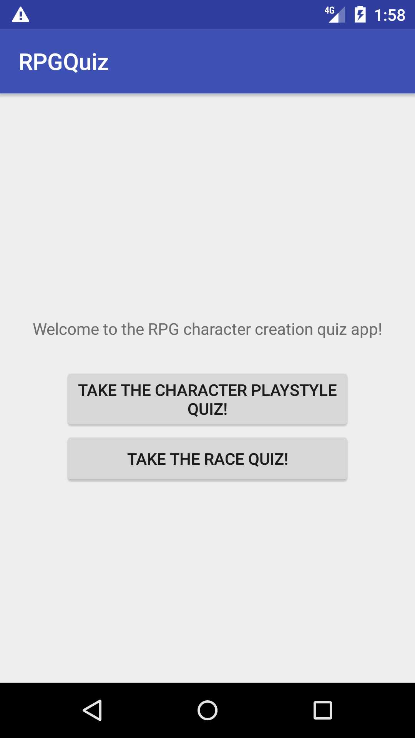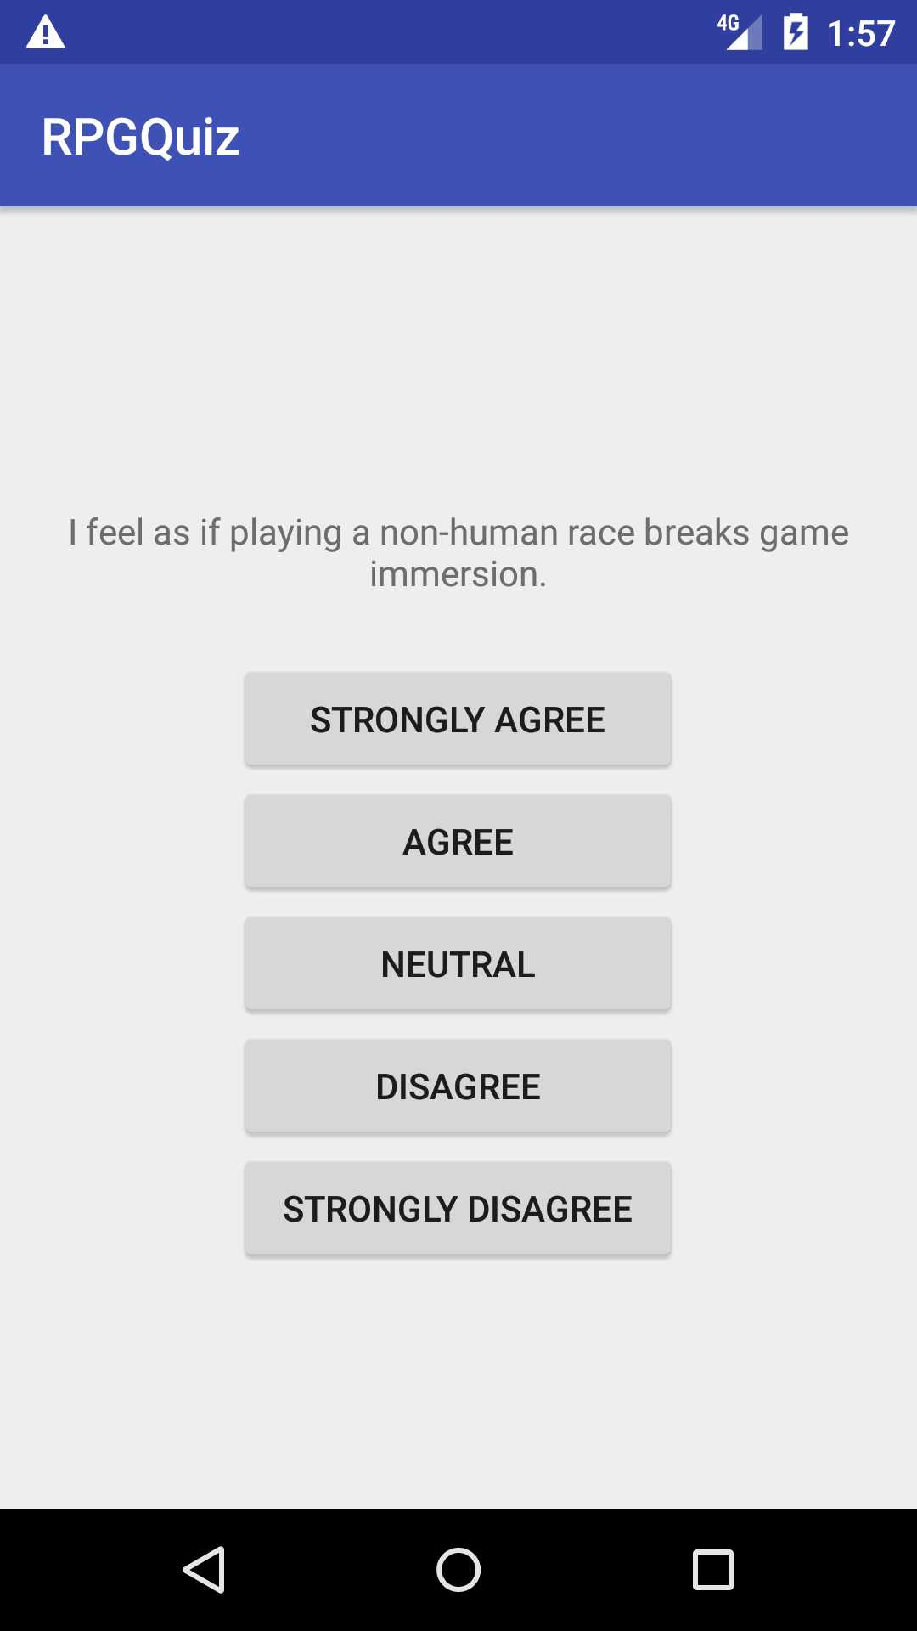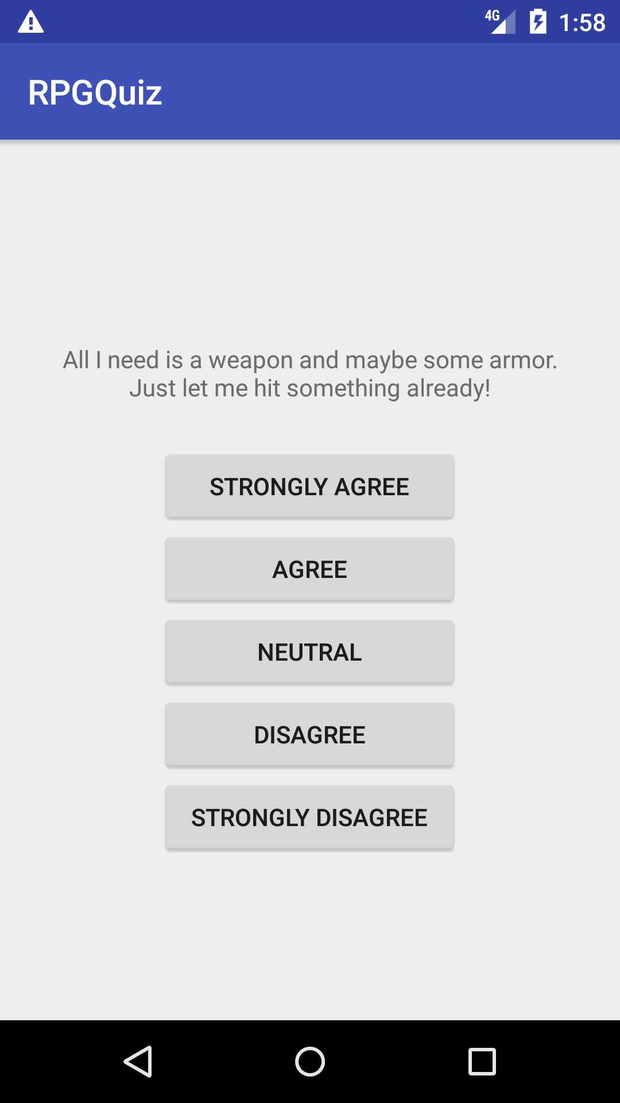

Main Menu Race Quiz Example Playstyle Quiz Example

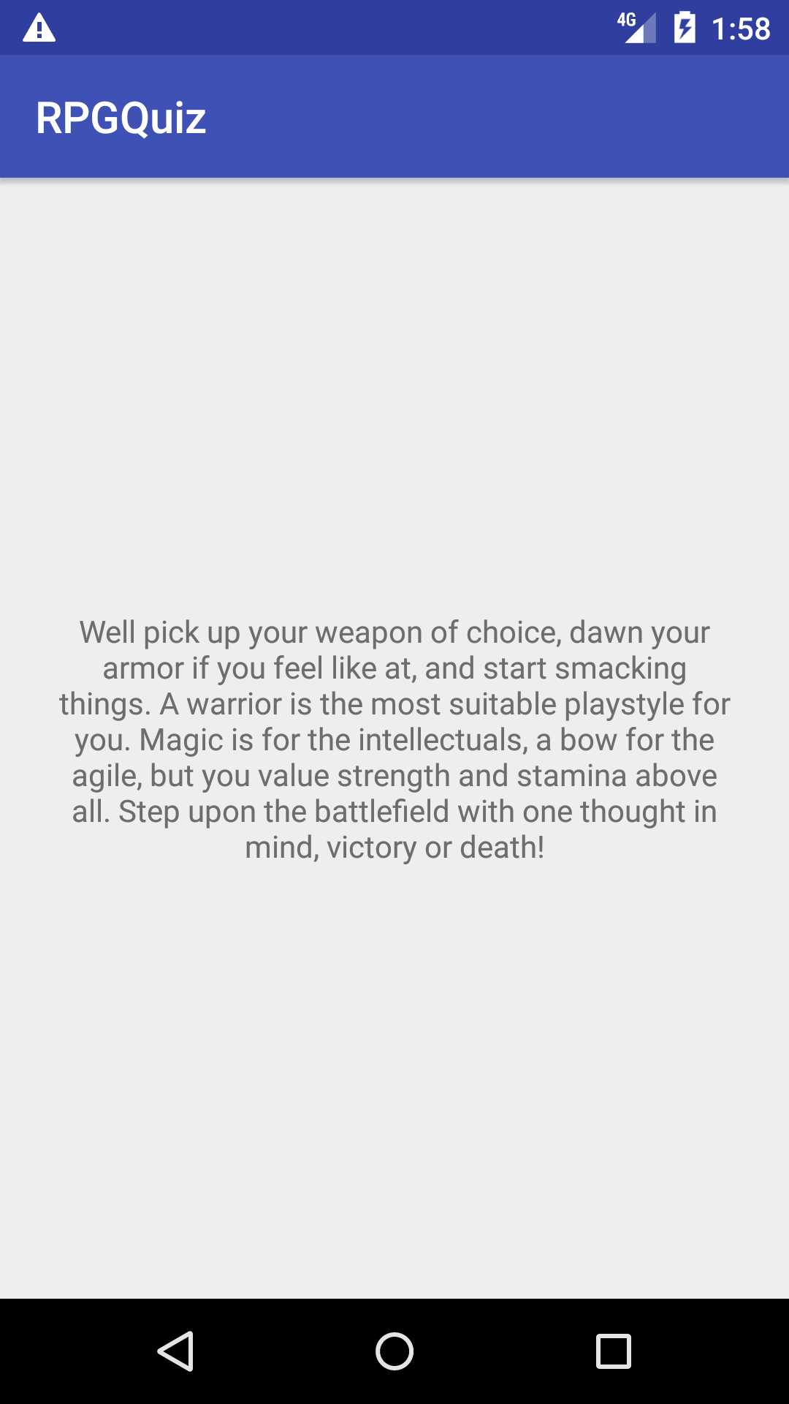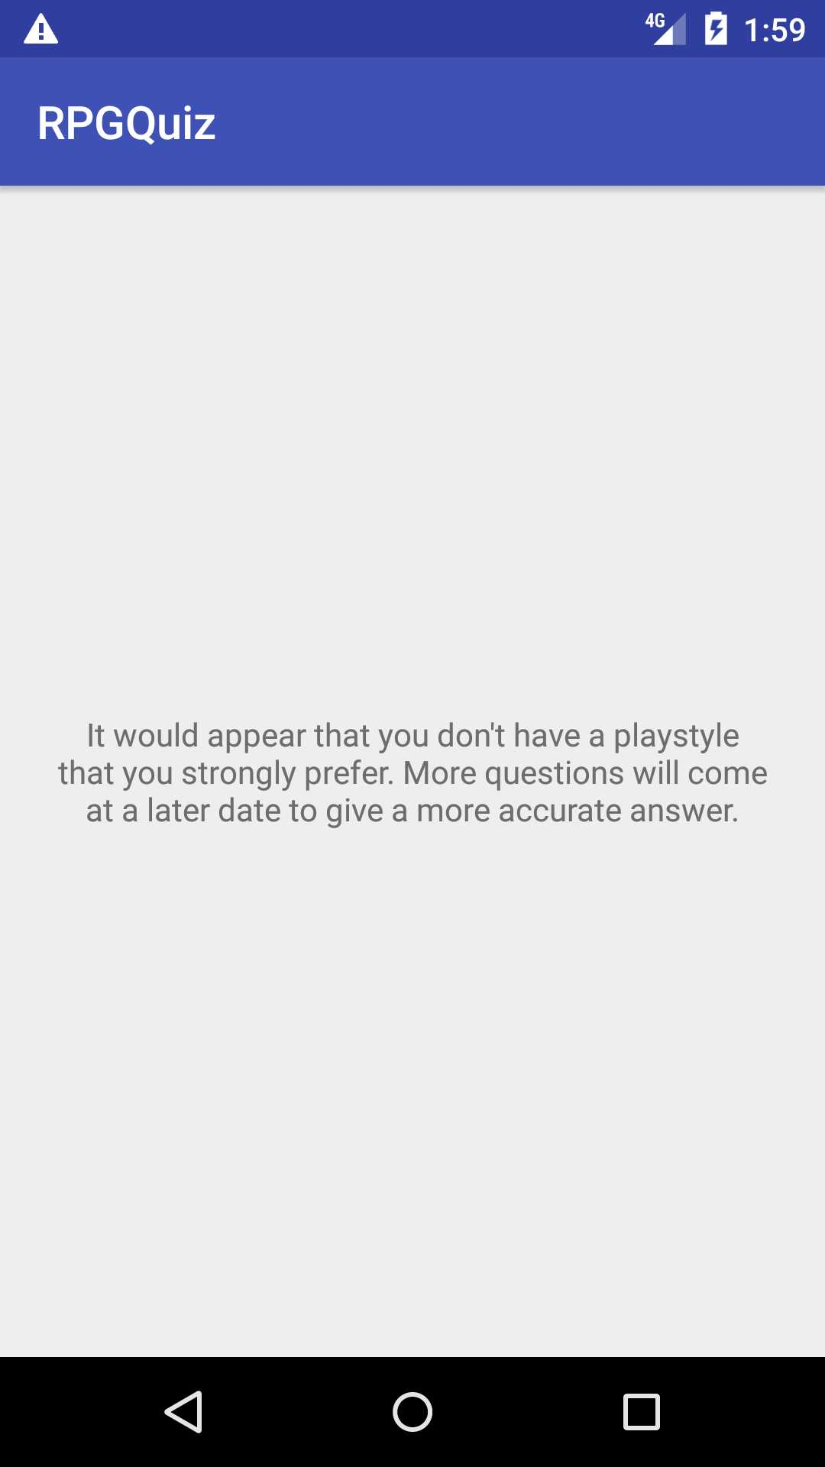

Warrior Answer No Current Result

Retrospective
The process went well for sprint one, however, only tasks which were relatively easy were tackled. Unfortunately as the semester progresses I will be unable to focus on tasks which I know how to do and must set aside time to learn how to complete different tasks in Android Studio. Easy tasks will still exist such as adding background art and changing the theme of the application to one which invokes thought of a fantasy world. These tasks are currently high priority so I plan to knock them out while learning some new things during sprint 2. The complications I encountered were not numerous, but they were difficult to overcome. Halfway through sprint one my laptop’s battery decided it no longer wanted to hold a charge and crapped out during an update. This caused me to have to restore to a point 3 days earlier, and one in which I had nothing completed. To top that off, my android studio’s gradle was starting to give me trouble and I was forced to swap to my desktop at home for this project. To avoid this in the future I can either push my changes through to git-hub when I’m done for the day, or save the files externally. I pray the gods, both old and new, that this does not happen again. Planning will continue tbe same as in sprint one, but tasks will become more specific, and more complex which should both aid in and increase the difficulty of estimating the time a specific task will take. Overall, I think that sprint 1 was handled well, and I hope to do as well on future sprints.

Sprint #2

Sprint Backlog
Story ID | Story / Task | Estimated  Hours | Actual  Hours
2B | Expand Race Quiz | 3
3B | Expand Playstyle Quiz | 3
4 | Menu Creation | 2
5 | Beautify | 4

Review

[Screenshots, etc go here. This is where you discuss the product, describing what was done this sprint (potentially shippable product increment) and what was planned for the sprint but was not done. ]

Retrospective
[This is where you discuss the process. What went well (and are you planning to do more of that?) What didn’t go so well (and do you have a way to do less of that)? What changes are you planning to make in how you plan & carry out the next sprint?]

Sprint #3

Sprint Backlog
Story ID | Story / Task | Estimated  Hours | Actual  Hours

Review

[Screenshots, etc go here. This is where you discuss the product, describing what was done this sprint (potentially shippable product increment) and what was planned for the sprint but was not done. ]

Retrospective
[This is where you discuss the process. What went well (and are you planning to do more of that?) What didn’t go so well (and do you have a way to do less of that)? What changes are you planning to make in how you plan & carry out the next sprint?]

Sprint #4

Sprint Backlog
Story ID | Story / Task | Estimated  Hours | Actual  Hours

Review

[Screenshots, etc go here. This is where you discuss the product, describing what was done this sprint (potentially shippable product increment) and what was planned for the sprint but was not done. ]

Retrospective
[This is where you discuss the process. What went well (and are you planning to do more of that?) What didn’t go so well (and do you have a way to do less of that)? What changes are you planning to make in how you plan & carry out the next sprint?]

Sprint #5

Sprint Backlog
Story ID | Story / Task | Estimated  Hours | Actual  Hours

Review

[Screenshots, etc go here. This is where you discuss the product, describing what was done this sprint (potentially shippable product increment) and what was planned for the sprint but was not done. ]

Retrospective
[This is where you discuss the process. What went well (and are you planning to do more of that?) What didn’t go so well (and do you have a way to do less of that)? What changes are you planning to make in how you plan & carry out the next sprint?]

Sprint #6

Sprint Backlog
Story ID | Story / Task | Estimated  Hours | Actual  Hours

Review

[Screenshots, etc go here. This is where you discuss the product, describing what was done this sprint (potentially shippable product increment) and what was planned for the sprint but was not done. ]

Retrospective
[This is where you discuss the process. What went well (and are you planning to do more of that?) What didn’t go so well (and do you have a way to do less of that)? What changes are you planning to make in how you plan & carry out the next sprint?]

