GitHub Link: https://github.com/dgenak/seip_assignment_1_2026

SCREENSHOTS

CI/CD Pipeline Runs

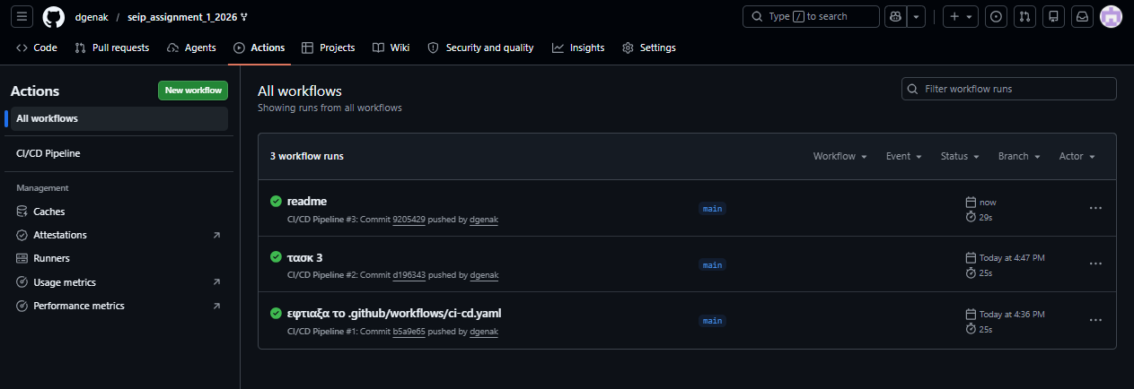
Kubernetes Cluster Status
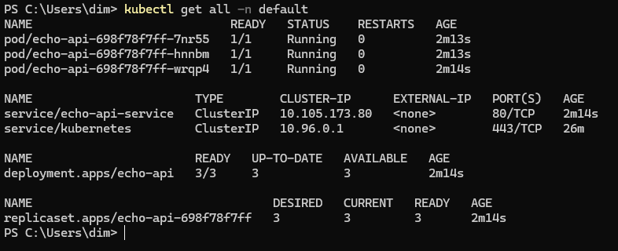

ConfigMap and Secret Verification
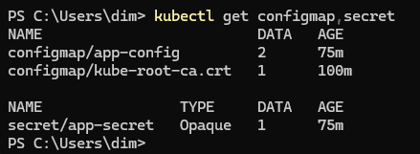
Greeting Endpoint Response
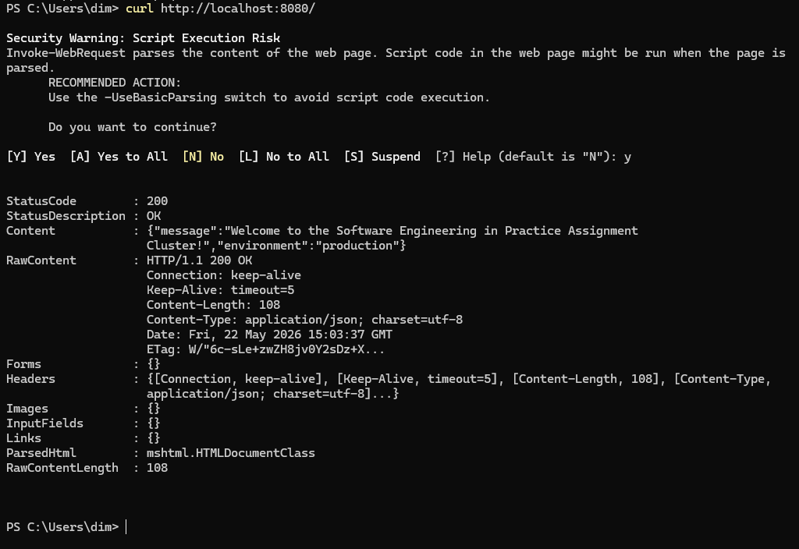

Secure Config Endpoint Response

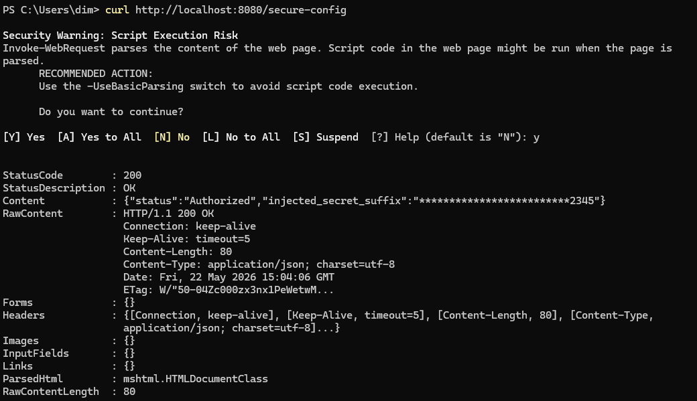

README.md on GitHub
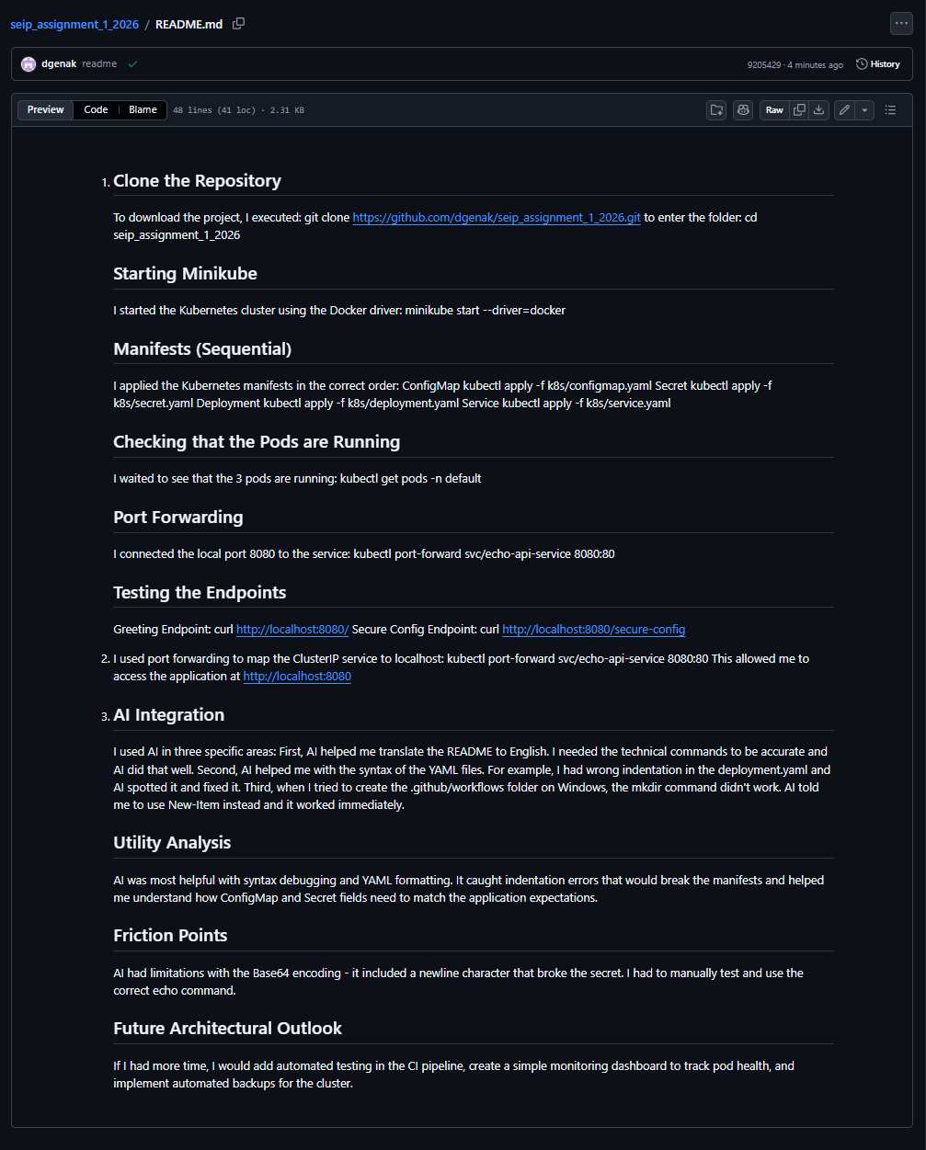

AI Integration
I used AI in three specific areas: First, AI helped me translate the README to English. I needed the technical commands to be accurate and AI did that well. Second, AI helped me with the syntax of the YAML files. For example, I had wrong indentation in the deployment.yaml and AI spotted it and fixed it. Third, when I tried to create the .github/workflows folder on Windows, the mkdir command didn't work. AI told me to use New-Item instead and it worked immediately.

Utility Analysis
AI was most helpful with syntax debugging and YAML formatting. It caught indentation errors that would break the manifests and helped me understand how ConfigMap and Secret fields need to match the application expectations.

Friction Points
AI had limitations with the Base64 encoding - it included a newline character that broke the secret. I had to manually test and use the correct echo command.

Future Architectural Outlook
If I had more time, I would add automated testing in the CI pipeline, create a simple monitoring dashboard to track pod health, and implement automated backups for the cluster.

