A Synopsis Report
on
Hustlrzz — AI-Powered Mock Interview Coach

Submitted to the Department of Information Technology
In partial fulfilment of the requirements
For the degree of
Bachelor of Technology
in
Information Technology
by
Arsh Yar Khan
(2300140130013)

Deepak Gangwar
(2300140130018)

Nikhil Singh
(2300140130035)

Riya Rastogi
(2300140130043)
Group No. 3
Guided By
Mr. Ashish Agrawal
Head of Department

Department of Information Technology

Shri Ram Murti Smarak College of Engineering & Technology, Bareilly
Dr. A. P. J. Abdul Kalam Technical University, Lucknow
September, 2026

ACKNOWLEDGEMENT

We would like to express our heartfelt gratitude to our Project Guide and Head of Information Technology Department, Mr. Ashish Agrawal and our Project Incharge, Ms. Sakshi Goel for their invaluable guidance, constant support and encouragement throughout our major project on Hustlrzz — AI Powered Mock Interview Coach. Their expertise, constructive feedback, and motivation have played a significant role in shaping our understanding and successfully completing this project.
We also extend our sincere thanks to the faculty and staff of SRMS CET for providing us with the necessary resources, facilities, and a supportive academic environment throughout the project.
Additionally, we are grateful to our peers and family for their unwavering support and feedback during this project. This undertaking would not have been possible without the collective efforts and contributions of everyone involved.
Thank you all for your encouragement and belief in our project.

Signature.................. Signature....................
Name: Arsh Yar Khan Name: Deepak Gangwar
Roll no: 2300140130013 Roll no: 2300140130018

Signature.................. Signature....................
Name: Nikhil Singh Name: Riya Rastogi
Roll no: 2300140130035 Roll no: 2300140130043

ABSTRACT

Preparation for job interviews today depends largely on generic question banks, irregular peer practice, and feedback that arrives too late to influence the next attempt. Candidates also find it difficult to translate the evidence already present in their resume into a convincing narrative for a specific role. Hustlrzz is proposed as a web-based, AI-powered interview-preparation and career-coaching platform that brings resume analysis, role-specific interview practice, explainable coaching insight, and progress tracking together in a single secure workspace for students, graduates, career switchers, and working professionals.
The proposed system accepts a resume, a target job description, and optional company context, and returns a preparation pack containing role-relevant questions, answer direction, and role context. A Resume Analyzer processes PDF or DOCX files in memory to identify visible skills, likely gaps, a directional readiness score, and the single highest-value revision. A practice interview, conducted through typed or spoken responses over an authenticated WebSocket channel, produces adaptive follow-up questions and a structured session report. The platform will be implemented using Next.js and TypeScript for the interface, FastAPI for REST and WebSocket services with structured AI orchestration, and Supabase for authentication, PostgreSQL persistence, and row-level security, together with an optional pgvector-based retrieval layer restricted to candidate-approved material.
Every result is presented through a consistent insight pattern — status or score, plain-language takeaway, highest-priority action, and supporting evidence — so that a candidate understands not only how an attempt went but what to do next. Candidate data is protected through authenticated owner checks, row-level security, in-memory document processing, request limits, and daily quotas on high-cost analysis, while a provider-agnostic AI layer with fallback and timeout handling preserves availability when an external service is unreachable. The system is positioned deliberately as a coaching aid rather than an automated hiring or applicant-tracking-system decision maker, and its documented architecture leaves room for later extensions such as multilingual coaching and broader candidate-approved knowledge retrieval.

TABLE OF CONTENT

ACKNOWLEDGEMENT 2
ABSTRACT 3
1. INTRODUCTION 5
1.1 Problem Statement and Scope 5
1.2 Intended Users 5
2. OBJECTIVE 6
2.1 General Objective 6
2.2 Specific Objectives 6
2.3 Success Metrics and Expected Evidence 6
2.4 Planned Deliverables and Boundaries 7
3. LITERATURE SURVEY AND SYSTEM DESIGN 7
4. METHODOLOGY 8
4.1 Working Principle 8
4.2 Technical Approach 9
4.3 End-to-End Data Flow 9
5. PROPOSED MODULES AND REQUIREMENTS 10
5.1 Core Functional Modules 10
5.2 Hardware Requirement/Specification 10
5.3 Software Requirement/Specification 10
5.4 Security and Deployment Requirements 11
6.1 Expected Outcomes 11
6.2 Responsible Use and Future Readiness 12
6.3 Application 12

1. INTRODUCTION

Hustlrzz is proposed as a web-based AI interview-preparation and career-coaching platform for students, graduates, career switchers, and working professionals. It will combine resume analysis, role-specific interview practice, simple coaching insights, and progress tracking in one secure workspace. The system is intended to replace generic question lists and irregular peer practice with tailored, repeatable preparation.

1.1 Problem Statement and Scope
Candidates often receive feedback too late, practice questions that do not match their target role, and struggle to convert a resume into a convincing interview narrative. The proposed solution will accept a resume, target job description, and optional company context; then produce a preparation pack, run typed or spoken practice, and identify one high-value next action. It will be a coaching aid, not an automated hiring or applicant-tracking-system decision maker.
Table 1: Problem-to-solution summary
Current challenge | Typical approach
Generic practice | Static question banks
Unclear feedback | Scores without context
Scattered tools | Separate utilities

1.2 Intended Users
The platform is intended for individual candidates, campus placement cells, career coaches, and training organisations. Individual users will practice privately; institutional users may use the platform to structure preparation activities, while candidate records remain owner-scoped and are not presented as hiring decisions.

2. OBJECTIVE

2.1 General Objective
To design and demonstrate a secure, accessible, and provider-resilient AI coaching platform that helps candidates prepare for interviews and improve their resumes for a chosen role.

2.2 Specific Objectives
- Generate role-specific questions, answer direction, and company/role context from a resume and job description.
- Analyse PDF or DOCX resumes to identify visible skills, likely gaps, and the highest-value revision.
- Provide a real-time typed or spoken interview using authenticated WebSocket communication and adaptive follow-up questions.
- Track presentation while the candidate answers — posture, gesture and eye contact — inside the browser, so camera frames are never sent to the server.
- Present every result as a simple insight: status or score, plain-language takeaway, highest-priority action, and supporting evidence.
- Protect candidate data through authenticated owner checks, row-level security, in-memory document processing, request limits, and browser security controls.
- Keep AI integration provider-agnostic so fallback handling can preserve availability when a provider is unavailable.

2.3 Success Metrics and Expected Evidence

Table 2: Success Metrics and Expected Evidence
Area | Measure | Expected evidence
Personalisation | Role relevance | Resume/JD-aligned question pack
Usability | Action clarity | One takeaway and next step per result
Reliability | Provider resilience | Fallback, timeout, and health checks

2.4 Planned Deliverables and Boundaries
The deliverable will comprise a responsive candidate workspace, authenticated backend APIs, Resume Analyzer, practice interview flow, structured coaching report, and documented deployment configuration. It will deliberately exclude automated selection, unsupported medical/legal advice, unrestricted storage of raw candidate files, and organisation-wide sharing of private candidate material.

3. LITERATURE SURVEY AND SYSTEM DESIGN

Interview-preparation systems commonly offer question banks, video recordings, or generic feedback. Retrieval-augmented generation indicates that responses become more grounded when relevant source material is retrieved before generation; this supports an optional candidate-owned knowledge base built only from approved resume, portfolio, note, or previous-session material. Structured prompting supports a focused coaching flow: understand the role, assess evidence, and give a practical improvement.
Browser-based pose tracking and the Web Speech API show that lightweight presentation and speech features can run on modern devices without storing raw video. The research gap is the lack of a single, candidate-controlled workflow that connects resume review, role preparation, interview practice, and explainable feedback.
Table 3: Comparative analysis of similar existing platforms
Platform | Resume/JD Personalisation | Feedback Approach | Candidate Data Handling
Pramp (peer mock interviews) | None | Peer-driven, subjective | Session shared with peer partner
Big Interview | None | Rubric-based scripted review | Video stored on provider platform
Google Interview Warmup | None | Keyword/tone insight only | No persistent candidate profile
HireVue (employer-facing) | Employer-defined, not candidate-controlled | Automated hiring score | Data used for hiring decisions
Hustlrzz (Proposed) | Resume + JD + company context | Evidence-based, one priority action | Owner-scoped; raw files not retained

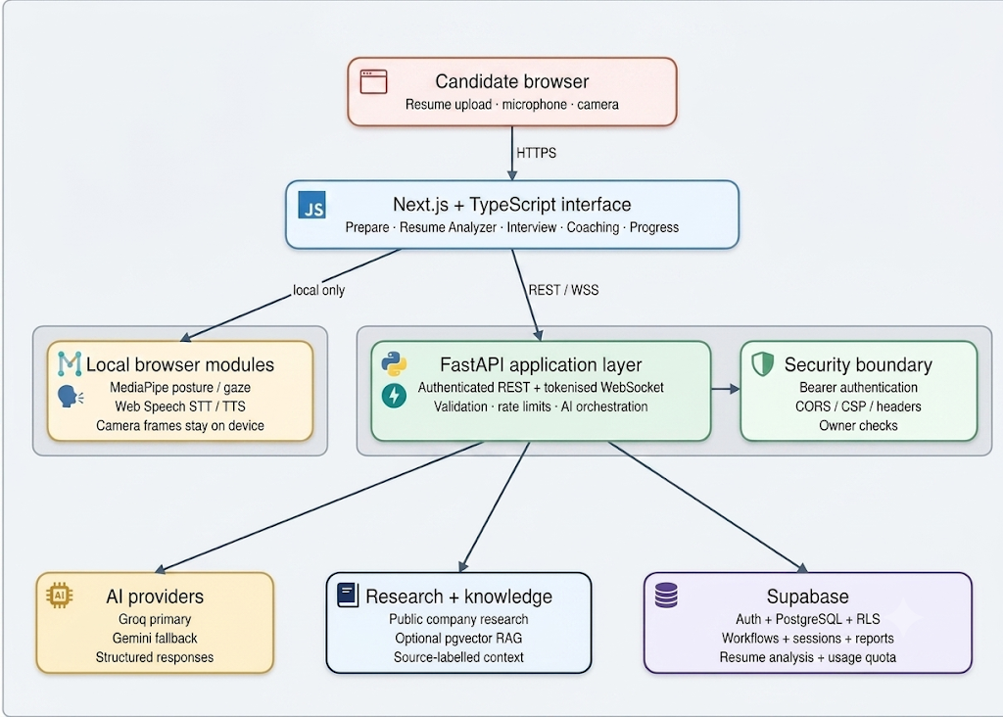

Figure 1: System Architecture of the AI-Powered Interview Platform

The architecture separates browser-local media processing from server-side AI orchestration and persistence. This separation reduces unnecessary transmission of camera data, keeps access controls at clear trust boundaries, and allows provider or knowledge components to evolve independently.

4. METHODOLOGY

4.1 Working Principle

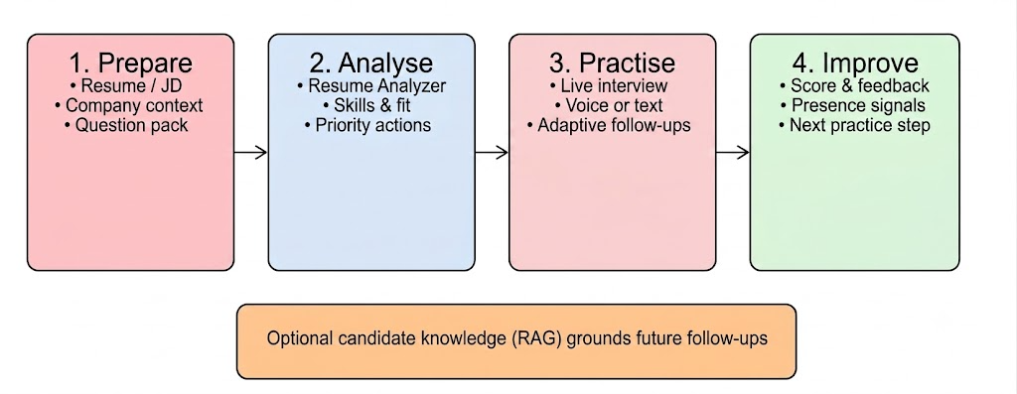
Figure 2: Four-Stage Candidate Workflow — Prepare, Analyse, Practice, Improve

- The candidate signs in and submits a resume, target job description, and optional context.
- The FastAPI application validates the request, extracts document content in memory, and coordinates structured AI analysis through a provider abstraction layer.
- The Next.js interface displays a preparation pack or Resume Analyzer insight, then opens a tokenised practice session through REST and WebSocket endpoints.
- The platform stores only owner-scoped structured results, workflows, sessions, and reports in Supabase; raw upload bytes are discarded after analysis.

4.2 Technical Approach

The frontend will use Next.js and TypeScript. FastAPI will provide REST and WebSocket APIs, structured AI orchestration, validation, and rate limits. Supabase will provide authentication, PostgreSQL persistence, and row-level security. Optional candidate retrieval will use embeddings and pgvector, with source-labelled context restricted to the same authenticated owner.

4.3 End-to-End Data Flow

Table 4: Proposed end-to-end data flow
Stage | Processing | Stored result
Input | Validate resume/JD; extract in memory | No raw upload retained
Analysis | AI orchestration and fallback | Structured workflow/analysis
Practice | Authenticated REST/WebSocket session | Transcript and report per owner
Coaching | Evidence-based insight generation | Priority action and progress

Quality will be checked through validation of inputs, structured-response parsing, authenticated ownership checks, actionable report review, and failure-path testing for provider timeouts or rate-limit responses. The interface will retain a consistent insight pattern so candidates can understand what happened and what to do next.

5. PROPOSED MODULES AND REQUIREMENTS

5.1 Core Functional Modules

Table 5: Proposed functional modules
Module | Candidate input | Planned output
Prepare | Resume, job description, company | Questions, answer direction, role context
Resume Analyzer | PDF/DOCX resume | Skills, gaps, directional score, revision
Interview | Typed/spoken answers | Adaptive follow-ups and session report
Coaching | Session/resume evidence | Takeaway, priority action, next practice
Knowledge base | Resume, portfolio, notes, session report, company research | Indexed chunks with similarity-scored search
Coaching workspaces | Session and resume evidence | Role fit, company playbooks, offer negotiation, practice room
Assessment | Timed multi-round responses | Graded rounds and a readiness report
Settings — provider key | Optional candidate provider credential | Encrypted at rest, shown only as a four-character hint
Account data rights | Authenticated owner | Full data export, or irreversible erasure of all records

5.2 Hardware Requirement/Specification

Table 6: Hardware requirement/specification
Component | Minimum Specification
Processor | Intel Core i5 or equivalent
RAM | 8 GB minimum (16 GB recommended)
Storage | 5 GB free disk space
Internet | Required for AI services and deployment

5.3 Software Requirement/Specification

Table 7: Software requirement/specification
Component | Specification
Operating System | Windows 10/11, Linux, or macOS
Frontend | Node.js 18+, Next.js, TypeScript
Backend | Python 3.11+, FastAPI
Database | Supabase PostgreSQL with Row-Level Security
Tools | VS Code, Git/GitHub, Postman, Docker

5.4 Security and Deployment Requirements
The proposed deployment will use environment-managed secrets, HTTPS, secure browser headers, allowed-origin controls, authenticated WebSocket sessions, owner-scoped access checks, daily usage quotas for high-cost analysis, and application health monitoring. A public launch will additionally require a shared work queue, distributed rate limiting, backup/recovery procedures, and provider-budget alerts.
Settings and provider keys | UI built — backend behavior not yet wired.
Account data rights | UI built — backend behavior not yet wired.
The knowledge base is the one module that is partly built. Source upload and search are implemented, but retrieval quality is still being checked against real documents rather than only against test fixtures, so it is not being reported as complete.
One issue is worth recording because it changes how results are trusted. The knowledge base appeared to pass its automated tests, which supplied a stubbed embedding service. When it was exercised through the running application instead, the configured embedding model had been withdrawn by its provider and every request failed. The tests had therefore confirmed the code path, not the feature. Retrieval is now being re-validated against a live provider before the module is reported as complete.
The remaining planned modules, together with capacity planning, backup and recovery procedures, and evaluation with real users, form the next stage of work. Until the status above changes, none of them should be treated as available.

6. EXPECTED OUTCOMES AND APPLICATION

6.1 Expected Outcomes
- A working prototype where a candidate can prepare for a target role, analyse a resume, practice an interview, and receive focused coaching.
- A Resume Analyzer that accepts PDF/DOCX files, identifies visible and missing skills, provides a directional readiness score, and prioritises the next revision.
- Secure candidate isolation through authenticated access, owner checks, Supabase row-level security, rate limits, and controlled WebSocket sessions.
- Provider fallback, request timeouts, quotas for high-cost analysis, and health monitoring to support dependable operation.
- A documented, extensible architecture suitable for future additions such as multilingual coaching, shared AI work queues, and broader candidate-approved knowledge retrieval.

6.2 Responsible Use and Future Readiness

Table 9: Responsible-use design controls
Design control | Purpose
Owner checks + RLS | Keep each candidate's records isolated
In-memory file processing | Avoid retaining raw resume uploads
Rate limits + quotas | Control high-cost AI actions
Fallback + timeouts | Reduce disruption during provider failure

6.3 Application
Hustlrzz can support any job seeker who wants structured career preparation: students applying for internships or placements, graduates entering their first role, professionals changing careers, and candidates preparing for leadership or salary-negotiation conversations. It can also support placement cells, career-coaching programmes, and training organisations as a guided practice platform. Before a wider public release, the proposed system will require production capacity planning, shared queueing, distributed rate limiting, provider-budget controls, privacy review, and user evaluation.

Hustlrzz — AI-Powered Mock Interview Coach
by
Group No. 3

Signature: ...................................... Signature:.....................................
Name: Arsh Yar Khan Name: Deepak Gangwar
Roll No.: 2300140130013 Roll No.: 2300140130018

Signature: ...................................... Signature: ....................................
Name: Nikhil Singh Name: Riya Rastogi
Roll No.: 2300140130035 Roll No.: 2300140130043

Mr. Ashish Agrawal Ms. Sakshi Goel
Project Guide Project Incharge


Department of Information Technology
Shri Ram Murti Smarak College of Engineering & Technology, Bareilly
Dr. APJ Abdul Kalam Technical University, Lucknow
September, 2026

