# Week 8 – ANT build

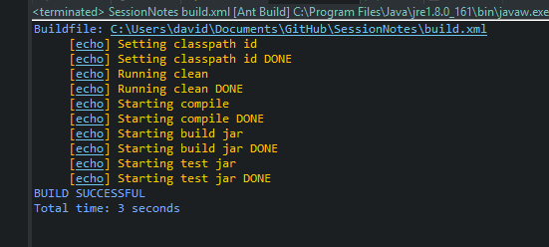

# Week7 – JUnit Application Suite

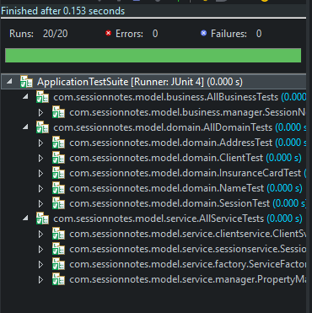

# Week6 – JUnit Application Suite

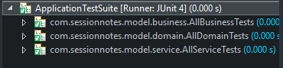

# Week5 – JUnit Application Suite

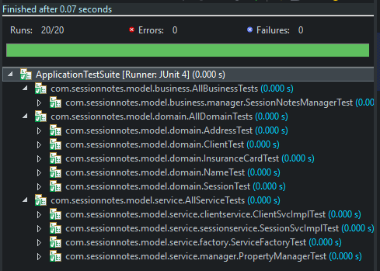

# Week 4 – JUnit Suite

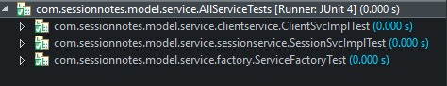

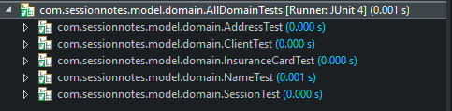

# Week 3 – JUnit Suite

com.sessionnotes.model.service.AllServiceTests

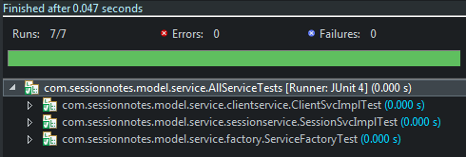

com.sessionnotes.model.domain.AllDomainTests

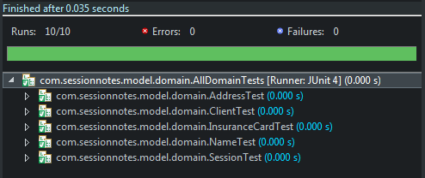

# Week2

