MLP _mnist데이터셋

* BatchSize : 100
* LearningRate : 0.001

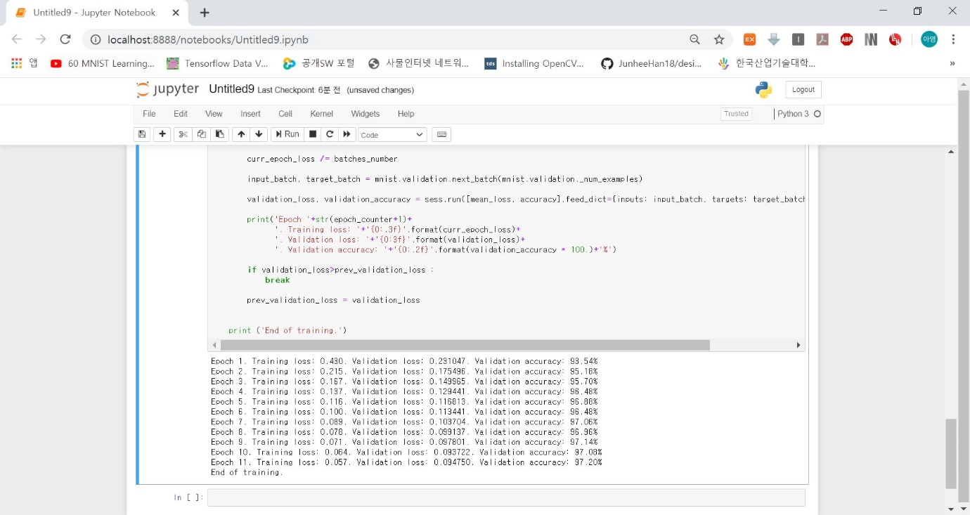

MLP

* BatchSize : 100
* LearningRate : 0.0001

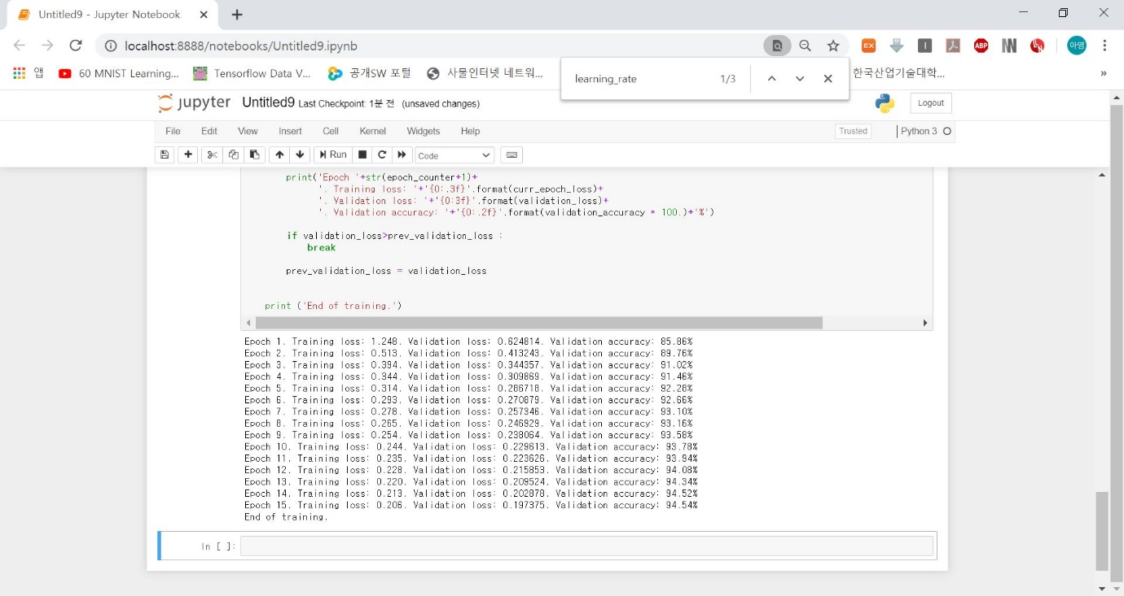

MLP

* BatchSize : 100
* LearningRate : 0.01

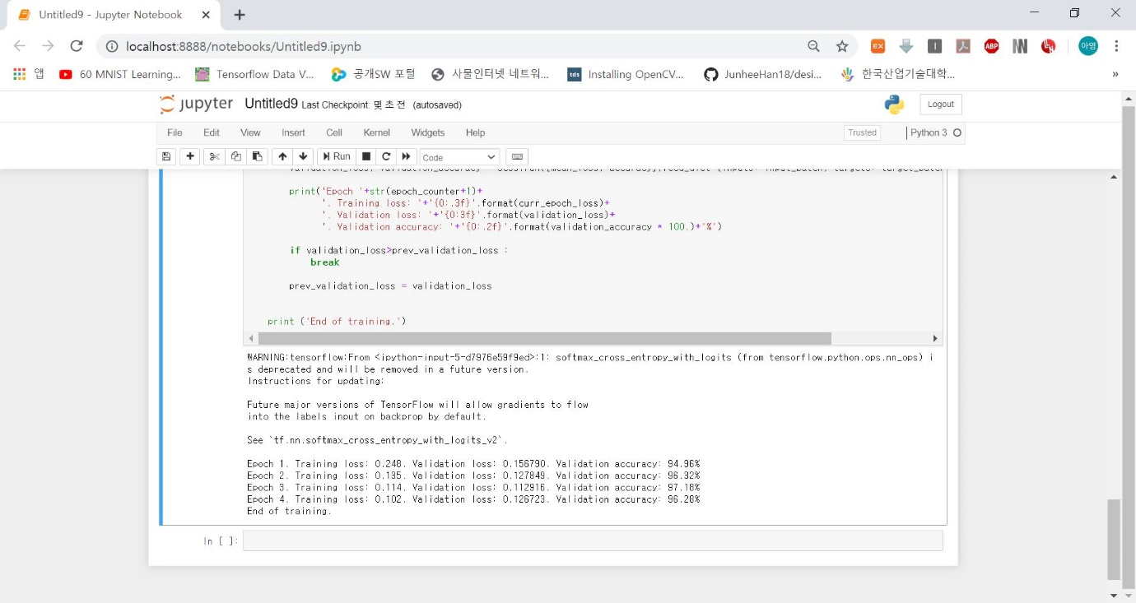

MLP

* BatchSize : 100
* LearningRate : 0.1

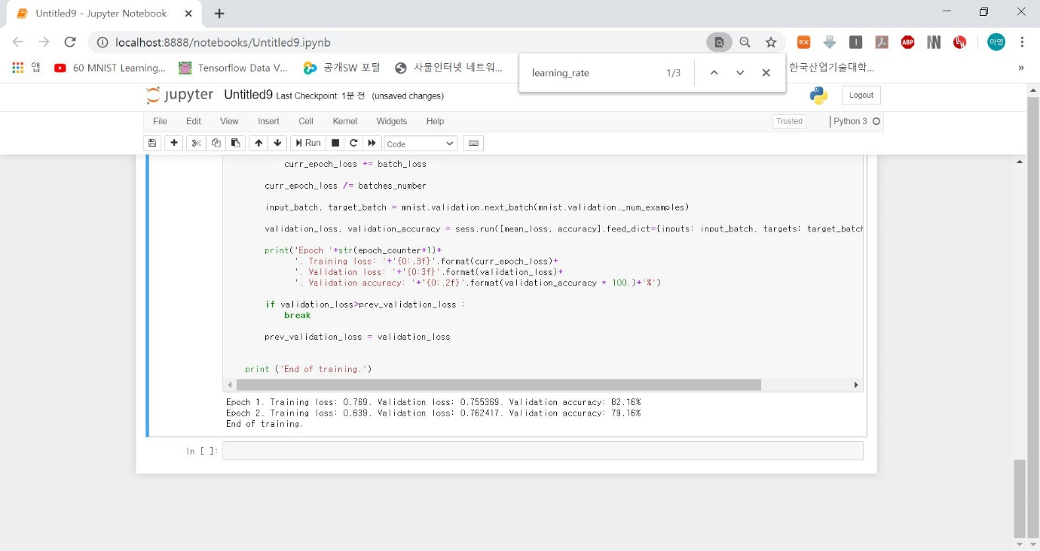

MLP

* BatchSize : 50
* LearningRate : 0.001

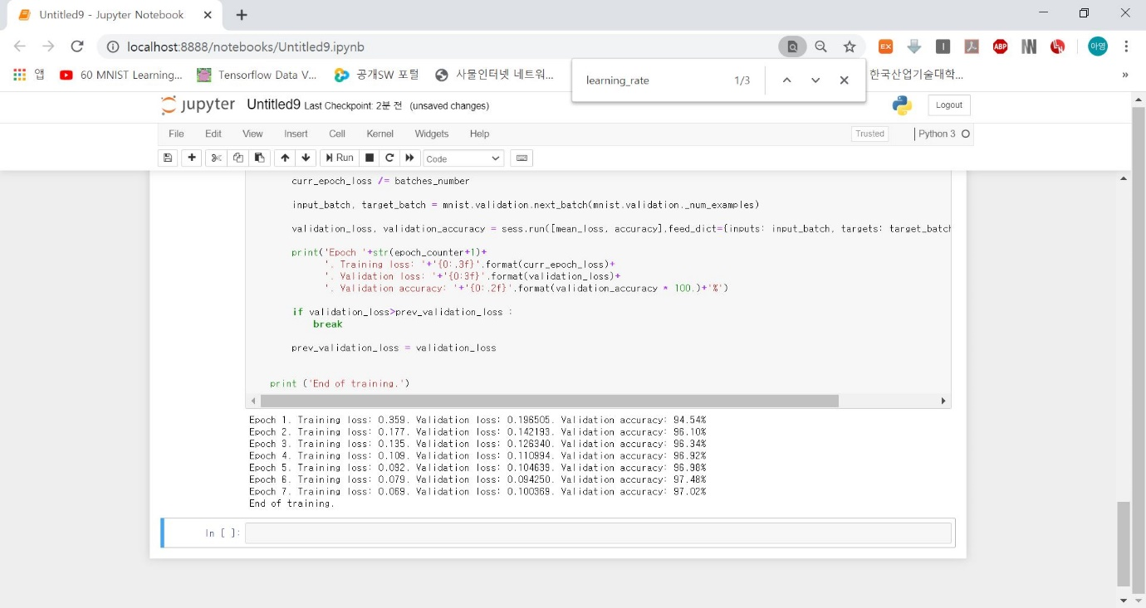

MLP

* BatchSize : 10
* LearningRate : 0.001

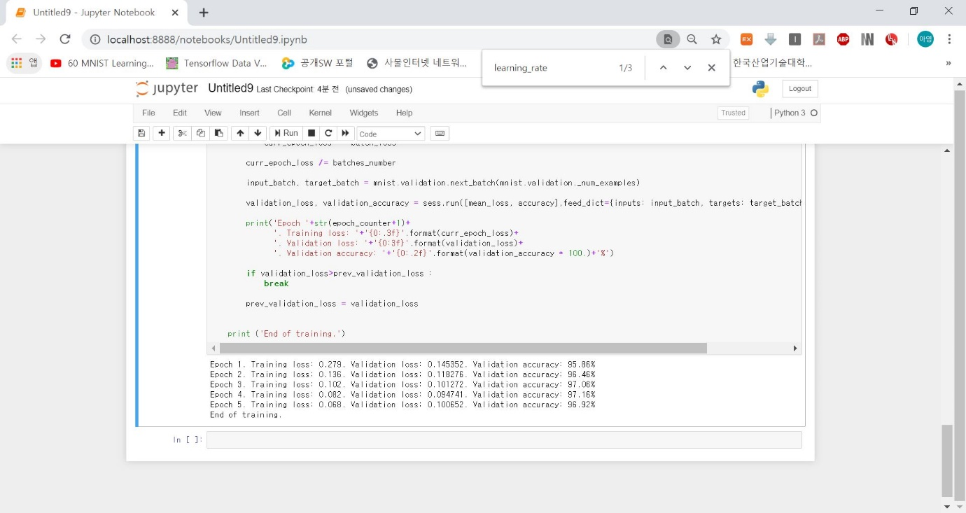

SGD optimizer 사용, cost function ->LMS 사용

* Hyperparameter information

Learning rate 조절(0.1,0.01,0.001), epoch25로 고정

* + Learning rate 0.1

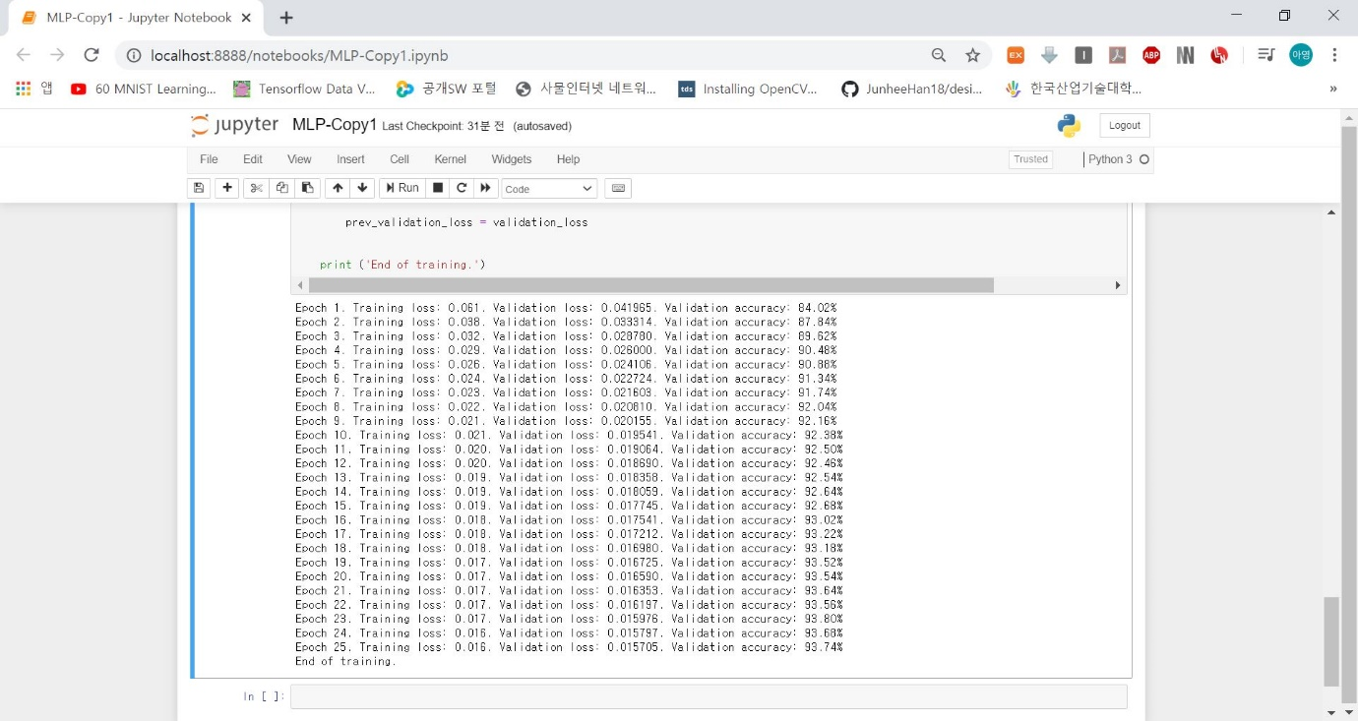

* + Learning rate 0.01

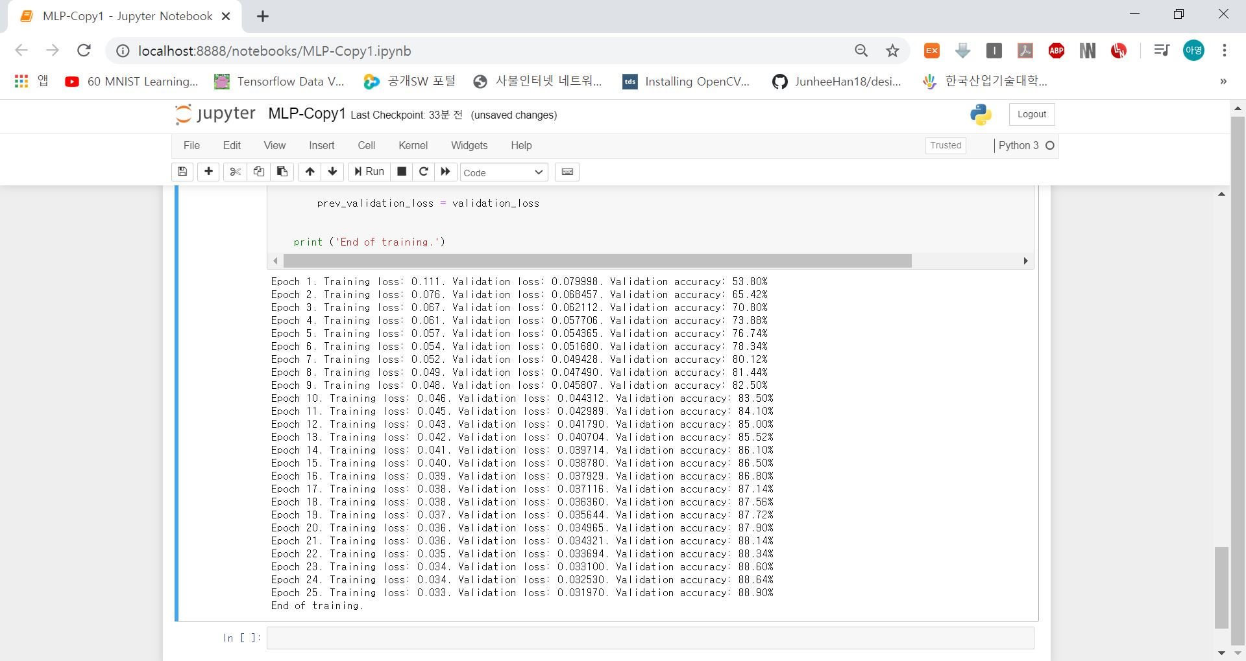

* + Learning rate 0.001

