Data Dictionary

2022-06-26

# Data Dictionary Help

[**Guidelines for Data Collection & Data Entry**](../files/Data_Dictionary_Vanderbuilt.pdf) - Theresa A Scott, MS (Vanderbilt University)

# Kenya DHS Data Dictionary ([file](../files/data_dict.csv))

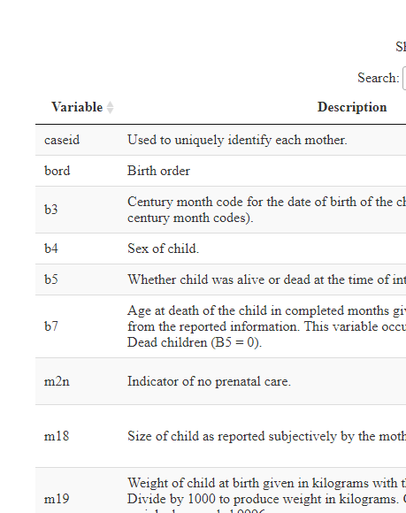

## Century Month Code

All dates in the data file are expressed in terms of months and years and also as century month codes. A century month code (CMC) is the number of the month since the start of the century.

For example, January 1900 is CMC 1, January 1901 is CMC 13, January 1980 is CMC 961, September 1994 is CMC 1137.

The CMC for a date is calculated from the month and year as follows: CMC = (YY * 12) + MM for month MM in year 19YY.

To calculate the month and year from the CMC use the following formulae: YY = int((CMC - 1) / 12) MM = CMC - (YY * 12)

For Dates in 2000 and after the CMC is calculated as follows: CMC = ((YYYY-1900) * 12) + MM for month MM in year YYYY.

To calculate the month and year from the CMC use the following formulae: YYYY = int((CMC - 1) / 12)+1900 MM = CMC - ((YYYY-1900) * 12)