Biostat Lab

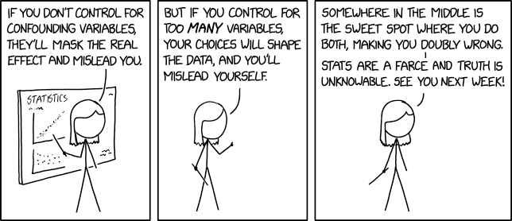

[Confounding Variables](https://www.explainxkcd.com/wiki/index.php/2560:_Confounding_Variables)