**[your name]**

**[your email ]**

**Project description Summary**

Website to display my favorite hobbies. Website includes a hobby list, about page and a contact us page.

**User Stories**

1. As a User, I would like to display a list of hobbies information on the home page.
2. As a User, I would like to display summary information about the website on the about page;
3. As a User, I would like to enter contact information such as name, email and comments on the contact us page, to submit request information.
4. As a user, Please provide a navigation menu to allow users to goto different webpages, for example, home page, contact us page, and about pages,

**Project Files**

Github repo url

Github pages Website Url

**Website file information**

Home page

About page

Contact Us page

README.md

**Technologies used**:

* HTML5
* CSS
* Bootstrap
* Git/GitHub workflow

Website Wireframes example - using ***draw.io*** , can also use ***Microsoft paint*** or other drawing programs

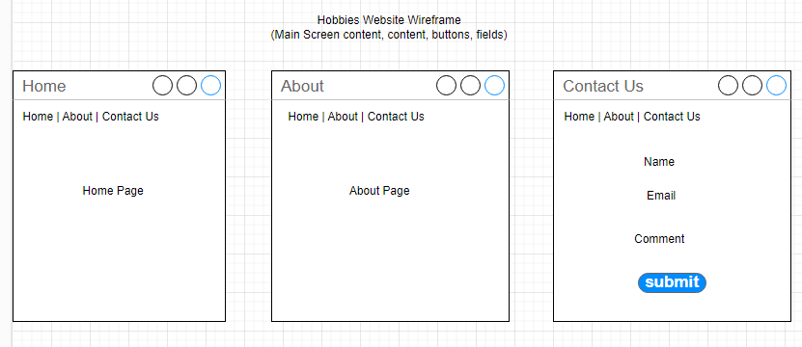

Text wireframe example   
—-------------------------------------------

Home Page

—---------------------------------

Home | About | Contact Us

[ image ]

* Hobbies Listing

- Hobby 1

- Hobby 2

- Hobby 3

Contact Us

—---------------------------------

Home | About | Contact Us

* Username

* Email

* Comment

[submit]

About Page

—---------------------------------

Home | About | Contact Us

[ image ]

About website

**Website REAMDE.md Example**::

[ your name ], [your email ]

Github repo

- <https://github.com/dgilbert-quickstart/dgilbert-quickstart.github.io.git>

Website Url

- https://dgilbert-quickstart.github.io

Project Summary:

Website to display my favorite hobbies. Website includes a hobby list, about page and a <br/> contact us page. Contact us page allows anyone to submit name, email and comment <br/> from the website.

### Website file information

- About page - information about the website

- Home page - welcome page and listing of favorite hobbies

- Contact us page

### Technologies used:

- HTML5

- CSS

- Bootstrap

- Git/Github

### future enhancements

- 1. Application logo icon in navigation menu

- 2. Font icons ie: menu icons

- 3. Screen flow diagram

- 4. Login page - allow user to access private webpage content

- 5. Registration page - allow user to access private webpage content

- 6. Responsive website in mobile and tablet views

## if website error

- mention error and screen prints in your project submit document