

Comparison of several forms of dimension reduction on cuantitative morphological features for normal, abnormal and reactive lymphocyte diferentiation.

Daniel Giménez Gredilla
Máster Universitario en Bioinformática y Bioestadística
Machine Learning

Advisor: Edwin Santiago Alférez Baquero

2 de Enero de 2018

Esta obra está sujeta a una licencia de Reconocimiento-NoComercial-SinObraDerivada 3.0 España de Creative Commons
FICHA DEL TRABAJO FINAL

Título del trabajo: | Comparison of several forms of dimension reduction on cuantitative morphological features for normal, abnormal and reactive lymphocyte diferentiation.
Nombre del autor: | Daniel Giménez Gredilla
Nombre del consultor/a: | Edwin Santiago Alférez Baquero
Nombre del PRA: | Edwin Santiago Alférez Baquero
Fecha de entrega (mm/aaaa): | 01/2018
Titulación: | Máster Universitario en Bioinformática y Bioestadística
Área del Trabajo Final: | Machine Learning
Idioma del trabajo: | Inglés
Palabras clave | Dimension, reduction, lymphocyte
Resumen del Trabajo (máximo 250 palabras): Con la finalidad, contexto de aplicación, metodología, resultados i conclusiones del trabajo.
La reducción dimensional es el proceso por el que el número de variables observado en un estudio es reducido a una cantidad menor. El término “linfoma” define un grupo de cánceres de glóbulos blancos que afectan tanto a adultos como a niños. El diagnóstico y tratamiento correcto del linfoma ofrece una tasa de supervivencia significativa. La “Maldición de la Dimensionalidad” es un problema común en el que la adición de dimensiones en conjuntos de datos produce una dilución de la información. Esto puede ser evitado mediante técnicas de reducción dimensional. Este estudio se enfoca en la comparación de la eficiencia de PCA, ICA, Análisis de Factores y LDA. PCA, LDA y Análisis de Factores demuestran buenos resultados. Los mismos se muestran en una tabla comparativa.

Abstract (in English, 250 words or less):
Dimension reduction, or dimensionality reduction, is the process through which the number of variables observed in a study is reduced to a smaller number. The term Lymphoma defines a group of very common white blood cell cancers that affect both adult individuals and children. The correct diagnosis and treatment of lymphoma offers a significant survival rate. The Curse of Dimensionality is a common problem in which additional dimensions in data sets make information sparser. This can be managed by dimension reduction techniques. This study aims to compare the performance of PCA, ICA, Factor Analysis and LDA. LDA, PCA and Factor Analysis are shown to yield good results. A comparative table is given.

Índice

1. Introduction 1
1.1 – Context and justification for this project 1
1.2 - Project goals 5
1.2.1 - General goals 5
1.2.2 - Specific goals 6
1.3 - Focus and followed method 6
1.4 - Project plan 6
1.4.1 – Tasks 6
1.4.2 - Calendar 7
1.4.3 – Milestones 8
1.4.4 - Risk analysis 8
1.4.5 - Associated project costs 9
1.4.6 - Ethical and legal data implications 9
1.4.7 - Briefing: first monitoring report - November 2017 9
1.4.8 - Briefing: second monitoring report - December 2017 10
1.4.9 - Final Gantt Diagram (after alterations) 12
1.4.9 – Final Gantt Diagram (after alterations) 12
1.5 - Brief summary of products obtained 13
1.5.1 - Work plan 13
1.5.2 – Report 13
1.5.3 – Product 14
1.5.4 - Virtual presentation 14
1.5.5 - Project self-evaluation 14
1.6 - Brief description of other chapters 15
2 - Dimension reduction: an introduction 16
2.1 – PCA 17
2.1.1 - Historical background 17
2.1.2 - Mathematical background 17
2.1.3 - Reasons for selection 18
2.2 – ICA 19
2.2.1 - Historical background 19
2.2.2 - Mathematical background 19
2.2.3 – Selection 20
2.3 - Factor Analysis 21
2.3.1 - Historical background 21
2.3.2 - Mathematical background 22
2.3.3 – Selection 23
2.4 – Autoencoders 23
2.4.1 - Historical background 24
2.4.2 - Mathematical background 24
2.4.3 – Selection 24
2.5 - T-distributed Stochastic Neighbor Embedding 24
2.5.2 - Mathematical background 25
2.5.3 – Selection 26
2.6 – LDA 26
2.6.1 – Selection 26
3 – Tools 26
3.1 – Criteria 26
3.2 – Python 27
3.2.1 - History 27
3.2.2 – Modules 28
3.3 – R 29
3.3.1 - Packages and libraries 29
4 - Comparative scoring 30
4.1 - Classification accuracy mètrics 30
4.2 - Binary classification versus multiclass classification mètrics 32
4.3 - Classification Rate 33
4.4 - Cohen’s Kappa 33
4.5 - Chosen scoring mètric 33
5 - Comparison methods and protocols 33
5.1 - Introduction and general data set description 33
5.1.2 - Class imbalance problema 34
5.1.3 - The SMOTE() function 34
5.2 - Goals and techniques 35
5.3 - Dimension Reduction Techniques – R 36
5.3.1 – PCA 36
5.3.2 – ICA 37
5.3.3 - Factor Analysis 38
5.3.4 – LDA 40
5.4 - Dimension Reduction Techniques – Python 40
5.4.1 – PCA 41
5.4.2 – ICA 41
5.4.3 - Factor Analysis 42
5.4.4 – LDA 43
5.5 - Missing techniques 43
6 – Conclussions 44
7 – Glossary 45
8 – References 47
9 - Annexes 50
Annex 1 - R comparison code 50
Annex 2 - Python comparison code 52

1. Introduction

The current project is framed in the context of lymphocyte classification. Lymphocyte classification is achieved through the evaluation of morphologic, geometric and colorimetric features. Dimension reduction, or dimensionality reduction, is the process through which the number of variables observed in a study is reduced to a “manageable” number, considering as “manageable” that which produces the best prediction accuracy while keeping the noise and processing requirements to a minimum.

Machine learning algorithms are expensive in processing power and benefit from appropriate data representations in the form of constructed features derived from the original input. There are a number of feature construction methods, both supervised and unsupervised, such as clustering (replacing a number of similar variables by a cluster centroid), basic linear transforms (such as SVD, Singular Value Decomposition, which reconstructs the data in the form of the best linear combination in the least square sense), Fourier Transforms, and also simple, task-specific functions (Guyon and Elisseeff 2003).

While dimension reduction is useful in every field of application of Machine Learning, the proposed area for this project is the morphological analysis of lymphocytes. Lymphocytes are classified as normal, abnormal or reactive attending to morphological features, being neoplasic lymphoid cells the most difficult to be recognized by only qualitative morphologic features (Puigví et al. 2017). The chosen topic for this project is the comparison of the behaviour of different dimension reduction techniques applied to this study.

1.1 – Context and justification for this project

The term Lymphoma defines a group of very common white blood cell cancers that affect both adult individuals and children. Symptoms include sweating, itches, enlarged lymph nodes, fever and a prolonged feeling of fatigue. It is classified into many subtypes, being first and mainly divided into Hodgkins and non-Hodgkins lymphomas, and then subdivided in dozens of subtypes. The correct diagnosis and treatment of lymphoma offers a significant survival rate.

This diagnosis involves, as part of the protocol, visual morphological analysis of peripheral blood cells in the form of a blood smear (Fig. 1). This is an expert-driven field in which interobserver and intraobserver variations may supose a hindrance (Puigví et al. 2017). The categorisation of cells depends on morphological features such as nucleus morphology, hairiness or nucleus-cytoplasm proportions.

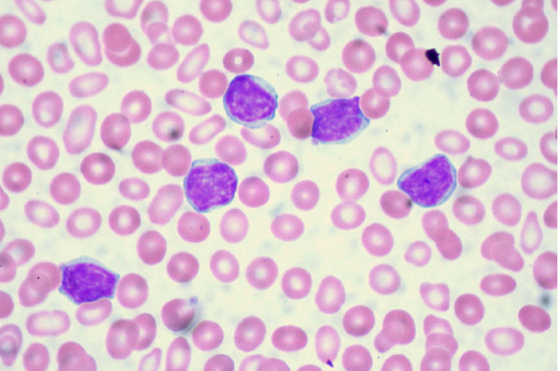
Figure 1: Microscopic image of blood smear containing lymphocytes (purple, with granulated nuclei) (Source: Euthman, https://www.flickr.com/photos/euthman/2869815349 )

As blood smear image examination is a tedious and time consuming process (Naugler et al. 2014), many algorithms have been developed to automate the process. Image recognition and segmentation is used to prepare the input, usually dividing the cell image into masks. A cell mask is produced, by selecting the cell amongst the other elements of the image. The cell is then divided into semantically significant regions (e.g. nucleus mask or cytoplasm mask) through image segmentation, via techniques such as the Watershed Transformation or unsupervised machine learning algorithms as Color Clustering. This image processing step is crucial for a good classification workflow, as it prepares the input for the following steps.

The next step is feature selection/extraction, in which a group of features is measured; these quantitative values are used for classification. Good features must be informative. Features that largely overlap between classes do not offer a significant amount of distinctiveness. The selected or extracted features must be very similar inside the same class and distinctive between classes. White blood cells are wildly different between them, varying substantially between cell families, and although there are features that are observably different between families, not all features will be significant for a classification task.

The last step is the classification itself. Classification searches for a pattern to be established that can reliably assign a given sample to a given class. There are many machine learning algorithms used to find these patterns, such as ANNs or SVMs. For the purposes of this project, a focus will be given to SVMs.

Support Vector Machines are a machine learning algorithm first introduced by Vladimir Vapnik (Leslie, Eskin, and Noble 2002). They aim to find one or a set of hyperplanes that divide the sample space into categories, as cleanly as possible and with as little interference of samples from one space into another. This or these hyperplanes are then used to classify new test samples into one of the original classe.

In a non-ideal, more realistic background, samples won’t be always cleanly separated into smooth groups. This situation is managed by searching for a compromise between maximum classification accuracy and a reasonable classification error. Different kernels can also be introduced in the SVM algorithm in order to improve the classification results.

The morphological features of peripheral blood cells were first translated into a mathematical scoring System by Benattar and Flandrin (Benattar and Flandrin 2001). Mathematical measurement of these features induces intraobserver and interobserver objectivity and allows for a quantitative assesment of cell features, being the ones in abnormal lymphocytes the most difficult to identify. Thus, mathematical morphology tools have been developed with the aim of processing peripheral blood images and extracting and processing sets of features which are then used to classify the cell. These features need to be constructed and optimized for best performance and accuracy of the derived classification, or, in some cases, risk being affected by the Curse of Dimensionality.

The Curse of Dimensionality is a common problem for many data analysis fields, in that as the dimensionality (number of observed features, or number of dimensions) of the data grows, the analytic space grows exponentially with each added dimension; even though the initial number of samples may be optimized for a study, the real quantity of information quickly grows “sparse” as the dimensionality of the study grows. In many nearest neighbor approaches to data analysis this problem is buffered by the fact that significant new dimensions also offer more contrast between points, so it is those noise dimensions that need to be identified and suppressed.

This can be managed by dimension reduction methods, as it has been in (Puigví et al. 2017) and (Alférez 2015). The most complete set of features is described in detail in the former, in the Materials and Methods section. In this study, a total of 325 patients were included (Fig.2), for a total of 12574 cell images. This images were obtained using the CellaVision DM96.

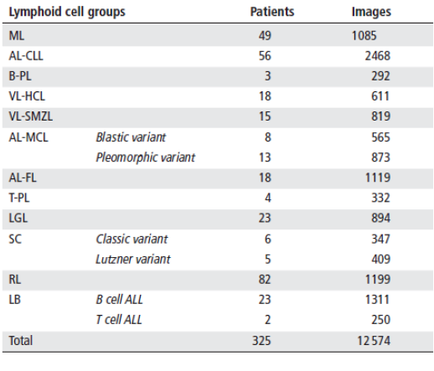
Figure 2: Distribution of lymphoid cell groups, number of patients and images included in the study (Source: Puigví et al.)

Three ROIs (Regions of Interest) are obtained (nucleus, whole cell and peripheral zone around the cell), and a fourth ROI is obtained as the difference between cell and nucleus regions (Fig.3). Features are divided in geometric features and color-texture features, all of them measured quantitatively.

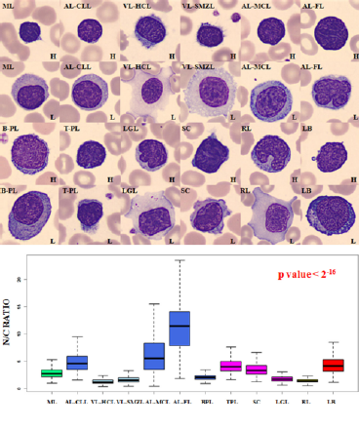
Figure 3: Examples of different cells, showing differential nucleus/cytoplasm ratio, with associated boxplots (Source: Puigví et al.)

All in all, 27 geometric features (including area, perimeter and N/C ratio) and 2649 colour-texture features (43 texture features applied through six colour spaces: RGB, CMYK, XYZ, Lab, Luv and HSV) are extracted, for a total of 2676 features.

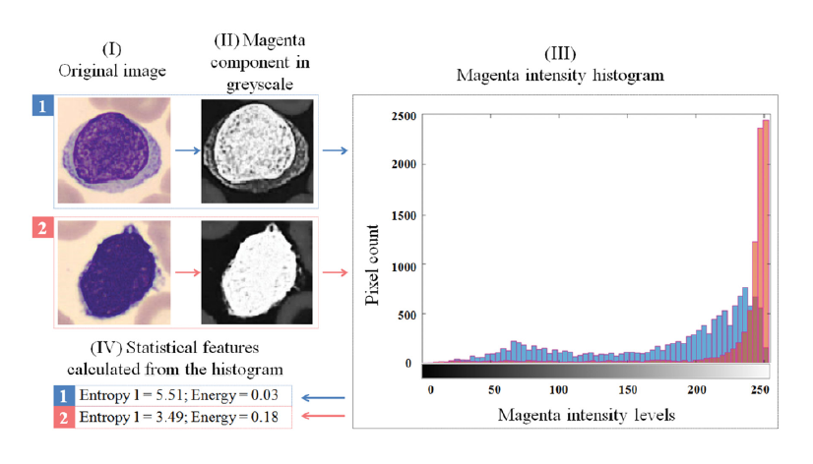
Figure 4: Magenta component grayscale decomposition and associated histogram (Source: Puigví et al.)

The problem of dimensionality is solved through dimension reduction techniques (theoretic feature selection), decreasing the number of features to a more relevant, less redundant subset of 20 features (Fig.5), and malignant diagnoses were confirmed following the WHO classification.

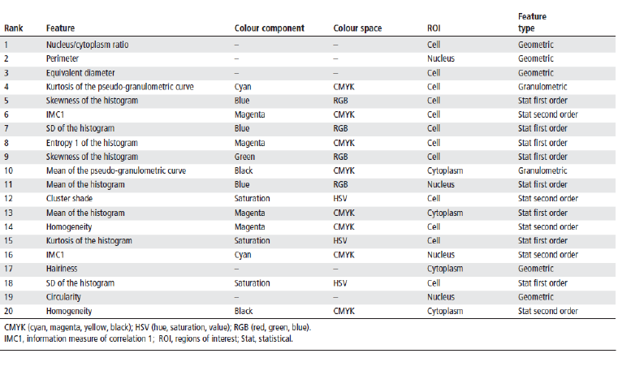
Figure 5:20 most relevant, less redundant features selected (Source: Puigví et al.)

Data analysis was performed with R code, validating for residual normality through Kolmogorov-Smirnov, homocedasticity through Flingner-Killeen, significance through Kruskal-Wallis and multiple comparisons through Kruskal-Wallis after Dunn tests applying a Bonferroni adjustment.

The selected features allowed for the quantification of different morphological characteristics with significant p-values, being N/C ratio the best feature for distinction.

As has been mentioned, the correct diagnosis of lymphoma offers a significant survival rate, an as such, every single step of the classification protocol should be optimised for best performance, both in terms of accuracy and costs. Thus, the justification for this project on a scientific level is to compare the feasibility of several dimension reduction techniques applied to the classification of lymphoma. This comparison will be made
through an accuracy scoring result.

The accuracy of a prediction is the proportion of true positives plus true negatives against the total prediction result. It measures the amount of cases in which the observed results matched the expected results. Errors in prediction may or may not have the same “weight” for a given problem (as an example, a false positive in cancer diagnosis may raise an unnecesary alarm; a false negative may cause a lack of treatment and so, a serious health issue). This project will, through understanding of the context of the mentioned study, establish an accuracy scoring system, determine if different errors have different costs, compare scores, and analyse the results for conclussions both on comparison of techniques and the implications of the scoring system.

1.2 - Project goals

1.2.1 - General goals
The goal of this project is to compare several techniques of dimension reduction through the construction of significant features and their respective results given a classification workflow. This classification workflow should differentiate normal, abnormal and reactive lymphoid cells. The resulting accuracy vàlues will serve as scoring for the features constructed, and as such, for the objective assesment of the behaviour of the dimension reduction techniques behind them.

1.2.2 - Specific goals

Specific goals for Phase 1 (17-10-2017 through 20-11-2017)

1 - To design a comparison protocol for different dimension reduction techniques.
1.1 - To research, understand, brief on, and choose an array of dimension reduction techniques for comparison.
1.2 - To choose a programming environment to work with (languages, frameworks. . . )
1.3 - To assess the methods of, understand and ultimately extract a subset of functions from the appointed languages and frameworks to apply to the test data.

Specific goals for Phase 2 (21-11-2017 through 18-12-2017)

2 - To apply this protocol to each technique within the frame of lymphocyte classification, achieving an objectively quantifiable scoring system.
2.1 - To set a scoring system to satisfy the need for an objective measure of accuracy. This scoring System will include weighing of types of errors.
2.2 - To apply each of the selected dimension reduction techniques, under equivalent parameters, to the test data.
2.3 - To classify the behaviour of the referred techniques, based on the selected scoring system, as applied to the stated problem (lymphocyte classification)

1.3 - Focus and followed method

Given the particular goal of this project (the comparison of dimension reduction techniques), the focus to accomplish it is directed to the evaluation of the accuracy of classification tasks implementing each of these techniques. Feature construction aims to explain the most variance through the less possible, most explicative, features. For a constant given amount of variance explained through variables in a classification
task, the accuracy of the predicted classes improves while the number of dimensions decreases.

The method to accomplish this is a selection of dimension reduction techniques, including PCA, ICA and Factor Analysis amongst others, applied to the problem dataset and used as input for the same Machine learning classification algorithm (SVM with a Radial Basis Function or RBF kernel).

This method has been evaluated as the most appropriate, as it makes it possible to subject the objects of evaluation to an equal environment, under equal conditions, and give out a numerical, objective measure of correlation with observed results.

1.4 - Project plan

1.4.1 – Tasks

Tasks for Phase 1:
1.1.1 - Choose a subset from the most used and widely applied dimension reduction techniques appliable to the present topic, including PCA, ICA and Factor Analysis. (1 week, 21 hours equivalent)
1.2.1 - Elaborate a list of widely bioinformatics-applied languages (and frameworks, if used within one). (7 days, 21 hours equivalent)
1.2.2 - Choose a subset from those languages and frameworks and elaborate a briefing of characteristics and examples of application. (3 days, 9 hours equivalent)
1.3.1 - Elaborate a list of dimension reduction packages and functions from chosen languages. (7 days, 21 hours equivalent)
1.3.2 - Choose a subset and elaborate a briefing of package traits: optimal application, parameters, exemple workflows it has actually been used for, etc. (4 days, 12 hours equivalent)
1.3.3 - Elaborate monitoring report for Phase 1. (7 days, 21 hours equivalent)

Tasks for Phase 2:
2.1.1 - Elaborate a short briefing on the value of prediction accuracy as output by this packages. (4 days, 12 hours equivalent)
2.1.2 - Assess the validity of it for all the packages selected, and, if it is not valid for all of them, extrapolate a valid, normalized scoring system. (6 days, 18 hours equivalent)
2.2.1 - Apply each and every package’s or function’s workflow to the supplied lymphocyte data. (4 days, 12 hours equivalent)
2.3.1 - Present the score output of each of the applications in a user-friendly manner. (3 days, 9 hours equivalent)
2.3.2 - Extract behaviour/comparison conclussions from this score output. (4 days, 12 hours equivalent)
2.3.3 - Elaborate monitoring report for Phase 2. (8 days, 24 hours equivalent)

1.4.2 - Calendar
The following Gantt diagram represents the division of time through the proccess of this project:

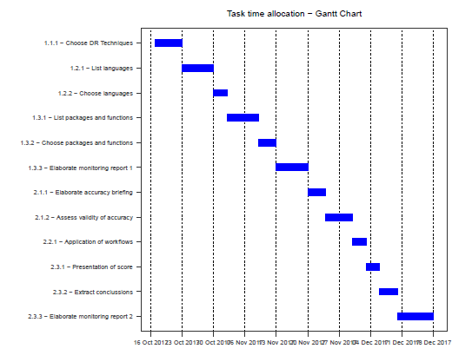

1.4.3 – Milestones

The following tables represent the milestones for each development phase.

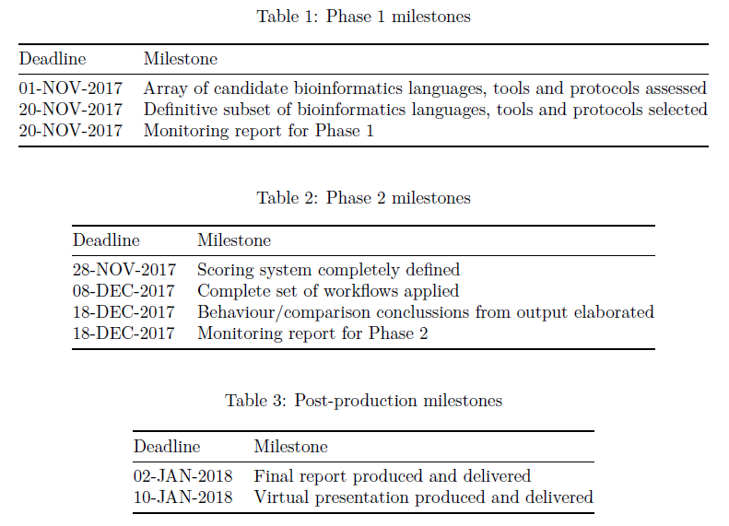

1.4.4 - Risk analysis

Some of the factors that could hinder the proposed work frames are the following:

1. Technical problems: a short buffer of time must be allocated for unexpected technical problems stemming from equipment malfunction, infrastructure breakdown, etc. Measures covering these problems include a recurrent backup system, cloud storage and accessibility to the project and its resources from several, if controlled, workstations.

2. Goal overextension: an incorrect or exaggerated choice of dimension reduction techniques or an overambitious reach could mean an ineffective use of time. This is controlled by allocating an initial time for a detailed judgement and selection of techniques to include in this project’s comparison goal.

3. Incompatibilities: accuracy measurements between packages or functions in different languages or frameworks could demonstrate to be incompatible between them, or not fit to compare; this is avoided through both the allocation of time for a strict selection of these languages and frameworks, and for the production of a normalized scoring system.

Although there are many other factors that could mean an obstacle for the correct development of each phase, they are not foreseeable and are, thus, to be assessed on an occurrence basis.

1.4.5 - Associated project costs

Economical costs for the present project will be only those associated with infrastructural uses (power and time used for computation), as all implemented software will be Open Source.

1.4.6 - Ethical and legal data implications

All data included in this project is anonymous and carries no risk for specific study patients. Even so, no data set will be made available for the public, and all computation and data presented will be in the form of final results in which no specific person will be addressed.

1.4.7 - Briefing: first monitoring report - November 2017

Development state:

Up to this date, a complete background for the project has been researched. The goal of the project is clear, and a good wealth of literature on the topic and multiple sub-topics at hand has been sought, found and studied. The ups and downs of both dimension reduction techniques and programming languages and packages have been assessed, evaluated and discriminated. The redaction of a complete report is on its way, and the general state of development is in accordance with both the official timetables and the personally scheduled tasks.

Undertaken tasks:

1.1.1 - Choose a subset from the most used and widely applied dimension reduction techniques appliable to the present topic, including PCA, ICA and Factor Analysis. (1 week, 21 hours equivalent)
State: Complete - In schedule. Two additional techniques (Autoencoders and T-distributed Stochastic Neighbor Embedding) have been added to the pool for the reasons stated in the report.

1.2.1 - Elaborate a list of widely bioinformatics-applied languages (and frameworks, if used within one). (7 days, 21 hours equivalent)
State: Complete - In schedule. Languages such as SPSS, Matlab or Haskell have been assessed and evaluated for their usefulness and fit to the goals of this project.

1.2.2 - Choose a subset from those languages and frameworks and elaborate a briefing of characteristics and examples of application. (3 days, 9 hours equivalent)
State: Complete - In schedule. The final candidates for comparison, due to the factors described in the project, are Python and R.

1.3.1 - Elaborate a list of dimension reduction packages and functions from chosen languages. (7 days, 21 hours equivalent)
State: Complete - In schedule.

1.3.2 - Choose a subset and elaborate a briefing of package traits: optimal application, parameters, exemple workflows it has actually been used for, etc. (4 days, 12 hours equivalent)
State: Complete - In schedule. The chosen packages have been listed with a historical and mathematical background where appliable, and reasons for selection.

1.3.3 - Elaborate monitoring report for Phase 1. (7 days, 21 hours equivalent)
State: Complete - In schedule.

Incomplete tasks:

As of this monitoring report there are no incomplete tasks.

Hindrances and unforeseen circumstances:

There have been neither hindrances nor unforeseen circumstances.

Update - milestones:

Up to this date, the original milestones still apply, as stated in the following table:

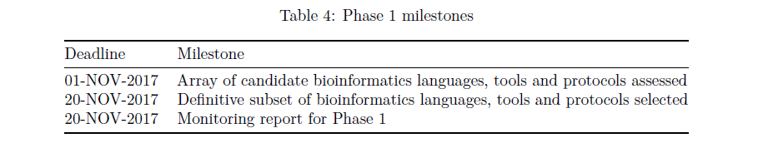

All milestones have been completed and the grounds for the second phase of the project are established.

List of products:

Given the development state of the project, in which a theoretical background has been stated and tools have been selected, the only product for this phase is the current monitoring report. It is expected, as part of the project’s plan, that the second phase will yield the final products.

1.4.8 - Briefing: second monitoring report - December 2017

Development state:

The project’s tasks have been largely completed by this point, given some extra tasks that are detailed here and unforeseen circumstances and hindrances that were buffered through corrective or paliative action.

Undertaken tasks:

2.1.1 - Elaborate a short briefing on the value of prediction accuracy as output by this packages. (4 days, 12 hours equivalent)
State: Complete - In schedule.

2.1.2 - Assess the validity of it for all the packages selected, and, if it is not valid for all of them, extrapolate a valid, normalized scoring system. (6 days, 18 hours equivalent)
State: Complete - In schedule.

2.2.1 - Apply each and every package’s or function’s workflow to the supplied lymphocyte data. (4 days, 12 hours equivalent)
State: Complete - Out of schedule.

2.3.1 - Present the score output of each of the applications in a user-friendly manner. (3 days, 9 hours equivalent)
State: Complete - Out of schedule.

2.3.2 - Extract behaviour/comparison conclussions from this score output. (4 days, 12 hours equivalent)
State: Complete - Out of schedule.

2.3.3 - Elaborate monitoring report for Phase 2. (8 days, 24 hours equivalent)
State: Complete - Out of schedule.

Unscheduled activities

As part of the tasks undertaken, it has been necessary to upgrade the technical resources available to the author. The machine in which the project’s computation is run is a Hewlett Packard Proliant Gen 8 microserver. It has proven reliable and sturdy, but not powerful enough for some of the proceedings. As such, more RAM and a more powerful processor were acquired and the server was modded with them. This process took the best part of two days of work, from November 30th through December 2nd.

Incomplete tasks:

There were no incomplete tasks.

Hindrances and unforeseen circumstances:

In the original planning, possible sources of deviation and obstacles were proposed as:

1. Technical problems: A single, important technical problem has arised when undertaking the second phase of this project: computing power. For some of the dimensional reduction techniques (PCA and ICA) the processing times and virtual memory requirements were met even under the most stringent parameters. On the other hand, some of the least tried or most resource-heavy techniques (Stacked Denoising Autoencoders and T-Stochastic Neighbor Embedding) repeatedly hit a technical roof which hindered the progress of this project.

2. Goal overextension: no problems associated with overextension have arised. The scheduled objectives have been deemed by the author as realistic and, apart from other hindrances, achievable.

3. Incompatibilities: no incompatibilities have been found neither in practice nor in literature.

As such, technical buffering measures were undertaken. In the first place, method optimization techniques were tested, such as the use of resource-light variable structures as turning data frames into sparse matrices or garbage-collection methods after each iteration of the processes, but none of them lowered the requirements in a manner significant enough to be able to complete them to satisfaction.

As this was clearly a hard-cap problem, an Intel® Xeon R E3-1265L processor, and two 8Gb Kingston DIMM 1600 Mhz 240 pins RAM chips were acquired in order to be able to parallelize processing and provide the machine with a higher virtual memory roof. This microserver modification took the best part of two days of work and brought with it a total blackout in computing during this time. This blackout time was put to use in redaction and problem-solving research.

1.4.9 - Final Gantt Diagram (after alterations)

Referring to the original the Gantt diagram presented within the initial plan:

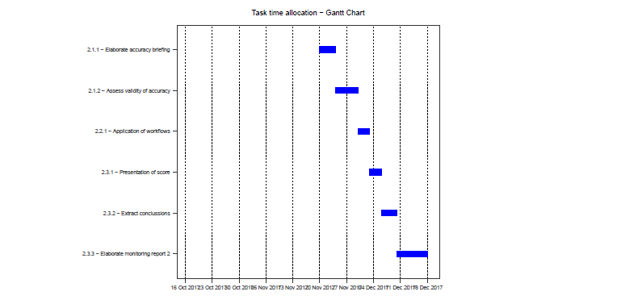

The planned tasks were slowed down by the aforementioned technical problem. Deviations were mainly focused in task 2.2.1 - Application of workflows. The unplanned use of two days was distributed evenly amongst all the following tasks, so the original Gantt diagram is recast as follows:

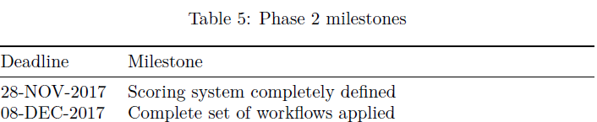
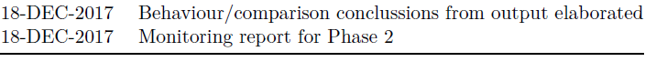

1.4.9 – Final Gantt Diagram (after alterations)

Referring to the original Gantt diagram, the planned tasks were slowed down by the aforementioned technical problem. Deviations were mainly focused in task 2.2.1 - Application of workflows. The unplanned use of two days was distributed evenly amongst all the following tasks, so the original Gantt diagram is recast as follows:

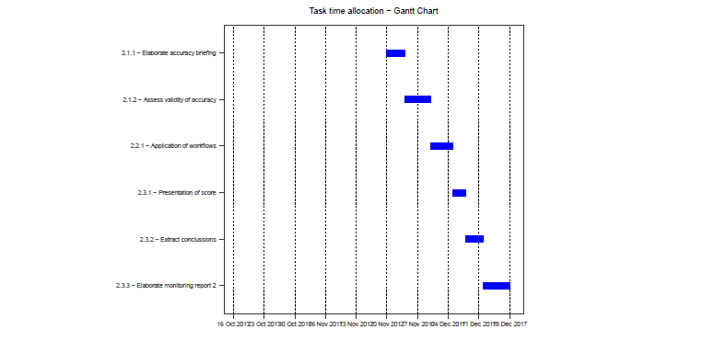

1.5 - Brief summary of products obtained

1.5.1 - Work plan

A document pertaining the project’s planification will be delivered by October the 16th, this being it. This document’s aim is to reflect the project’s expected goals and tasks to accomplish and the time frames in which to fit them. Pragmatism is expected in this planning, meaning the ability to fit realistic goals and tasks in realistic timeframes, acknowledge possible hindrances and obstacles, and establishing procedures to avoid or sort them out.

This project’s work plan is been rendered via R, using packages Rmarkdown, ggplot2, knitr, and reshape2. The embedded Gantt graph is produced via ggplot2 and reshape2, from an input of tasks in data frame format and a series of graphic parameters.

This document will also establish the products that will stem from the project, any additional outputs, and the monitoring and evaluation thereof.

1.5.2 – Report

Three reports will be made through this project’s duration, structured as follows:

The first document will be a monitoring report, due November the 20th, in which the project’s ongoing evolution will be described. This will be composed of the description itself, a complete relation of overtaken activities, both foreseen and unforeseen, a relation of hindrances and obstacles and the measures taken to buffer them, complete with an update of time frames, a list of delivered partial results and any particular comment by the project’s tutor.

Another monitoring report, due December the 18th, will be generated with contents similar to the first one, this time with a focus on the completed second phase of the project and the degree of accomplishment of the planned goals for it.

The final report, due January the 2nd, with a maximum length of 90 pages, will present the output of the project, with a justification of its interest, goals, methodology and materials, and results obtained.

1.5.3 – Product

In the course of this project, an automated comparison report script will be produced. The code used will be added as an addendum to the final report, along with code comments and protocols of use. The code will be stored in a GitHub repository, available for the public to clone, review and use. GitHub is a version-control platform used to store git repositories, with an emphasis on open-source, collaborative efforts and project versioning. Mendeley will be used as referencing tool, syncronized with R Markup through an embedded .bib file.

1.5.4 - Virtual presentation

The virtual presentation for this project will be carried out through Present@, a presentation tool offered by Universitat Oberta de Catalunya for the display of project results. This presentation will be comprised of approximately 20 slides with an oral presentation for a maximum of 20 minutes. This presentation’s aim is to be as concise and informational as possible, while delivering the results and conclussions of the project in a clean, outreaching way.

The presentation will be produced between the 3rd and 10th of January 2018, January the 10th being the deadline. Of special importance is the content, synthetic ability and clarity of purpose and expression. Evaluation criteria have been provided by the project’s tutor.

1.5.5 - Project self-evaluation

This project’s self-evaluation will confront it from two angles: first, a side-by-side comparison of initial goals and time schedules and final, actual results and time schedules, and second, a thorough analysis of style, clarity and informative value. Being this:

Goals and schedules:

1 - Correct assertion of techniques to compare: the techniques assessed are widely used, available to the general research personnel, and suited for the task at hand. Also, the number of techniques is decided pragmatically, avoiding overextension and, thus, decrease in effective time.

2 - Validity of scoring system and conclussions: the scoring system is, by itself or through normalisation, fit to give an objective, comparable value. The conclussions that follow are in agreement with this scoring system.

3 - Adecuation of assigned times: the assigned times corresponded to the times actually employed for each task, and so, milestones are accomplished within the expected period.

Style and structure:

1 - Style: the project is easily readable, is expressed in a correct way, follows correct style guidelines, quotes and references are strictly marked.

2 - Structure: the project follows the structure established by the documentation provided through the subject. Contents are correctly divided in sections. The project as a whole presents a semantic flow without logical leaps that may hinder the reader’s comprehension.

1.6 - Brief description of other chapters

2 - Dimension reduction: an introduction: A brief presentation of the main topic for this project. What they are, what they are useful for.

2.1 - PCA: Historical and mathematical background of this technique, and reasons for its selection.

2.2 - ICA: Historical and mathematical background of this technique, and reasons for its selection.

2.3 - Factor Analysis: Historical and mathematical background of this technique, and reasons for its selection.

2.3 - Autoencoders: Historical and mathematical background of this technique, and reasons for its selection.

2.4 - T-distributed Stochastic Neighbor Embedding: Mathematical background of this technique, and reasons for its selection.

2.5 - LDA: Historical and mathematical background of this technique, and reasons for its selection.

3 - Tools: Languages and packages used for this project.

3.1 - Criteria: Criteria through which these tools were selected.

3.2 - Python: History, modules and implementations from this language used for the current project.

3.3 - R: History, packages and libraries and implementations from this language used for the current project.

4 - Comparative Scoring: Assessment of an objective, measurable way to compare dimension reduction techniques.

4.1 - Classification Accuracy Metrics: A general look at the ways in which prediction accuracy is measured.

4.2 - Binary Classification Versus Multiclass Classification Metrics: On how different accuracy metrics are best suited to evaluating classifiers with two classes or more.

4.3 - Classification Rate: Focus on this multiclass accuracy metric.

4.4 - Cohen’s Kappa: In-depth look at this multiclass accuracy metric.

4.5 - Chosen Scoring Metric: The metric to be used in this project and reasons for it.

5 - Comparison Methods and Protocols: Previously explained techniques and implementations, put to work.

5.1 - Introduction and General Data Set Description: A brief introduction to the data being treated, and ways to sort out imbalance.

5.2 - Goals and techniques: Brief resume of techniques being implemented.

5.3 - Dimension Reduction techniques - R: R implementations of the selected dimension reduction techniques.

5.4 - Dimension Reduction techniques - Python: Python implementations of the selected dimension reduction techniques.

2 - Dimension reduction: an introduction

Data derived from actual studies, as opposed to ideal data is mudded by the complexity of reality, and in order to approximate it needs to be measured by large quantities of variables; this results in high dimensionality datasets, as may be the case of digital imaging, speech recognition or complex classification tasks. This high dimensionality needs to be adequately reduced in order to make studies attainable. In fact, not all the measured variables may be “important” to the goal of a study.

This can be mathematically formulated as follows (Fodor 2002):

Given the p-dimensional random variable x = (x₁, ..., x_{p})^{T} , we need to find a lower dimensional representation of it, s = (s₁, ..., s_{k})^{T} with k ≤ p that captures the information in the original data.

Ideally, this involves constructing a representation of the data according to its intrinsic dimensionality. The intrinsic dimensionality of data is the minimum number of parameters needed to account for the oberserved properties of the data (Van Der Maaten, Postma, and Van Den Herik 2009). As a result, many techniques have been developed, both supervised and unsupervised, to handle the construction of this representation.

Traditionally, dimensionality reduction techniques relied in linear transformations, as those used in PCA (Principal Component Analysis), Factor Analysis or classical scaling. Linear techniques result in newly constructed features that are a linear combination of the originals. However, given that in many fields, complex, nonlinear data is obtained, many other nonlinear methods have been developed, like Autoencoders, nonlinear applications of PCA, Kernel PCA, Laplacian Eigenmaps, etc.

The techniques used for this project are described in the next subsections. History, mathematical background and reasons for its selection are addressed where available. Further along this document, programming applications and protocols are addressed.

2.1 – PCA

PCA is the most used unsupervised, linear dimension reduction technique currently available. It is also the best, in the mean-square error sense (Fodor 2002). Its central idea is the construction of a set of features from a number of initial variables (Jolliffe 2002). The number of new features will be less than the initial variables, while retaining as much as possible of the initial variation. This is achieved by linear transformations of the original data, and then establishing a descending order of the new features attending to the amount of variation retained or explained by each of them.

Given X, a vector of p random variables, as object of interest for any study, and given that X is complex enough, the raw study of the correlation between variables may get to be inefficient and expensive in time and effort. Instead of getting the p variances and the ½ p(p − 1) correlations for each sample in the study, the goal is to search for less, equally (or effectively equally) explicative features.

2.1.1 - Historical background

PCA was invented in 1901 by Karl Pearson, the roots of it deeply burrowed in regression-thinking. In its first approach, which independently builds up on singular value decomposition, Pearson is concerned with finding lines and planes that best fit a set of points in a p-dimensional space through geometric optimization (Jolliffe 2002).

It has been mathematically reinterpreted several times along its history. In the thirties, Hotelling takes his own approach. He introduces the term “components”, as “factors”, which is used in psychological literature, may create confussion with other mathematical uses of this word. His motivation is the thought that there may be a smaller set of derived variables that explain the values of the original variables. It is his own interpretation that coins the term “method of principal components”.

Hotelling gives more weight to the Principal Components axis’ directions, in a much more multivariate statistical approach. In Hotelling’s approach he defines the Principal Axis Property: the first component explains the most variation, the second component the second most variation, and so on. The first Principal Components define new axis to be taken into account for the next Principal Components. This means a rotation of the subspace has an effect on the resulting Principal Components (Bro and Smilde 2014).

From then on further applications and extensions of PCA have been made by researchers such as Anderson (1963), Gower (1966) or Jeffers (1967).

Even though it seems to be a simple technique and much has been discussed about it, it has been applied to an extensive range of fields and is still in research.

2.1.2 - Mathematical background

Let X be a matrix with I rows (i = 1, ..., I). These I rows will usually be the observations or samples for the study. X is also composed of J columns (j = 1, ..., J), that represent the measured variables. Each of these variables are denoted x_{j}, and thus the matrix is of I x J dimensions.

The linear combination of these variables can be written as t = w₁ * x₁ + ... + w_{J} * x_{J} . The new vector t is in the same I-dimensional space as the original variables, and it is a linear transformation of these variables. This can be expressed, in matrix notation, as t = wX, w being the linear factor vector with elements w_{j}(j = 1, ..., J) (Bro and Smilde 2014).

As has been explained in former sections, as much information of X should be carried on to t as possible. With enough of that information preserved, t acts as a good summary of X. This information can be expressed as variance, var(t).

Variance, s², is statistically almost identical to standard deviation (SD) (Smith 2002). The formula for variance is:

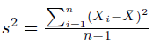

Being this just the squared SD.

So the goal is to choose a linear transformer w₁, ...,w_{J} such that this var(t) is maximized. Given that measures are subject to number sizes according to their own background, they need to be scaled down to a comparable scale, such that w may really be appliable with significant results unaffected by arbitrary size changes.

So, the problem can be expressed as

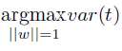

argmax being the argument w of length 1 that maximizes var(t). Returning to matrix notation, and going back to the equation t = wX, the can be equaled to:

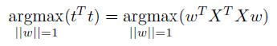

Which can be solved as an eigenvector problem, being the first eigenvector the first Principal Component, the second eigenvector the second Principal Component, and so on.

2.1.3 - Reasons for selection

PCA is an ubiquitous technique that is described and analyzed, in any of its many interpretations, almost in every book about feature analysis (Tipping and Bishop 1999). It’s a widely used linear dimension reduction technique that has proven itself of the utmost power time and time again. As such, including it in this comparison is useful not only for the comparison of the technique itself, but as a kind of benchmark: to asses any dimension reduction technique that, applied to the subject of this study (feature construction for lymphocyte classification), is able to hold a candle to PCA.

Also, as has been stated, PCA has been focused on from many angles, and it is expected to have been widely tackled by bioinformatics languages and tools. A suitable bioinformatics integration of this technique is expected to be found, or several, that fit this study for comparison; in an ideal context, it should be accessible, Open Source and the methods and results of this study should be easily reproducible by anyone reviewing it.

2.2 – ICA

Independent Component Analysis (ICA) is a statistical method for transforming an observed multidimensional random vector into components that are statisticaly as independent from each other as possible, this is, a tendency to redundancy reduction (Tobergte and Curtis 2013). In its linear approach, as with other dimension reduction algorithms, its goal is to take a zero-mean, m-dimensional variable, and by means of a linear transformation, find its n-dimensional transform, such that n ≤ m, this transformation having some suitable properties. The vectors obtained from this transformation are neither orthogonal nor ranked in order.

Feature extraction is a prominent application of ICA. It is originally motivated by results in neuroscience that suggest that the same cited principle of redundancy reduction is applied by the brain for the early processin of sensory data.

ICA is a generative model (it describes how the observed data are generated by describing the components), and it seeks the minimization of mutual information between the transformed variables. It depends on the supposition of nongaussianity for the data; gaussian data is independent and of mean zero, it has no skewness and as such can only be estimated up to an orthogonal transformation (Hyvärinen and Oja 2000).

2.2.1 - Historical background

ICA is relatively modern compared to other dimension reduction techniques. It’s originally introduced by Jeanny Hérault and Bernard Ans in 1984, by approach if not by name. This original application concerned neurological signals and muscle movement, and proposed a specific feedback circuit to explain how the nervous system was able to infer the position and velocity of these signals by measuring their responses (Hyvärinen, Karhunen, and Oja 2001).

Christian Jutten then retakes work on it by 1985, but among many other papers written in the middle 80’s, ICA is obscured by an interest in back-propagation, Hopfield networks, and Kohonen’s Self-Organizing Map (SOM). In the early 90’s, a nonlinear application of ICA is developed by Aapo Hyvärinen, Juha Karhunen, and Erkki Oja.

By this time, A. J. Bell and T. J. Sejnowski publish their infomax approach to ICA, and S. I. Amari et al by using the natural gradient and maximum likelihood estimation. Some time later, Aapo Hyvärinen, Juha Karhunen, and Erkki Oja present the fixed-point or FastICA algorithm, a computation-efficient ICA algorithm.

ICA is currently used in fields such as optical imaging, face recognition and prediction of apparently stochastic phenomena.

2.2.2 - Mathematical background

Using vector-matrix notation, let us denote by x the random vector whose elements are the mixtures x₁, ..., x_{n}, and by s the random vector with elements s₁, ..., s_{n}, being this the independent component; A is the mixing matrix with elements aij (Hyvärinen and Oja 2000). Using this notation, the model for this data is x = As. Working with the columns of matrix A, and denoting them by a_{j}, the model can also be written as

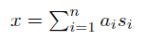

The mixing matrix is assumed to be unknown. As such, A and s must be estimated through the random vector x and the inverse of A, say W, may be computated, obtaining the independent component s as s = Wx. This is done under some assumptions, being these independence and non-gaussianity:

Independence: two variables y₁ and y₂ are said to be independent when information on the value of one doesn’t yield information on the value of the other, and viceversa. This means that the joint probability density function p(y₁, y₂) is factorizable as p₁(y₁) * p₂(y₂). This definition is applied given any number n of terms, in which case the joint pdf must be factorizable in n terms.

Nongaussianity: as stated in 2.3, data must be given in non-gaussian variables. Nongaussianity must be measurable, and the classical way to measure it is the kurtosis of the fourth order cumulant. Kurtosis of a variable y of mean zero and variance one is defined as:

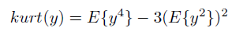

As variance of y is stated to be of value one, it can be simplified to:

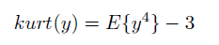

For almost all nongaussian variables, kurtosis will be non-zero. Another measure of nongaussianity is negentropy. Entropy can be considered as the amount of information that a variable yields. Randomness and unpredictability of a variable are proportional to entropy. Negentropy is a variation of entropy that aims to be zero for a gaussian variable and always nonnegative. Negentropy of a variable y is defined as:

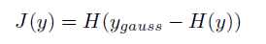

Where H(y_{gauss}) is the entropy value of a gaussian variable of the same covariance as y. This way, negentropy is always nonnegative and J(y) is only zero if the entropy of y is the same as that of its equivalent gaussian variable, this is, its gaussian itself.

2.2.3 – Selection

Other studies have already been centered around the comparison of PCA and ICA on different fields, such as (Tibaduiza Burgos et al. 2013). ICA is a widely-used, exhaustively applied to bioinformatics linear dimension reduction technique that rivals PCA in terms of use. Algorithms for this technique have been developed in popular bioinformatics programming languages, in Open Source environments, that are available for researchers to use.

ICA uses a different method to derive principal components, being this nongaussianity. Even though this tecnique doesn’t rank principal components, this is not critical to the present study, as the main objective is the accuracy of prediction.

For this reasons (wide use, availability in Open Source environments, different approach to principal components), ICA has been selected for this comparison study.

2.3 - Factor Analysis

The basic idea underlying Factor Analysis is that p observed random variables, x, can be expressed, excepte for an error term, as linear functions of m(< p) hypothetical (random) variables or common factors (Jolliffe 2002). The aim of Factor Analysis is to group variables that share a “common theme” under the same grouping, such that the dimensionality of the dataset is decreased.

Factor Analysis has been applied in psychology to identify groups of inter-related variables, as those components of intelligence that can be placed under a single factor g or general intelligence, grouping factors such as broad visual perception (it includes all the intelligence variables related to visual tasks), or broad auditory percention (same as before, but with auditory tasks). This is interpreted as someone with a high g having good broad auditory and visual perceptions, and g sinthetically explaining the behaviour of the factors and variables “contained” within itself.

2.3.1 - Historical background

The origin of factor analysis, initially applied to the field of psychology, is usually ascribed to Charles Spearman back in 1904. He worked to develop a psychological theory involving a single general factor and a number of specific factors. In this phase of development, “factors” were still not mentioned explicitly. In the next twenty years a lot of work would go into following advancements in this theory, with researchers such as Cyril Burt, Karl Pearson, Godfrey H. Thompson, J. C. Maxwell Garnett and Karl Holzinger. Special mention goes to Karl Pearson, who devoted the remaining forty years of his life to the study of Factor Analysis (Harry H. Harman 1976).

The term “factors” as applied to latent-ability variables grouping other explicit variables comes with L. L. Thurstone in the 30s. He added a component of hyerarchically organization to the mind, and sought to find factors which related to observed variables in a way that each of them pertained as much as possible to one overlapping subset of them.

In the 50s and 60s factor analysis entered the age of large-scale computing. It was applied blindly to all sorts of data, and whether it often succeeded in providing significant explanations for relationships between variables is a topic for debate. As an example, blind, computerised factor analysis failed to provide a meaningful account of the structure underlying Rorschach Test score variables.

The major advancements, in a statistical, mathematical and computational sense, were made by Karl Jöreskog, in the University of Uppsala, in Sweden. He developed a maximum-likelihood estimation algorithm that has, since then, been applied in most commercial computer programs ever since. He himself, and Bock and Bargman (1966) pre-sprecify various parameters about the common factor analysis model relating manifest variables to latent variables according to a structural theory. This model is then used to generate a covariance matrix that is testes for goodness of fit to an empirically-tested covariance matrix. This has had the effect of guiding later researchers to a protocol of action where variables are assessed before blind application of factor analysis to a dataset (Stanley A Mulaik 2009).

2.3.2 - Mathematical background

Factor analysis is a method for investigating whether a number of variables of interest Y₁, Y₂, ..., Y_{l}, are linearly related to a smaller number of unob- servable factors F₁, F₂, ..., F_{k}.

Let us consider Y₁, Y₂ and Y₃ as variables in a study (Gorsuch 1998). Through factor analysis, it may be postulated that these variables are functions of two underlying factors, F₁ and F₂, that can be described or named in a fitting way with the intent of handling them. It is assumed that the original variables linearly relate to the two factors as follows:

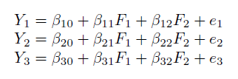

The modeled formulas include an error term each. The β parameters are technically referred as loadings.

Factor loadings are numerical measures of how much a factor explains a variable. Loadings can range from -1 to 1, with absolute values near 1 indicating that a factor strongly affects a variable. Factor loadings can be interpreted as standardized regression coefficients. Loadings as high as ~0.6 can be interpreted as strong associations between a factor and a variable.

The simplest method of Factor Analysis is based on two assumptions:

• That the error terms are independent, of mean 0 and variance σ².
• That the unobservable factors F_{j} are independent of one another and of the error terms, and of mean 0 and σ 1.

Given this assumptions, each variable can be formulated as:

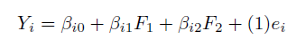

And, to obtain the associated variance:

Splitting this variance definition in two parts, β²_{i1} + β²_{i2} is what is called the communality, and σ²_{i} is the specific variance. The communality denotes the part of the variance that is explained by the common factors F₁ and F₂. The second, the specific variance, is the part of the variance of the variable Y_{i} that is not explained by the common factors. The aim, then, is to minimise this specific variance, σ²_{i}.

The loadings are not unique. There exist an infinite number of sets of values of β_{ij} that yield the same variances and covariances.

2.3.3 – Selection

Factor Analysis is inexpensive and simple to use. It has been extensively integrated in many programming languages, some of the most powerful, Open Source and community-supported, like R. It’s a great suport tool when used in conjunction with other dimension reduction methods, and it can yield not only the aforementioned dimension reduction, but also an insight on the relation between the original variables and structure that may be add a further value to this method.

For all these reasons, Factor Analysis has been selected as one of the techniques to assess in this project.

2.4 – Autoencoders

Even though there are many types of autoencoders and all will be at the very least mentioned in this section, denoising autoencoders will be the main subject of this project in this area, and they will be explained in more depth.

An autoencoder is an unsupervised machine learning algorithm, with an emphasis on feature extraction, that applies backpropagation, setting the targets to be equal to the inputs. The aim of the autoencoder is to learn a function h_{Wb}(x) ≈ x (University).

Briefly explained, an autoencoder, through at least an input layer, an output layer and a hidden layer, tries to encode and decode data such that the output layer’s result is as similar as possible to the original data, and, in the process, attempts to learn the identity function, this is, the central layer is the real goal. Even though autoencoders have enough freedom to easily be able to overfit the model, when handicapped with different types of constraints they can find interesting traits of the data structure. There are different ways to achieve this:

• Sparse autoencoders: Autoencoders can be imposed strong requirements for the units in its hidden layers to “fire up”. This may be achieved by adding terms to the loss function, or by considering as zero every activation score but for those nearest to 1. This produces the so called sparsity and makes it possible to learn structural traits about the studied data.

• Variational autoencoders: Variational autoencoders use Stochastic Gradient Variational Bayes (SGVB) to add losses by generating latent vectors that more or less follow a gaussian distribution.

• Contractive autoencoders: Contractive autoencoders try to impose small variations on the mapping by the hidden layer when inducing similar small variations in the input data, which reduces the chance of overfitting and makes the function more applicable to generalised data(Rifai and Muller 2011).

• Denoising autoencoders: Denoising autoencoders, which will be the focus of this study, are autoencoders that put an emphasis on constructing a good representation of a model, this being one that is able to fill in gaps in data. This is accomplished by introducing noise in the input (i.e. partially destroying it). If the output of the model is similar to the uncorrupted version of the input, then that is a good representaction (Vincent et al. 2008). Then repeat the process by corrupting the input in a diferent way. What was just described is an unsupervised initialization by explicit fill-in-the-blanks training. Other corruption processes are possible.

Autoencoders’ extracted features can be used in other classification algorithms, as will be done in this project.

2.4.1 - Historical background

Not much autoencoder historical background is addressed in current literature. (T. Chen et al. 2017) states that, as autoencoders have evolved gradually and much of the terminology has changed and evolved with it, it’s difficult to put a finger on the origin of all ideas used in them. Even so, (Ballard 1987) first proposes them in 1987 as an unsupervised pre-training method for Artificial Neural Networks (ANNs).

2.4.2 - Mathematical background

Let P(X) be the data-generating distribution over observed random variable X (Bengio et al. 2013). Let C be a given corruption process that stochastically maps an X to a X ̃ through conditional distribution C(X ̃|X). The training data for the generalized denoising auto-encoder is a set of pairs (X, X ̃) with X ~ P(X) and X ̃ ~ C(X ̃|X). The DAE is trained to predict X given X ̃ through a learned conditional Distribution P_{ϴ}(X|X), by choosing this conditional distribution within some family of distributions indexed by ϴ, not necessarily a neural net. The training procedure for the DAE can generally be formulated as learning to predict X given X ̃ by possibly regularized maximum likelihood, i.e., the generalization performance that this training criterion attempts to minimize is

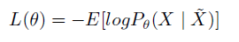

where the expectation is taken over the joint data-generating distribution

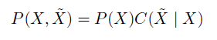

2.4.3 – Selection

Autoencoders, specifically stacked denoising autoencoders, have been stated to perform well as feature constructors in machine learning classification algorithms (Vincent et al. 2008). This unsupervised algorithm is a modern addition to the pool of existing feature construction techniques, backed by a copious amount of literature, and applied to several bioinformatics-focused programming languages. Thus it has been selected for this project.

2.5 - T-distributed Stochastic Neighbor Embedding

T-distributed Stochastic Neighbor Embedding is a nonlinear algorithm for dimension reduction. It was developed in 2008 by Laurens Van der Maaten and Geoffrey Hinton (L. V. D. Maaten and Hinton 2008). It’s a variation of Stochastic Neighbor Embedding and improves it by allowing a better visualization of high-dimensional data lying in several, lower-dimension, related manifolds. This technique is allegedly able to capture much of the local structure of the original, high-dimensional data, while also revealing global structure such as the presence of clusters at several scales.

SNE is a probabilistic approach to the visualization of the structure of complex data sets, preserving neighbor similiarities (Bunte et al. 2012). It was proposed by Hinton and Roweis (G. E. Hinton and Roweis 2002).

SNE converts high dimensional Euclidean distances between data points into probabilities that represent similarities. The similarity of one point to another is the probability that the first would choose the second as its neigbor. For points that are near one another, this probability p will be high. Due to the characteristics of the cost function, for widely separated points p will be almost infinitesimal.

The T-distributed Stochastic Neighbor Embedding differs from the basic SNE in its cost function. SNE’s cost function is difficult to optimize due what has been called the crowding problem (the artifact through which even the small attractive forces between the moderately distant points around the center of the low-dimensional map effect the natural distances between clusters, decreasing them drastically), and applies a Gaussian distribution to compute similarity between two points in the lower-dimension space. The t-SNE algorithm uses instead a heavy-tailed Student-T distribution. This alleviates the crowding problem.

2.5.2 - Mathematical background

Assume we have a data set of high-dimensional objects D = {x₁, x₂, ..., x_{N}} and a function d(x_{i}, x_{j}) to compute an Euclidean distance between two objects (L. van der Maaten 2014). The aim of the t-Distributed Stochastic Neighbor Embedding is to learn an n-dimensional embedding in which each object is represented by a point ϵ = {y₁, y₂, ..., y_{N}} with y_{i} € R^{S} (typical values for S are 2 or 3). Let P be the joint probability p_{ij} that measures the similarity between x_{i} and x_{j} by symmetrizing two probabilities:

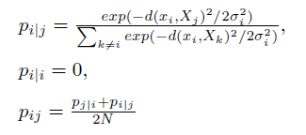

In the low-dimensional ϵ, the similarity Q between y_{i} and y_{j} are measured using the already mentioned heavy-tailed, normalized Student-T distribution with a single degree of freedom.

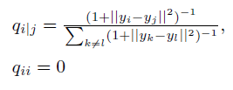

The locations of the y points in ϵ are determined by minimizing the Kullback-Leibler distance between P and Q.

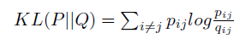

T-SNE scales exponentially to the number of observations, so the processing power required to apply it scales non-efficiently beyond a few thousands of observations.

2.5.3 – Selection

The T-SNE algorithm is a useful dimension reduction technique that allegedly gives a better visualization of complex data sets and solves the original problem of the technique, namely the crowding problem. It has been applied in the fields of computer security, cancer research, image recognitiona and bioinformatics, and given the current state of its application in bioinformatics programming languages and frameworks, it is deemed to be a qualitative addition to this study.

2.6 – LDA

Linear Discriminant Analysis, or LDA, is a generalization of Fisher’s Linear Discriminant. It is a well-known technique for feature extraction, and it has been widely used for such uses as facial recognition, image retrieval or microarray data classification. LDA focuses on the response variable classes. It projects the data onto a lower-dimensional vector space such that the ratio of the between-class distance to the within-class distance is maximized, thus achieving maximum discrimination.

Mathematically, given a data matrix A, classical LDA aims to find a transformation that maps each column a_{i} of A, for 1 ≤ i ≤ n in the N-dimensional space to a vector b_{i} in the l-dimensional space. It creates clusters, such that the quality of each cluster is high if it is well-separated from other clusters and tightly grouped (Klecka 1980).

2.6.1 – Selection

The Linear Discriminant Analysis technique has been selected because of its pattern recognition capabilities, and the fact that it has been shown to perform well in multiclass classification. It’s been implemented in both of the programming languages that will be used in this project, and it is included in packages and modules of wide use and tested good performance.

3 – Tools

The digital tools used for this project are described in this section. It will cover a brief definition, some background where available, and a collection of packages, libraries, modules, etc. to be used for each. All code used or created is available on Annex I: Code.

3.1 – Criteria

The tools to be used in this project must fulfill some basic criteria to be considered as fit. This criteria are as follows:

• Open Source. Given the nature of research, and the specific circumstances and parameters that derive from it, any tool used in this project must be flexible to adapt and re-code, and subsequently make available to other researchers under an Open Source agreement.

• Wide application. Any language, package or toolkit used in this project must have been backed, tested and reviewed by the community as a valid tool based on sound workflows and methods. This adds reproducibility to the project and avoids “it worked in my environment” situations.

• Accessibility for non-computer-science oriented users (i.e. biologists). A researcher aiming to use these tools must only fulfill the requirement of understanding the probabilistic implications of the methods applied, and has to be able to apply them without the risk of being confused by arcane or excessively-complex frameworks or workflows which would only add another layer of error.

As such, some programming languages have been discarded, either for not being Open Source (like SPSS or MATLAB) or for being obscure or niche-focused (like Haskell). The selected languages and tools are below.

3.2 – Python

Python is a powerful, system accessible, interpreted scripting language (B. W. J. Chun and Chun 2006). Data types like lists (resizable arrays) and dictionaries (hash tables) are built-in, providing a dynamic typing instead of having to declare types of variables, as is the case in C++. This reduces the framework development time.

Python is an OOJ (Object-Oriented Programming), high-level, general-purpose language. It is initially developed with a focus on being easy to read and write (Granger and Hunter 2011), while also granting access to low-level proccesses, offering simple portability and well-defined exception catching and handling. Even so, it doesn’t force this work model on the user, and can be actuated upon in a procedural way if needed.

In Python programs are organized as packages (packs of modules), modules (related code grouped together), classes, methods and functions. It offers a creative, Open Source environment suited to the development of new, more focused tools and objects, such as NumPy or Scikit-learn, both libraries specially developed for the scientific treatment of data, each with its own goal.

Python can be used as a scripting language; it’s able to use modular components written in other languages. An example would be coding a program in C++ and importing it as a module in Python, then creating a GUI for it (Nosrati 2011). It supports other technologies, such as .net objects, even going as far as specific modules having been created to interface with them.

Last, but not less important, Python relies on a wide support by its community. Everyday modules and packages are improved, developed and distributed in a collaborative environment, making it accessible to everyone, and giving researchers a fast, powerful tool for their goals. Literature and documentation is vastly available in digital and physical formats.

3.2.1 - History

Python is created in the late 1989/early 1990 by Guido Van Rossum at the CWI (Centrum voor Wiskunde en Informatica, the National Research Institute for Mathematics and Computer Science) (B. W. J. Chun and Chun 2006). It’s developed as a research tool substituting another language called ABC, as Van Rossum felt it lacked scalability with his own needs and didn’t want to fall back to using languages like C++ or LISP. Python is released for public distribution in 1991. Several releases of version 1 are published by CWI, until Guido Van Rossum moves to Reston, Virginia, to the CNRI (Corporation for National Research Initiatives), where he releases versions of Python up until 1.6.

Changing to commercial software development in 2000, Guido Van Rossum felt that the ability to work under the GNU Public License was desirable. Both versions 1.6.1, with the collaboration if the CNRI and the FSF (Free Software Foundation), and Python 2.0 conform to this license.

Python 2.0 is released under BeOpen.com as a derivative work from Python 1.6.

Guido Van Rossum and the other PythonLabs developers have since then joined Digital Creations. All their work from then on is owned by the PSF (Python Software Foundation), a non-profit foundation modeles after the Apache Software Foundation.

3.2.2 – Modules

The following Python modules and functions are used in this project. Every module is provided with citation where available.

Scikit-learn (Pedregosa et al. 2012): Scikit-learn is a “toolbox” of implementations of many popular machine learning algorithms. It has been developed with researchers from fields outside of computer sciences to use, thus its simplicity of application for many machine learning problems. It is distributed under a BSD license, and it only has NumPy and SciPy as dependencies. It has even been distributed as part of main OS distributions such as Ubuntu or Debian.

• PCA: sklearn.decomposition.PCA().
This implementation of Principal Component Analysis uses SVD to project the data to a lower dimensional level, using either a LAPACK implementation of the full SVD, the method of (Halko, Martinsson, and Tropp 2009), or the SciPy module’s own ARPACK implementation of the truncated SVD.

• ICA: sklearn.decomposition.FastICA().
This function applies the FastICA method to the data, accepting parameters like number of components to use, iterations to fit or a stated mixing matrix.

• Factor Analysis: sklearn.decomposition.FactorAnalysis()
This function performs a maximum-likelihood estimate of the loading matrix (what loading is has been assessed in section 2.3.2).

• Stacked Denoising Autoencoders: Keras (Chollet 2015):
Keras is a high-level neural networks API developed for Python and developed for direct and simple application. In the author’s own words, “being able to go from idea to result with the least possible delay”.

• T-Distributed Stochastic Neighbor Embedding: sklearn.manifold.TSNE().
Even though this implementations documentation states the need for a previous dimension reduction technique for fully significant results, for the sake of comparison equality it will be used on the data set as is, with all the original variables.

• Linear Discriminant Analysis: sklearn.discriminant_analysis. LinearDiscriminantAnalysis().

This function is a classifier with a linear decision boundary. It’s implemented in Scikit-learn, as part of the main module.

• NumPy and SciPy: these two modules act as dependencies for Scikit-learn. NumPy (Walt et al. 2011) arrays are the standard object for data representation in Python. These arrays can have any number of dimensions and can contain other kinds of elements. ScyPy (Jones, Oliphant, and Peterson 2001), is a collection of algorithms and functions built on Numpy. It adds high-level commands and classes for manipulating and visualizing data.

3.3 – R

R (Team 2008) is a quite modern statistics-focused programming language. It is an implementation of the S language with lexical scoping semantics inspired by Scheme. S was developed at Bell Laboratories by John Chambers and coleagues, while R was developed by Ross Ihaka and Robert Gentleman at the University of Auckland, New Zealand.

The project started its development in 1992, with a first release in 1995 and a stable beta in 2000. The base package of the program provides with native functions for many common-use mathematical workflows, and it is easily expanded via libraries and packages delivered in an Open Source environment through the CRAN site cluster.

R’s main advantages are:

• Effective data handling and storage capabilities.
• Many generic and specific object families, flexible enough to cover most uses.
• Powerful graphical tools, either for direct display or hard copy, with output of publication-level quality.
• User-defined function creation for adaptation of R’s capabilities to each individual requirements.
• Community-supported development environment. R is distributed as Free Software under the terms of the Free Software Foundation’s GNU General Public License in source code form. It is multiplatform, running seamlessly in MacOS, Windows and a wide variety of UNIX platforms, even being distributed natively with some of them. It is documented via its own LaTeX documentation format.

3.3.1 - Packages and libraries

The following R packages and libraries are used in this project. Every library is provided with citation where available.

• Base package:
The base package for R implements many generalistic functions for data handling, information structure, basic mathematical functions and more.

• Base package::prcomp() (https://stat.ethz.ch/R-manual/R-devel/library/stats/html/prcomp.html):
Prcomp() is R’s native implementation of Principal Component Analysis. It is parameterized with the options to scale and center data before the analysis, rank (the maximum number of principal components to be used) or the magnitude of the standard deviation below which components should be omitted.

• ICA package::icafast() (A. N. E. Helwig and Helwig 2015):
This package assesses the implementation of several ICA algorithms, including FastICA, Infomax and JADE. FastICA (Hyvärinen and Oja 2000) will be used for this project, accepting parameters like the number of components to extract, options to center data before ICA decomposition or convergence tolerance.

• Stats package::factanal() (https://stat.ethz.ch/R-manual/R-devel/library/stats/html/factanal.html):
This function performs maximum-likelihood factor analysis on a covariance matrix or a data matrix. As parameters it accepts the number of factors to be fitted, the type of scores to be output (Thompson’s, Bartlett’s, etc), or the number of observations if the input given to the function is a covariance matrix.

• RcppDL package::RsdA() (Package, Kou, and Sugomori 2015):
The RcppDL package includes a kit of basic, multilayer machine learning algorithms, Restricted Boltzmann Machines and Deep Belief Networks amongst them. The rsda() function is a wrapper to initialise a deeplearning object implementing stacked denoising autoencoding on a set of data. It can be then pretrained, fine tuned and used for prediction or classification.

• Tsne package::tsne() (Package 2016):
The Tsne package contains only one function, namely tsne(), an implementation of the T-distributed Stochastic Neighbor Embedding for R. It provides an interface for the application of t-SNE on R matrices or dist objects.

• MASS package::lda() (Brian et al. 2017):
The MASS package contains datasets and functions used in Venables and Ripley Modern Applied Statistics with S. As part of the package it includes several feature extraction techniques, amongst which is LDA.

4 - Comparative scoring

This section covers the topic of accuracy scoring. Although this may seem like a simple topic (“best prediction makes best score”) there are nuances to the concept of “best prediction”.

Measures of classification accuracy are usually extracted from a confusion matrix composed of true positives and true negatives in a diagonal row, and an assortment of false negatives and false positives on the other cells. The most simple, most direct measure of accuracy is the proportion between true positives and negatives and the total number of observations; but, as is often the case, most simple is not always more fitting.

4.1 - Classification accuracy mètrics

There are several metrics commonly used to measure accuracy. Each kind of metric focuses on one or a few aspects of concordance between observed and expected results (Sokolova, Japkowicz, and Szpakowicz 2006).

Accuracy: the most direct metric; it’s a partial one, even if logically correct. Accuracy is the proportion of correct labels of the studied classes. Thus:

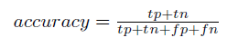
This meaning total correct predictions divided by total observations. Although it correctly assesses the proportion of concordance, it takes only this into account. Many times different kinds of errors have a diferent weight or cost to them. Not being able to distinguish total true positive accuracy and total true negative accuracy is a hindrance in real life context, where failing to correctly identify, as an example, the malignancy of a tumour as positive, may carry more dire consequences than incorrectly identifying an otherwise harmless growth as malignant.

This need for more specific assessment is reflected in the following metrics.

Sensitivity: It’s the ratio of true positives to total real positives (true positives + false negatives). It focuses on the accuracy of the positive class, which in biomedical environments is usually the most important class.

Values nearest to 1 are better. It’s expressed as:

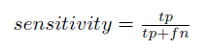

Specificity: It’s the ratio of true negatives to total real negatives (true negatives + false positives). It focuses on the accuracy of the negative class. Values nearest to 1 are better.

Precision: It’s the ratio of true positives to total predicted positives (true positives + false positives). It focuses on how well the model distinguishes factual positive cases. Values nearest to 1 are better. It’s expressed as:

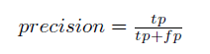

Fallout: Also called False Alarm Rate, it’s the complementary rate to specificity, or fallout = 1−specificity. It’s the ratio of false positives to total real negatives (false positives + true negatives), and it is expressed as:

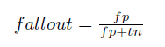

Depending on the context, False Alarm Rate as an error can be equivalent in cost to false negatives or differ in cost. In a medical assesment, where failing to reject the null hypothesis of normality of conditions when it should have been rejected can mean decease or loss of life quality, false positives are usually less costly than false negatives.

F-Score: F-Score is a technique that measures the discrimination of two sets of real numbers (Y.w. Chen and Lin 2006). The F-Score or F₁ Score considers both the precision and recall to compute its value; it’s the harmonic average of both, and F₁ Scores near 1 are best (Hutchison and Mitchell 2013).

It is expressed as:

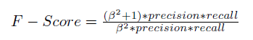

F-Score has been used many times in language recognition, and also in document classification and speech pattern recognition.

ROC: (Hanley and McNeil 1982) A Receiver Operating Characteristic curve is a graphical interpretation of sensitivity against fallout in the context of predictive diagnosis. This curve can be plotted as the cumulative distribution function of sensitivity in the vertical axis against fallout on the horizontal axis. The function for the ROC curve is expressed as:

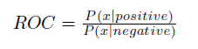

Where P(x|C) denotes the conditional probability that a data entry will belong to the C class label (Sokolova, Japkowicz, and Szpakowicz 2006). ROC and the Area Under the Curve have been widely used as accuracy metrics in studies with assymetric cost functions and imbalanced data sets. ROC results can be analyzed in various ways and extracted in many experimental protocols. Usually, the slope and intercept of the curve are used to measure the probability of hits and false alarms. (Yonelinas and Parks 2007)

4.2 - Binary classification versus multiclass classification mètrics

Classification can be primarily divided by the number of class labels potentially assignable to a sample. With this discriminator in mind, classification can be binary or multiclass. Binary classification ussually takes the form of a positive label or a negative label. Multiclass classification takes more than two states.

Although it would seem like a moot difference, depending on a critical analysis of the classification it can be profoundly important for the process of accuracy analysis.

Most of the accuracy metrics that have been described in the present document depend on the concept of positive or negative to sort out their measure. Depending on the presented problem, class labels may or may not be ascribed to a positive or a negative state. Neutral-value, descriptive labels won’t be able to be classified this way, as their values will be neither positive nor negative, just a neutral value, distinct and definable state.

Even so, there may be ways to assimilate these kind of problems to a binary classification. Decomposing class labels in a state of “being or not being”, this meaning belonging or not belonging to a given class, is one way. If the labels are not neutral states, but levels of “positive” and “negative” states, a boundary can be established so that everything above it is positive and everything below it is negative.

For the problem stated in this document there are three possible labels: ATYPICAL_LYMPHOCYTE, LYMPHOCYTE and VARIANT_LYMPHOCYTE. Atypical lymphocytes are found in patients with lymphoid neoplasms, including prolymphocytes. Variant lymphocytes are reactive lymphocytes. Lymphocytes are normal cells. All this means is that all three are distinct states that can’t be ascribed to a binary classification, at the risk of losing important information.

An accuracy metric that can be applied to a multiclass classification is needed in order to assess the accuracy of this study. Multiclass accuracy metrics are described in (Luengo 2009). Multiclass variants to ROC are mentioned, although it’s stated to be computationally restrictive. Classification Rate and Cohen’s Kappa are also mentioned as simple and successful in their application.

4.3 - Classification Rate

This metric is described as the number of successful hits relative to the total number of classifications. It’s been stated to be the most commonly used metric for assessing the performance of classifiers for years.

4.4 - Cohen’s Kappa

Cohen’s Kappa (Luengo 2009) is an alternative to Classification Rate that takes into account random correct hits. It was originally used to measure the degree of agreement between two subjects describing the same event. In the meantime it has been adapted for classification tasks, as it compensates for random hits in the same way that AUC does for ROC. The mathematical expression for Cohen’s Kappa is applied to the contingency table of an event in the following way:

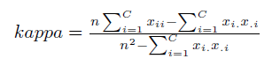

Where x_{ii} is the cell count in the main diagonal, n is the number of examples, C is the number of class values and x_{.i}x_{i}. are the total columns and rows counts, respectively.

The value range of Cohen’s Kappa goes from -1 (total disagreement) to 1 (perfect agreement).

4.5 - Chosen scoring mètric

For this project, the chosen accuracy metric is Cohen’s Kappa. The reasons are as follows:

• The data set upon which it is going to be used has a multiclass factor response variable.
• Those labels are not ascribable to a binary synthetic class system.
• Cohen’s Kappa yields a scalar, simple value well suited for multiclass classification.
• It is more powerful than Classification Rate, because it takes into account random hits, scoring successes separately for each class and aggregating them.

For these reasons, the scoring metric to be applied in this project is Cohen’s Kappa.

5 - Comparison methods and protocols

5.1 - Introduction and general data set description

The current data set is a study on abnormal lymphoid cells circulating in peripheral blood, as stated in (Puigví et al. 2017). The study included mature lymphocytes from healthy individuals, abnormal lymphocytes from patients with CLL, B-PLL, HCL, SMZL, MCL, FL, T-PLL, T-LGL, Sézary syndrome, LB from patients with B-lymphoid precursor neoplasms and RL from patients with viral or other infections, in which 2867 numerical variables, based on colorimetric and geometric features have been measured.

The current data set has 13074 observations for 2874 variables, of which 7 (in which the response variable, tipoCelula, is included) are factors and 2867 are numeric predictor variables.

The response variable, tipoCelula, has three levels, being these ATYPICAL_LYMPHOCYTE, VARIANT_LYMPHOCYTE and LYMPHOCYTE. Two subsets will be generated with this data, a training set comprising 66% of all data, and a test set formed by the remaining entries. Both sets are generated by defining a random seed with the set.seed() function (the seed beeing 123) and applying that seed, either to the sample() function in R, or to the train_test_split() function in Python to generate, respectively, either an array of indexes or the training-test subsets themselves.

5.1.2 - Class imbalance problema

While dyagnosing the data set, a single look at the response classes is enough to find a pronounced imbalance in the number of observed classes. There is an important proportion of atypical lymphocytes, in respect to the variant and normal lymphocytes. Such imbalance can create an artifact of classification. In this case, this artifact would be less costly, as it would skew towards an excessive zeal when classifying atyipical lymphocytes, but still, it’s a source of noise that should be avoided when possible.

Highly imbalanced datasets bring with them the problem of random accuracy. If a data set, such as the one being assessed in this project, has, let it be said 75% of samples in one class, there’s an initial chance that by pure, random luck, predicting all test samples as belonging to that class will yield a 75% accuracy score.

There are several class balancing techniques designed to avoid this artifact. As stated in (Barandela et al. 2004), basic methods for reducing class imbalance can be sorted in three groups:

• Over-sampling, which aims to replicate samples in the minority group to artificially augment its representation.
• Under-sampling, which serves the opposite goal, to cut samples from the majority group.
• Internally biasing the discrimination based process in order to balance the classes.

Also, there is a hybrid approach, which relies on both over- and under-sampling to bring the classes to a balance. This is the approach that will be used and discussed in this project.

5.1.3 - The SMOTE() function

SMOTE (Synthetic Minority Oversampling Technique) (Ramentol et al. 2012) is a data-level balancing approach, in opposition to learning-algorithm approaches. These are said to be more versatile, as its use is independent of the protocol followed and can then be used to train any classifier.

The SMOTE algorithm oversamples the minority class by introducing synthetic minority class examples along the line segments that join the k nearest neighbors. What it does is take each of these k nearest neighbors, randomly chosen, and substract it from the sample in question. Then multiply the difference by a random value between 0 and 1, and add this point as a new minority class example.

Even though SMOTE itself is an over-sampling method, it is implemente as a hybrid approach by R in the SMOTE() function, from the DMwR package. This function, which will be used for this dataset, under- and over-samples the data set, with parameters allowing to put focus on one or both. For this project, given the aim to over-sample the minority class, focus will by put on this by setting the perc.over parameter to a suitable quanity, decided by trial and error (200).

5.2 - Goals and techniques

This script aims to assess the comparative performances of different dimension reduction techniques. They will be measured for a common accuracy metric and judged by their processing performance. Being PCA the most used, most assessed technique, it will be used as a kind of touchstone in respect to requirements for the other techniques in R. This techniques will then be replicated in their Python implementations keeping, as much as possible, all parameters as a measure of objectivity between both languages.

Other optional parameters, where possible, will be kept to a minimum. The reason for this is to assess the validity of techniques out of fine-tuning, in their most raw conditions, as fine-tuning each of them would be a matter for a latter study.

For the effects of this project, the benchmark minimum number of extracted features is that which satisfies one condition, being this that these extracted features account for an accumulated 95% of variance in the reference dimensionality reduction technique, PCA. Having determined this, a continued test of cumulative numbers of extracted features, between a floor of 10 and an estimative limit of 250 yields the following result.

With a single plot of the variance explained by the first PC’s the fact that the most variance is mainly explained by the most influential PC’s is clearly visible:

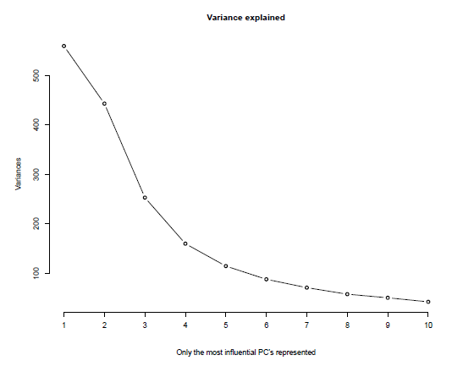

With this number of extracted features as an objective benchmark, the following techniques will be conducted:

• PCA
• ICA
• Factor Analysis
• Linear Decomposition Analysis

The resulting features will then be divided in training and test sets, and used as input, first, for the fitting and training of an SVM function (svm(), from the caret package for R and sklearn.svm.SVC() for Python), and then as input of a predict() function, from the stats package for R, and a fit().predict() pipeline for Python. The predicted classes will then be cross-tested with the actual test classes. A confusion matrix and a Cohen’s Kappa weighted value will then be output, and used as that technique’s entry in the final performance comparison.

Cohen’s Kappa (Luengo 2009) is an alternative to Classification Rate that takes into account random correct hits. It was originally used to measure the degree of agreement between two subjects describing the same event, in psychology, but has since then been implemented for accuracy testing in other fields. It has been adapted for classification tasks, as it compensates for random hits in the same way that AUC does for ROC. The mathematical expression for Cohen’s Kappa is applied to the contingency table of an event in the following way:

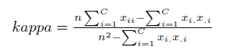

Where x_{ii} is the cell count in the main diagonal, n is the number of examples, C is the number of class vàlues and x_{.i}x_{i}. are the total columns and rows counts, respectively.

A weighted value of Cohen’s Kappa will be given. Weighted and unweighted values of Cohen’s Kappa differ, as their name implies, in that weighted scores take into account the differential weights of several levels of disagreement between observed and predicted classes. This is a level of information that is lost in binary classification, as all disagreements between observed and predicted classes share the same level of disagreement.

5.3 - Dimension Reduction Techniques – R

5.3.1 – PCA

PCA is the most used unsupervised, linear dimension reduction technique currently available. It is also the best, in the mean-square error sense (Fodor 2002). Its central idea is the construction of a set of features from a number of initial variables (Jolliffe 2002). The number of new features will be less than the initial variables, while retaining as much as possible of the initial variation. This is achieved by linear transformations of the original data, and then establishing a descending order of the new features attending to the amount of variation retained or explained by each of them.

For this project, 210 are retained and use in the fitting, training and prediction of classes. The following section depicts the results of this protocol.

The data set, previously scaled and balanced via a SMOTE function, is fitted to a PCA. The optimal amount of PC’s (Principal Components) is retained, and the resulting, transformed data set, is subset into training and test sets. They’re are then used to train an SVM C-clasiffication type protocol, and predict the test classes.

After fitting and predicting, the hit and hit percentage values are extracted and represented in Table 6 and Table 7, in absolute and percentage values, respectively.

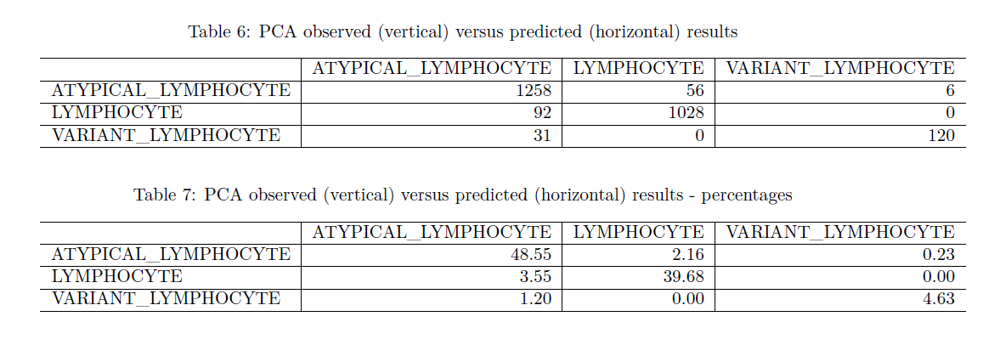

PCA yields a weighted Cohen’s Kappa value of 0.84, which will be a benchmark for other techniques. As a visual, informative measure, it is interesting to have the PCA fitted components plotted, coloured by tipoCelula label. With other, less dimensional examples, plotting PCA would be more informative, as a small number of PCs would be plottable in a few graphs without too much cluttering, something that doesn’t happen with the 210 components extracted in this study. Even so, the points transformed to the 2 main PCs are plotted here, and their centroid is pointed in red.

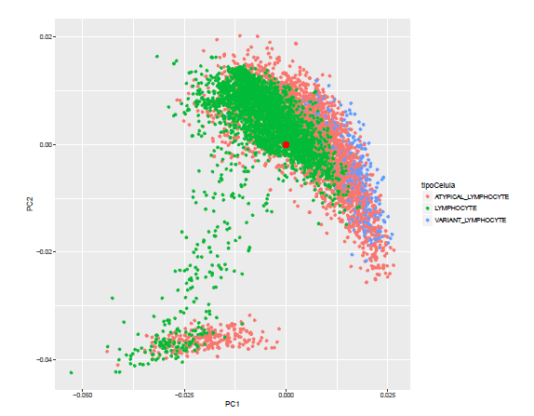

Points in space are grouped by PC and colored by response label.

5.3.2 – ICA

Independent Component Analysis (ICA) is a statistical method for transforming an observed multidimensional random vector into components that are statisticaly as independent from each other as possible, this is, a tendency to redundancy reduction (Tobergte and Curtis 2013). In its linear approach, as with other dimension reduction algorithms, its goal is to take a zero-mean, m-dimensional variable, and by means of a linear transformation, find its n-dimensional transform, such that n ≤ m, this transformation having some suitable properties. The vectors obtained from this transformation are neither orthogonal nor ranked in order.

Feature extraction is a prominent application of ICA. It is originally motivated by results in neuroscience that suggest that the same cited principle of redundancy reduction is applied by the brain for the early processin of sensory data.

ICA is a generative model (it describes how the observed data are generated by describing the components), and it seeks the minimization of mutual information between the transformed variables. It depends on the supposition of nongaussianity for the data; gaussian data is independent and of mean zero, it has no skewness and as such can only be estimated up to an orthogonal transformation (Hyvärinen and Oja 2000).

Applying it to the current data set, the results are as follows:

The data set, previously scaled and balanced via a SMOTE function, is fitted to an ICA. The optimal amount of extracted features is retained, and the resulting, transformed data set, is subset into training and test sets. They’re are then used to train an SVM C-clasiffication type protocol, and predict the test classes.

After fitting and predicting, the hit and hit percentage values are extracted and represented in Table 8 and Table 9, in absolute and percentage values, respectively.

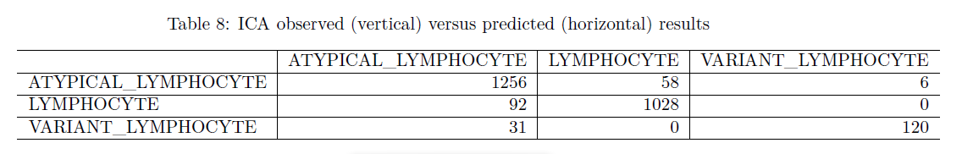
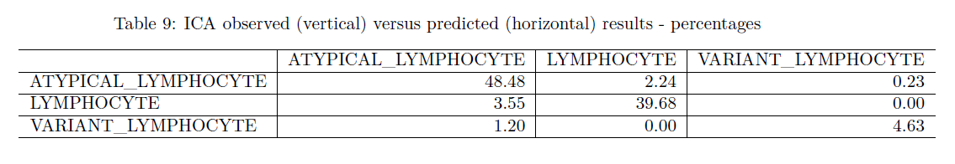

Curiously, ICA yields results similar to PCA, with a weighted Cohen’s Kappa of 0.84. Even though this puts it at eye level with PCA, the processing power needed for this technique is noticeably larger, and thus, the hollistic assessing of ICA still has it behind PCA.

5.3.3 - Factor Analysis

The basic idea underlying Factor Analysis is that p observed random variables, x, can be expressed, except for an error term, as linear functions of m(< p) hypothetical (random) variables or common factors (Jolliffe 2002). The aim of Factor Analysis is to group variables that share a “common theme” under the same grouping, such that the dimensionality of the dataset is decreased.

This technique is applied here to the given data set, with a lower tolerance boundary of 0.07, found through trial to get to convergence.

The data set, previously scaled and balanced via a SMOTE function, is fitted to a Factor Analysis workflow. The optimal amount of extracted features is retained, and the resulting, transformed data set, is subset into training and test sets. They’re are then used to train an SVM C-clasiffication type protocol, and predict the test classes.

After fitting and predicting, the hit and hit percentage values are extracted and represented in Table 10 and Table 11, in absolute and percentage values, respectively.

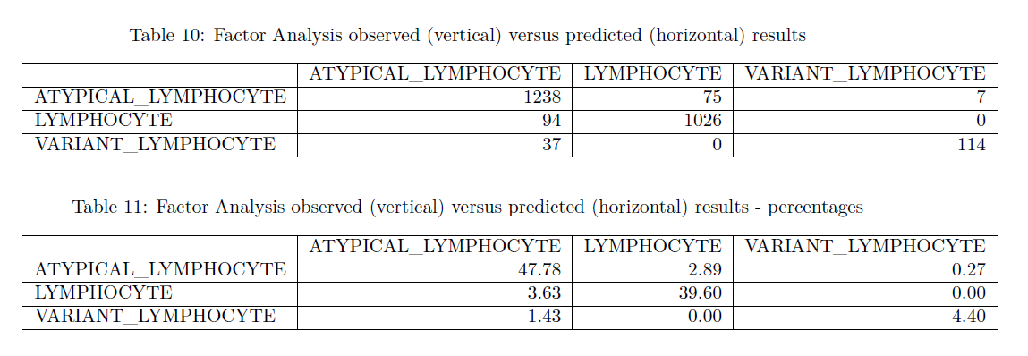

This technique gives a weighted Cohen’s Kappa Value of 0.81. This value is surprising, given that it puts the Factor Analysis technique’s accuracy near the PCA’s, which is a good result without fine tuning. This can be a specific case in which Factor Analysis is near PCA in a metric sense, while it is clearly more costly in processing power.

As a visual, informative measure, it is interesting to have the Factor Analysis output fitted components plotted, coloured by tipoCelula label. Once again, only the two main extracted factors will be plotted, as plotting the whole set of 210 factors would clutter the plot and make it unintelligible. The centroid for this two factors is pointed in red.

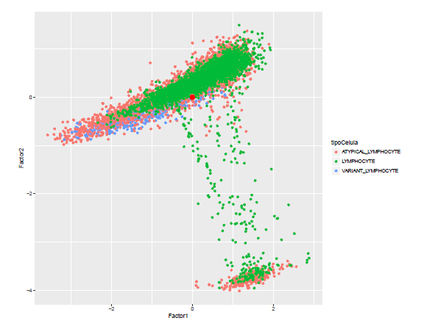

All this said, what Factor Analysis does (and what makes it unique) is create a matrix of loadings, this is, it creates columns with synthetic factors that “rely” on and group up subsets of the original variables.

These new features are semantic groupings of the original variables, giving this technique an added value as it reveals hidden relations between variables.

Given these new relationships, it is up to the analyst to name them in a semantically comprising manner (let it be said, as an example, that two theoretical variables “speed” and “agility” were revealed to be bound; the wrapping extracted feature could be named, maybe, “mobility”). In this project these complex relationships won’t be named, but given more time, the traits that bind these variables together could be analysed and these new features named. Still, for the sake of visualization, the loadings for (some of) the variables in the main two factors can be plotted as follows:

5.3.4 – LDA

LDA is a generalization of Fisher’s Linear Discriminant widely used for dimension reduction and feature extraction. Here it will be used to find a linear combination of features able to classify the data set’s entries into its correct class.

The data set, previously scaled and balanced via a SMOTE function, is fitted to a Linear Discriminant Analysis function. LDA, by nature, won’t be able to return the same number of components as the other techniques, so as an exception, this protocol will return two extracted features, and the resulting, transformed data set, will continue the protocol as standard and be subset into training and test sets. They’re are then used to train an SVM C-clasiffication type protocol, and predict the test classes.

After fitting and predicting, the hit and hit percentage values are extracted and represented in Table 12 and Table 13, in absolute and percentage values, respectively.

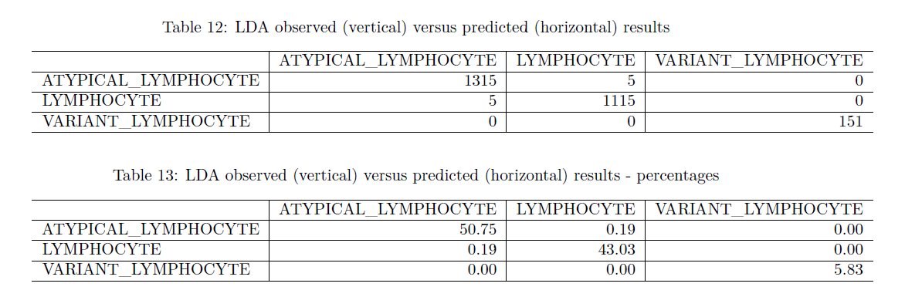
This technique gives a weighted Cohen’s Kappa Value of 0.99. It seems a high value is extracted from a data set with well defined class groupings and it may be that, for this application specifically, LDA is a good feature reduction technique.

5.4 - Dimension Reduction Techniques – Python

During coding, it was discovered that even in a streamlined coding and editing environment like R Markdown and Knitr, where chunks of different programming languages can be concatenated and run in the same script and then rendered into a TeX-PDF document, Python variables and objects don’t persist between chunks.

For this reason, data had to be loaded and preprocessed for every technique. Where necessary, a randomizer seed (123) was used, as to make results replicable.

Cohen’s Kappa and Confusion Matrices were extracted via R functions. This was done to streamline the process, via extraction of observed and predicted labels to secondary files and using them as input for the R functions.

The implementations of each of them are undertaken in this section.

5.4.1 – PCA

PCA in Python is undertaken via Scikit-learn, a Python module built on Numpy, Scipy and Matplotlib for machine learning tasks. As in R, the basic function for PCA is of a basic simplicity.

The data set is scaled and centered, then over-sampled via imblearn’s implementation of the SMOTE() function, subset into training and test sets via a randomizing splitter function (train_test_split(), from sklearn.model_selection), and then reduced via PCA. It is subsequently used for SVM training and testing.

For this project, 210 of the features extracted by PCA are retained and used in the fitting, training and prediction of classes, in order to replicate R parameters where possible. The following section depicts the results of this protocol.

After fitting and predicting, hit and hit percentage values are extracted and represented in Table 14 and Table 15. It must be noted that the overall process of PCA in Python is faster than in R, and yields a Cohen’s Kappa value of 0.9801115.

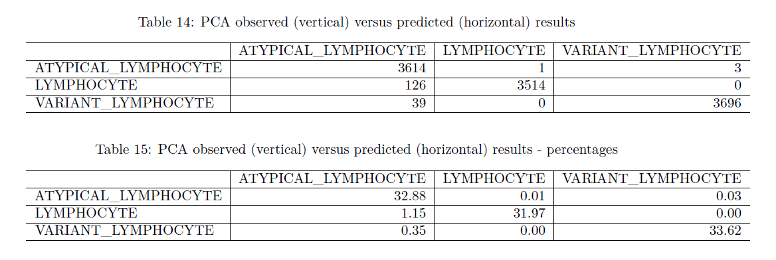

5.4.2 – ICA

ICA in Python is undertaken via Scikit-learn too. It doesn’t need to be overly parameterized in order to run a basic ICA protocol. The data set is scaled and centered, then over-sampled via imblearn’s implementation of the SMOTE() function, subset into training and test sets via a randomizing splitter function (train_test_split(), from sklearn.model_selection), and then reduced via ICA. It is subsequently used for SVM training and testing.

For this project, 210 of the features extracted by ICA are retained and used in the fitting, training and prediction of classes, in order to replicate R parameters where possible. Also with this goal in mind, tolerance and maximum iterations before convergence were adjusted to mimic the R defaults (tolerance: 0.000001 and maximum iterations: 100). The following section depicts the results of this protocol.

Applying it to the current data set, the results are as follows:

It is discovered that the predicted values all yield an ATYPICAL_LYMPHOCYTE result. This is due to the fact that if tuned with the same default parameters as its R analogue, Python’s FastICA does not even get to convergence, apart from taking a lot of processing time; still, it provides an interesting result: this technique’s Cohen’s Kappa is zero, which is remarkable. In the observed test labels the ATYPICAL_LYMPHOCYTE result is registered a majority of times, which, if only raw accuracy was used as metric, would yield a high random hit rate. Instead, Cohen’s Kappa takes into account the probability of this one being the result, which in the predicted values is of a 100%, and lowers the expected validity of such a prediction from the high random accuracy potential yield to a round zero. Even though the raw ICA-constructed prediction is of an underwhelming precision, the solidity of Cohen’s Kappa as a metric is supported by this occurrence.

Hit and hit percentage values, although invalid for comparison, are nevertheless extracted and represented in Table 16 and Table 17.

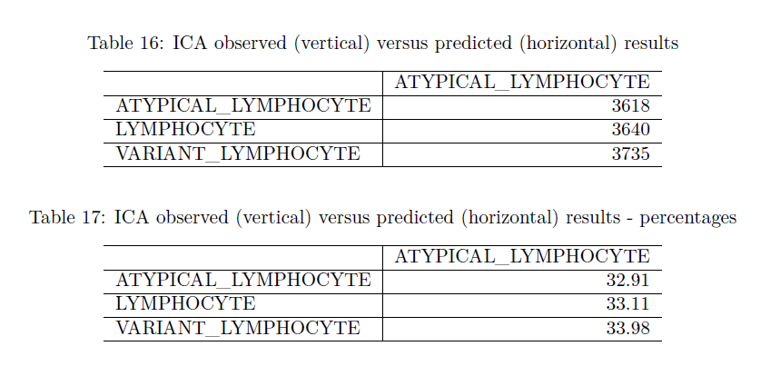

5.4.3 - Factor Analysis

Factor Analysis in Python is undertaken via Scikit-learn’s function FactorAnalysis(), using as parameter the number of features to be extracted.

The data set is scaled and centered, then over-sampled via imblearn’s implementation of the SMOTE() function, reduced via Factor Analysis, and then subset into training and test sets via a randomizing splitter function (train_test_split(), from sklearn.model_selection). It is subsequently used for SVM training and testing.

For this project, 210 of the features extracted by Factor Analysis are retained and used in the fitting, training and prediction of classes, in order to replicate R parameters where possible. The following section depicts the results of this protocol.

After fitting and predicting, hit and hit percentage values are extracted and represented in Table 17 and Table 18. The confusion matrix and Cohen’s Kappa score show n improvement over PCA and ICA.

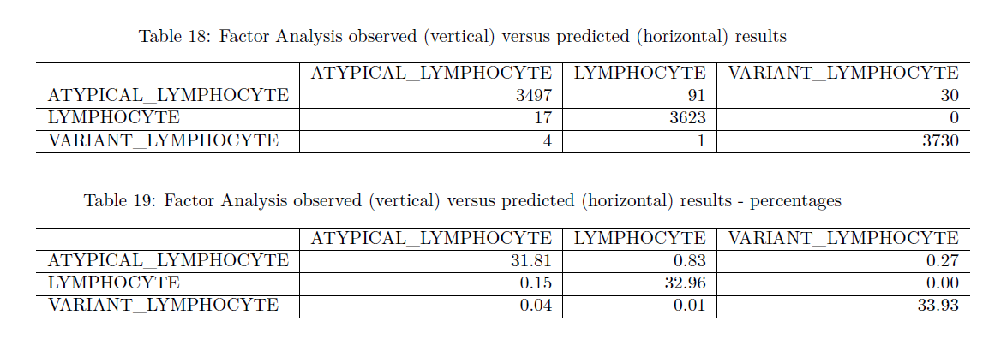

This technique gives a weighted Cohen’s Kappa Value of 0.98. This value is similar to that given by PCA, in some degree of accordance to the R results.

5.4.4 – LDA

LDA in Python is undertaken via Scikit-learn’s function FactorAnalysis(), from the submodule discriminant_analysis, using as parameter the number of features to be extracted.

The data set is scaled and centered, then over-sampled via imblearn’s implementation of the SMOTE() function, reduced via Linear Discriminant Analysis, and then subset into training and test sets via a randomizing splitter function (train_test_split(), from sklearn.model_selection). It is subsequently used for SVM training and testing.

For this project, 210 of the features extracted by LDA are retained and used in the fitting, training and prediction of classes, in order to replicate R parameters where possible. The following section depicts the results of this protocol.

After fitting and predicting, hit and hit percentage values are extracted and represented in Table 20 and Table 21. LDA in Python yields a high Cohen’s Kappa score, 0.98, in accordance to the results from the R implementation of this technique. The fact that in both languages the best-ranking technique is LDA is significant.

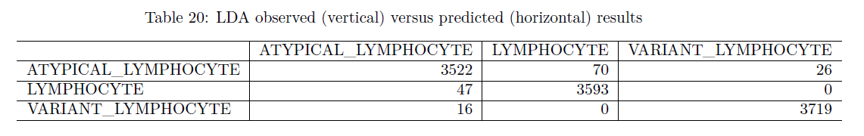
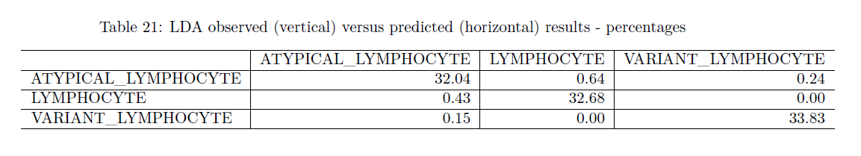

5.5 - Missing techniques

Two more techniques have been mentioned in this project that didn’t make the final cut to this report. These are T-Stochastic Neighbor Embedding and Stacked Denoising Autoencoders. The reasons why have been explained in the partial reports for this project, and are as follows:

T-Stochastic Neighbor Embedding: This visualization technique, even although it produces a kind of dimension reduction, has been dropped mainly for two resons, being these its performance and its function. Its function, in the end, was more of a visualization tool, which finally didn’t fit this project’s interest spectrum.

Its performance, on the other hand, and at least for this kind of data, was appaling, having exhausted during trials both the resources of an HP Proliant Gen8 upgraded microserver and a c3.2xlarge EC server from Amazon Web Services. In both cases, the workflow didn’t even get to a significant point before running out of virtual memory.

For the purposes of this project, this is considered as a result in and of itself for this technique.

Stacked Denoising Autoencoders: This dimension reduction technique, being especially constructed with digital image reconstruction in mind, didn’t finally fit the goals of this project. As an input, this technique uses boolean matrices, and the current data set couldn’t be coerced to such a data structure without either becoming impracticably complex or losing a significant amount of information in the process.

This is also considered as a result, even if a negative one.

6 – Conclussions

The values for the Cohen’s Kappa for each programming language’s technique and a brief commentary for each are presented in Table 21, and the following conclussions are extracted.

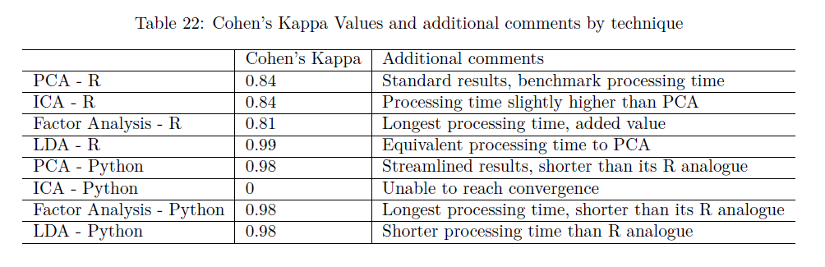

• That Python, in respect to statistics-oriented modules, is a more-streamlined, less flexible language than R.

• That R offers more implementations of even obscure or little known protocols and algorithms, and offers better flexibility to tamper with them, if the user is adept at coding.

• That PCA acts as an effective benchmark, being the “golden standard” of widely appliable dimension reduction techniques.

• That in R, ICA produces similar results, while not fine-tuned, to PCA; in Python, it requires a tolerance threshold too high to achieve convergence and under-performs compared to PCA.

• That Factor Analysis and Linear Discriminant Analysis, for this area of application, generally yield better results than PCA or ICA.

• That, while Factor Analysis has a greater processing time, it also yields an additional value: it establishes semantic relationships between features that, in a smaller data set or given more time to analyse them, could reveal new and interesting traits for the original variables or the study cases to which they belong.

• That Linear Discriminant Analysis gives up the most efficiently reduced dimensional space after the technique, with a surprisingly high Cohen’s Kappa for a very limited processing time in both programming languages.

• That both T-Stochastic Neighbor Embedding and Stacked Denoising Autoencoders are not valid for the requirements/input this study imposes.

• That Cohen’s Kappa is a valid accuracy metric that not only yields information about hits, but also takes into account the chance of those hits being random.

• That preprocessing of the data is important for accuracy of classification: both scaling and centering data sets help improve significance and accuracy of classification.

• That class imbalance can be, and in fact is, a problem with data sets, and that balancing observed classes with techniques such as SMOTE improves accuracy of classification and avoids statistical artifacts.

Also, as a last conclussion, this study merits a longer research. As such, milestones along a theoretical future roadmap should include:

• Implementing a processing objective metric, such as System.time() or tictoc in R or time() in Python, and a trial protocol, such that differences in processing time can be objectively measured and cross-tested.

• A better implementation of Python code, more object-oriented, as to optimise processing.

• Cross-testing of different parameter setups, in order to better understand not only the best performers, but the best configurations.

• A visualization module or script for both Python and R. Right now, while R offers direct applications of plotting systems for the practical majority of its functions, Python requires a lot of tweaking of its modules (mainly matplotlib), especially for data sets with so many features, even when reduced to such a number as 210.

7 – Glossary

Dimension reduction: Process by which the number of random variables under consideration is reduced either by obtaining a set of transformations, combinations of variables or selection of most informative traits.

Feature (statistics): Equivalent to variable or attribute.

Gaussianity: Equivalent to Normality.

Normality: The quality of adjusting to a normal distribution.

Lymphoblast: Activated form of a lymphocyte with an increased volume and protein-synthesis activity.

Lymphocyte: White blood cell subtype, part of the immune system, which includes adaptive and innate immunity cells.

Object-oriented: Programming paradigm focused on the creation of objects, entities or classes, with a complete semantic body, full with attributes and methods.

8 – References

Alférez, S. 2015. “Methodology for Automatic Classification of Atypical Lymphoid Cells from Peripheral Blood Cell Images,” no. February: 181.

Ballard, Dana H. 1987. “Modular Learning in Neural Networks.” Aaai, 279–84.

Barandela, Ricardo, Rosa M Valdovinos, J Salvador Sánchez, and Francesc J Ferri. 2004. “The Imbalanced Training Sample Problem: Under or over Sampling?” Structural, Syntactic, and Statistical Pattern Recognition, 806–14. doi:10.1007/b98738.

Benattar, Laurence, and Georges Flandrin. 2001. “Morphometric and Colorimetric Analysis of Peripheral Blood Smears Lymphocytes in B-Cell Disorders: Proposal for a Scoring System.” Leukemia & Lymphoma 42 (1-2): 29–40. doi:10.3109/10428190109097674.

Bengio, Yoshua, Li Yao, Guillaume Alain, and Pascal Vincent. 2013. “Generalized Denoising Auto-Encoders as Generative Models,” 1–9. http://arxiv.org/abs/1305.6663.

Brian, Author, Bill Venables, Douglas M Bates, David Firth, and Maintainer Brian Ripley. 2017. “Package ‘ MASS ’.”

Bro, Rasmus, and Age K. Smilde. 2014. “Principal component analysis.” Anal. Methods 6 (9): 2812–31. doi:10.1039/C3AY41907J.

Bunte, Kerstin, Sven Haase, Michael Biehl, and Thomas Villmann. 2012. “Stochastic neighbor embedding (SNE) for dimension reduction and visualization using arbitrary divergences.” Neurocomputing 90. Elsevier: 23–45. doi:10.1016/j.neucom.2012.02.034.

Chen, Tao, Ruifeng Xu, Yulan He, and Xuan Wang. 2017. “Improving sentiment analysis via sentence type classification using BiLSTM-CRF and CNN.” Expert Systems with Applications 72: 221–30. doi:10.1016/j.eswa.2016.10.065.

Chen, Yi-wei, and Chih-jen Lin. 2006. “Combining SVMs with Various Feature Selection Strategies.” Feature Extraction 324 (1): 315–24. doi:10.1007/978-3-540-35488-8_13.

Chollet, François et al. 2015. “Keras.” GitHub. https://keras.io/getting-started/faq/.

Chun, By Wesley J, and Wesley J Chun. 2006. Core Python Programming , Second Edition.

Fodor, Imola. 2002. “A Survey of Dimension Reduction Techniques.” doi:10.1.1.8.5098.

Gorsuch, Richard L. 1998. Factor analysis. Edited by 1998) Wiley; 1 edition (January 23. English.

Granger, Brian E, and John D Hunter. 2011. “Python : An Ecosystem,” 13–21.

Guyon, Isabelle, and André Elisseeff. 2003. “An Introduction to Variable and Feature Selection.” Journal of Machine Learning Research (JMLR) 3 (3): 1157–82. doi:10.1016/j.aca.2011.07.027.

Halko, Nathan, Per-Gunnar Martinsson, and Joel A. Tropp. 2009. “Finding structure with randomness: Probabilistic algorithms for constructing approximate matrix decompositions,” 1–74. doi:10.1137/090771806.

Hanley, A.J., and J.B. McNeil. 1982. “The Meaning and Use of the Area under a Receiver Operating Characteristic (ROC) Curve.” Radiology 143: 29–36. doi:10.1148/radiology.143.1.7063747.

Harry H. Harman. 1976. Modern Factor Analysis. Edited by 1976 University of Chicago Press. Illustrate.

Helwig, Author Nathaniel E, and Maintainer Nathaniel E Helwig. 2015. “Package ‘ ica ’.”

Hinton, Geoffrey E, and Sam T Roweis. 2002. “Stochastic neighbor embedding.” Advances in Neural Information Processing Systems, 833–40. doi:http://books.nips.cc/papers/files/nips15/AA45.pdf.

Hutchison, David, and John C Mitchell. 2013. Advances in Information Retrieval. Vol. 7814. doi:10.1007/978-3-642-36973-5.

Hyvärinen, Aapo, and Erkki Oja. 2000. “Independent Component Analysis: Algorithms and Applications.” Neural Networks 13 (45): 411–30. doi:10.1016/S0893-6080(00)00026-5.

Hyvärinen, Aapo, Juha Karhunen, and Erkki Oja. 2001. “Independent Component Analysis.” Applied and Computational Harmonic Analysis 21 (1): 135–44. doi:10.1002/0471221317.

Jolliffe, I T. 2002. “Principal Component Analysis, Second Edition.” Encyclopedia of Statistics in Behavioral Science 30 (3): 487. doi:10.2307/1270093.

Jones, Eric, Travis Oliphant, and Pearu Peterson. 2001. “SciPy: Open source scientific tools for Python.” http://www.scipy.org/.

Klecka, William. 1980. “Discriminant Analysis.” Advances in Neural Information Processing Systems 17 (60): 1569–76. doi:10.4135/9781412983938.

Leslie, Christina, Eleazar Eskin, and William Stafford Noble. 2002. “The spectrum kernel: a string kernel for SVM protein classification.” Pacific Symposium on Biocomputing 575: 564–75. doi:10.1142/9789812799623_0053.

Luengo, Æ J Æ. 2009. “A study of statistical techniques and performance measures for genetics-based Machine learning : accuracy and interpretability,” 959–77. doi:10.1007/s00500-008-0392-y.

Maaten, Laurens Van Der, and Geoffrey Hinton. 2008. “Visualizing Data using t-SNE.” Journal of Machine Learning Research 1 620 (1): 267–84. doi:10.1007/s10479-011-0841-3.

Maaten, Laurens van der. 2014. “Accelerating t-SNE using Tree-Based Algorithms.” Journal of Machine Learning Research 15: 3221–45. doi:10.1007/978-1-60761-580-4_8.

Naugler, Christopher, EmadA Mohammed, MostafaM. A. Mohamed, and BehrouzH Far. 2014. “Peripheral blood smear image analysis: A comprehensive review.” Journal of Pathology Informatics 5 (1): 9. doi:10.4103/2153-3539.129442.

Nosrati, Masoud. 2011. “Python: An appropriate language for real world programming.” World Applied Programming, no. 12: 110–17.

Package, Type. 2016. “Package ‘ tsne ’,” 2–5.

Package, Type, Author Qiang Kou, and Yusuke Sugomori. 2015. “Package ‘ RcppDL ’.”

Pedregosa, Fabian, Gaël Varoquaux, Alexandre Gramfort, Vincent Michel, Bertrand Thirion, Olivier Grisel, Mathieu Blondel, et al. 2012. “Scikit-learn: Machine Learning in Python” 12: 2825–30. doi:10.1007/s13398-014-0173-7.2.

Puigví, L, A Merino, S Alférez, A Acevedo, and J Rodellar. 2017. “New quantitative features for the morphological differentiation of abnormal lymphoid cell images from peripheral blood.” J Clin Pathol, Published Online First: 13 June 2017. doi:10.1136/jclinpath-2017-204389.

Ramentol, Enislay, Yailé Caballero, Rafael Bello, and Francisco Herrera. 2012. “SMOTE-RSB *: A hybrid preprocessing approach based on oversampling and undersampling for high imbalanced data-sets using SMOTE and rough sets theory.” Knowledge and Information Systems 33 (2): 245–65. doi:10.1007/s10115-011-0465-6.

Rifai, Salah, and Xavier Muller. 2011. “Contractive Auto-Encoders : Explicit Invariance During Feature Extraction.” Icml 85 (1): 833–40. doi:10.1007/s13398-014-0173-7.2.

Smith, Lindsay I. 2002. “A tutorial on Principal Components Analysis Introduction.” Statistics 51: 52. doi:10.1080/03610928808829796.

Sokolova, Marina, Nathalie Japkowicz, and Stan Szpakowicz. 2006. “Beyond Accuracy, F-Score and ROC: A Family of Discriminant Measures for Performance Evaluation,” no. c: 1015–21. doi:10.1007/11941439_114.

Stanley A Mulaik. 2009. Foundations of Factor Analysis, Second Edition. Edited by 2009 CRC Press. 2nd, Illus.

Team, R Development Core. 2008. “R: A Language and Environment for Statistical Computing.” Vienna: R Foundation for Statistical Computing. doi:3-900051-07-0.

Tibaduiza Burgos, Diego Alexander, Luis Eduardo Mujica Delgado, Maribel Anaya, José Rodellar Benedé, and Alfredo Güemes Gordo. 2013. “Principal component analysis vs. independent component analysis for damage detection,” 1–8.

Tipping, Michael E., and Christopher M. Bishop. 1999. “Probabilistic Principal Component Analysis.” Journal of the Royal Statistical Society: Series B (Statistical Methodology) 61 (3): 611–22. doi:10.1111/1467-9868.00196.

Tobergte, David R., and Shirley Curtis. 2013. “Independent Component Analysis by Minimization of Mutual Information.” Journal of Chemical Information and Modeling 53 (9): 1689–99. doi:10.1017/CBO9781107415324.004.

University, Stanford. “Unsupervised Feature Learning and Deep Learning Tutorial.” ufldl.stanford.edu/tutorial/unsupervised/Autoencoders/.

Van Der Maaten, Laurens, Eric Postma, and Jaap Van Den Herik. 2009. “Dimensionality Reduction : A Comparative Review.” October, 1–35. doi:10.1080/13506280444000102.

Vincent, Pascal, Hugo Larochelle, Yoshua Bengio, and Pierre-Antoine Manzagol. 2008. “Extracting and composing robust features with denoising autoencoders.” Proceedings of the 25th International Conference on Machine Learning - ICML ’08, no. July: 1096–1103. doi:10.1145/1390156.1390294.

Walt, Stefan Van Der, S Chris Colbert, Gaël Varoquaux, Stefan Van Der Walt, S Chris Colbert, Gaël Varoquaux, and The Numpy. 2011. “The NumPy array: a structure for efficient numerical computation.” doi:10.1109/MCSE.2011.37.

Yonelinas, Andrew P., and Colleen M. Parks. 2007. “Receiver operating characteristics (ROCs) in recognition memory: A review.” Psychological Bulletin 133 (5): 800–832. doi:10.1037/0033-2909.133.5.800.

9 - Annexes

Annex 1 - R comparison code

require(knitr)
require(stats)
require(caret)
require(e1071)
require(ica)
require(psych)
require(MASS)
require(ggplot2)
require(ggfortify)
require(DMwR)

# Data metavariables
data_class_factors <- 7
data_class_numeric <- 2867
data_response_index <- 2

# Classes of variable by column
colClasses <- append(c(rep("factor", data_class_factors)),
c(rep("numeric", data_class_numeric)))

# Load CSV data
data_df <- read.csv2(file = "data/data.csv", sep = ",",
dec = ".", colClasses = colClasses, stringsAsFactors = FALSE)

# Model formula
data_formula <- as.formula(paste(colnames(data_df[data_response_index]),
"~", paste(colnames(data_df)[-(1:data_class_factors)],
collapse = " + ")))

# Balance out data with SMOTE, as ROSE only works
# on binary classifications.
data_df <- SMOTE(data_formula, perc.over = 200, k = 5)

# Seed for controlled randomization
set.seed(123)

# Response and predictor subsets
data_df_predictors <- data_df[, 8:2874]
data_df_predictors <- scale(data_df_predictors)
data_df_responses <- data_df[, data_response_index]

# Training indices
data_train_index <- sample(1:nrow(data_df), ceiling(nrow(data_df) *
0.66))
write.table(as.vector(data_train_index), file = "data/data_train_index.csv",
row.names = FALSE, col.names = FALSE, sep = ",")

# Training responses subset
data_df_train_responses <- data_df_responses[data_train_index]

# Test responses subset
data_df_test_responses <- data_df_responses[-data_train_index]

# Fit PCA
data_pca <- prcomp(data_df_predictors)

# Summarize PCA
data_pca_summary <- summary(data_pca)

# Get the number of variables explaining at the
# very least 85% of variance
for (i in seq(from = 10, to = 250, by = 10)) {
data_varExp <- sum(data_pca_summary$importance[2,1:i])
if (data_varExp >= 0.95) {
varImpMessage <- paste("For ", i, " components, the percentage of variance explained is ",
data_varExp, ".", sep = "")
data_optimal_exfeat <- i
return(print(varImpMessage))
}
}
cat(varImpMessage)

# Choose the selected number of PCs
data_pca_exfeat <- data_pca$x[, 1:data_optimal_exfeat]

# Generate training and test sets
data_pca_train <- subset(data_pca_exfeat[data_train_index,
])
data_pca_test <- subset(data_pca_exfeat[-data_train_index,
])

# Fit SVM with training sets
data_pca_svm <- svm(data_pca_train, y = data_df_train_responses,
type = "C-classification", kernel = "radial")

# Feed SVM with test data for prediction
data_pca_predict <- stats::predict(data_pca_svm, data_pca_test)

# Tabulate and solve Cohen's Kappa
data_pca_table <- table(data_pca_predict, data_df_test_responses)
data_pca_perc_table <- prop.table(data_pca_table) * 100
data_pca_perc_hit <- sum(diag(data_pca_perc_table))
data_pca_cohen <- cohen.kappa(data_pca_table, n.obs = length(data_df_test_responses))
kable(data_pca_table, caption = "PCA observed versus predicted results", digits = 2, format = "latex")
kable(data_pca_perc_table, caption = "PCA observed versus predicted results - percentages", digits = 2, format = "latex")

# Choose the selected number of features while
# fitting ICA
data_ica <- icafast(data_df_predictors, nc = data_optimal_exfeat)
data_ica_exfeat <- data_ica$S

# Generate training and test sets
data_ica_train <- subset(data_ica_exfeat[data_train_index,])
data_ica_test <- subset(data_ica_exfeat[-data_train_index,])

# Fit SVM with training sets
data_ica_svm <- svm(data_ica_train, y = data_df_train_responses, type = "C-classification", kernel = "radial")

# Feed SVM with test data for prediction
data_ica_predict <- stats::predict(data_ica_svm, data_ica_test)

# Tabulate and solve Cohen's Kappa
data_ica_table <- table(data_ica_predict, data_df_test_responses)
data_ica_perc_table <- prop.table(data_ica_table) * 100
data_ica_perc_hit <- sum(diag(data_ica_perc_table))
data_ica_cohen <- cohen.kappa(data_ica_table, n.obs = length(data_df_test_responses))
kable(data_ica_table, caption = "ICA observed versus predicted results", digits = 2, format = "latex")
kable(data_ica_perc_table, caption = "ICA observed versus predicted results - percentages", digits = 2, format = "latex")

# Choose the selected number of features with a
# lower tolerance boundary extracted on trial and
# error to be the best in convergence
data_factanal <- factanal(data_df_predictors, factors = data_optimal_exfeat, scores = "Bartlett", lower = 0.07)

# Use loadings to transform preditor values
data_factanal_exfeat <- data_df_predictors %*% data_factanal$loadings

# Generate training and test sets
data_factanal_train <- subset(data_factanal_exfeat[data_train_index,])
data_factanal_test <- subset(data_factanal_exfeat[-data_train_index,])

# Fit SVM with those factors
data_factanal_svm <- svm(data_factanal_train, y = data_df_train_responses,
type = "C-classification", kernel = "radial")

# Use fitted SVM to predict test responses
data_factanal_predict <- stats::predict(data_factanal_svm, data_factanal_test)

# Tabulate and solve Coehn's Kappa
data_factanal_table <- table(data_factanal_predict,data_df_test_responses)
data_factanal_perc_table <- prop.table(data_factanal_table) * 100
data_factanal_perc_hit <- sum(diag(data_factanal_perc_table))
data_factanal_cohen <- cohen.kappa(data_factanal_table)
kable(data_factanal_table, caption = "Factor Analysis observed versus predicted results", digits = 2, format = "latex")
kable(data_factanal_perc_table, caption = "Factor Analysis observed versus predicted results - percentages", digits = 2, format = "latex")

# Fit LDA with predictors
data_lda <- lda(data_df_predictors, grouping = data_df_responses)

# Transform predictors with linear discriminants
data_lda_predictors_trans <- data_df_predictors %*% data_lda$scaling

# Generate training and test sets
data_lda_train <- subset(data_lda_predictors_trans[data_train_index,])
data_lda_test <- subset(data_lda_predictors_trans[-data_train_index,])

# Use training values to fit SVM
data_lda_svm <- svm(data_lda_train, y = data_df_train_responses, type = "C-classification", kernel = "radial")

# Feed test data to SVM and predict
data_lda_predict <- stats::predict(data_lda_svm, data_lda_test)

# Tabulate and solve Cohen's Kappa
data_lda_table <- table(data_lda_predict, data_df_test_responses)
data_lda_perc_table <- prop.table(data_lda_table) * 100
data_lda_perc_hit <- sum(diag(data_lda_perc_table))
data_lda_cohen <- cohen.kappa(data_lda_table)
kable(data_lda_table, caption = "LDA observed versus predicted results", digits = 2, format = "latex")
kable(data_lda_perc_table, caption = "LDA observed versus predicted results - percentages", digits = 2, format = "latex")

Annex 2 - Python comparison code

#Import all necessary modules
import scipy
import numpy
import pandas as pd
from sklearn.decomposition import PCA
from sklearn import svm
from sklearn.model_selection import train_test_split
from sklearn.metrics import cohen_kappa_score
from sklearn.metrics import confusion_matrix

#Define data metavariables and load data
data_pydf_predictor_ids = range(7,2874)
data_pydf_predictors = pd.read_csv('data/data.csv', usecols=data_pydf_predictor_ids)
data_pydf_predictors = data_pydf_predictors.values
data_pydf_responses = pd.read_csv('data/data.csv', usecols=['tipoCelula'])
data_pydf_responses = data_pydf_responses.values

#Configure PCA object
data_pca_py = PCA(n_components=210,copy=True)

#Fit PCA with predictors
data_pca_py_fit = data_pca_py.fit(data_pydf_predictors, data_pydf_responses.ravel())

#Transform predictors on selected PCs
data_pca_py_transf = data_pca_py_fit.transform(data_pydf_predictors)

#Subset transformed data into test and training subsets
data_pca_predictors_train,data_pca_predictors_test,data_pca_responses_train,data_pca_responses_test =

#Convert response array to 1D for prediction
data_pca_responses_test_1D = data_pca_responses_test[:,0]

#Initialize SVM
data_pca_py_svm = svm.SVC(kernel='rbf')

#Fit SVM
data_pca_py_svm_fit=data_pca_py_svm.fit(data_pca_predictors_train, data_pca_responses_train.ravel()).predict(

#Put classification results in temp file
numpy.savetxt("data_pca_responses_test_1D.csv", data_pca_responses_test_1D, delimiter=",", fmt="%s")
numpy.savetxt("data_pca_py_svm_fit.csv", data_pca_py_svm_fit, delimiter=",", fmt="%s")

#Load classification data as R objects
require(knitr)
require(psych)
data_pca_responses_test_1D<-read.csv(file="data_pca_responses_test_1D.csv",sep = ",", header = FALSE)
data_pca_responses_test_1D <- data_pca_responses_test_1D[,1]
data_pca_py_svm_fit <- read.csv(file = "data_pca_py_svm_fit.csv", sep = ",", header = FALSE)
data_pca_py_svm_fit <- data_pca_py_svm_fit[, 1]

#Tabulate and solve Cohen's Kappa
data_pca_py_table <- table(data_pca_py_svm_fit, data_pca_responses_test_1D)
data_pca_py_perc_table <- prop.table(data_pca_py_table) * 100
data_pca_py_perc_hit <- sum(diag(data_pca_py_perc_table))
data_pca_py_cohen <- cohen.kappa(data_pca_py_table, n.obs = length(data_pca_responses_test_1D))
kable(data_pca_py_table, caption = "PCA observed versus predicted results", digits = 2, format = "latex")
kable(data_pca_py_perc_table, caption = "PCA observed versus predicted results - percentages",
digits = 2, format = "latex")

#Import all necessary modules
import scipy
import numpy
import pandas as pd
from sklearn.decomposition import FastICA
from sklearn import svm
from sklearn.model_selection import train_test_split
from sklearn.metrics import cohen_kappa_score
from sklearn.metrics import confusion_matrix

#Define data metavariables and load data
data_pydf_predictor_ids = range(7,2874)
data_pydf_predictors = pd.read_csv('data/data.csv', usecols=data_pydf_predictor_ids)
data_pydf_predictors = data_pydf_predictors.values
data_pydf_responses = pd.read_csv('data/data.csv', usecols=['tipoCelula'])
data_pydf_responses = data_pydf_responses.values

#Configure ICA object
data_ica_py = FastICA(n_components=210)

#Fit ICA with predictors
data_ica_py_fit = data_ica_py.fit(data_pydf_predictors, data_pydf_responses.ravel())

#Transform predictors on selected factors
data_ica_py_transf = data_ica_py_fit.transform(data_pydf_predictors)

#Subset transformed data into test and training subsets
data_ica_predictors_train, data_ica_predictors_test, data_ica_responses_train, data_ica_responses_test = #Convert response array to 1D for prediction
data_ica_responses_test_1D = data_ica_responses_test[:,0]

#Initialize SVM
data_ica_py_svm = svm.SVC(kernel='rbf')

#Fit SVM
data_ica_py_svm_fit = data_ica_py_svm.fit(data_ica_predictors_train, data_ica_responses_train.ravel()).predict(2

#Put classification results in temp file
numpy.savetxt("data_ica_responses_test_1D.csv", data_ica_responses_test_1D, delimiter=",", fmt="%s")
numpy.savetxt("data_ica_py_svm_fit.csv", data_ica_py_svm_fit, delimiter=",", fmt="%s")

#Load classification data as R objects
data_ica_responses_test_1D <- read.csv(file = "data_ica_responses_test_1D.csv",sep = ",", header = FALSE)
data_ica_responses_test_1D <- data_ica_responses_test_1D[,1]
data_ica_py_svm_fit <- read.csv(file = "data_ica_py_svm_fit.csv",sep = ",", header = FALSE)
data_ica_py_svm_fit <- data_ica_py_svm_fit[,1]

# Tabulate and solve Cohen's Kappa
data_ica_py_table <- table(data_ica_py_svm_fit, data_ica_responses_test_1D)
data_ica_py_perc_table <- prop.table(data_ica_py_table) * 100
data_ica_py_perc_hit <- sum(diag(data_ica_py_perc_table))
data_ica_py_cohen <- cohen.kappa(data_ica_py_table,
n.obs = length(data_ica_responses_test_1D))
kable(data_ica_py_table, caption = "ICA observed versus predicted results", digits = 2, format = "latex")
kable(data_ica_py_perc_table, caption = "ICA observed versus predicted results - percentages",
digits = 2, format = "latex")

#Import all necessary modules
import scipy
import numpy
import pandas as pd
from sklearn.decomposition import FactorAnalysis
from sklearn import svm
from sklearn.model_selection import train_test_split
from sklearn.metrics import cohen_kappa_score
from sklearn.metrics import confusion_matrix

#Define data metavariables and load data
data_pydf_predictor_ids = range(7,2874)
data_pydf_predictors = pd.read_csv('data/data.csv', usecols=data_pydf_predictor_ids)
data_pydf_predictors = data_pydf_predictors.values
data_pydf_responses = pd.read_csv('data/data.csv', usecols=['tipoCelula'])
data_pydf_responses = data_pydf_responses.values

#Configure Factor Analysis object
data_factanal_py = FactorAnalysis(n_components=210)

#Fit FA with predictors
data_factanal_py_fit = data_factanal_py.fit(data_pydf_predictors, data_pydf_responses.ravel())

#Transform predictors on selected factors
data_factanal_py_transf = data_factanal_py_fit.transform(data_pydf_predictors)

#Subset transformed data into test and training subsets
data_factanal_predictors_train, data_factanal_predictors_test, data_factanal_responses_train, data_factanal_

#Convert response array to 1D for prediction
data_factanal_responses_test_1D = data_factanal_responses_test[:,0]

#Initialize SVM
data_factanal_py_svm = svm.SVC(kernel='rbf')

#Fit SVM
data_factanal_py_svm_fit=data_factanal_py_svm.fit(data_factanal_predictors_train, ata_factanal_responses_

#Put classification results in temp file
numpy.savetxt("data_factanal_responses_test_1D.csv",data_factanal_responses_test_1D, delimiter=",", fmt=="%s")
numpy.savetxt("data_factanal_py_svm_fit.csv", data_factanal_py_svm_fit, delimiter=",", fmt="%s")

#Load classification data as R objects
data_factanal_responses_test_1D <- read.csv(file = "data_factanal_responses_test_1D.csv",sep = ",", header = FALSE)
data_factanal_responses_test_1D <- data_factanal_responses_test_1D[,1]
data_factanal_py_svm_fit <- read.csv(file = "data_factanal_py_svm_fit.csv",sep = ",", header = FALSE)
data_factanal_py_svm_fit <- data_factanal_py_svm_fit[,1]

#Tabulate and solve Cohen's Kappa
data_factanal_py_table <- table(data_factanal_py_svm_fit,
data_factanal_responses_test_1D)
data_factanal_py_perc_table <- prop.table(data_factanal_py_table) * 100
data_factanal_py_perc_hit <- sum(diag(data_factanal_py_perc_table))
data_factanal_py_cohen <- cohen.kappa(data_factanal_py_table,n.obs = length(data_factanal_responses_test_1D))
kable(data_factanal_py_table, caption = "Factor Analysis observed versus predicted results",digits = 2, format = "latex")
kable(data_factanal_py_perc_table, caption = "Factor Analysis observed versus predicted results - percentages",digits = 2, format = "latex")

#Import all necessary modules
import scipy
import numpy
import pandas as pd
from sklearn.discriminant_analysis import LinearDiscriminantAnalysis
from sklearn import svm
from sklearn.model_selection import train_test_split
from sklearn.metrics import cohen_kappa_score
from sklearn.metrics import confusion_matrix

#Define data metavariables and load data
data_pydf_predictor_ids = range(7,2874)
data_pydf_predictors = pd.read_csv('data/data.csv', usecols=data_pydf_predictor_ids)
data_pydf_predictors = data_pydf_predictors.values
data_pydf_responses = pd.read_csv('data/data.csv', usecols=['tipoCelula'])
data_pydf_responses = data_pydf_responses.values

#Configure LDA object
data_lda_py = LinearDiscriminantAnalysis(n_components=210)

#Fit LDA with predictors
data_lda_py_fit = data_lda_py.fit(data_pydf_predictors, data_pydf_responses.ravel())

#Transform predictors on selected factors
data_lda_py_transf = data_lda_py_fit.transform(data_pydf_predictors)

#Subset transformed data into test and training subsets
data_lda_predictors_train, data_lda_predictors_test, data_lda_responses_train, data_lda_responses_test = #Convert response array to 1D for prediction
data_lda_responses_test_1D = data_lda_responses_test[:,0]

#Initialize SVM
data_lda_py_svm = svm.SVC(kernel='rbf')

#Fit SVM
data_lda_py_svm_fit=data_lda_py_svm.fit(data_lda_predictors_train, data_lda_responses_train.ravel()).predict(#Put classification results in temp file
numpy.savetxt("data_lda_responses_test_1D.csv",data_lda_responses_test_1D,delimiter=",",fmt="%s")
numpy.savetxt("data_lda_py_svm_fit.csv", data_lda_py_svm_fit, delimiter=",", fmt="%s")

#Load classification data as R objects
data_lda_responses_test_1D <- read.csv(file = "data_lda_responses_test_1D.csv",sep = ",", header = FALSE)
data_lda_responses_test_1D <- data_lda_responses_test_1D[,1]
data_lda_py_svm_fit <- read.csv(file = "data_lda_py_svm_fit.csv",sep = ",", header = FALSE)
data_lda_py_svm_fit <- data_lda_py_svm_fit[,1]

#Tabulate and solve Cohen's Kappa
data_lda_py_table <- table(data_lda_py_svm_fit, data_lda_responses_test_1D)
data_lda_py_perc_table <- prop.table(data_lda_py_table) * 100
data_lda_py_perc_hit <- sum(diag(data_lda_py_perc_table))
data_lda_py_cohen <- cohen.kappa(data_lda_py_table,
n.obs = length(data_lda_responses_test_1D))
kable(data_lda_py_table, caption = "LDA observed versus predicted results",
digits = 2, format = "latex")
kable(data_lda_py_perc_table, caption = "LDA observed versus predicted results - percentages",
digits = 2, format = "latex")

