**Census API Data – Annual Business Survey 2019: Project Report**

Darrell Gerber, Grace Seiler, Pemba Sherpa, Amy Yucus  
1/17/2021

Artificial intelligence (AI) is one of the hottest technologies businesses explore in the new decade. As a result, expected AI market growth is USD 58.3 billion in 2021 to USD 309.6 billion by 2026.[1] In addition, the COVID pandemic has further affected the industry as businesses seek to find new ways to utilize a smaller available workforce and increasingly dispersed working locations.

Artificial Intelligence providers have exceptional opportunities to expand market share yet face challenges adapting to a dynamic marketplace. This report looks at a few questions of interest to an AI provider looking to adjust their marketing, sales, and support resources to best address the needs of their customers.

**Business Questions**

1. Customers who already have experience with and high usage of AI provide a unique marketing and sales opportunity for AI suppliers. These firms are likely to have high knowledge of AI, and existing internal expertise requiring marketing and sales approaches differing from firms just exploring AI. The first question addressed, “what firms already have high AI use,” helps an AI provider segment the market and better tailor their offerings. For example, an AI provider’s marketing department may be interested in which firms are more heavily using AI and which business sectors are the highest adopters of AI. The sales department may be interested in a state and regional breakdown of high AI acceptance to better allocate sales resources to meet the needs of their customers.
2. The COVID pandemic has severely impacted the available workforce for many top AI customers. As a result, customers are looking for opportunities to use AI to reduce the need for additional workers and reduce the burden on already stressed workers. Therefore, the second question addressed is: does AI technology use affect the number of workers and worker skill level?
3. Sales and marketing departments are also interested in the motivation behind firms using Artificial Intelligence. Knowing these motivations can help persuade companies to consider using Artificial Intelligence, drawing on case studies of other companies with the exact needs (and thus motivations for use). Therefore, the third question looks more closely at the sizes, sectors, and geographies with the highest level of use of AI and what they report as their driving motivations to use AI.
4. Even though AI is one of the hottest technologies, there is still some hesitation. So, what do businesses find to be the main factors adversely affecting their adoption and utilization of AI? What kind of firm is indicating which factors? Are they mainly small firms? Also, how does the data on the proportion of firms indicating these factors vary by location? Understanding these pain points can help sales and marketing departments head off concerns early.

**Data Sources**

The United States Census Bureau publishes the Annual Business Survey (ABS) to provide information on economic and demographic characteristics of businesses and business owners. The survey also measures research and development and business topics like technology. The survey covers all nonfarm employer businesses. Data combines survey data with data collected from economic census and administrative records. Estimates are available at the US, state, MSA, county, and economic place levels and NAICS sector.[2]

The US Census Bureau provides API calls to access four ABS datasets for 2019 (data collected from 2016 to 2018).[3] For example, this report pulls data from the ‘Technology Characteristics of Businesses’ via the API call: api.census.gov/data/2018/abstcb.html.

A GitHub repository hosted by Chris Halpert provides additional information on state regions and sub-regions.[4]

**Who Has the Highest Use of Artificial Intelligence?**

The ABS asked businesses, “During the three years 2016 to 2018, to what extent did this business use the following technologies in production processes for goods or services?” with technology options being Artificial Intelligence, Cloud-Based, Specialized Software, Robotics, and Specialized Equipment. Within each, respondents were allowed to select Low, Medium, or High Use along with Did Not Use, Tested but did not use in production or service, and Don’t Know.

To understand businesses with the highest use of AI, those responding to High Use are broken down by business size, sector, and location.

**High Artificial Intelligence Use By Firm Size**

Despite the high level of media attention on artificial intelligence, the proportion of all firms with a high level of AI adoption remains low at 0.45 percent. Within that group, larger firms have a significantly higher portion reporting high AI use than firms with 1 to 9 employees. Firms with no employees have a slightly higher than average portion with high AI use. Note, the measurement used is the number of firms responding as making High Use of AI and is normalized against all respondees to the question.

Smaller firms likely don’t have the internal resources to devote to the high overhead required to adopt artificial intelligence in their business. Additionally, smaller firms may be less likely to have a suitable application for AI. Single-proprietor technical consulting firms, which are much more likely to utilize AI in their business, likely explain the higher adoption of AI by firms with no employees.

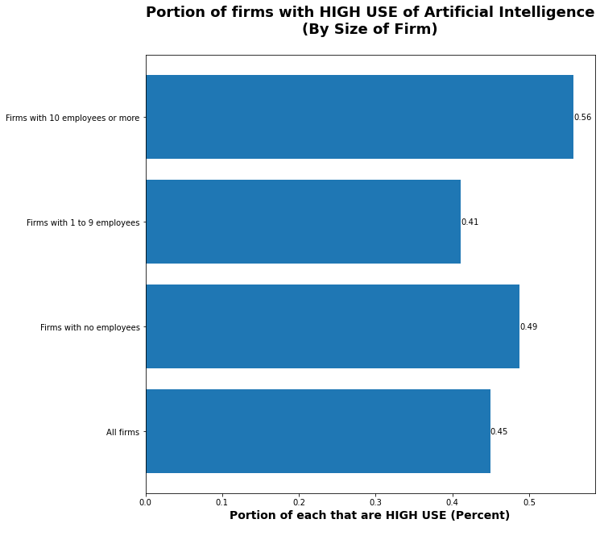

Figure : A higher proportion of firms with ten or more employees responded that they have adopted artificial intelligence in many of their production processes than smaller firms.

**High Artificial Intelligence Use By Sector**

The Information sector has a significantly higher level of adoption of AI than other sectors. Finance and Insurance and Professional, Scientific, and Technical Services are the only adopters with more high use than the average.

The Information NAICS sector[5] includes several business types that are already high adopters of AI, including:

* Data Processing, Hosting, and Related Services,
* Internet Publishing and Broadcasting and Web Search Portals, and
* Cable and Other Subscription Programming

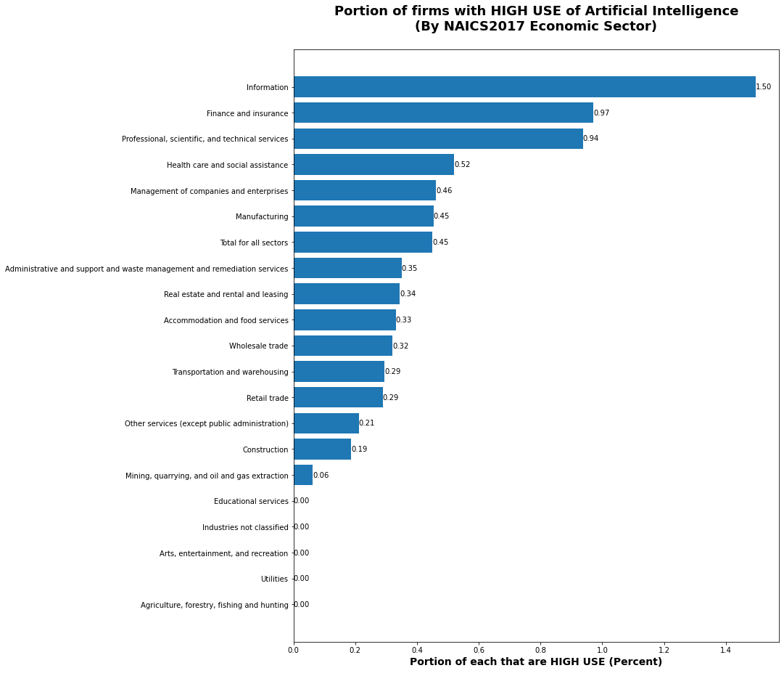

Figure : Significantly more Information-sector firms are high adopters of artificial intelligence. The Finance and Insurance sector and Professional, Scientific, and Technical Services sector are the next more frequent adopters of artificial intelligence.

**High Artificial Intelligence Use By State and Region**

Delaware (1%) has the highest portion of high AI adoptees than any other state, with 22% more than the following states, New Mexico (0.78%) and Washington, DC (0.77%).

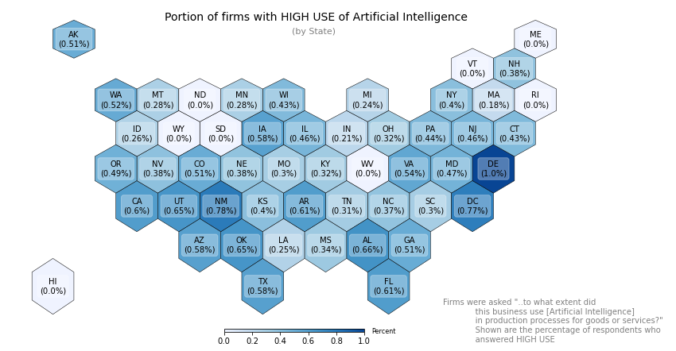

Figure : Delaware, New Mexico, and Washington, DC significantly lead other states in the number of firms who are high adopters of AI.

Buoyed by the high adoption rates in these three states, the Western and Southern regions have significantly higher adoption rates than the rest of the country. Notably absent from the top five states adopting AI is California, where Silicon Valley is the traditional technology industry leader.

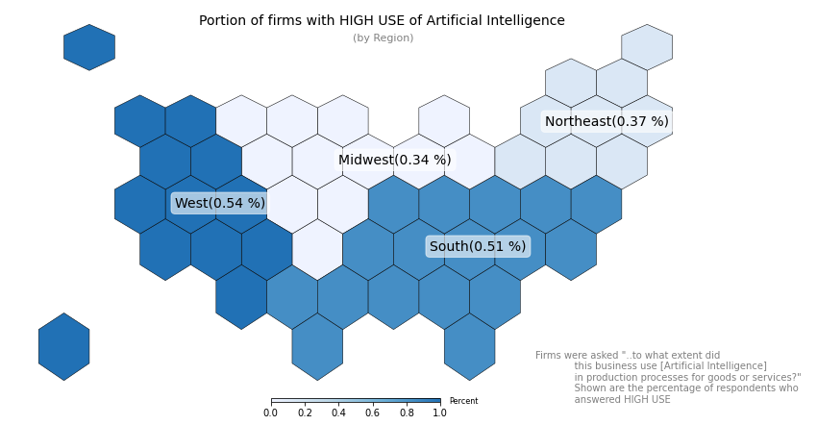

Figure 4: The West and South house significantly more firms who are high adopters of AI

**Does Use of Artificial Intelligence Affect Employee Numbers and Skills?**

The size of a firm or company is essential when considering implementing any technology. Therefore, doing market research into your target audience is expected and needed. In this situation, we will look at how Artificial Intelligence’s use affects employee numbers and skills.

This first graph shows that overwhelmingly there is no change in the number of workers when a firm uses Artificial Intelligence. The next thing to notice is that the percentage of firms that increased workers is double at firms with more than ten employees compared to the other sizes.

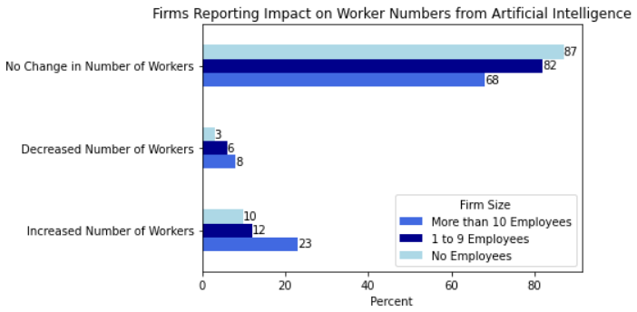

Figure . Percentage of firms reporting how Artificial Intelligence usage has altered their number of workers.

The next point to examine is worker skill with the application of Artificial Intelligence. Similar to the above horizontal bar graph, there was no change for most firm sizes. What differs is the disparity between not having any changes in worker skill and an increase in worker skill. In addition, the firms with more than ten employees have a higher percentage of increased worker skills. Because of these takeaways, it’s wise to look at firms with more than ten employees as case studies for developing a marketing plan.

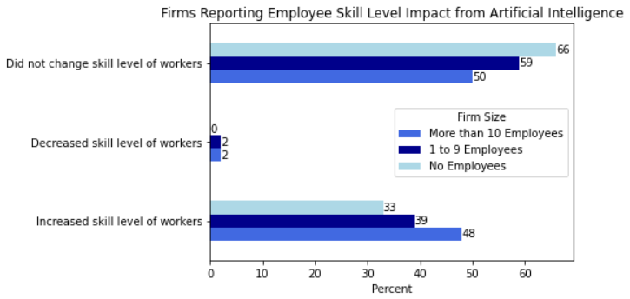

Figure . Percentage of firms reporting how Artificial Intelligence usage has altered employee skill level.

The last visualization focusing on the impact of Artificial Intelligence looks at a specific location: Delaware. This graph focuses on the impact of Artificial Intelligence usage in an area with high use, as reported by the first question addressed in this report. There wasn’t a notable increase in the number of workers at Delaware firms, but AI increased workers’ skill levels. This finding brings up an avenue for future marketing: Artificial Intelligence to improve worker skills. Also, promising is marketing AI to increase productivity.

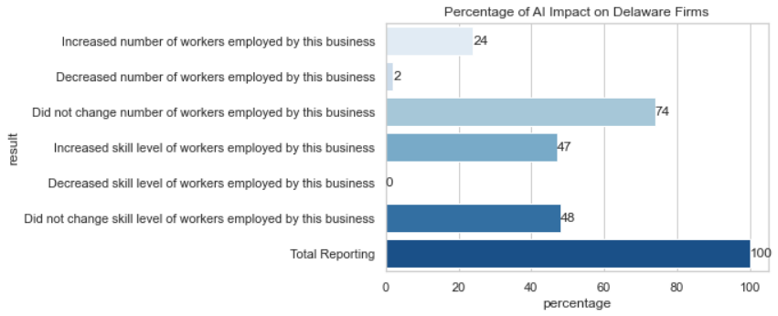

Figure . Percentage of reporting firms on the impact of Artificial Intelligence.

**Motivations for the use of Artificial Intelligence**

As a sales or marketing team, knowing companies’ motivations that use Artificial Intelligence can better inform the proposals made to companies considering AI. In addition, these motivations identify potential Pain Points in a company’s operations that AI can alleviate. Therefore, exploring more deeply the categories found to have the highest AI use (outlined above in the section: Who has the Highest Use of Artificial Intelligence?) reveals the most influential motivation factors for AI use. Note, firms were allowed to select more than one factor motivating them to use AI.

Firms with ten employees or more reported the highest use of Artificial Intelligence. Figure 8 shows that large firms have the strongest motivation to use AI to improve the quality or reliability of processes or methods.

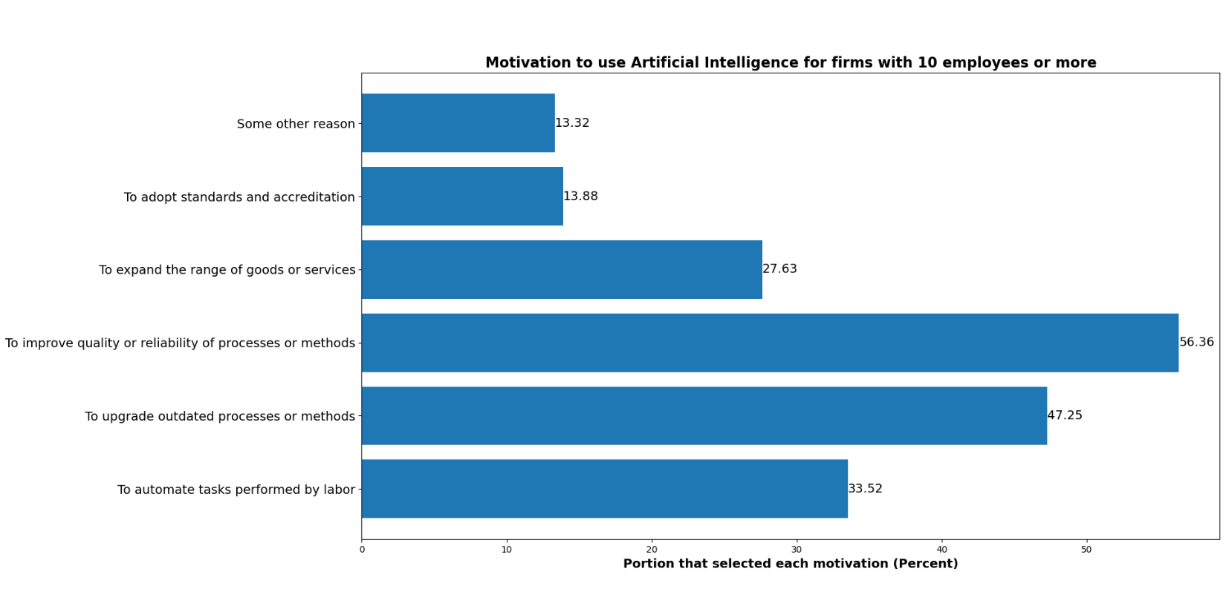

Figure : Motivation to use Artificial Intelligence high utilization firms with ten employees or more.

The next category explored was the location. Again, the state with the highest use of Artificial Intelligence was Delaware, with 1.0% of respondent firms reporting a high utilization of AI. Figure 9 breaks down the motivations to use AI in the state of Delaware. There is once again a solid motivation to improve the quality or reliability of processes or methods, with the push to upgrade outdated processes or procedures being the second most selected response.

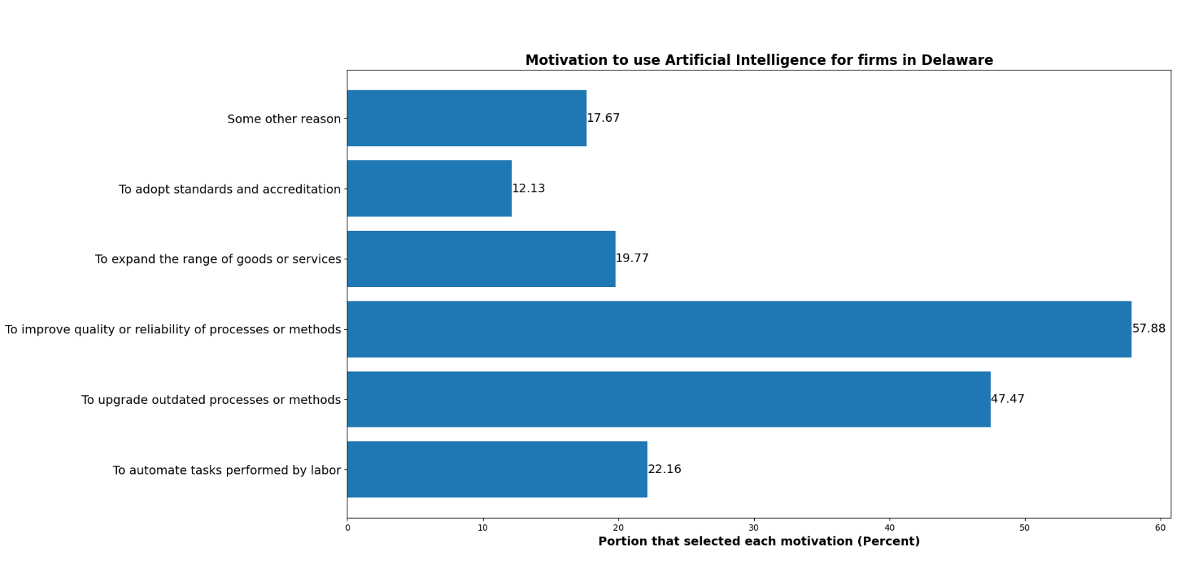

Figure : Motivation to use Artificial Intelligence for the state with the highest use of AI - Delaware.

Finally, we inspected respondents that report high utilization of Artificial Intelligence by sector, finding that the highest proportion of high use responses was in the Information sector. Figure 10 illustrates the motivations in the Information sector to use AI. Similar to previous findings, improving the quality or reliability of processes or methods is an essential motivation for using AI. Interestingly, the Information sector has the lowest proportion of respondents for adopting standards and accreditation than any of the categories explored so far.

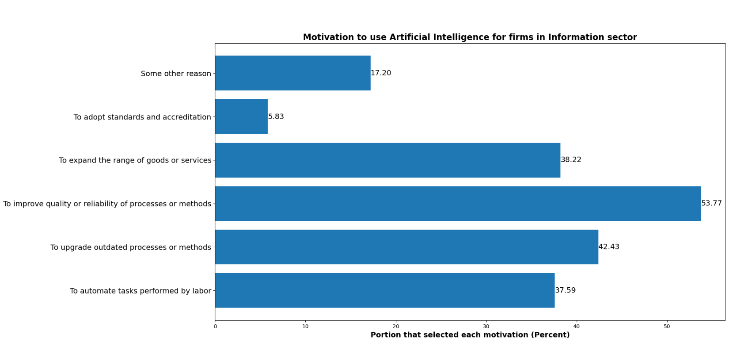

Figure : Motivations to use Artificial Intelligence for the sector with the highest use of AI - Information.

The motivations of the types for firms, by the firm’s size, location, and sector, with the highest use of Artificial Intelligence can provide a sales and marketing team key insights. A sales and marketing strategy should highlight AI as a tool to improve the quality or reliability of processes or methods or upgrade outdated processes or methods. They should then look further into a specific size, location, and sector information to potentially use a companies desire to expand their range of goods or services or automation of tasks performed by labor as influencing factors. Adopting standards and accreditation is an insignificant motivating factor for firms in all categories investigated.

**What Factors Adversely Affected the Adoption and Utilization of AI?**

Figure 11 shows that most firms indicated that either AI did not apply to their business or that no factors adversely affected their adoption of AI. Likely, many firms that indicated that no factors adversely their adoption of AI were already utilizing AI for their businesses. Firms responding that AI did not apply to their business are unlikely to adopt AI anytime soon. Eliminating the first two responses as unuseful for marketing or sales leaves the third most common factor affecting a firm’s adoption of AI: AI is too expensive. Note, firms were allowed to select more than one factor adversely affecting their use of AI.

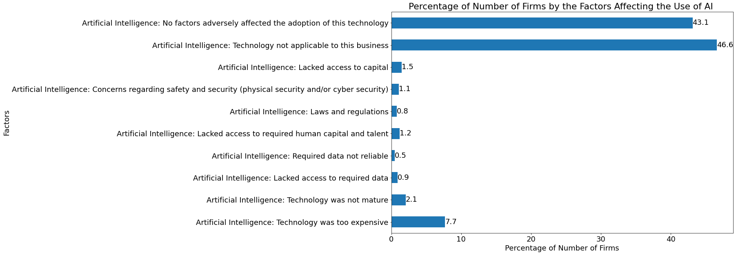

Figure : Bar chart showing the proportion of firms’ by the factors that adversely affected the adoption or utilization of AI to produce goods or services.

Focusing on the cost of AI, Figure 12 shows the proportion of firms answering that AI was too expensive by firm size. Significantly, 69.3 % of those finding AI too expensive were small firms, while larger firms accounted for 24.9%.

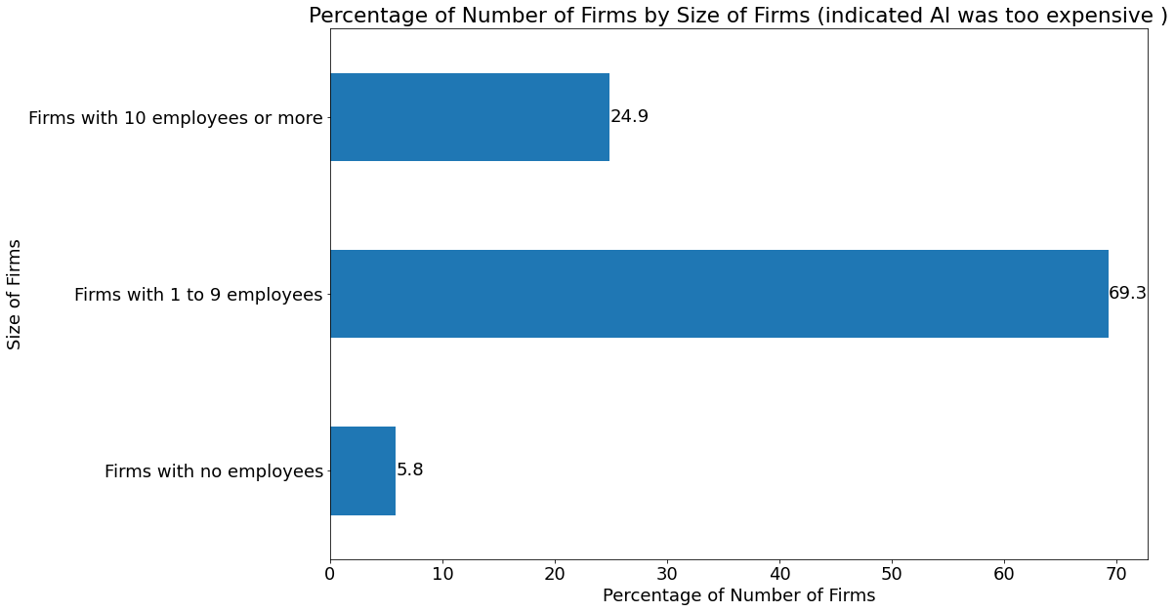

Figure : Bar chart showing the proportion of firms answering AI is too expensive broken down by the firm’s size.

Figure 13 shows a heat map shaded by the proportion of firms in each state, indicating that AI is too expensive. The data is normalized to the number of reporting firms in each state and not the US. North Dakota has the highest percentage of firms that indicated AI to be expensive. On the other hand, Montana has the lowest rate of firms finding AI too expensive. It is an interesting result as North Dakota and Montana are neighboring states yet produced polar opposite results.

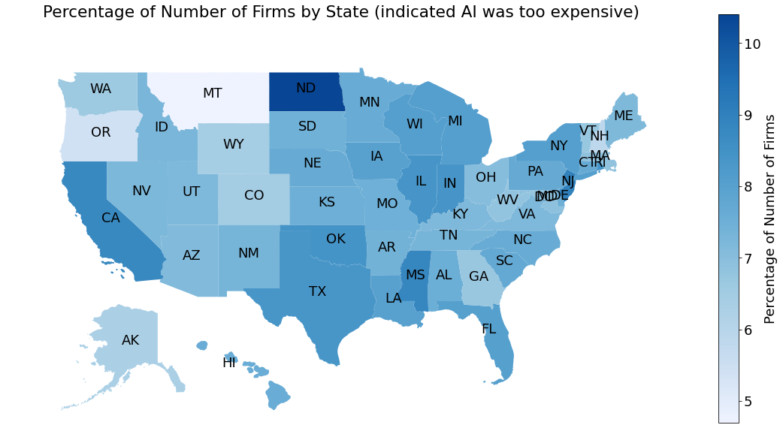

Figure : US Heat map shows the percentage of firms that indicated AI is too expensive.

**Conclusion**

A company marketing and selling Artificial Intelligence solutions to other companies…

To make case studies to make marketing and sales research, examining existing firms and companies helps immensely. In addition, segmenting the firms into different sizes helps break data down into more manageable chunks. For example, after looking at the differences in percentages of worker skills, the marketing team should focus on cases where their technology can be used to increase worker skill and productivity.

The motivations to use AI for companies that already utilize the technology in their operations highlight potential Pain Points for prospective companies. The sales and marketing team should highlight the motivation to improve the quality or reliability of processes or methods to influence companies for why they should choose to use AI.

Knowing the reason behind adverse factors affecting the adoption and utilization can be beneficial to create plans to improve sales. For example, 7.7 % of the firms mentioned AI were too expensive, which means creating a plan to counter that could significantly increase the number of clients.

1. “Artificial Intelligence Market.” Markets and Markets, Market Research Firm, https://www.marketsandmarkets.com/Market-Reports/artificial-intelligence-market-74851580.html.
2. “About the Annual Business Survey (ABS).” Census.gov, US Census Bureau, 8 Oct. 2021, https://www.census.gov/programs-surveys/abs/about.html.
3. Bureau, US Census. “Annual Business Survey (ABS) APIs.” *Census.gov*, US Census Bureau, 14 Oct. 2021, https://www.census.gov/data/developers/data-sets/abs.2019.html.
4. Halpert, Chris. “census-regions.” *GitHub*, 23 Jun. 2014, https://github.com/cphalpert/census-regions/blob/master/us%20census%20bureau%20regions%20and%20divisions.csv.
5. [Six Digit NAICS Codes: 51 Information | NAICS Association](https://www.naics.com/six-digit-naics/?code=51)