
Applications, Capabilities and Technologies
Contents
Introduction 2
Applications 3
Bridge Inspection 3
Crime Scene Investigation 3
Development Platform 3
Home Inspection 3
Nature Surveying 3
Reconnaissance 3
Survivor Search 3
Planned Capabilities 5
Automatic Takeoff/Hover/Landing 5
Extended Autonomous Navigation via GCS 5
Limited Autonomous Navigation via RCU 5
Manual Control 5
Simple Calibration/Testing via Test-Stand 5
Vehicle Health System 5
Future Capabilities 5
Advanced Hover 5
Configurable Payloads 6
Extended Flight Duration 6
Extended Range 6
Image Capture 6
Obstacle Avoidance 6
Swarm Autonomy 6
Terrain Following 6
Vehicle Status – Audio 6
Video Transmission to GCS 7
Wi-Fi Repeater 7
Wireless Airborne Programming 7
Wireless Charging other Systems 7
Planned Technologies 8
Co-Axial Rotors 8
Command/Control Network Monitoring 8
Communications Protocol v 1 8
Communications Protocol v 2 8
Data Storage 8
Inertial Navigation Unit (INU) 8
Power Management 8
Primary/Secondary Controller Implementation 8
Rotatable Pylons 8
Waypoint Navigation 8
Future Technologies 9
3D Feedback 9
Audio Commands 9
Automatic Landing Pad 9
Cellular Network 9
Cel-Phone Control 9
Ground Control Station – Interface in MatLab 9
Joint Unmanned Architecture System (JAUS) Interoperability 9
Motor Heat Dissipation 9
Multiple Vehicles 9
R/C Control 9
RCU Testing Software 9
Recovery System 9
Safety System 9
Satellite Communications 10
Simultaneous Localization and Mapping (SLAM) 10
Target Detection 10
Wireless Charging 10

Introduction
The ICARUS Project serves many applications through its extensive capabilities enabled by advanced technologies. This document is designed to illustrate the entire feature set of ICARUS, give examples of suggested applications and report the status of the enabling capabilities and technologies.

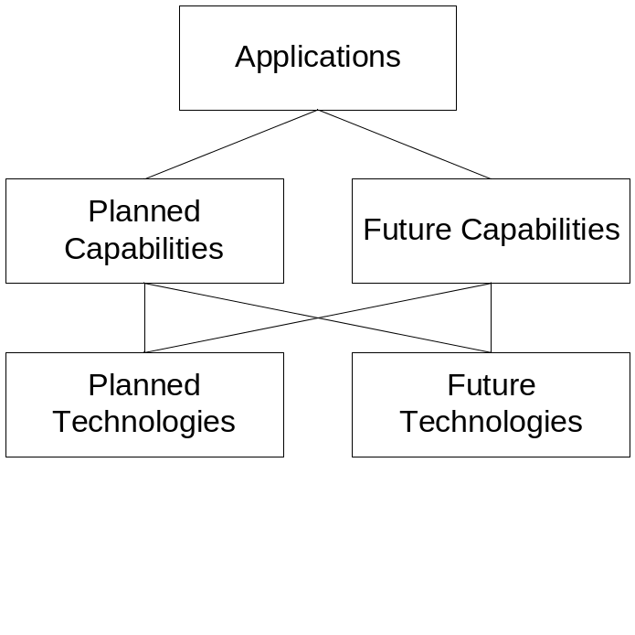

Applications

Bridge Inspection
Industry: Civil Engineering
Description: Bridge inspection can be accomplished by an airborne platform capable of recording still images and transmitting live video to Operator’s and hovering over regions of interest.
Required Capabilities and Technologies: Automatic Takeoff/Hover/Landing Image Capture Obstacle Avoidance Video Transmission to GCS Advanced Hover Rotatable Pylons

Crime Scene Investigation
Industry: Law Enforcement
Description: Police Officers can utilize an airborne platform to assist a crime scene investigation by recording still images and transmitting live video to Operator’s and hovering over regions of interest.
Required Capabilities and Technologies: Automatic Takeoff/Hover/Landing Image Capture Video Transmission to GCS

Development Platform
Industry: Academia
Description: ICARUS can be a very effective development platform, for the inexperienced hobbyist to the advanced researcher.
Required Capabilities and Technologies: Simple Calibration/Testing via Test-Stand Command/Control Network Monitoring Recovery System

Home Inspection
Industry: Residential Construction
Description: Roof and exterior walls that are hard/impossible to reach by human’s can be inspected by an airborne platform capable of recording still images and transmitting live video to Operator’s and hovering over regions of interest.
Required Capabilities and Technologies: Automatic Takeoff/Hover/Landing Image Capture Obstacle Avoidance Video Transmission to GCS Rotatable Pylons

Nature Surveying
Industry: Environmental
Description: Environmental research can be accomplished over a wide array of terrain. Video and image acquisition along with atmospheric sampling can be accomplished.
Required Capabilities and Technologies: Automatic Takeoff/Hover/Landing Image Capture Obstacle Avoidance Video Transmission to GCS Configurable Payloads Power Management

Reconnaissance
Industry: Military
Description: Surveillance and Reconnaissance tasks can be fulfilled, especially in areas that are hazardous or dangerous to friendly forces.
Required Capabilities and Technologies: Automatic Takeoff/Hover/Landing Image Capture Obstacle Avoidance Video Transmission to GCS Configurable Payloads Terrain Following Satellite Communications Joint Unmanned Architecture System (JAUS) Interoperability

Survivor Search
Industry: Emergency Management
Description: Searching for survivor’s and establishment of communications with survivor’s can be accomplished. Survivor’s can give audible commands for ICARUS to follow.
Required Capabilities and Technologies: Automatic Takeoff/Hover/Landing Image Capture Obstacle Avoidance Video Transmission to GCS Configurable Payloads Terrain Following Audio Commands Cellular Network Satellite Communications Swarm Autonomy

Planned Capabilities

Automatic Takeoff/Hover/Landing
Description: Vehicle capable of automatic takeoff/hover and landing using on-board sensors, allowing simpler control by User and preventing flight accidents.
Enabling Technologies: Primary/Secondary Controller Implementation
Owner: David Gitz

Extended Autonomous Navigation via GCS
Description: GCS capable of recording, displaying and transmitting waypoint commands to Vehicle. Vehicle capable of receiving, navigating and reporting status of waypoint traversal.
Enabling Technologies: Waypoint Navigation
Owner: David Gitz

Limited Autonomous Navigation via RCU
Description: Vehicle able to travel directly to RCU, using GPS sensor on-board RCU. Useful when using ICARUS without GCS and Vehicle travels outside communications range of RCU.
Enabling Technologies: Command/Control Network Monitoring Inertial Navigation Unit (INU)
Owner: David Gitz

Manual Control
Description: Manual control of Vehicle via RCU or GCS. Each will gather user commands for desired pitch, roll, yaw and throttle settings and Vehicle will implement commands. RCU input from 2 dual-axis joysticks. GCS input from keyboard, joystick or xbox-360 (wired) controller.
Enabling Technologies: Inertial Navigation Unit (INU)
Owner: Mike Welling

Simple Calibration/Testing via Test-Stand
Description: Control System design/analysis using capabilities of Test-Stand, including off-board power supply, vertical lift measurement and stable platform that offers full range of flight motion of Vehicle.
Enabling Technologies: Data Storage
Owner: James Chaklos

Vehicle Health System
Description: Vehicle capable of monitoring parameters of interest, including power supply, altitude, flight time, etc to communicate with GCS and RCU and inform User any condition that could cause malfunction and in some specific cases mitigate the cause by taking preventative measures.
Enabling Technologies: Command/Control Network Monitoring Power Management
Owner: Mike Welling

Future Capabilities

Advanced Hover
Description: Vehicle capable of hovering on dynamic and/or non-zero angles, although this would result in increased energy consumption.
Enabling Technologies: Inertial Navigation Unit (INU) Primary/Secondary Controller Implementation Rotatable Pylons
Owner: Mike Welling

Configurable Payloads
Description: Vehicle capable of supporting different payloads, including lift/grapple, camera (still/video/IR), atmospheric sampler, etc.
Enabling Technologies:
Owner:

Extended Flight Duration
Description: Vehicle capable of determining minimum lift needed to stay aloft. Vehicle capable of landing/taking off when not needed. Vehicle capable of landing on non-uniform and/or non-flat surfaces (perch).
Enabling Technologies: Automatic Landing Pad Power Management
Owner:

Extended Range
Description: ICARUS capable of using existing cellular network for Command/Control. ICARUS capable of using Satellite Communications (SATCOM) for Command/Control.
Enabling Technologies: Automatic Landing Pad Power Management Cellular Network Satellite Communications
Owner: Mike Welling

Image Capture
Description: Vehicle capable of storing images on removable flash-media, with up to HD resolution.
Enabling Technologies: Data Storage
Owner: Mike Welling

Obstacle Avoidance
Description: Using ultrasonic/IR/vision sensors, Vehicle capable of flight navigation around obstacles in direct path by sensing objects, calculating path around object, moving towards new path and next waypoint/target. Supported Technologies:
Enabling Technologies: Inertial Navigation Unit (INU)
Owner:

Swarm Autonomy
Description: Multiple Vehicles capable of flying in formation or accomplishing mission objectives in conjunction while preserving Vehicle Health.
Enabling Technologies: Multiple Vehicles
Owner: David Gitz

Terrain Following
Description: Using ultrasonic/IR/vision sensors, Vehicle capable of flight navigation around obstacles in direct path by sensing objects, calculating path around object, moving towards new path and next waypoint/target. Vehicle capable of detecting altitude over ground and maintaining altitude while navigating waypoints and avoiding obstacles.
Enabling Technologies:
Owner:

Vehicle Status – Audio
Description: RCU capable of reporting Vehicle Status via audio, through User wearable headphones.
Enabling Technologies:
Owner:

Video Transmission to GCS
Description: Vehicle transmits real-time Video to GCS and/or User. Capability of stabilized video.
Enabling Technologies:
Owner:

Wi-Fi Repeater
Description: Vehicle capable of acting as a Wi-Fi Repeater
Enabling Technologies: Power Management Motor Heat Dissipation
Owner:

Wireless Airborne Programming
Description: Using Wi-Fi, Vehicle able to be programmed while airborne.
Enabling Technologies: Primary/Secondary Controller Implementation
Owner: Mike Welling

Wireless Charging other Systems
Description: Vehicle capable of giving and receiving energy from other Systems, including other Vehicles.
Enabling Technologies: Wireless Charging Power Management Motor Heat Dissipation
Owner:

Planned Technologies

Co-Axial Rotors
Description: Each Rotor on Vehicle is composed of 2 motors and 2 counter-rotating propeller’s, which results in increased lift and removes induced yaw force.
Owner: David Gitz

Command/Control Network Monitoring
Description: GCS capable of measuring number of transmit/receive packets sent, discarded and re-sent.
Owner: David Gitz

Communications Protocol v 1
Description: Complete System Communications Protocol, offers reliable and non-reliable messages, error handling and human readable.
Owner: David Gitz

Communications Protocol v 2
Description: Complete System Communications Protocol, offers reliable and non-reliable messages, error handling, higher bandwidth than Comm Protocol v 1 but not human readable.
Owner: Steve Warren

Data Storage
Description: Vehicle capable of storing data on removable flash-media.
Owner: Mike Welling

Inertial Navigation Unit (INU)
Description: Vehicle capable of determining precise Pitch/Roll/Yaw angles for purpose of flight navigation and vehicle health.
Owner: Mike Welling

Power Management
Description: Vehicle capable of monitoring and reporting status of energy supply, reducing energy consumption rate to increase flight longevity.
Owner: Mike Welling

Primary/Secondary Controller Implementation
Description: Vehicle Primary Controller capable of being programmed “on-the-fly” (such as re-defining control system, troubleshooting, etc) while Secondary Controller maintains Vehicle stability.
Owner: Mike Welling

Rotatable Pylons
Description: Vehicle capable of independently rotating Pylons to offer advanced flight modes.
Owner: David Gitz

Waypoint Navigation
Description: Vehicle capable of receiving waypoints to traverse, along with specified objectives at waypoints, navigating waypoints and implementing objectives, returning to base before energy supply is consumed, calculating estimated time of arrival.
Owner: David Gitz

Future Technologies

3D Feedback
Description: GCS capable of displaying in real-time (simulated) 3D view of Vehicle. GCS capable of simulated flying of Vehicle.

Audio Commands
Description: Vehicle capable of being given commands over audio.

Automatic Landing Pad
Description: Landing Pad capable of field charging Vehicle using contact or non-contact methods (e.g. inductive charging). Capable of recharging using on-board solar collectors, Landing Pad communicating with GCS and directly with Vehicle for automatic landing/takeoff. Capable of accommodating Vehicle payload, temporarily or permanently. Capable of being field transportable, light (< 15 lbs) and environmentally robust.

Cellular Network
Description: ICARUS capable of using Cellular Network to increase range.

Cel-Phone Control
Description: Vehicle capable of being controlled by Cellular Phone.

Ground Control Station – Interface in MatLab
Description: MatLab programmed GCS Interface.

Joint Unmanned Architecture System (JAUS) Interoperability
Description: JAUS is DOD-designed protocol to increase interoperability with Remotely Piloted Aircraft(RPA), Remotely Piloted Vehicle(RPV)’s, etc.

Motor Heat Dissipation
Description: Aluminum Heat Sinks on Motors to dissipate produced heat.

Multiple Vehicles
Description: ICARUS able to control multiple Vehicles, with multiple types of Vehicles.

R/C Control
Description: Vehicle and RCU capable of communicating via standard R/C parameters. Vehicle capable of manual control by any standard R/C Transmitter.

RCU Testing Software
Description: GCS-Interface capable of field testing operation of RCU.

Recovery System
Description: Vehicle will be capable of automatically deploying a recovery system (such as a parachute or Balloon) in event of an in-flight accident. RCU and GCS will be capable of deploying recovery system.

Safety System
Description: Vehicle capable of having an installed safety shield around Propeller’s (such as a foam ring).

Satellite Communications
Description: ICARUS capable of using Satellite Communications to increase range.

Simultaneous Localization and Mapping (SLAM)
Description: Vehicle capable of operating without GPS assistance, and still performing waypoint navigation and all other modes of operation.

Target Detection
Description: Vehicle capable of detecting, acquiring and reporting of defined targets. Targets may be defined by color and/or shape.

Wireless Charging
Description: Vehicle capable of energy supply being recharged wirelessly.

