**Placer Documentation**

Object placement and snapping tools for Unity

* Automatically align the object to the surface normal.
* Scatter objects within a specified range with customizable minimum spacing.
* Customizable random rotation, scale, height setting.
* Delete objects within a specified range with a red highlighted outline.
* Snap already existing objects to the mouse position.
* Display a grey preview outline with intersection highlighted before placing objects.
* Custom shortcuts to speed up workflow.
* Dragging and dropping the object from the hierarchy will automatically convert it to the right prefab.

**How to use**

-After importing, click the upper menu **Tools -> Placer** to open up the editor window.

-The Placer window will appear, drag object to the prefab slot from the hierarchy (must be an instanced of prefab) or manually assign to it.

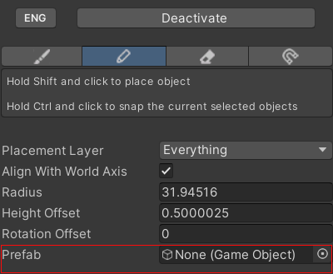

**Mode**

* Scatter mode: Scatter objects within radius
* Place mode: Place a single object
* Deletion mode: Delete objects within radius
* Snap Only mode: Snap selected objects to mouse position (snapping is also available in other modes)

**Keyboard Shortcut**

|  |  |
| --- | --- |
| **Keys** | **Function** |
| Shift and Mouse left click | Execute |
| Ctrl and Mouse left click | Snap the selected object to mouse position |
| Shift and Mouse scroll wheel | Adjust the radius |
| Alt and Mouse scroll wheel | Adjust the height offset |

**Base Property**

|  |  |
| --- | --- |
| **Property** | **Description** |
| Placement Layer | Specify which layer to place objects |
| Align With World Axis | When enabled, Align the object XZ axis with world axis.  When disabled, Align the object XZ axis with view port camera axis |
| Radius | Specify the radius of the range |
| Spawn Count | Specify the number of objects to spawn |
| Min Spacing | Specify the minimum allowed distance between any two points |
| Height Offset | Specify a height offset from the surface |
| Rotation Offset | Specify a rotation offset from the initial rotation |
| Prefab | Specify which prefab to spawn (or delete). Dragging instance of prefab in the hierarchy will automatically convert it to the root prefab. Prefab variant is currently not supported |

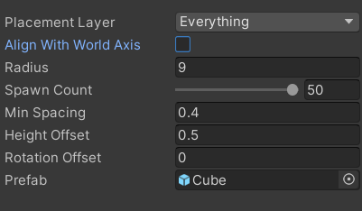

|  |  |  |
| --- | --- | --- |
| **Property** | | **Description** |
| Random Rotation | | Rotate the object randomly around the local y axis |
|  | Min Euler Angle | Minimum random euler angle |
|  | Max Euler Angle | Maximum random euler angle |
| Random Scale | | Apply a random scale multiplier relative to the original prefab |
|  | Min Scale | Minimum random scale mutilplier |
|  | Max Scale | Maximum random scale mutiplier |
| Random Height | | Apply a random height offset in the local y axis |
|  | Min Height | Minimum random height |
|  | Max Height | Maximum random scale height |

**Randomness Property**

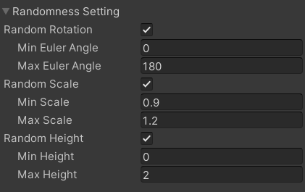

|  |  |
| --- | --- |
| **Property** | **Description** |
| Keep Root Rotation | When enabled, alignment to the object will also consider the rotation of the root prefab object |
| Scatter Height Tolerance | Specify how much height difference is allowed from the mouse position in scatter mode (gizmo turns into dotted line when out of range) |
| Circle Color | Specify the color of gizmo |
| Show Preview | Specify whether to show the preview of the object before placing or not |

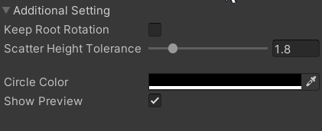**Additional Setting**

**FAQ**

***“The object preview is grey in some areas.”***

It is a hightlight feature, the grey part indicates intersection with other meshes. (Make sure to enable the scene light for it to work properly)