**Deborah Moore CIS241 Web Page Project Documentation**

The purpose of this website is to create a personal website portfolio and to demonstrate my ability to:

* use X/HTML, HTML5, CSS 1, 2, and 3 to develop Web pages and sites
* use digital media within a web site

All pages have been validated at the [W3C validator](http://validator.w3.org/)

**Site Map:**

* **Moore2273**
  + **site_folder**
    - **css –** (stores the Cascading Style Sheet used by the website)
    - **documentation –** (stores A site specification Microsoft Word document describing the features and purposes of the webpages)
    - **html –** (stores the html files for all the website pages)
    - **images –** (stores all images contained within the website pages)
    - **media –** (stores any video or audio files contained within the webpages, currently EMPTY)

**Home Page:**

The Home Page is an introduction and Welcome to the website. The file is named ***home.html***

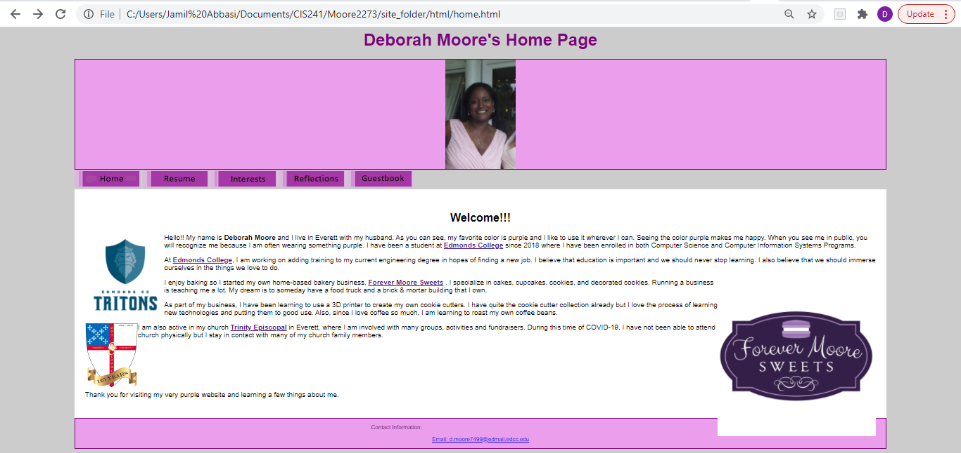

**Resume Page:**

The Resume Page displays Deborah Moore’s resume in table form. The file is named ***resume.html***

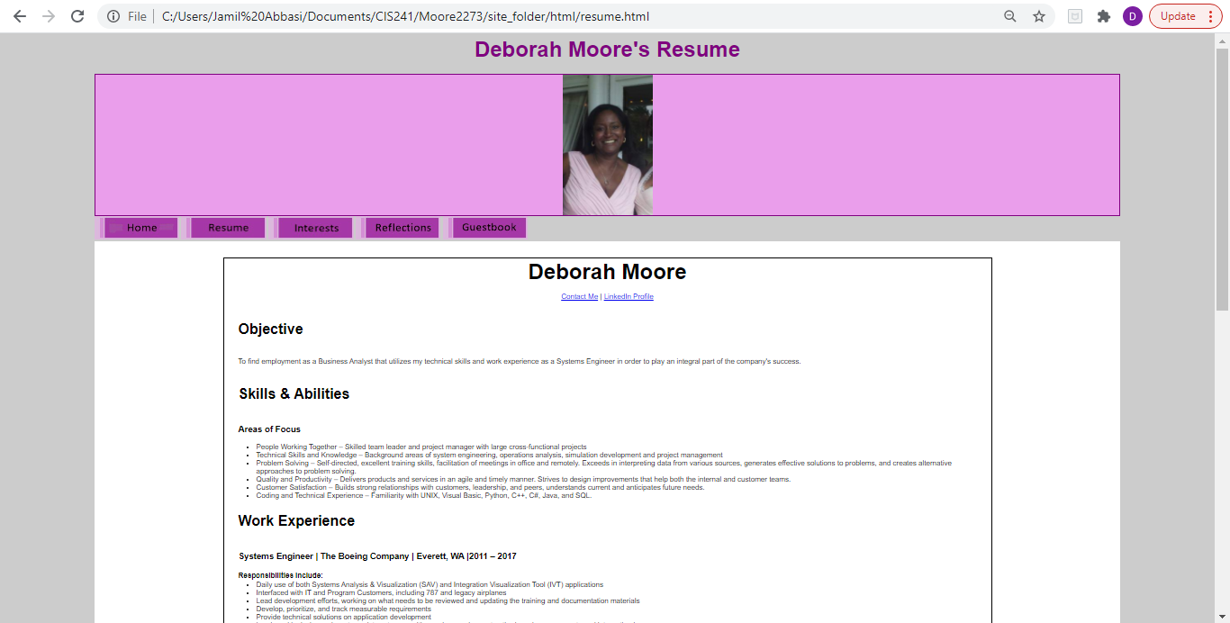

**Interests Page:**

The Interests Page discusses Deborah Moore’s personal interests and hobbies with external links to each of those interests. The file is named ***interests.html***

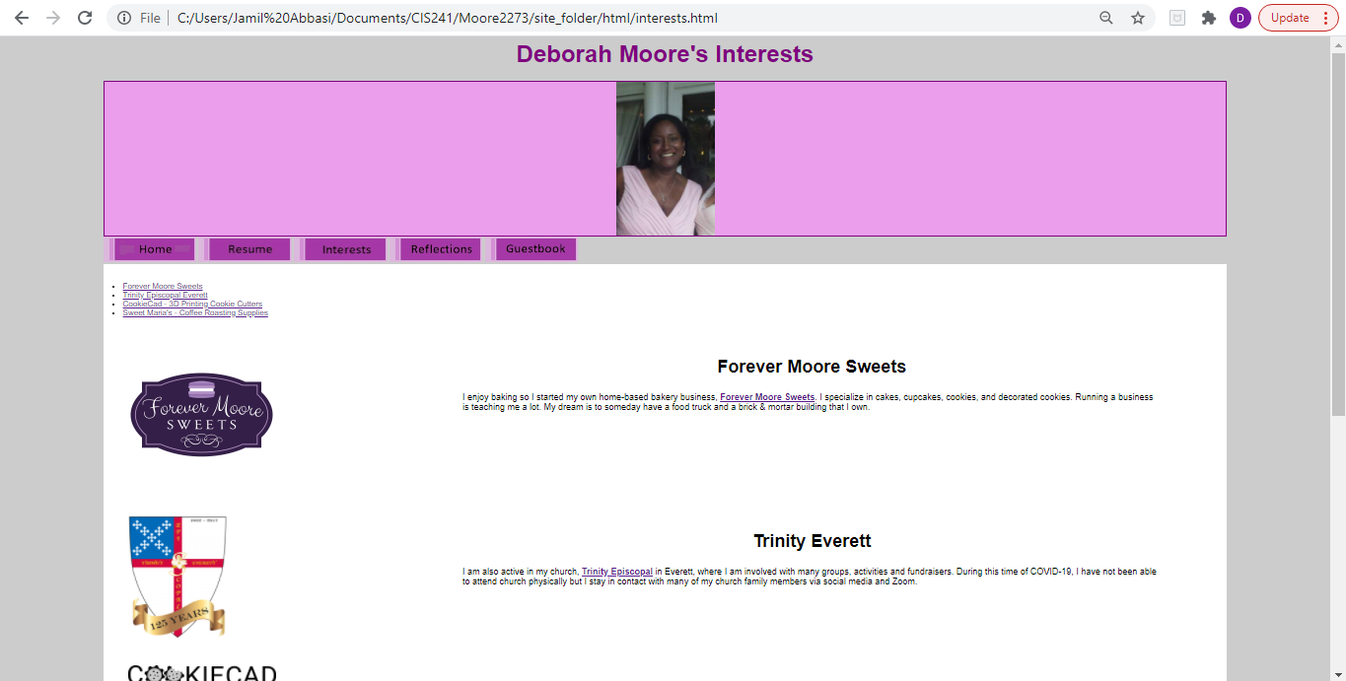

**Reflections Page:**

The Reflections Page is Deborah Moore’s reflection on what she learned during the quarter in CIS241 and her feeling concerning the course. The file is named ***reflections.html***

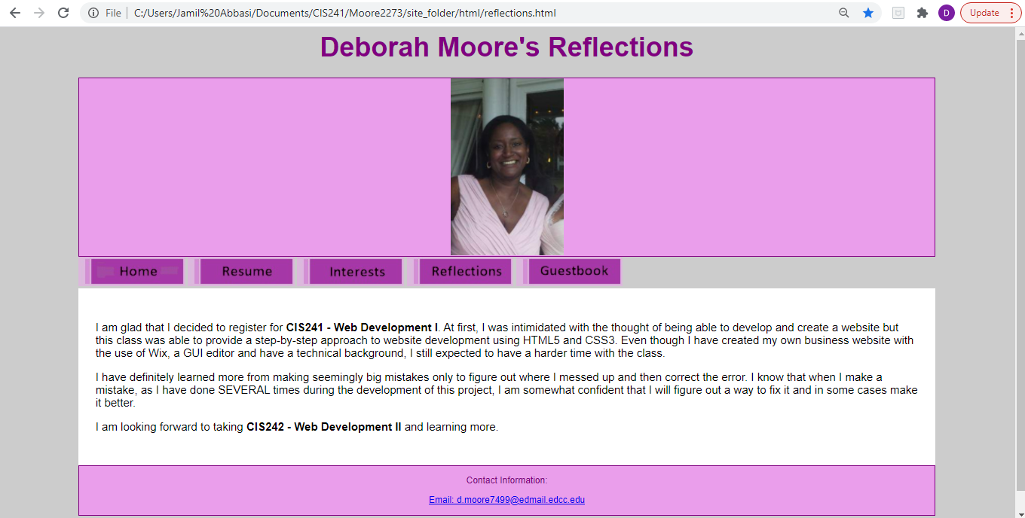

**Guestbook Page:**

The Guestbook Page is a form that requests information from the user. The file is named ***guestbook.html***

