eARThKids survey report - April 2018

# Introduction

The external evaluation of eARThKids by MN Associates, Inc. examines to what extent the various strategies and activities of the project have led to the intended programmatic outcomes. The main sources of data collection are: document reviews, meeting notes, teacher and teaching artists surveys, students’ demographics and attendance data, and pre-and-post student assessments using data from the Directed Reading Assessments.

The eARThKids evaluation is based on the following evaluation questions:

Program Implementation

1. To what extent are the participating schools implementing the eARThKids model as designed and envisioned by Young Audiences and PG County Public Schools?
2. To what extent do participating teachers find eARThKids to be effective in improving their instructional practices through co-teaching and professional development?

Program Impact

1. To what extent has the eARThKids out-of-school-time program assisted students in meeting academic requirements?

This short survey summary report, completed by MN Associates, Inc., was generated from data collected in a survey of classroom teachers and teaching artists.

# Overall Satisfaction

Question asked: Based on your experience as a classroom teacher/teaching artist in the eARThKids program, please rate the degree to which you agree to the following statements that speak to your knowledge and satisfaction with the program:

**Disagree   Agree   Strongly agree**

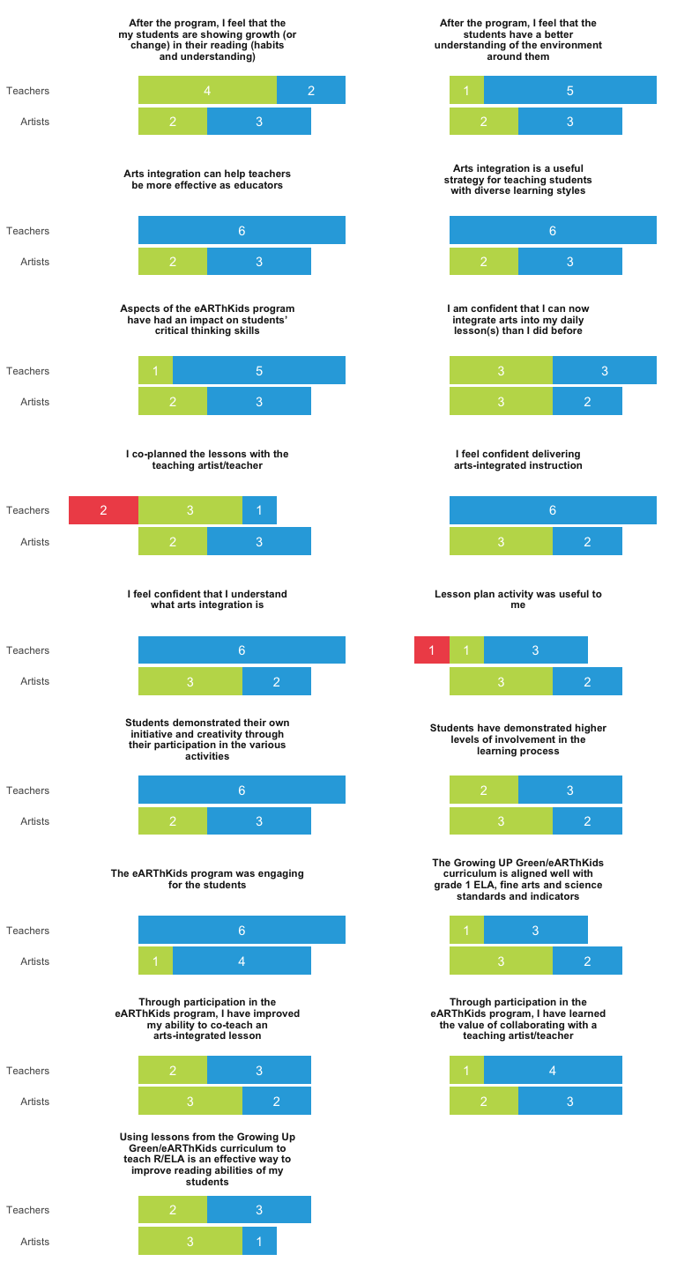

Question asked: Based on your experience as a classroom teacher/teaching artist in the eARThKids program, please rate the degree to which you agree to the following statements that speak to your knowledge and satisfaction with the program:

**Disagree   Agree   Strongly agree**

# 

# Learning

Question asked to teaching artists: I feel that the teacher(s) I worked with can… Question asked to teachers: I can…

**Disagree   Agree   Strongly agree**

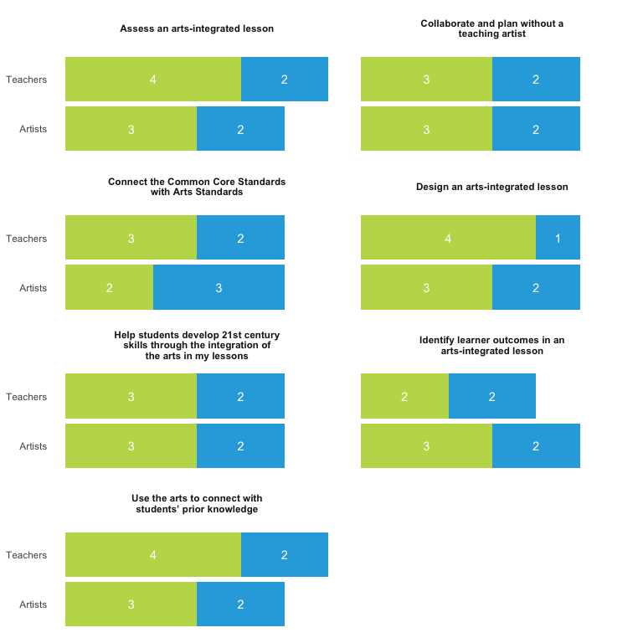

# Professional Development

Question asked: Please rate the quality of professional development, feedback, and support

**Disagree   Agree   Strongly agree**

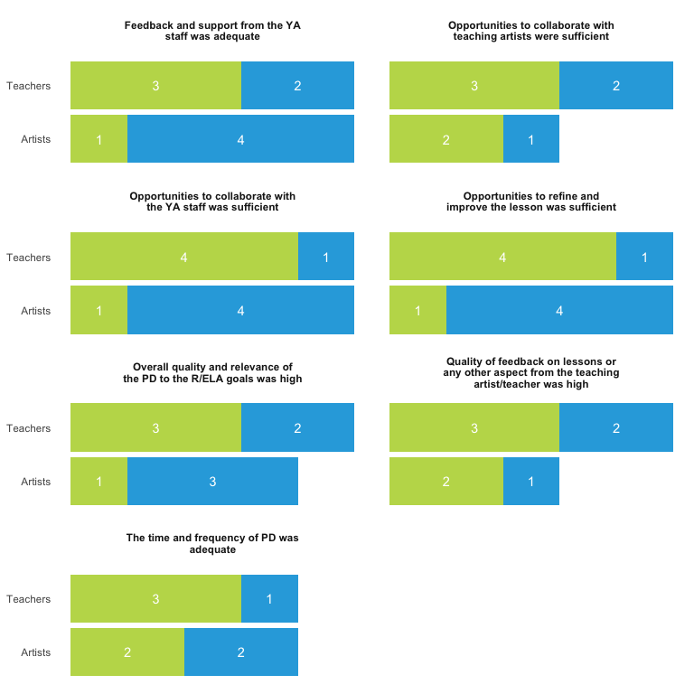

# Open-Ended Responses (Teaching Artists)

**What projects did the students complete?**

* Art work, Posters about worms, a worm bin.
* The students lesson focused on Composting. In the sessions they learned what, how, and why they should compost as well as 6 site words with beat and rhythm patterns. Students also connected three steps of the compost process to a tap step to create a Compost Tap Dance. Also within each session the students practiced using their site words in a sentence, create a compost collage, and present their creations for an audience.
* We built wooden birdhouses for the schools and we wrote original song lyrics about birds
* Individual Painted Screens, based on Reading & Eating the Rainbow.
* Multiple visual art projects: turtle recycled collage, 3D jelly fish, waterway painting, woven flowers for a rain garden installation

**What did you like the most about the program overall:**

* The student response, the teachers’ creativity.
* I enjoyed the challenge of connecting my art form to Environmental Literacy. I also enjoyed using basic rhythm patterns and steady beat on the body to teach site words.
* It was far better structured than typical after-school programs. The students were engaged and focused.
* The Children were very enthused during the entire process.
* Getting kids excited about environmentalism and art at the same time!
* The consistency of working with the same kids, the environmental connection

**What aspects of the program could be improved further?**

* Planning with the teachers. One of my partners didn’t send me her plans to bring to the other schools.
* I’d suggest creating time the weekend before with the artist and teacher to get together and make sure each other is clear on the lesson plan and needs for the residency week. I think this could be done/ scheduled between the teacher and the artist.
* It was hard to write a lesson with one teacher and then expect others to teach them.
* Collaboration with Teachers

**In your opinion, what changes have you observed in the students after they attended and completed the eARThKids program? (e.g., changes in attentiveness, behavior, critical thinking skills, art, others). Please provide an example(s) of one or more student(s) to illustrate the change. Any anecdotes that you can share will be good.**

* Ability to work together, critical thinking.
* I observed students who were once apprehensive begin to come out of their shell. In each culminating presentation that students stood in front of an audience and performed. Some students had special parts where the stood and spoke on what they learned about composting and they spoke clearly.
* Songwriting is an advanced skill, but using my magnetic words and rhymes over 4 days, students were able to grow more and more successful with it each day. Students that have trouble with spelling of handwriting didn’t have to struggle with those elements using the magnetic words. Using color-coded phrases and rhymes, they could succeed on a simple level pretty quickly, but with repetition they expanded their lyrics to incorporate more vocabulary about birds and more nuanced ideas and poetic beauty. We used 8 different phrases which could be made into rhyming couplets. Students worked individually or with a partner. By the last day, several group had written all 8 couplets, whereas they had only completed one or two on the first day.
* Enthusiasm high throughout.
* They really knew a LOT about recycling and composting…it was quite impressive.

**Please describe the quality of your interactions with the teacher(s) at the school? (e.g., type of discussions, co-planning a lesson, developing a lesson plan, plan to improve the lesson, ways to engage the students better, etc).**

* Working together in class- supporting each other, improvising, helping the kids was all great.
* I had great interactions with each of the teachers at all the schools. Before each session I made sure to ask the teacher if there were any specific items that should be adjusted and they all loved the flow of the class. I especially liked the way the teacher and I flowed through the lesson plans and piggy backed off of each other.
* Timing always an issue. Intentions were always good.
* My partner was always in a rush. She mostly just let me take the lead, which was fine, but it would have been nice if she had engaged more in the arts part. She was, however, very kind and enthusiastic.
* All 5 of the teachers with whom I worked were enthusiastic at the end of long work days and able to flexibly adjust lessons as we saw what had worked, or hadn’t work, at previous sites.

**Any additional comments:**

* Wish we could do it again.
* I think that teachers were often new to arts integration, so it was a valuable experience for them to see how as new AI lesson works.
* Had a challenging, but successful time at all three schools. Would prefer a residency during school time.

# Open-Ended Responses (Teachers)

**What projects did your students complete?**

* Compost bin, worm bin, screen painting
* They built a compost bin, a bird house, completed 2 screen paintings and learn how to Tap Dance, created a song which they performed on stage for their parents. The students also had an amazing week with Mr Phelps and his music.
* Bird House, Earthworm Bin, Rain garden bulletin board display, other visual projects the students were working with the other artists, simple tap dance presentation with the parents as our audience
* We created a rain garden, word crowns, color wheels, biomes, and animal habitat mobiles.
* Basic Sight Words Chain , Screen Painting, Birdhouses , Watershed Painting , Worm bin

**What did you like the most about the program overall:**

* The opportunity to explore different art forms.
* The students were very well engaged during the program. They loved performing during the Arts integrated piece. It was learning through the Arts.
* The students learning about composting in many ways and how to take care of the environment: hip hop, tap dance, visual presentations, making of projects
* The hands-on activities that allowed students’ maximum participation and learning.

**In your opinion, what changes have you observed in your students after they attended and completed the eARThKids program? (e.g., changes in attentiveness, behavior, critical thinking skills, art, others). Please provide an example(s) of one or more student(s) to illustrate the change. Any anecdotes that you can share will be good.**

* One student who usually struggles with involvement graciously participated in every task he was asked to perform.
* The students became very creative and were willing to participate.
* The eARTHKids group are already practicing how to throw their stuff properly and it is clearly shown as they eat their supper before they start the after school. It is putting what they learn into practice.

**One of the goals of the eARThKids program is for teachers to integrate the arts when an artist is not in the room. Please provide a brief example or two of a time that you integrated the arts into your curriculum when an artist was not present.**

* After studying on how to make worm bins, I introduced the students to the three layers of soil, use their sight word to create an art project.
* The teacher worked hand in hand with the Artist.
* When my students were putting the concept into an action to understand the meaning. They did a simple tableau.
* I taught the first hour each time, which allowed me to teach an integrated lesson, individually. This allowed the students to get the “core understanding” of what was to follow and it allowed them to be exposed to new vocabulary.
* As a RELA teacher , I was able to integrate arts using varied entry points in the teaching - learning process through songs and actions . I also used some art crafts to encourage students to apply what they have learned .

**Please describe the quality of your interactions with the teacher artist(s) who came to your school? (e.g., type of discussions, co-teach, co-plan a lesson, plan to improve the lesson, ways to engage the students better, etc).**

* Artist and I collaborated on plan lessons and work flow.
* We discussed how to better work with the students. What can we do to better help the students? Incentives for the students.
* So far we have a co - teach style of engaging the students considering the most part that is best for them. We make adjustments together to reach the objectives for the day.
* It was positive and motivating! She always had an excited attitude and we were both “in sync” regarding the planning and delivery of each lesson.
* We begin collaborating on what materials the students are going to work on , the questions and activities we are going to use and the end goal for each day. As for behavior management , both the artist and the teacher will assist each other to ensure smooth transition and learning.

**How can the program be improved in the future?**

* At the end of each period we can have a celebration and give the students a certificate for attending.
* The type of dismissal the school has for the kids, that will matter as to the staff who needs to stay until dismissal time ( William Paca has car riders and bus dismissal.)
* More reading resources specifically about the environment that the students may read and require them to analyze the story and look for key details in the text.

**Any additional comments:**

* I really enjoyed this program since I realized how the students can benefit.
* The program is a great opportunity for the kids to learn how to take care of the environment at their young age and at the same time integrate and enhance their reading skills through the art.
* The program has helped the students to be better listeners and participants in the teaching - learning process.