ODS final report

# Schools that do ODS

## How many schools do ODS?

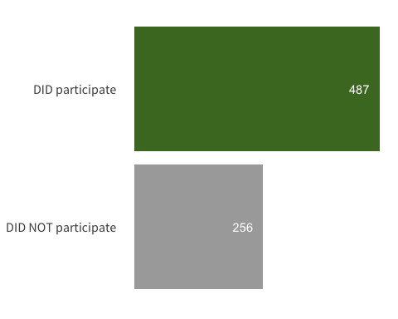

## How many students and how many grades?

## Program length

## Where do they go for ODS?

## Accommodations

## Curriculum development

## Staffing