TRIO survey analyses 2018

# Introduction

This is a report on surveys conducted after online TRIO training in March 2018. This training was conducted by Cuyahoga Community College. More infomation available here. As of April 11, 54 (87% of those who initially registered) have successfully completed the training.

Of the 62 participants registered for the training, 45 completed the pre survey (a 73% response rate) and 42 completed the post survey (a 68% response rate).

Please use the arrow on the right side or the contents on the left side to navigate through the findings.

# Institutions Represented

62 participants were involved with the March training. The locations of the institutions they represent are below. Click on any point to see the name of the institution.

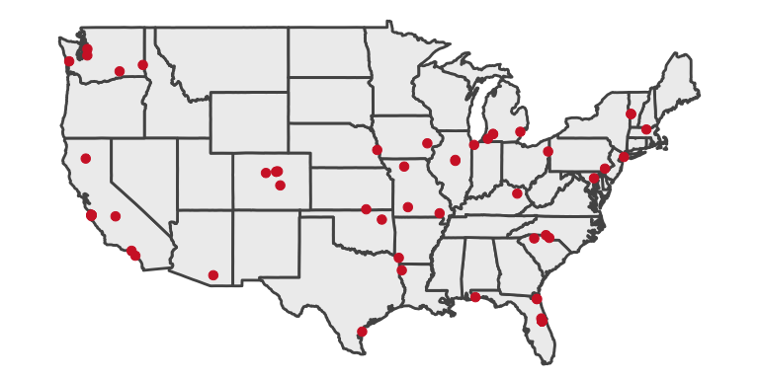

# Demographics of Training Participants

## How long have you managed the budget(s) for a Federal TRIO program at your current institution?

| **Year** | **Training** | **Years of Experience** |
| --- | --- | --- |
| 2017 | Hybrid | 1.6 |
| 2017 | In person | 1.9 |
| 2017 | Online | 2.2 |
| 2018 | Online | 3.3 |

## Have you attended a similar TRIO training program in the past?

**No Maybe Yes**

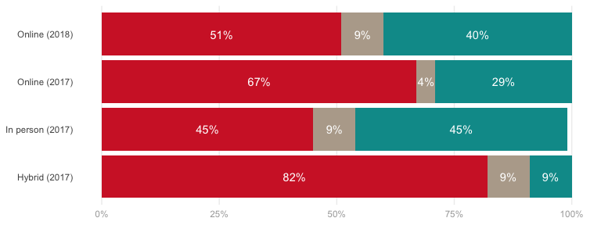

## Currently, are you one of the main budget-related decision makers at your institution?

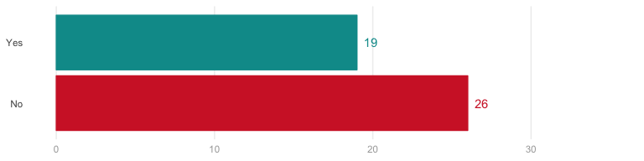

### If no, how many other staff members work in your department?

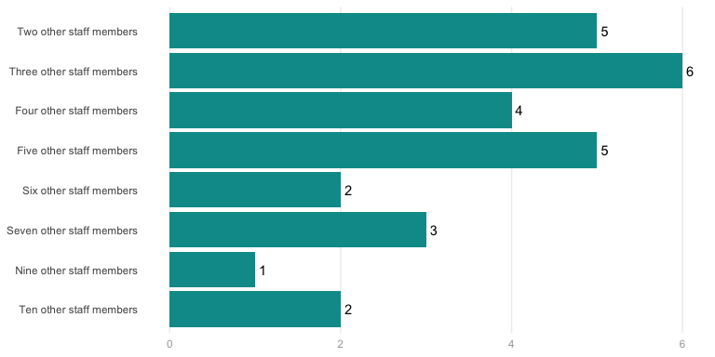

# Pre-Training

## Currently, how would you rate your levels of knowledge and understanding of the following aspects of the training you are about to receive

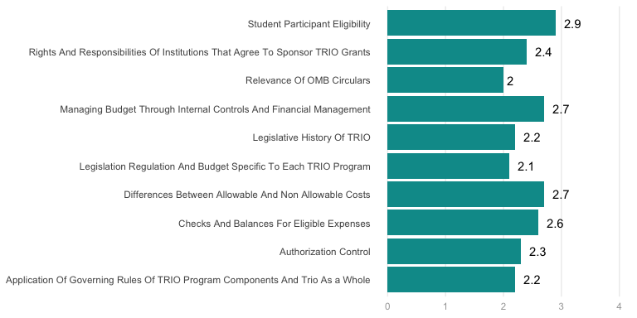

## What are some of your main expectations from the training?

* To be able to articulate this information in a clear and concise manner. To gain understanding that will serve as a solid foundation.
* To gain a better understanding of the regulations governing TRIO grants
* Understanding budgets.
* New legislation, rule, and regulation
* Comprehensive budget management and understanding regulations
* A clear understanding and ability to locate regulations for spending.
* A deeper understanding of all the aspects of budget management
* A better understanding of regulations for SSS, since this is a new program for me. A refresher of regulations for UB, since I’ve been away from the program for 5 years.
* To learn more about the budget and governing rules.
* I want to learn more about the overall budget process of TRiO
* Refresher for SSS and UB, learning for McNair
* New to Upward Bound and to the University get a better understanding.
* Better understanding of budgeting and regulations
* A review of TRIO policies and procedures that must be followed as we administer the grant.
* A general overview of budget regulations
* Making sure I am following the regs and legs
* understand allowable and unallowable costs
* Legislation, regulation, and budget specific to UBMS program. OMB
* A better understanding of the Programs from a budget aspect. Also, help with federal regulations and Trio regulations.
* Contextual information on Legs, Regs, budget; examples; Q&A; Do’s & Don’ts
* I am hoping to understand as much as I possibly can relating to budget
* Learning more about allowable and unallowable costs
* Better understanding of operating a TRiO budget under Federal Regs.
* I am always looking to strengthen my understanding of Legislation - past and current - that could affect funding, etc
* Better understanding of the processes of running the program
* Costs & Budget
* Learning the differences between the SSS and Upward Bound budget restrictions.
* A good understanding of TRIO
* Learn more on budgets regarding TRIO
* Refresher training for budget management
* Learn more about budgeting and compliance
* To gain a better understanding of TRiO legislation and rules and regulations surrounding grant funding
* To become more familiar with TRIO and to learn about participant support.
* Gain an stronger understanding of the differences between programs
* Learn more about the budget process

## 

## What are some of the challenges that your institution currently faces as related to budget management in a Federal TRIO program?

* Finding sources for unallowable costs (t-shirts, some food, etc.)
* organization
* training personnel to ensure we are following the proper procedures.
* Growing wages and small budget.
* We are a new program, all new staff
* New Comptroller in Business Office and Budget Cuts from State Budgets
* Indirect costs
* Allowable Expenses, most of the allowable expense for Upward Bound are very “gray”.
* we’re all new
* Lack of support from Executive level.
* Mostly internal; management - who needs to be involved in the process to assure appropriate spending and management
* A constant change of administration
* State Funding
* We always seem to be in a deficit by the end of the year.
* Legislation and regulations of TRIO grant funds
* Complex draw-down of budget items
* Spending the money we are allotted in various line items within the budget
* Misunderstandings of how participant support costs should be allocated.
* Buy-in from programmatic people on changes with adoption of Uniform Guidance
* carryover
* changing staff in budget office, poor communications

## 

## Additional questions/comments regarding the training you are about to receive.

* I have been assigned to this position for less than 3 weeks. I have served as an advisor of talent search, so understanding the behind the scene work is crucial to understanding TRIO as a whole.
* I hope I’ll get answers to the specific questions about the programs I administer!
* I am looking forward to getting a better understanding of legislation and regulations pertaining to the budget in TRiO programs.

# Course Ratings

## How would you rate the quality of the following course, topic or content area?

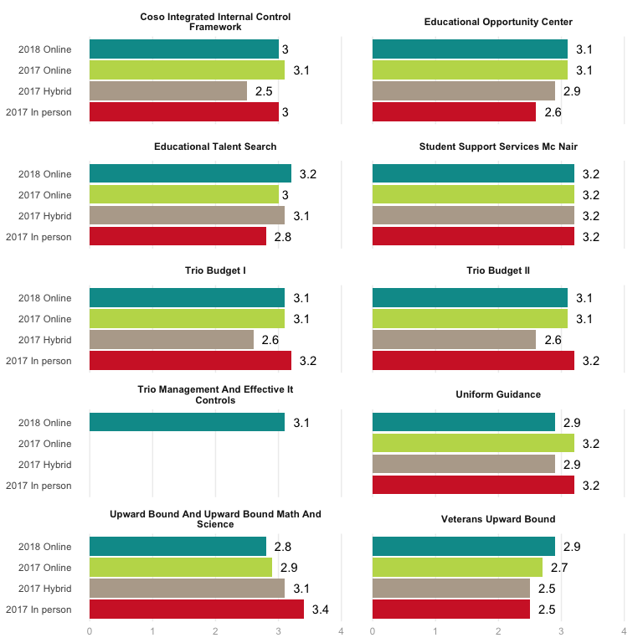

## 

## If you rated low or medium on any of the items above, please mention why.

* The topic wasn’t covered in depth relative to the content. (Surface skimmed)
* I didn’t feel like there was a real explanation in the difference of programs.
* You could tell that some people were just reading straight from a script, which wasn’t very dynamic or engaging.
* Would have liked a bit more than the text on the slides. For example, applying some of the requirements to specific TRIO case studies.
* I believe there is still growth possible in those areas. Continual reinforcement is key.
* Presenter’s style wasn’t inviting.
* It is so much information, I just feel I would need several more training sessions to feel comfortable with all of it
* I felt the IT one was very long and didn’t always pertain to what I was doing
* it wasn’t the information per se, the speaker didn’t sound as clear as the others.

## To what extent were your general expectations of the training met?

* To become more familiar with the TRIO regulations.
* they were met
* I feel that the training met my expectatons.
* To have a better understanding of management of the TRiO budget
* very informative. Lots of information to understand. By day 3 I felt a better understanding of acronyms used.
* To the highest extent
* The training was more detailed than I expected.
* Gaining a better understanding of TRIO budget management
* Well beyond what I expected!
* I figured the information would be provided, but expected it to be boring
* yes, very helpful!
* a good extent
* I had some understanding of this already
* It was met - I received the information I had hoped to during the training.
* The training covered everything I expected it to cover.
* Exceeded my expectations.
* Great Information Above expected
* To be introduced to topics I wasn’t informed on prior to this training.
* All my expectations were met.
* Exceeded my expectations
* Fully met my expectations
* Expectations were met by providing a thorough overview of the program and resources available
* I expected a brief overview.
* Needed overview of budget management and received it
* They were met I learned a lot about budgeting and what is and what isn’t allowed
* Amazing! I really learned a lot!
* The majority of my expectations were met. This training is needed to all those new to TRIO upon hire! This is really the “meat and gravy” of the projects.
* Overall, the training exceeded my expectations. I gained information on internal controls and IT controls.

## 

## Please mention three (3) main take aways from the overall training

* Documentation is key. 2. Consistency 3. Always follow internal control procedures.
* Although there is a lot of material that was covered, I really appreciated that the training referenced where to find the information related to regulations and legislation. It was helpful that each of the TRIO programs were covered since they vary in allowable costs, etc.
* Federal vs. institution policies/regulations. Importance of budget and spending associated with program objectives. Maintaining checks and balances in budget.
* Internal control mechanisms, OMB importance, Legislation
* An accounting background would have been helpful for some of the content. I found I already knew much of the information.
* Legislation & regulations refresher, effective budget management, and effective IT controls
* Using OMB, COSO, VUB specific regulations
* what is allowed, what isn’t allowed and where to find answers to questions
* creating a “Bridge Report” for linking Dept of Ed budget with inst. budget system, overview of Uniform Guidance, and basic cyber security
* good review of key concepts and documents, good reminders about institutional responsibilities and director responsibilities, good budget review
  + Allowable costs; 2. the need for effective IT controls; 3. Similarities and differences between TRIO programs
  + Allowable/unallowable costs, internal controls, and security
  + Understanding the project, the policies and purpose of the project.
  + Internal Audit, Internal Control, IT
  + Computer risk management & overall details about budgeting, reporting, audit. It was a great overview of many topics.
  + Documentation, Accountability, Organization + Communication
  + How an audit works, why and what is required. Location of documents needed to answer budget questions when they arise. Thorough understanding of payment systems designed for multiple checks along the way.
  + Internal Controls, Authorization controls and IT Conrols
  + I learned about the budget controls and management our program uses
  + It is a lot of information, some of the information is very technical, and to touchinformation for a short period if time
  + compliance, internal controls, and allowable/unallowable cost
  + reporting, allowable costs and guidelines
  + allowable and unallowable costs, the legislative policy of the programs, that Upward Bound is the only project to get T-shirts and a banquet every year
    - The most common IT breaches can be prevented by the user versus IT department. 2) Drawdowns are the primary monitoring system for the TRIO grants. 3) Costs unallowable to each of the TRIO programs.

# Satisfaction with Aspects of the Training

## Please rate the following aspects of the overall training

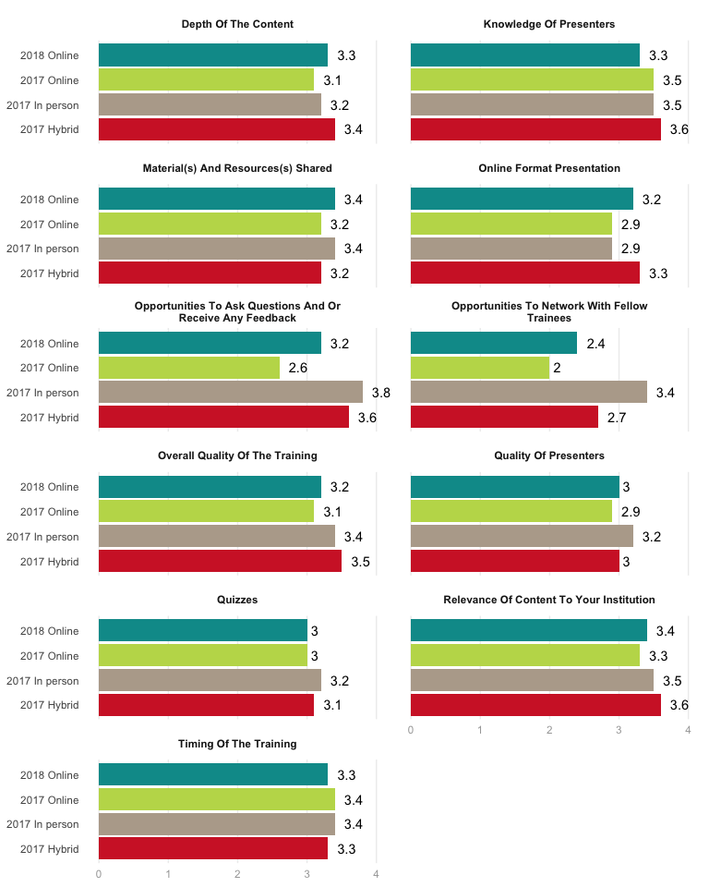

## 

## If you rated low or medium, please mention why.

* Some of the presenters read straight from a script - it wasn’t very dynamic or engaging.
* I wasn’t aware of opportunities to network with fellow trainees if there was any.
* Quizzes varied regarding what they focused on. On one quiz, I accidentally took it before watching the module and I passed anyway.
* It happened during the Trio Conference.
* The lowest mark is because of the online format.
* On-line format doesn’t really allow for effective networking

## 

## Live webinar

### If you participated in the live webinar, how helpful was it to have an opportunity for online participants to connect directly with a speaker?

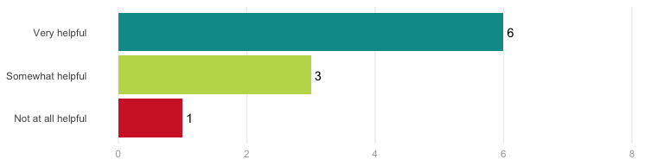

### Is there anything you would suggest that we do differently for the live webinar?

* I liked the live webinar because it was interactive.
* Make sure to emphasize time zone.
* Livelier presenters
* would like copies of anything shown on the screen (i.e. example of UB spreadsheet that was shown, etc.)
* Improve VUB webinar & make review courses accessible to people who have already taken course (I would like to visit topics for refresher)

# Knowledge Growth

Below are the results for the pre and post self-assessments of participant knowledge in various areas. The larger the gap between the red and blue dots, the greater the knowledge growth that occured for participants.

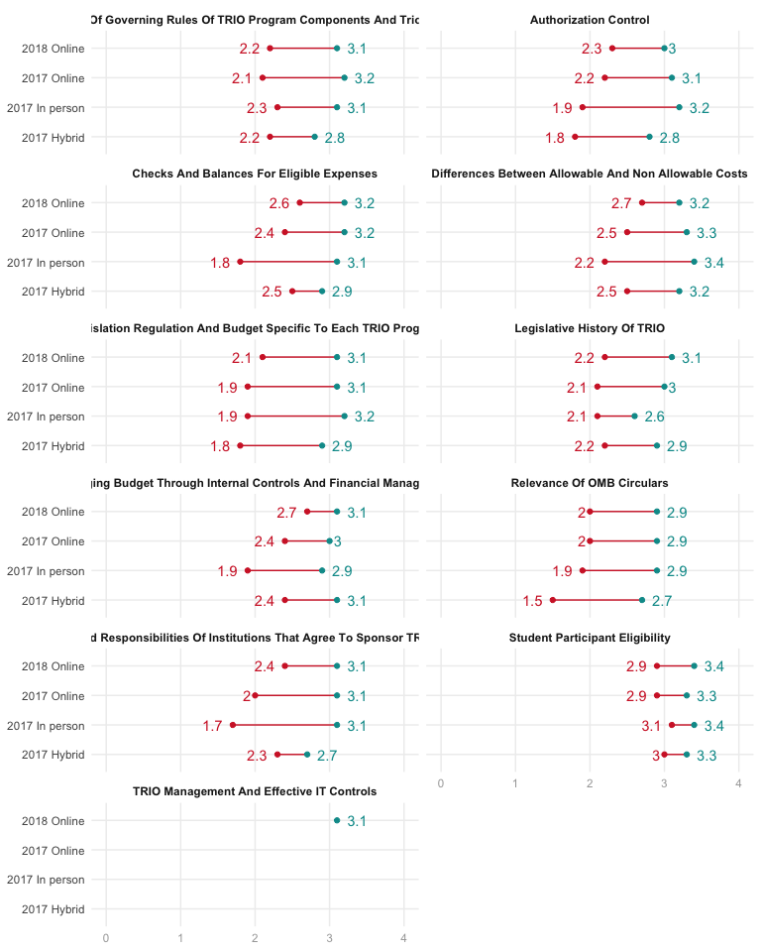

# General Feedback

## Are there any additional topic(s) that could be added in future training(s)?

* More on records retention, especially digital vs. paper
* What is considered allowable and unallowable for each program such as specific examples
* I don’t think so - you covered all of the must have’s.
* Leadership focused training. How to be a leader in the program for staff, students, colleges/organizations, and for the community.
* Separate topics such as (how to determine) eligibility, low income, Vet status

## Would you like a follow-up training session on the same topic(s)?

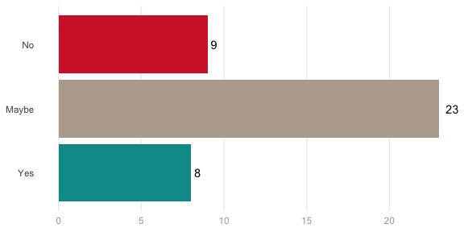

## Will you recommend this training to your colleague(s)?

