TRIO survey analyses - June 2018

# Introduction

This is a report on surveys conducted after the hybrid TRIO training in May 2018. This training was conducted by Cuyahoga Community College. More infomation available here. Of the original 21 who had signed up, all but one (and, indeed, this person did not show up for the training) completed the training.

Of the 21 participants registered for the training, 18 completed the pre survey (a 86% response rate) and 10 completed the post survey (a 48% response rate).

# Institutions Represented

20 participants were involved with the March training. The locations of the institutions they represent are below.

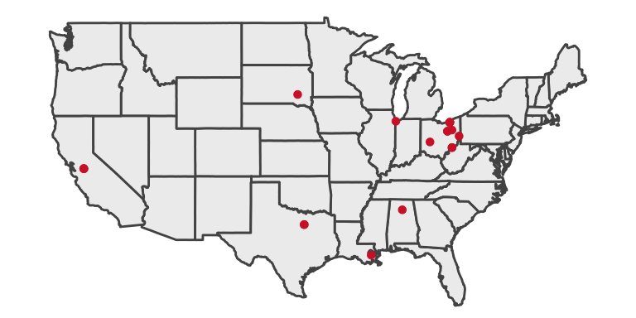

# Demographics of Training Participants

## How long have you managed the budget(s) for a Federal TRIO program at your current institution?

| **Year** | **Training** | **Years of Experience** |
| --- | --- | --- |
| 2018 | In person | 3.67 |

## Have you attended a similar TRIO training program in the past?

No Maybe Yes

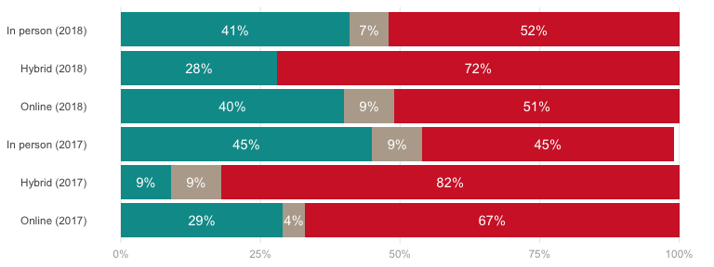

## Currently, are you one of the main budget-related decision makers at your institution?

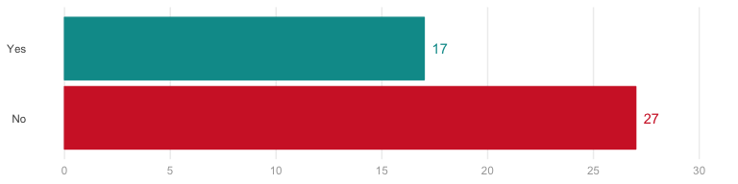

### If no, how many other staff members work in your department?

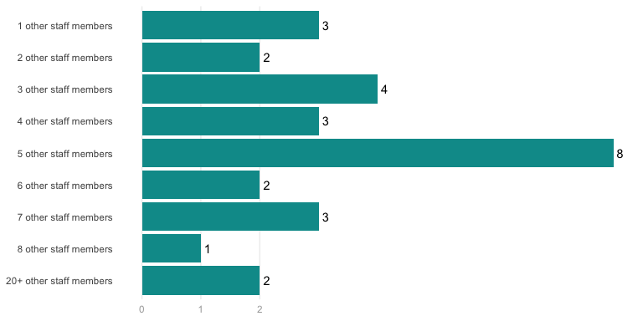

# Pre-Training

## Currently, how would you rate your levels of knowledge and understanding of the following aspects of the training you are about to receive

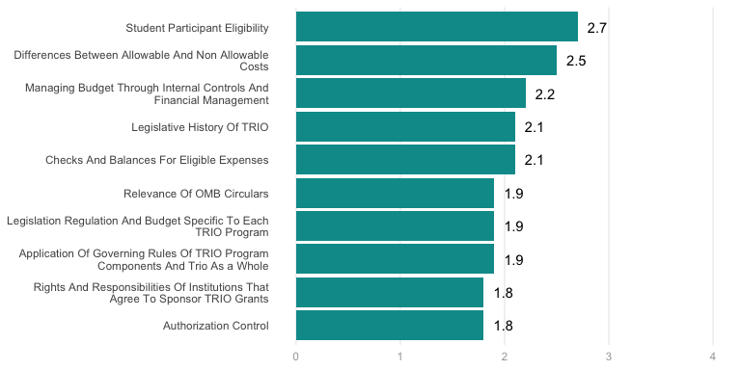

## What are some of your main expectations from the training?

* I am one of those people who do not think that experience is the sole catalyst for better management of TRIO programs. We must always avail ourselves to training/professional development, and I am hoping to learn more about the topics reference above. I learn something new everyday. I am excited for the opportunity.
* To gain an understanding of how to keep the budget in line with what’s in G5 as well as gain a better understanding of the grey areas in allowable and unallowable costs. I also would like to get some ideas of items that will help my program run more efficiently.
* I would like to be able to bring back information for our Budget Office/Officers and my Program Specialist to make sure that we are handling the budget within all guidelines and to help with the next grant competition.
* To gain the budget and regulations knowledge that I need to successfully manage this TRiO program. I want to walk away feeling more confident regarding what our program is allowed to do/not allowed.
* To gain a better understanding of the financial and budgetary issues facing TRIO programs. I am brand new in my role and have a very limited understanding of these issues.
* To develop tools to better manage budgets for multiple programs that overlap in staff and some services; condensed “cheat sheets” to save time on certain regs
* Gain insight into the differences between DOEd and specifically TRIO awards as against other federal agencies, such as NSF, NIH, AHRQ, HRSA, EPA, etc.
* Better understanding of compliance with uniform guidance. Understanding allowability of costs that are not enumerated in legs/regs.
* I’m looking forward to learning more about legs and regs, as well as about budgeting and what it entails
* Allowable vs unallowable; the role of a director in decision making, rules, legislation, resources
* Learn about expectations of program as well as what type of expenses are reasonable and allowable.
* Reacquaint myself with how TRIO regulations work and learn the differences between SSS and ETS
* Overview of managing the budget and where to locate information/resources related to it.
* Better understanding of regulatory bodies, decision tree, and reporting of Trio program
* Better understanding of how to use and find grant allowables in legs and regs CFR OMB
* Foundation budget info - will be learning /working with TRiO budget this next year
* To get a better base understanding how grants differ and work from Private sector
* TRIO Legislation/Regulation as it relates to daily activities as a TRIO director
* This is my first training. So, I am hoping for a good foundation to get a start.
* Great understanding of budgetary oversight for TRiO programs at our university
* To increase my total understanding of all legislative and regulation of TRIO.
* I hope to become very familiar with regulations and best practices.
* Budget management from the program and institutional perspectives
* Increase my knowledge of the federal regulations and guidelines.
* Gain additional knowledge of one of the major grants we manage.
* Learn more about the grant and laws and rules surrounding it.
* To learn more about financial management of TRIO programs
* To become more informed about all aspects of the grant.
* Reaffirmation, review of legislation and regulation
* Staying within trio regulations when spending
* Learning about program rules and regulations.
* Better understanding of Uniform Guidance
* More knowledge on TRIO Legs & Regs
* Refresher and support new staff.
* To learn how to manage budget
* To learn as much as I can.
* Learn more

## What are some of the challenges that your institution currently faces as related to budget management in a Federal TRIO program?

* Confusion regarding DOEd’s position on (1) the cost of what is generally considered unallowable food and entertainment costs; and (2) prior-approval requirements for TRIO Student Support Services awards for meals & lodging costs for participants and staff on approved educational and cultural activities as codified in EDGAR 34 646.30 (e).
* Does everything (especially travel) need to be explicitly spelled out in the budget and budget narrative? Or does the program director have flexibility on their own - without having to go back to USDOE for prior approval.
* Timely logging of expenditures and thus delayed G5 draw downs; hard to hire perm and temp staff when needed and thus some budget surplus hard to expend when staff are hired late into the grant year.
* Data entry of expenditures in timely manner, fiscal year ends during time when most TRIO activities are in full swing, so coordinating PO/p-card process with TRIO operations is challenging
* Keeping the institutions balance in line with what’s in G5. The balances are sometimes completely off.
* The financial technician in our grants office recently left. She gave us our monthly reports
* People unsure of rollover process, what applies where in Ecode; who is responsible for what.
* Cost of living increases, indirect funds management, institutional policy v. Grant policy
* Training of personnel during turnover and importance of drawdown from G5.
* Allowable vs unallowable and who can make the hiring/budgeting decisions
* We are unable to be as flexible with our funds as we would like
* Institution/State guidelines versus federal guidelines
* Funding balance in G5 not matching balance in banner.
* State of Idaho Cost Accounting Standards vs. TRIO.
* Knowledge on appropriate/ grant approved wording
* Sometimes not understanding allowable costs.
* Allowable cost. Required Documentation
* ED wanting more oversight
* None that I am aware of.
* None that I am aware of
* Unsure at this time.
* Never enough money
* Not really sure
* I am not sure.
* Not sure
* OSP/time
* Unsure

## Additional questions/comments regarding the training you are about to receive.

* What kind of oversight should the Business and Finance of an institution have over the TRIO program director? If there is a questionable cost, who has the ultimate decision about the allowability?
* How much control does the director have over making budgeting decisions. How to support those decisions, how to advocate for those decisions
* I am new to the whole process and I hope to get a plethera of valuable information.
* I’m sure I will have additional questions when I get there!
* Thank you very much for offering this training opportunity.
* Can’t wait to learn.

# Course Ratings

## How would you rate the quality of the following course, topic or content area?

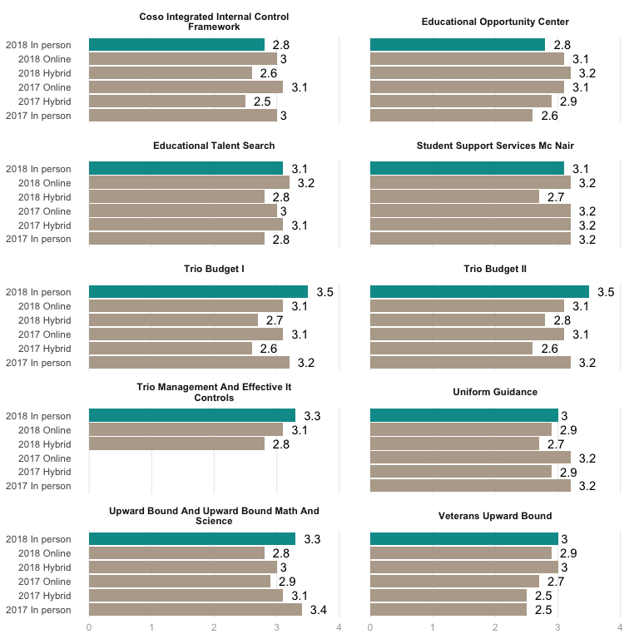

## If you rated low or medium on any of the items above, please mention why.

* COSO information was good in the handout but the presenter mentioned too much about his family and how little time we had to cover things but then didn’t hurry through the things that we actually needed to cover. It was basically a presentation that told you to read COSO but didn’t explain it in normal terms if you were not an accountant, which is what we needed.
* My professional background is not in accounting or auditing and I am new to a grant program, so many of the terms used during the COSO and uniform guidance did not make complete sense(even after providing examples). I will need to do additional research to get a better understanding.
* The TRIO management was great, perhaps because I deal with that on a daily basis. The Effective and IT Controls, it is really not something I deal with on a daily basis. It is the purview of the University of Kansas. Thus, my medium rating. Great presenter, though.
* Too technical not specific enough to TRIO. This would be great for general college accounting staff but not TRIO staff. For example Giving information such as a number for indirect costs at 10% is very misleading. I’m glad I know that it is 8% for TRIO.
* Less specifics were provided. More general budget intro info. Nothing really on specific internal controls. But also, please realize I am new to budget, so i was slower picking up some details.
* It was pretty general. Maybe I knew more than I thought. Again would have liked to had copies of the sections that pertain to SSS and given scenarios to work through.
* Some of the presentations weren’t very specific to TRIO programs in my estimation.
* I really like a high level of applicability through examples.
* IT info was good but was too lazy g and not specific to SSS.
* Would like to have gone more in depth maybe working samples
* I did not retain any info on veterans UB…
* Content covered in breakout sessions

## To what extent were your general expectations of the training met?

* It was a very well thought training. I missed the first day so I’m looking forward to getting the link so I can increase my knowledge. I found everything very pertinent to my job, even though I am not a TRIO staff member.
* I thought it was worth while. I would have liked to have more of a hands on experience working with regulations and what we are allowed to do. Ex. Scenarios now justify why we can do such activity and cite rule.
* My expectations were met by attending this training. I learned a great deal more about legs. & regs and how they specifically relate to TRIO budget.
* As a new employee, I was prepared to absorb all information. On the whole, the training met my expectations by increasing my knowledge in all areas.
* Very much. I did not know anything of the subjects covered, but I now know a lot more about the different rules and regulations behind the programs.
* This was different than any other TRIO training I’ve attended so I’d say my expectations were met though in a way different than I anticipated
* My general expectations of learning about budgets, legislation, and regulations were met.
* My expectations were met beyond of what I thought I will learn before the training.
* Medium - We talked at high level about best practices, but less about specifics.
* I expected greater depth into the legs and regs so my expectations were not met
* Way above average. They were organized, great speakers and information.
* The second and third days of the training were more what I expected.
* They were met, would loved to be able to some working examples.
* I thought that it was more comprehensive that I anticipated
* This training went beyond what I expected!
* My expectations are definitely met.
* Expectations generally met.
* They were met
* All of them.
* Completely
* Exceeded

## Please mention three (3) main take aways from the overall training

* Internal Controls do not have to be overwhelming, they can be implemented as regular checks and balances. I have confirmed our processes are on track with regulations. I feel much more confident about OMB and how to prepare for an audit. I learned that audits can be self or peer performed and can be a form of program evaluation rather than a penalty.
  1. Affirmation of the importance of attending training no what how long you have been in the business. 2. Quality sessions. 3. Dedicated and knowledgeable trainers.
* Internal controls are important, SSS students cannot also be counted for McNair at the same time, and the importance of networking with other programs.
* Conversation among peers is good, have our internal auditor perform trainings on campus, it’s great hearing audits from an auditor’s point-of-view
* Need to create a system that allows for tracking eligibility early on. Networking with other schools. Where to go find answers.
* Allowable and unallowable expenses, when prior approval is required, the requirements of the various programs.
* The need for IT protections. The importance of documentation. Be audit ready, even if I don’t get audited.
* Allowable and unallowable costs, coso, and additional readings for myself (EDGAR, OMB, etc.)
* What COSO is, what more understanding of Uniform Guidance, and effective IT controls.
* Importance of knowing the legislation, allowable and unallowable costs, networking
* Networking and diverse strategies of facilitating programs; internal controls
* Students should not be in both sss n mcnair, about good winks, the pyramid
* TRIO - what is it! Cyber Security and protocols, OMB relativity.
* Allowable/Unallowable; Internet Security; BIUB organization
* Internal controls, peer resources, budget spreadsheet
* Awareness of areas I need more infor/research in.
* Networking, examples of budget tracking and COSO
* Cyber security, Budget management, Networking
* COSO framework, IT security applicability
* IT, training resources, audits

# Satisfaction with Aspects of the Training

## Please rate the following aspects of the overall training

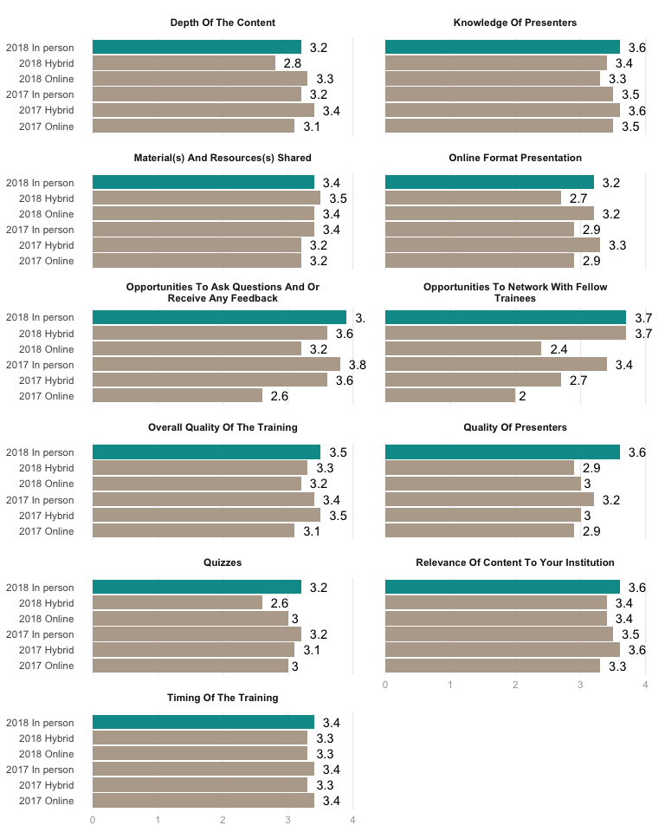

## If you rated low or medium, please mention why.

* The trainings varied from day to day. I thought the program specific session was great as were the budget sessions. The first day, however, was not very helpful.
* The quizzes were more a fun activity, nice touch, but not what I would consider “testing” really.
* Should have been more in depth into the legs and regs
* I like lots of scenarios and examples.
* My expections may have been to high.

# Knowledge Growth

Below are the results for the pre and post self-assessments of participant knowledge in various areas. The larger the gap between the red and blue dots, the greater the knowledge growth that occured for participants.

## geom_path: Each group consists of only one observation. Do you need to  
## adjust the group aesthetic?

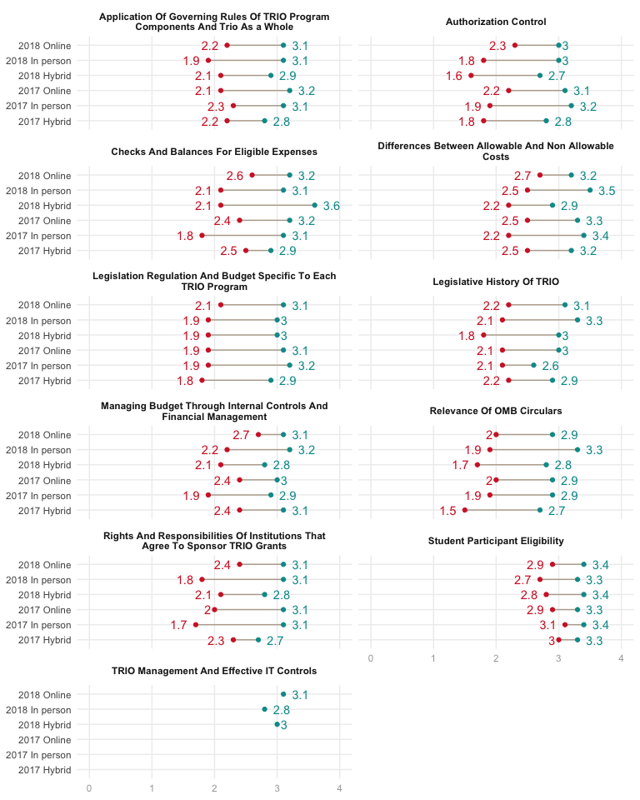

# General Feedback

## Are there any additional topic(s) that could be added in future training(s)?

* Maybe real life scenarios, 10, discussion relevant to each position in split outs
* Less talk about ITS and Auditor portion more about a trio audits and senerios
* More trio specific details about implementing internal controls.
* More coverage on Uniform Guidance Cost Principles
* I would like to cover Peer Audits a bit more.
* Maybe offer 2 break out sessions; one
* Not that I can think of.
* Nope! Great coverage!
* Not at this time.
* TRIO Legislation

## Would you like a follow-up training session on the same topic(s)?

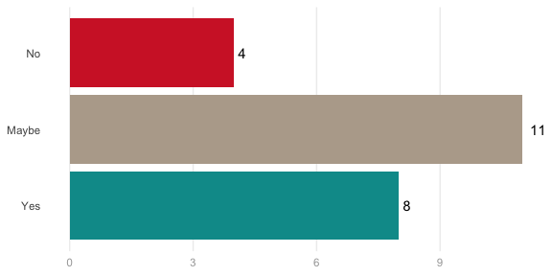

## Will you recommend this training to your colleague(s)?

