1 docker compose version
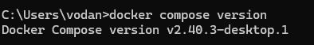
2 docker compose up
3 docker compose up -d
4 docker compose ps
5 docker compose down
6 docker compose restart
7 docker compose logs -f
8 docker compose build
9 docker compose exec <service_name> <command>
10 docker compose down -v
11 docker compose run <service_name> <command>
12 docker compose stop <service_name>
13 docker compose rm <service_name>
14 docker compose config
15 docker compose up -d --build

