Experiment 1
Backward elimination from full factorial model (AIC = -13,941, BIC = -13,568) with LRTs retained main effects plus spacing x width interaction (final model: AIC = -13,979, BIC = -13,886). RM trials (M = 0.004, SE = 0.006) differed significantly from No-RM trials (M = -0.021, SE = 0.006), z = -11.60, p < 0.001, d = 0.358, 95% CI [-0.030, -0.021].
RM trials did not differ significantly from zero, z = 0.79, p = 0.430, 95% CI [-0.007, 0.016].
No-RM trials differed significantly from zero, z = -3.74, p < 0.001, 95% CI [-0.032, -0.010].
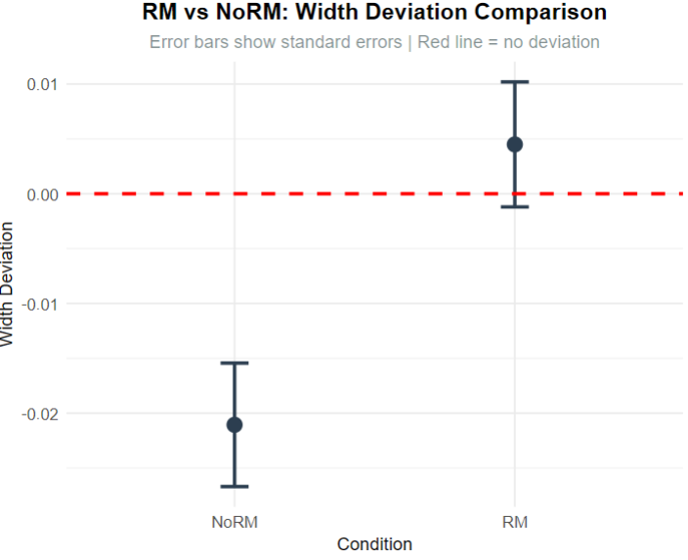
Experiment 2
Backward elimination from full factorial model retained main effects, all 2-way interactions, and three 3-way interactions. Elimination stopped at Step 2 after removing only “RM x spacing x set size” (final model: AIC = -9646). Final model retained three-way interactions indicating RM effects varied significantly by experimental conditions (set size × width combinations).
RM vs NoRM effects examined across 9 set-size × width combinations with FDR correction for multiple comparisons. Significant RM effects found in 5 of 9 conditions (55.6%).
Largest RM effect: Set size 3, Width 0.55 (RM-NoRM = -0.101, z = -9.84, FDR p < 0.001).
Overall
- RM vs NoRM: z = -12.36, p < 0.001, d = -0.402, 95% CI [-0.048, -0.035].
- RM condition did not differ from zero: z = -0.32, p = 0.753, 95% CI [-0.018, 0.013]
- No-RM condition differed from zero: z = -5.74, p < 0.001, 95% CI [-0.059, -0.029]
Note: Individual condition tests represent averages across all experimental combinations.
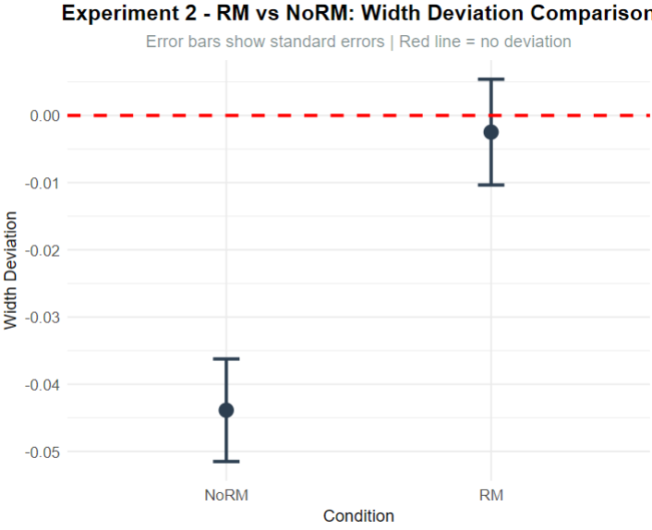

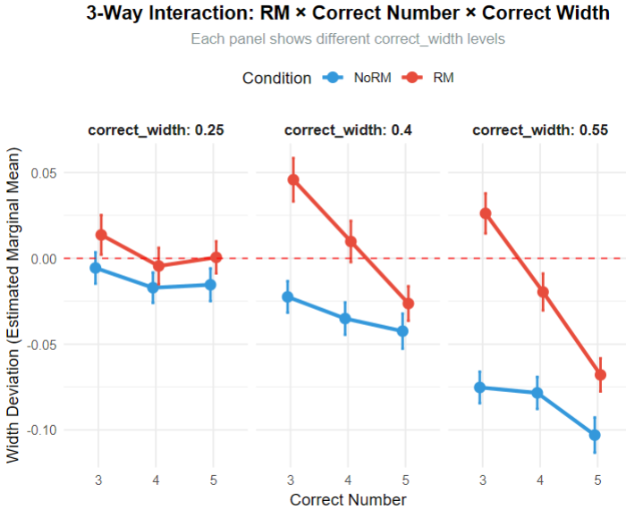
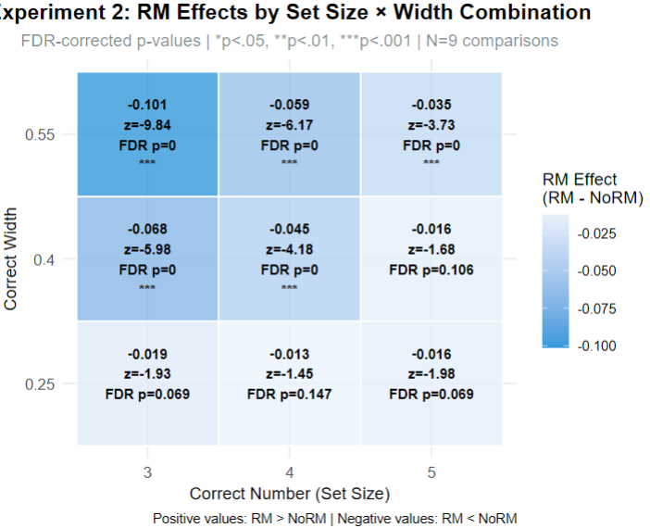
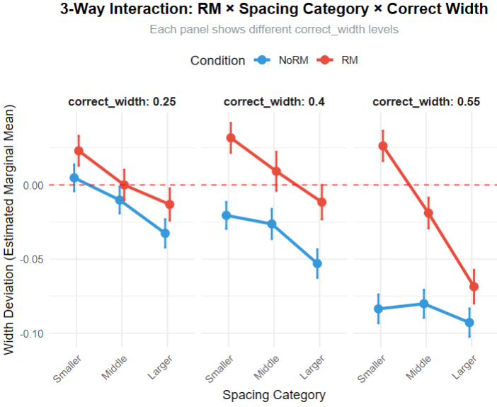
Experiment 3
Backward elimination from full 3-factor model retained 2-way interactions indicating RM effects vary by width conditions.
RM trials (M = 0.020, SE = 0.011) compared to NoRM trials (M = -0.015, SE = 0.011), differ significantly z = -13.69, p < 0.001, d = 0.415, 95% CI [-0.040, -0.030].
RM vs NoRM effects examined across 3 width conditions. Significant RM effects found in 3 of 3 width conditions.
Strongest effect: Width 0.4 (RM-NoRM = -0.049, z = -12.74, p < 0.001)
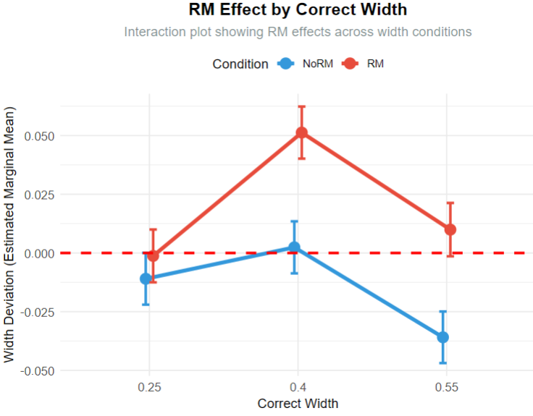

RM trials did not differ significantly from zero, z = 1.83, p = 0.068, 95% CI [-0.001, 0.041].
NoRM trials did not differ significantly from zero, z = -1.37, p = 0.172, 95% CI [-0.036, 0.006]. Note: Individual condition tests represent marginal averages
