Weather Route

Weather Route is a custom Google map that allows the user to generate route information with weather forecasts for up to 14 days out. You are limited to 10 waypoints on your route. It can happily run on a local computer or be served up on a web server. Whatever it is running on, it must have high-speed internet access to run properly.

These instructions will show you how to use it on a local web connected Windows pc. To load it on a web server, please contact your web admin for more information on setting up websites on a server.

To get started, download proj.zip and place it in your “My Documents” folder. Unzip the file there (including subfolders, the existing directory structure must stay intact). Then just load index.html in current versions of any browser (tested on latest versions of Chrome, Firefox, IE11). I recommend using Chrome, as it seems to give the best perfomance.
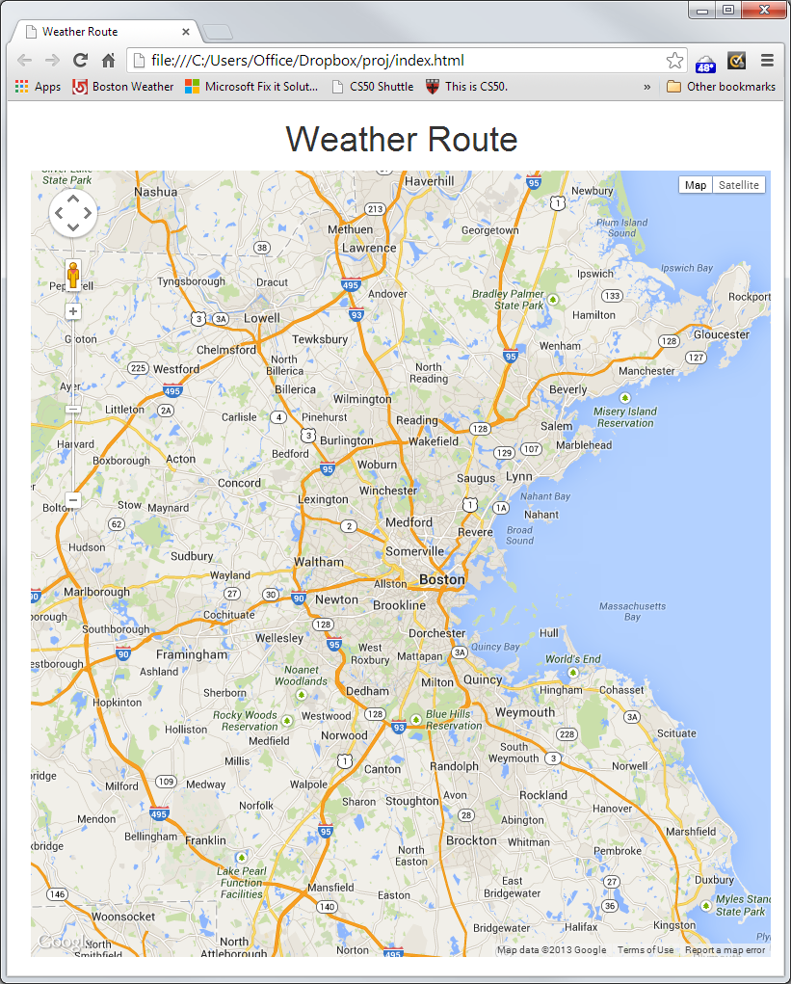

When the page loads you will be presented with a 2d google map of the Boston area. You can use the standard Google maps navigation buttons to pan and zoom the map. Click on the map to set your starting point for your trip. A marker will appear. You can click on this marker to see weather information (They default to today’s weather). If you hover over any marker you will get the stop number as well as detailed address information for that stop.

Pan and zoom, using your mouse on the Google map, to your next destination and click the map again. A route will appear on the map. You can continue this last step and add up to ten waypoints on your map. The first marker is always the origin of your trip. The last marker is your final destination. Select any locations within the USA.
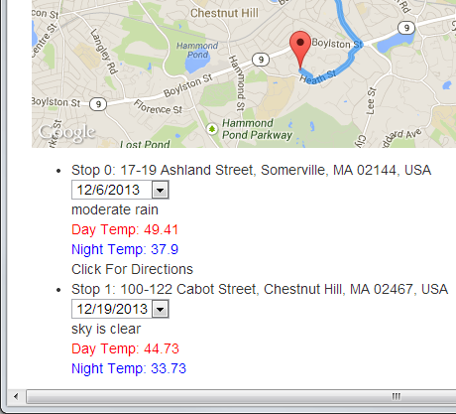

Once you have added at least 2 waypoints, and you have a route on the map, you can scroll down to view details about your trip. This is where you set the date for each waypoint. The display will update to weather information for that date in that location (weather provided by openweathermap.org). Now, if you click on any of the markers on the map, the weather pop up will reflect your chosen date specific weather.

Below all stops, except the final destination, there is a link labeled “Click For Directions”. If you click this link then Google turn-by-turn directions for each leg will appear below.

Use your browsers print functionality to print your map and information (with or without directions showing), if you wish (usually ctrl+p).

Known Issues: If you are using the “HTTPS Everywhere” plug in on your browser, you must disable it. If you don’t, some of the google api’s won’t load properly, and nothing will happen when you click on the map. This does not work in IE9.

