# Using Trader Sentiment Analysis (TraderSA)

The Graphical User Interface (GUI) is designed to go from top to bottom in typical fashion with the user required to execute the desired and required functions. In most cases, predecessor functions are included in later functions where dependencies exist.

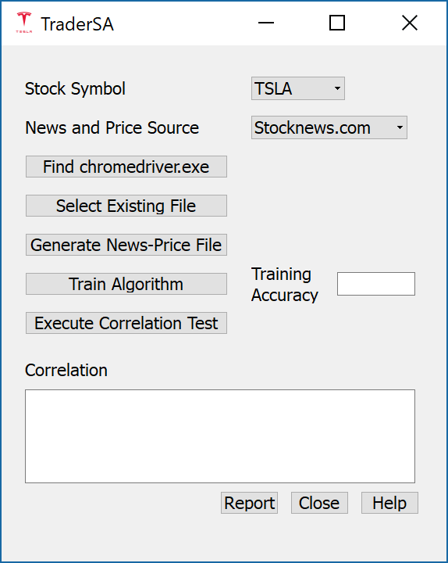

# Selecting Dependencies

Stock Symbol -

News and Price Source -

Find chromedriver.exe –

Select Existing File -

# Harvesting the Data

Generate News-Price File –

Train Algorithm -

# Correlation/Reporting

Execute Correlation Test –

Report –

# Supporting Features

Help –

Close –