OPEN WEATHER PROJECT

**Test Strategy**

**Revision History**

|  |  |  |  |
| --- | --- | --- | --- |
| Date | Version | Author | Description |
| 11/18/2021 | 0.1 | Quang | Draft |
|  |  |  |  |
|  |  |  |  |
|  |  |  |  |

Table of Contents

1. Scope 3

2. Test Approach 4

3. Test Environment 5

4. Test Tools 7

5. Defect report 8

6. Release Management 9

7. Risk Analysis 10

8. Review and Approvals 11

# Scope

OpenWeather is highly recognisable weather products that make working with the weather data a way easier.

Test team will validate and verify the requirement of the application

This document describes the following:

* Test approach
* Test environment
* Test tool
* Release management
* Risk analysis
* Review and approval

# Test Approach

* 1. **System Test:**

**2.1.1 Functional test:**

All pages of website should be tested.

The list of page need to be tested as below:

* 1. Landing page
  2. Guide page
  3. Pricing page
  4. Maps page
  5. Our Initiatives page
  6. Partners page
  7. Blog page
  8. Marketplace page
  9. Sign in page
  10. Support page

**2.1.2 Non - functional test:**

The scope of non-functional test as below:

* 1. Performance test
  2. Security test
  3. **Integration Test**

Execute API test for all APIs which are listed in API page

# Test Environment

The web application with URL: <https://openweathermap.org> and this website is used for both System test and Integration test

* 1. **System test**

Application will be tested on environment:

**3.1.1 Desktop:**

- All popular browsers are used to test:

+ Windows: Chrome/Firefox/Edge with latest version

+ Mac: Safari with latest version

**3.1.2 Mobiles:**

- Application are installed from market store and are tested with:

+ Android phone with latest OS version

+ Iphone with latest OS version

* 1. **Non-functional test**

Testing will be performed by Jmeter with distributed configuration with 1 Master and 5 Slave

These Jmeter application (latest version) will be installed on PC

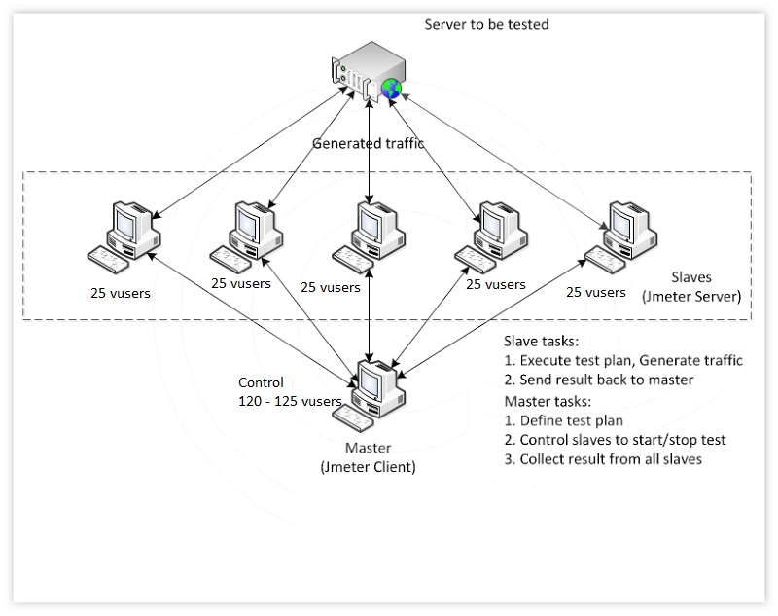

* 1. **Security test**

ZAP (latest version) will be installed on PC and used to scan vulnerability of web application

* 1. **Integration test**

Postman will be installed on PC and used to send and receive the response from the server

# Test Tools

The following tools will be used by the Test teams during Test Execution phases

| **No** | **Tool** | **Purpose** |
| --- | --- | --- |
| 1 | Chrome/Firefox/Edge/Safari | Web browser is used to test UI feature |
| 2 | Postman | Tool is used for API testing |
| 3 | Jmeter | Tool for performance test |
| 4 | ZAP | Tool for Security scan |
| 5 | Android phone | Test UI |
| 6 | Iphone | Test UI |

# Defect report

The defects will be reported via Jira Tool

Test team will track the defect via standard of defect tracking process with status such opened, fixed, resolved (valid or invalid), and closed.

Following is standard model for internal defect review in Test team, PM and Test Lead review before adding to report tool, then getting feedback from Dev/Client, update and tracking defect status accordingly.

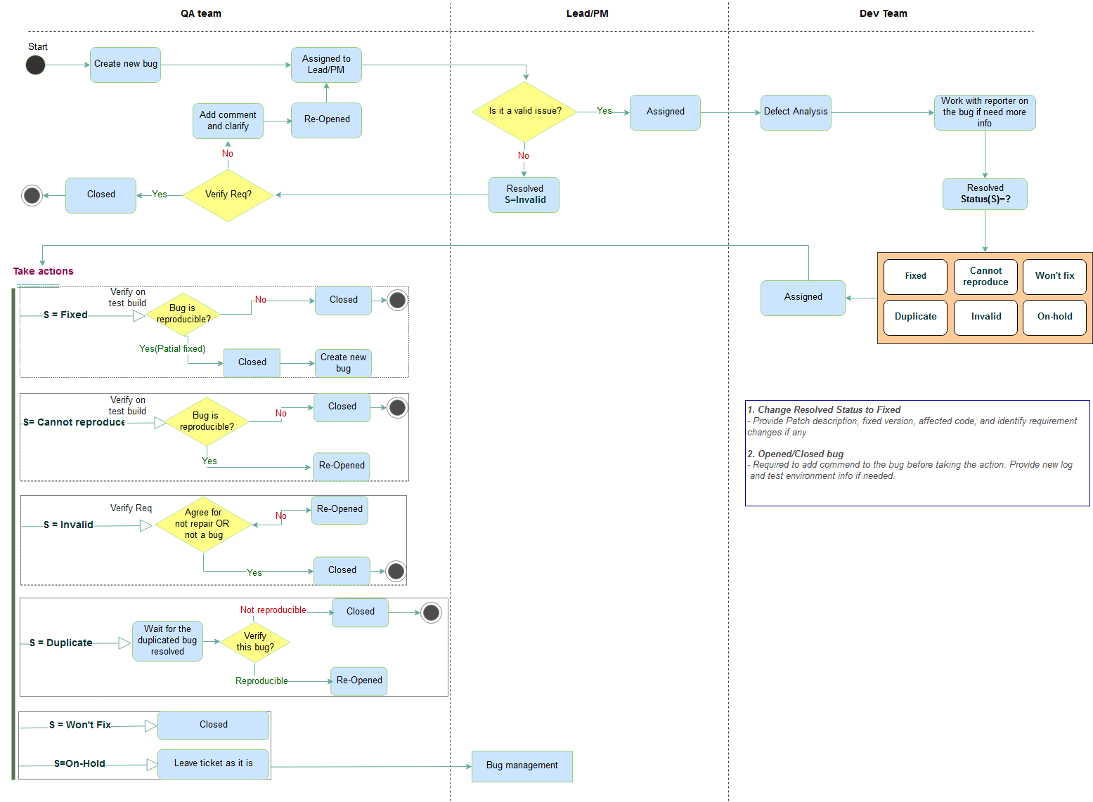

# Release Management

The below are the deliverables from the test cycles:

|  |  |  |
| --- | --- | --- |
| Document | Summary | Document Type |
| Weekly Status Report | Week Test Activities Report | Excel |
| Test Completion Report | A detailed report of the overall testing after completion | Excel |

# Risk Analysis

|  |  |  |
| --- | --- | --- |
| Risk | Mitigation Strategy | Contingency Plan |
| Requirement is so general, there are a lot of features | Try to explore to understand application better | TBD |

# Review and Approvals

Project Manager will review and ensure that all test cases should be executed and all severe bugs are fixed