Instructions…
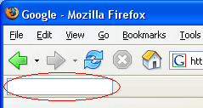
In this study, you will use words to do web browsing, rather than typing or clicking directly on web pages. There are 5 simple browsing tasks. Do the tasks by typing stuff into the command box shown here:

Each task is a picture of a web page with red circles showing what you have to do. For each red circle, type something into the command box to make it happen. Do not click or type anywhere but the command box. It's up to you to decide what to type into the command box.

Ok, let’s begin…

NOTE: you can press Ctrl-Space to bring the focus to the command box.

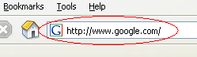
Task 1 of 5:
1.1

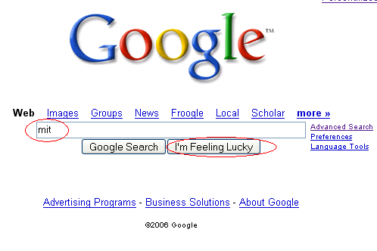

1.2
1.3

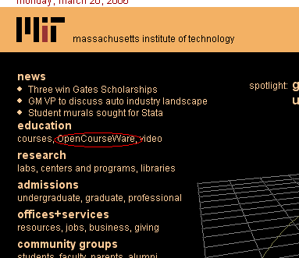

1.4



1.5

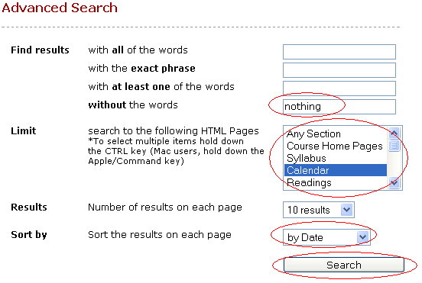

1.6

1.7

1.8

1.9

1.10

Task 2 of 5:
2.1

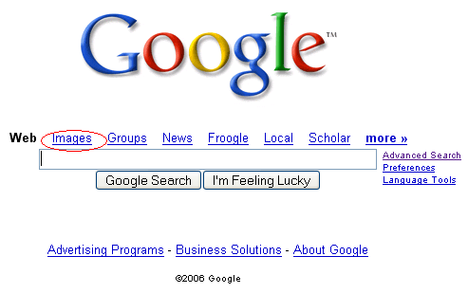

2.2

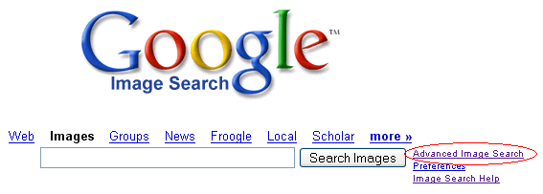

2.3

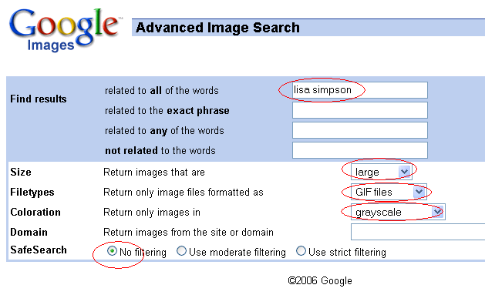

2.4

2.5

2.6

2.7
2.8

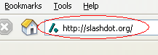
Task 3 of 5:
3.1

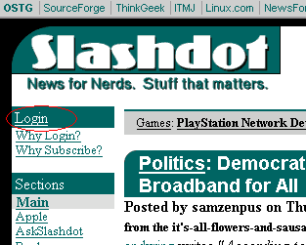

3.2

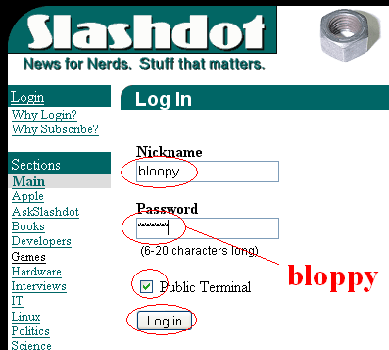

3.3

3.4

3.5

3.6

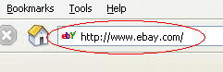
Task 4 of 5:
4.1

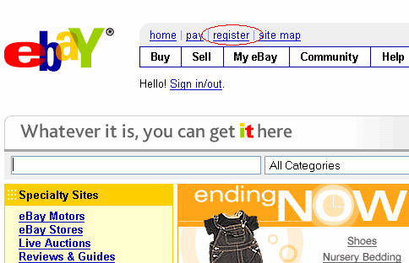
4.2

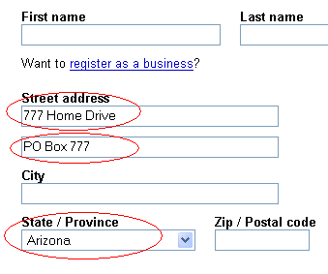

4.3

4.4

4.5

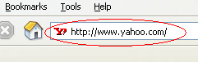
Task 5 of 5:
5.1

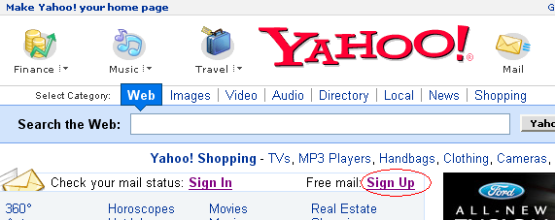

5.2



5.3

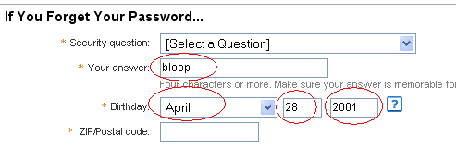

5.4

5.6
5.7
5.5

