原作者：Alex Birkett

原文地址：https://conversionxl.com/8-ways-to-measure-ux-satisfaction/

译者：kaishi

译文地址：

A good [user experience equals more money](https://conversionxl.com/great-user-experience-ux-leads-to-conversions/). But how do we measure user experience? How do we know if it’s getting better or worse?

良好的用户体验意味着更多付费，但是应该如何衡量用户体验呢？我们应该如何知道我们的用户体验是正在变好还是正在变坏呢？

**What is User Experience?**

There are many definitions for “user experience.” To keep things concise, [NN/g defines it like this](https://www.nngroup.com/articles/definition-user-experience/): “’User experience’ encompasses all aspects of the end-user’s interaction with the company, its services, and its products.”

**什么是用户体验？**

“用户体验”这个概念有很多定义，NN/g曾经给出过一个简洁的定义：“用户体验”包含终端用户与公司及其服务、产品进行互动的方方面面。

Continuing, it’s important to distinguish this from UI (user interface). Here’s a quote from Peep further defining UX:

然后，将UX(用户体验)与UI(用户操作界面)进行概念上的区分是非常重要的。下面是引用自Peep对UX（用户体验）的进一步定义：

**Peep Laja:**  
 “First of all, UI (user interface) is not UX (user experience). A car with all its looks, dashboard and steering wheel is the UI. Driving it is the UX. So the interface directly contributes to the experience (beautiful car interior makes a better experience sitting in one), but is not the experience itself.

Peep Laja:

首先，UI（用户操作界面）不是UX（用户体验）。举例来讲，一个车全部的外观、仪表盘、方向盘是它的UI(用界面)，驾驶汽车是它的UX(用户体验)。因此，用户界面直接影响用户体验，但其并不是用户体验本身。

Visual beauty is important for websites, but visual design is only one step in the process. A beautiful website might make a great first impression, but if it has terrible usability, users can’t figure out what to do, forms on the site don’t quite work, the error messages are not helpful and the copy on the website is vague, the overall experience will be quite bad.

漂亮的界面对网站很重要，但是视觉设计仅仅是良好用户体验的第一步。一个漂亮的网站或许能够给用户留下深刻的第一印象，但是如果其可用性差，用户不知如何找到自己需要的，网站上的表单也不起作用，错误提示信息没有用，网站上的副本也是模式的。那么网站的整体体验是很差的。

Experience is also personal and subjective – and is greatly affected by our past experiences, personal preferences, mood and a myriad of other things.”

体验是一个很个人的带有主观色彩的东西— —它与你过往经验、个人喜好、当时心情等等很多因素相关。

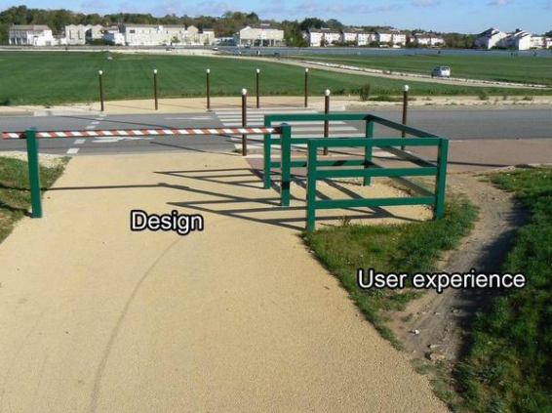

User experience is a subjective feeling, as each individual experiences the world through their own lens. The total experience of each user could depend on a variety of external factors, like how they began their day to their mood to their socio-economic status and so on.

用户体验是一个人的主观感受，每个人都从自己的角度去感受世界。每个人的总体感受取决于很多外界因素，比如他们的心情、社会经济状况等等情况。

Still, though, there are a variety of valid ways to measure usability and the overall user experience, and how people are interacting with each part of your site as well as holistically.

然而，仍然有许多方法可以衡量网站可用性和整体用户体验，以及用户如何与网站的整体或是部分进行互动。

**Why Measure User Experience?**

*“Measurement is the first step that leads to control and eventually to improvement. If you can’t measure something, you can’t understand it. If you can’t understand it, you can’t control it. If you can’t control it, you can’t improve it.”*

― H. James Harrington

为什么要去衡量用户体验？

衡量用户体验是控制和概述用户体验的第一步。如果你不能衡量某事，那你也不能理解他。如果你不能理解它，那你也不能驾驭它，如果你不能驾驭它，那你也不能完善它。

― H. James Harrington

There are lots of reasons to measure the user experience, the main one being that you can pinpoint problem areas and work to improve them.

我们有许多利用去衡量用户体验，但是最主要的一点就是我们能够找到问题所在然后致力于提升用户体验。

The other reason is to identify, quantify, and communicate UX to stakeholders. Finally, measuring user experience can give you greater clarity as to your positioning and competitive advantage.

另一个原因是向利益相关者定义、量化、识别用户体验。最后，衡量用户体验能让您更清晰您的定位和竞争优势。

[UsabilityGeek puts it well](http://usabilitygeek.com/usability-metrics-a-guide-to-quantify-system-usability/), saying that, “ultimately, the primary objective of usability metrics is to assist in producing a system or product that is neither under- nor over-engineered.”

UsabilityGeek上的一篇文章曾经提到，“最终，可用性度量的主要目的是保持产品设计的适度性-既要满足要求又不能被过度设计。”

There are many metrics used to measure UX. For this article, however, I’ll focus on [usability measurements for satisfaction](http://usabilitygeek.com/usability-metrics-a-guide-to-quantify-system-usability/). These break down more broadly into two categories: task level satisfaction and test level satisfaction.

有很多指标能够衡量用户体验，在这篇文章中，我将聚焦于用户满意度衡量。这些指标被分解为任务级别满意度和测试级别满意度两个维度。

**Task Level Satisfaction Measurements**

**任务级别满意度衡量**

For both types of user satisfaction metrics, the method by which these numbers are determined are short questionnaires. With task level satisfaction, users should immediately be giving a questionnaire after they complete a task (whether or not they manage to complete the goal).

对于这两种类型的用户满意度指标，确定具体数字的方法是短问卷调查。对于任务级别的满意度，用户应在完成一个任务后立即给出问卷（无论其是否完成目标）。

There are a few different types of these questionnaires, some more popular than others, but all attempt to gauge and quantify how difficult or easy it was to complete a certain task in a user test.

Some of the [more popular ones are](http://www.measuringu.com/blog/single-question.php):

* ASQ: After Scenario Questionnaire (3 questions)
* NASA-TLX: NASA’s task load index (5 questions)
* SMEQ: Subjective Mental Effort Questionnaire (1 question)
* UME: Usability Magnitude Estimation (1 question)
* SEQ: Single Ease Question (1 question)

这些问卷调查有几种不同的类型，比其他类型的问卷更流行。这些问卷调查都试图衡量或是量化用户测试中完成一项具体任务的难易程度。

方法如下：

* ASQ: 情景调查表（3个问题）
* NASA-TLX: 任务负载指数（5个问题）
* SMEQ: 主观心理调查问卷（1个问题）
* UME: 可用性评估（1个问题）
* SEQ: 单一易用性调查问卷（1个问题）

**1. After Scenario Questionnaire (ASQ)**

The [After Scenario Questionnaire](http://garyperlman.com/quest/quest.cgi?form=ASQ) features three questions, post-task:

[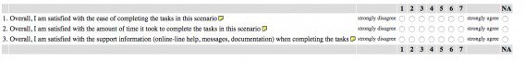](https://conversionxl.com/wp-content/uploads/2016/01/Screen-Shot-2016-01-25-at-9.27.04-AM.png)[Image Source](http://garyperlman.com/quest/quest.cgi?form=ASQ)

1、情景调查

情景调查是在用户完成任务后进行，包含三个问题：

* 总体上来讲，在此场景中，您对完成这个任务的难易度的评分
* 总体上来讲，在此场景中，您对完成任务所花时间的评分
* 总体上来讲，在此场景中，您对完成任务时所获支持（在线客服、提醒信息、帮助文档）的满意度评分

The ASQ is commonly used, and [research has supported](https://dl.acm.org/citation.cfm?id=122692) that it “ has acceptable psychometric properties of reliability, sensitivity, and concurrent validity, and may be used with confidence in other, similar usability studies.”

ASQ被广泛应用。研究表明这种方法能应用在在可靠性、敏感性、并发性等的衡量方面，而且它能够被应用在其他类似的可用性研究上。

**2. NASA-TLX**

The NASA-TLX is “a widely-used,[1] subjective, multidimensional assessment tool that rates perceived workload in order to assess a task, system, or team’s effectiveness or other aspects of performance.” It’s also been cited [in over](https://scholar.google.ca/scholar?cites=4762768246889591427&as_sdt=2005&sciodt=0,5&hl=en) 4,400 studies.

NASA-TLX是一个被广泛应用的主观多维度评测工具，用来评估工作量，其目的是评估一个任务，或是一个组织，或是一个团队的效率或是其他他们方面的表现情况。这种方法已经被4400项研究引用。

The questionnaire is broken into two parts, the first part being divided into six subscales that are represented on a single page:

这个调查问卷被分为两部分，其中第一部分由在一张纸上的6个子项组成。

[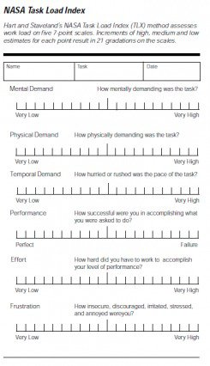](https://conversionxl.com/wp-content/uploads/2016/01/NasaTLX.png)[Image Source](https://en.wikipedia.org/wiki/NASA-TLX)

各项如下：

1. 此任务的精神消耗情况
2. 此任务的体力消耗情况
3. 此任务的时间紧张程度
4. 你在任务中的完成情况
5. 你在任务完成中的努力情况
6. 您的不安全感、挫败感、紧张感、压力、愤怒等的感觉情况

The next part lets the user weight the measurements based on what they thought was more important to the task.

第二部分则让用户根据自己认为的对这个任务比较重要的方面来衡量这个测评标准。

**3. Subjective Mental Effort Questionnaire (SMEQ)**

SMEQ is made up of just one scale, and it measures the mental effort that people feel was involved in a certain task.

According to [Jeff Sauro](https://twitter.com/MeasuringU) in [Quantifying the User Experience](https://books.google.com/books?id=QncH02-bvjoC&pg=PA214&lpg=PA214&dq=SMEQ+correlates+with+time&source=bl&ots=kkSLhNTymE&sig=Y7QHxFdIA2a6vX6hhr-yqlmERGo&hl=en&sa=X&ved=0ahUKEwiG2YDJgcTKAhWIKGMKHd3qCt0Q6AEIMDAC#v=onepage&q=SMEQ%20correlates%20with%20time&f=false), SMEQ correlates highly with SUS scores, as well as completion time, completion rates, and errors.

[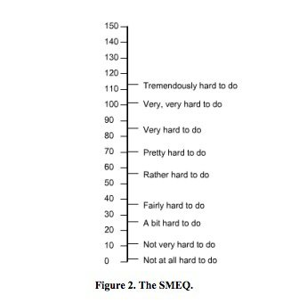](https://conversionxl.com/wp-content/uploads/2016/01/Screen-Shot-2016-01-25-at-9.31.12-AM-1.jpg)[Image Source](https://www.measuringu.com/papers/Sauro_Dumas_CHI2009.pdf)

SMEQ is easy to administer, and is [supported](https://www.ucc.ie/research/hfrg/emmus/methods/summary.html) by a good amount of research.