Contents

1.0 Introduction 1

1.1. Setting 1

1.2. Scene flow 1

2.0 Project plan 2

2.1. Initial Project Plan 2

2.2. Week 1 6

2.3. Week 2 8

2.4. Week 3 9

2.5. Week 4 10

3.0 Technical Element 11

3.1. Ray Tracing 11

4.0 Script 11

5.0 Unique Element 11

6.0 Summary 11

7.0 Future Work 11

8.0 References 11

8.1. Github 11

8.2. External References 11

8.3. Assets 11

8.4. Scripts 11

8.5. Report References 11

9.0 Appendix 11

# Introduction

## Setting

The scene will start with the player outside in a forest in a perpetual foggy night cycle with a spooky house in front of them, they will then approach the house triggering a floodlight. Upon entering the house the front door will lock and they will have to complete the following steps to escape the house and trigger a daytime cycle, completely changing the mood of the scene

## Scene flow

1. Approach house triggering floodlight.
2. Enter house and doors lock – loud clock ticking.
3. Go up stairs.
4. Cuckoo clock at top of stairs goes off when near dropping matches.
5. Enter bedroom, bedroom door locks.
6. Light fire in bedroom vase appears.
7. Exit bedroom via bathroom.
8. Drop vase from landing / stairs smashing to reveal lounge key.
9. Enter lounge – TV comes on and kitchen serving hatch flaps.
10. Pick up conservatory key.
11. Exit via the kitchen to the conservatory.
12. Exit conservatory triggering daytime.
13. Display Message – “You escaped!”
14. Look around house in daytime (if time).

# Project plan

## Initial Project Plan

Below is my initial project plan (Figure 2.1) on Trello (Atlassian, 2021) which is available at the following link - <https://trello.com/b/x2qX9eYN/p3d-asignment>.

All expandable cards are also shown below (Figures 2.2 – 2.7)

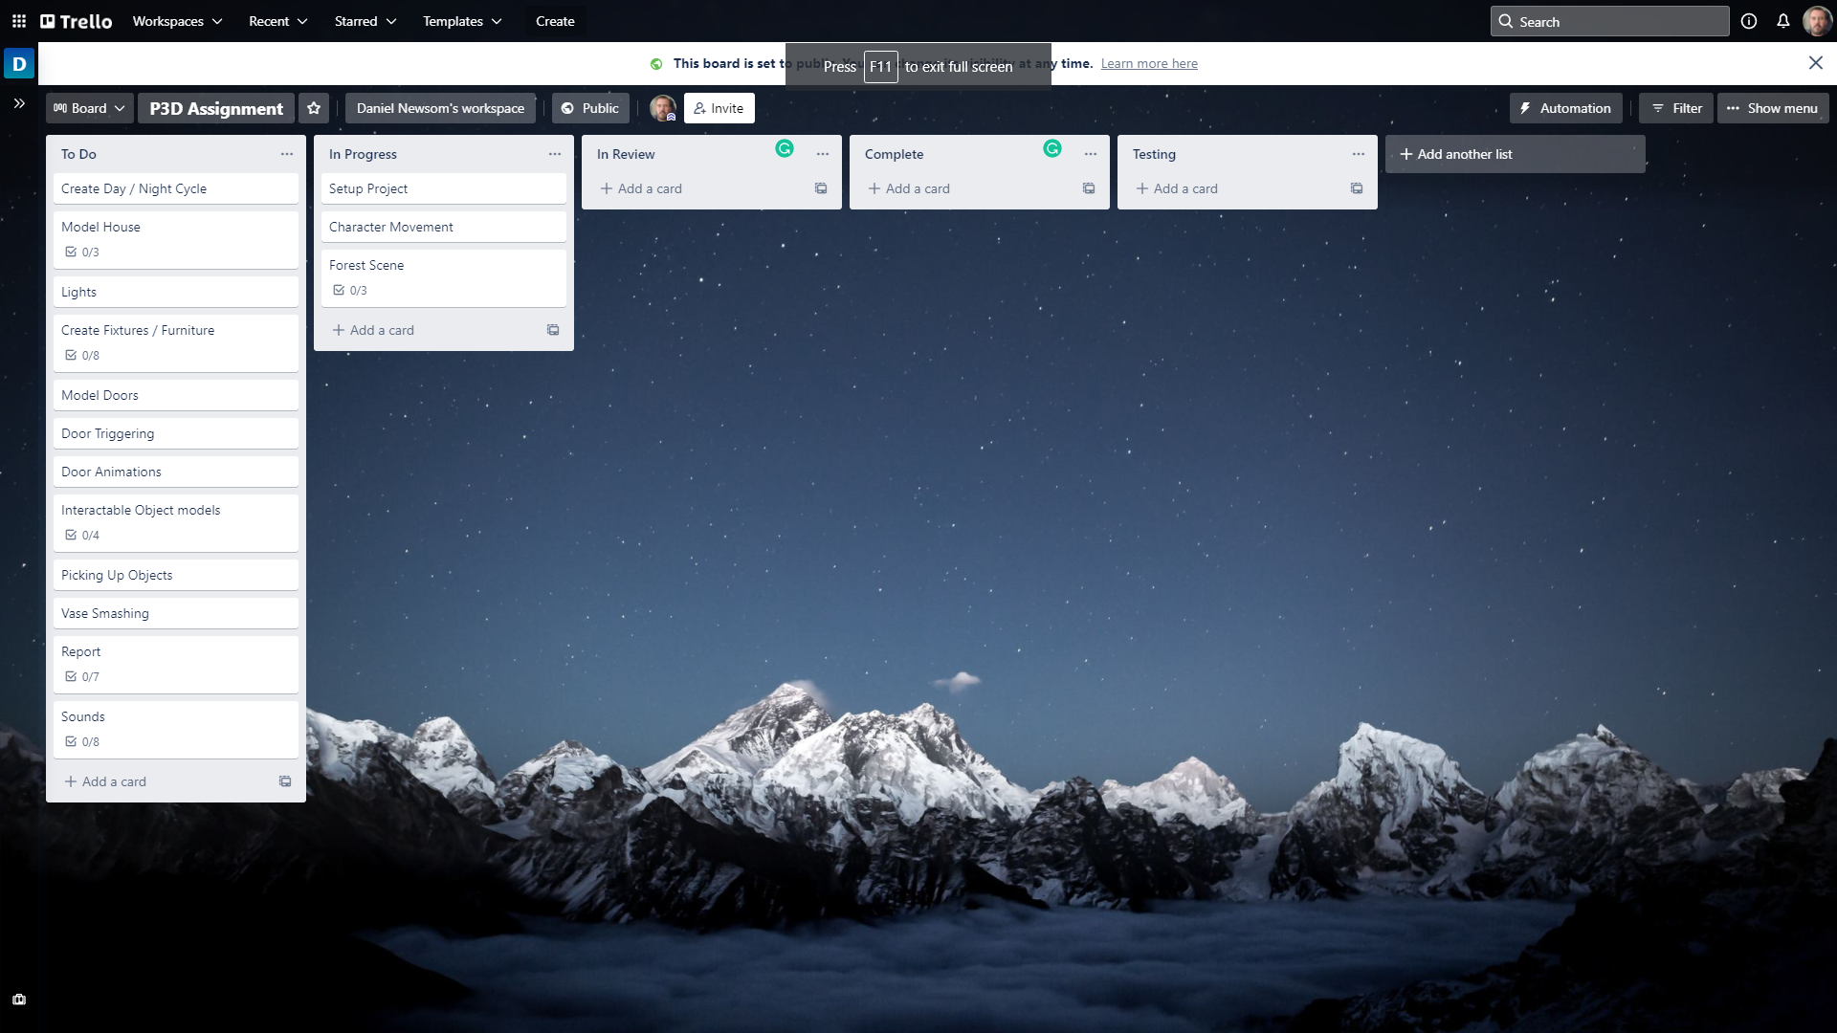

Figure 2.1 – Initial project plan on Trello (Atlassian, 2021)

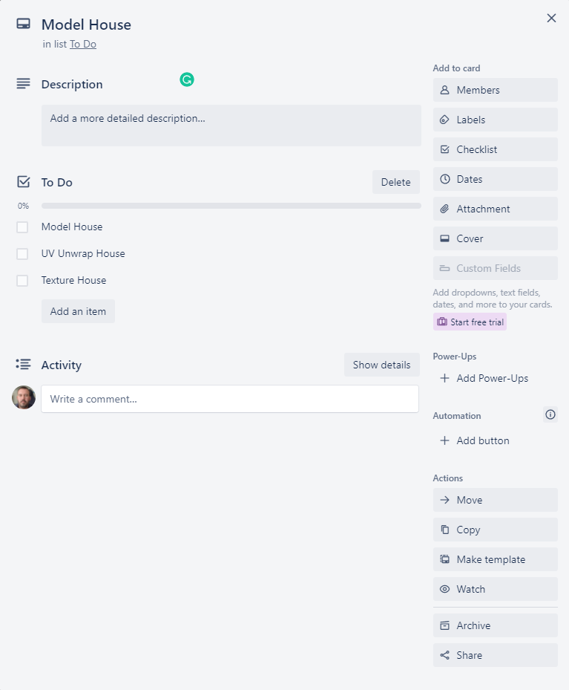

Figure 2.2 – Model house card

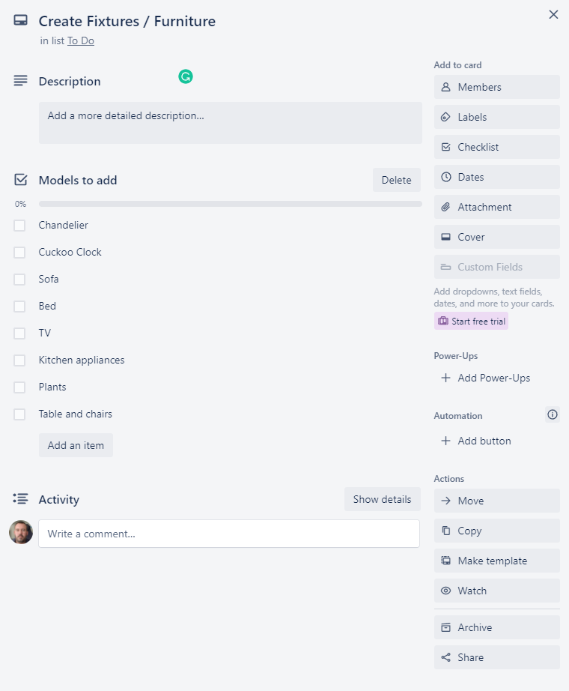

Figure 2.3 – Create Fixtures / Furniture card

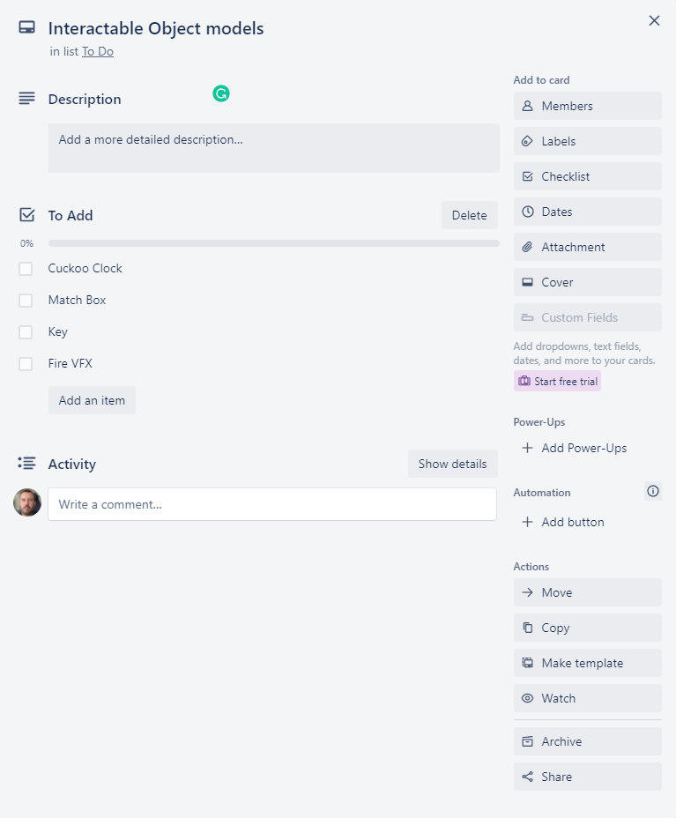

Figure 2.4 – Interactable Object Models card

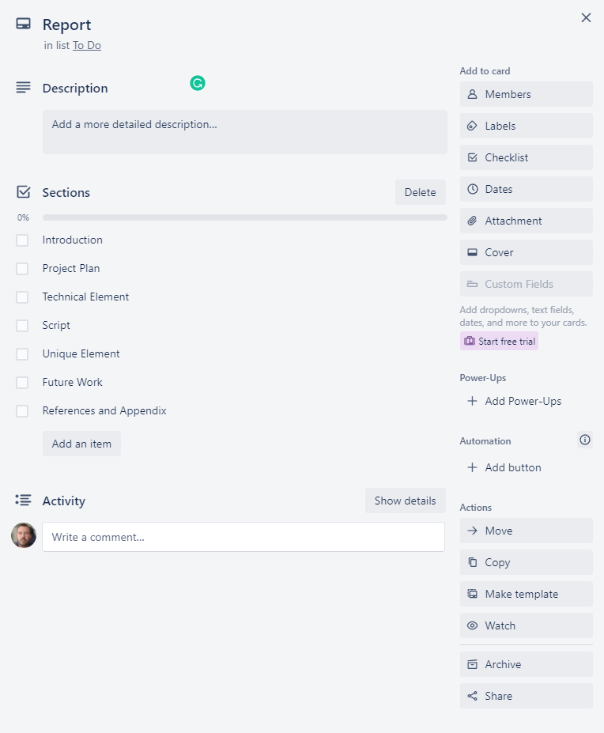

Figure 2.5 – Report card

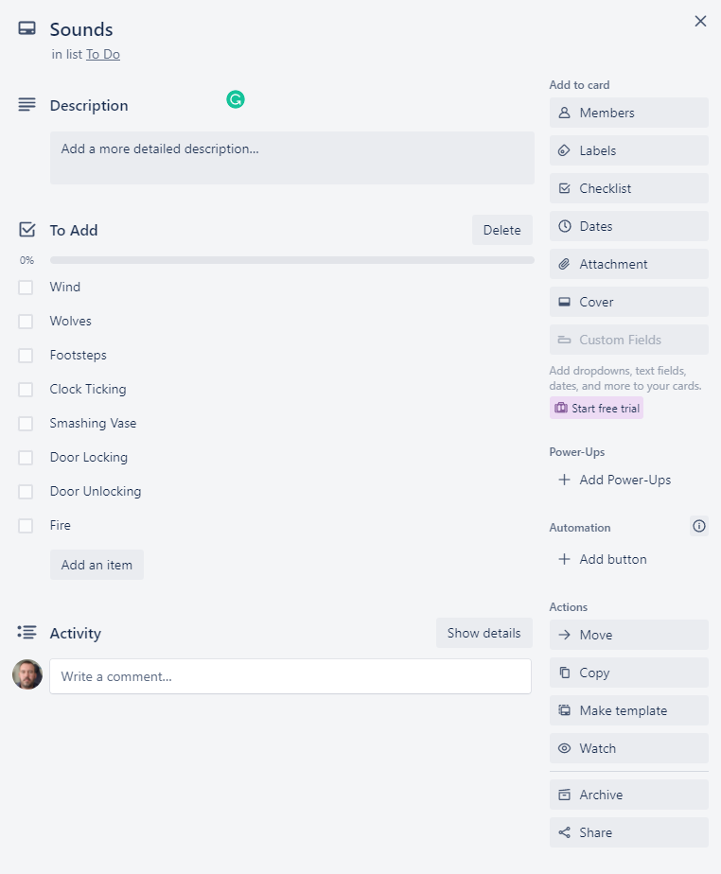

Figure 2.6 – Sounds card

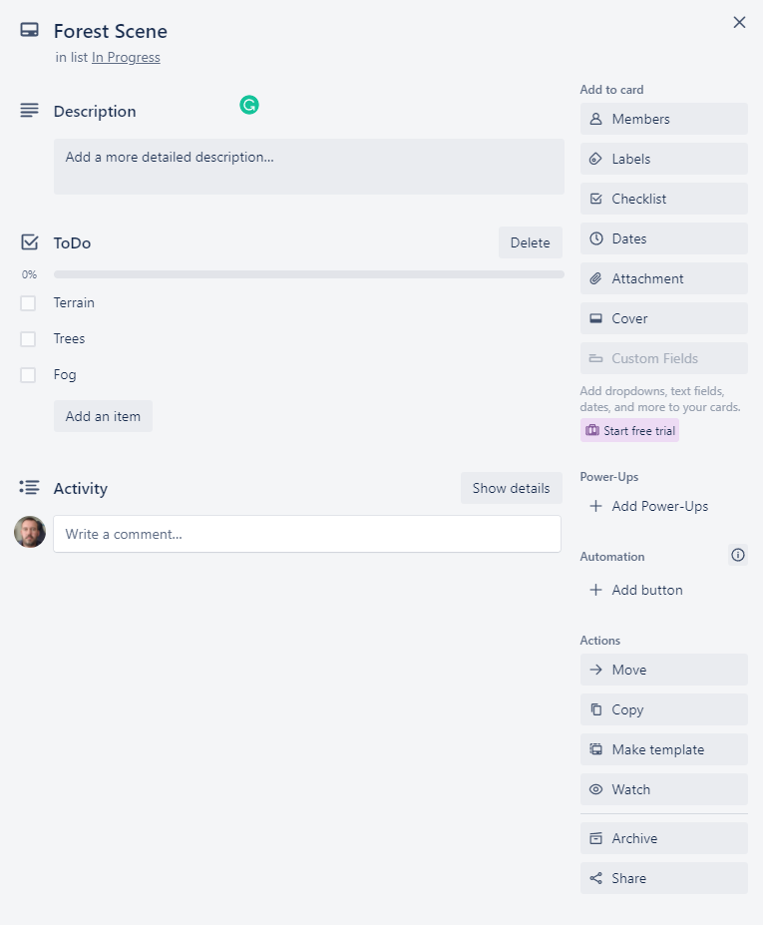

Figure 2.7 – Forest Scene card

## Week 1

The plan for week 1 is as follows

* Setup the Unity (Unity, 2021) project using the high definition render pipeline (HDRP).
* Create the main scene and add a Terrain.
* Paint textures on the terrain from the Forest Environment - Dynamic Nature (NatureManufacture, 2021) asset pack.
* Add Trees on the terrain using the Mountain Trees - Dynamic Nature (NatureManufacture, 2021) asset pack.
* Implement the characters movement using the Starter Assets - First Person Character Controller (Unity, 2021) as a base to build upon.
* Start Modelling house using Blender (Blender, 2021)

The updated Trello (Atlassian, 2021) board at the end of week 1 is shown below (Figure 2.8) as well as the relevant expanded forest scene card (Figures 2.9) and report card (Figure 2.10).

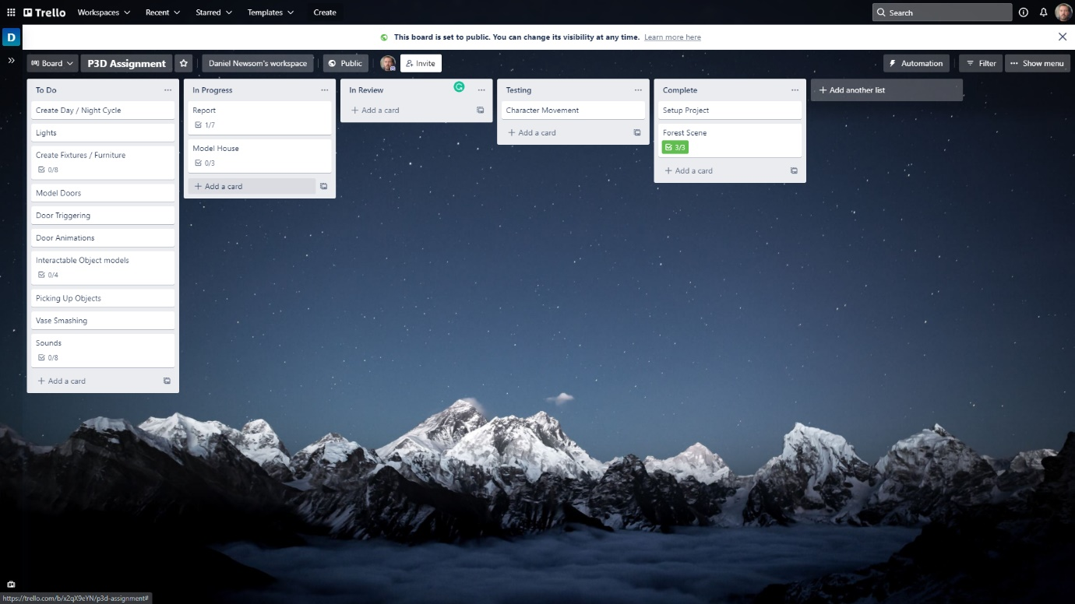

Figure 2.8 – Trello (Atlassian, 2021) board status at the end of week 1

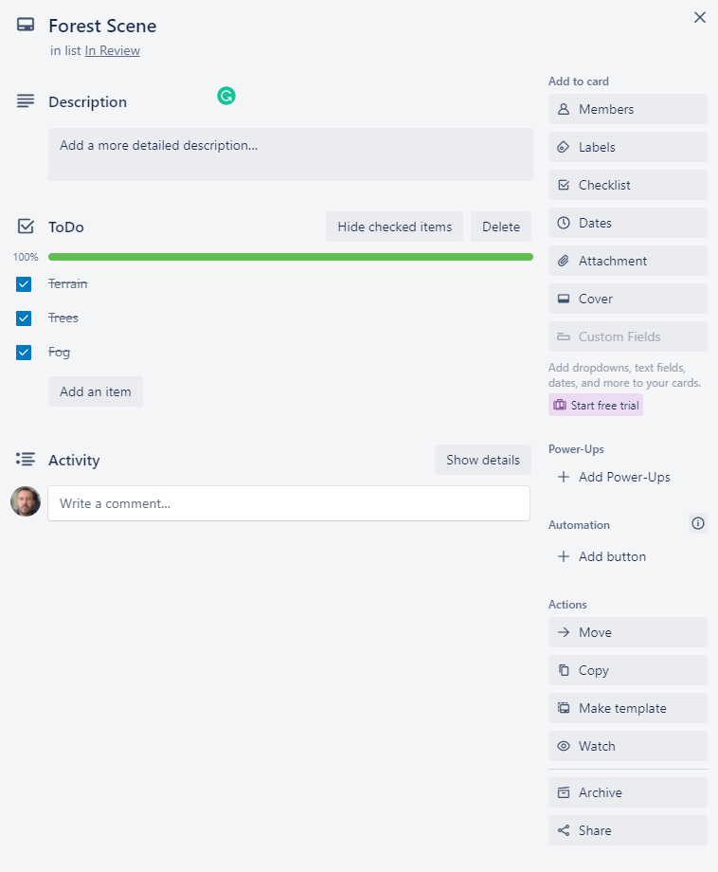

Figure 2.9 – Forest scene card updated

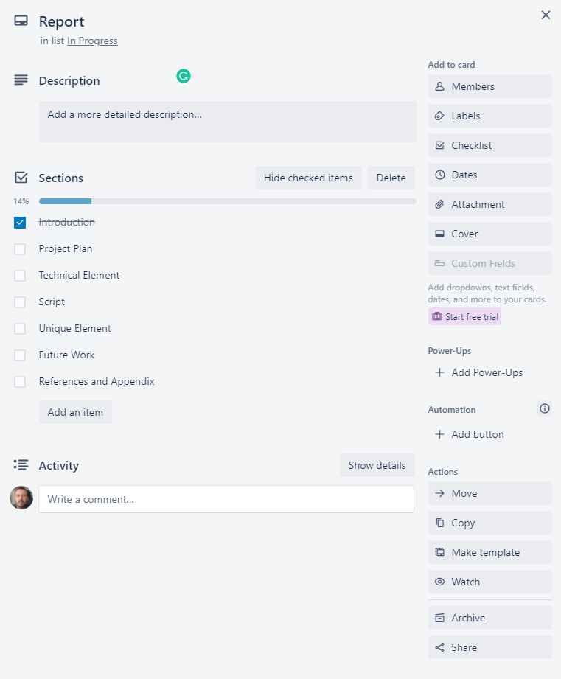

Figure 2.10 – Report card updated

## Week 2

The plan for week 2 is as below

* Finish modelling the house
* UV unwrap the house
* Add textures and materials to the house model
* Model the doors
* Animate the doors
* Add trigger scripts to the doors

The updated Trello (Atlassian, 2021) board at the end of week 2 is shown below (Figure 2.11) as well as the relevant expanded model house card (Figures 2.12)

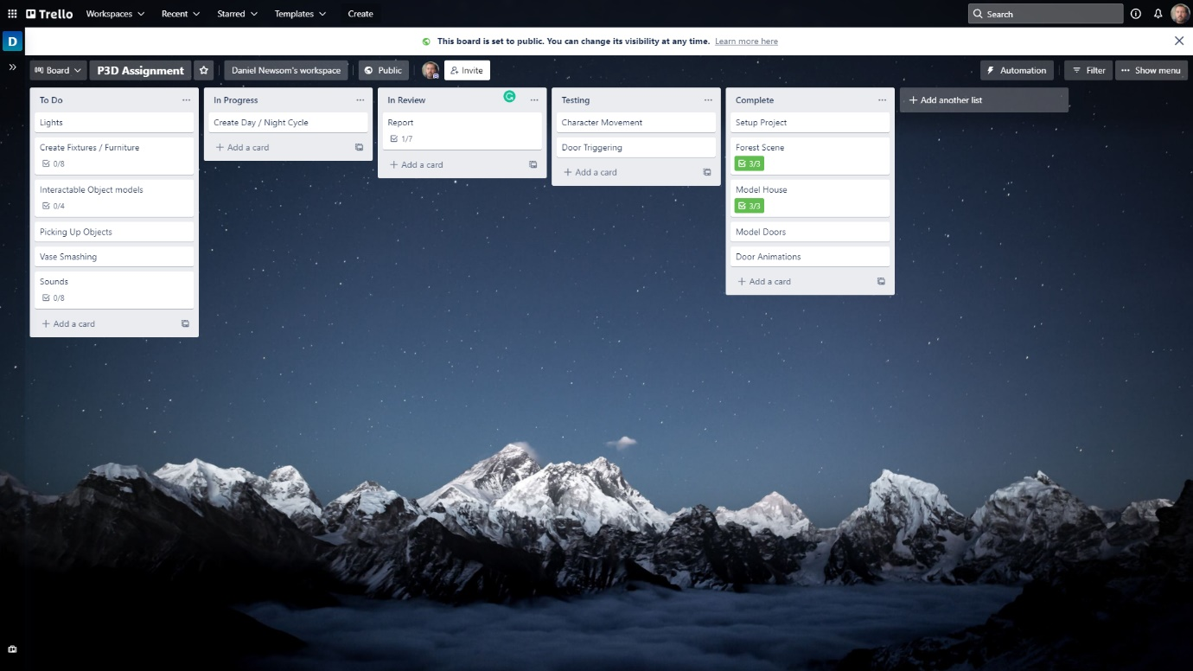

Figure 2.11 - Trello (Atlassian, 2021) board status at the end of week 2

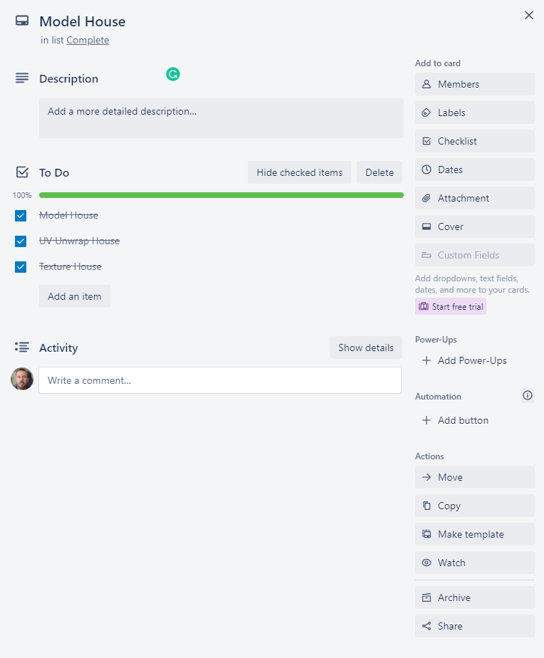

Figure 2.12 – Model House card expanded

## Week 3

The plan for week 3 is as follows

* Re-write introduction section of report
* Add chandelier model
* Animate chandelier model to sway
* Add light models to all other rooms
* Add / adjust lights to light models within Unity (Unity, 2021)
* Refactor Character controller script
* Start Day / Night Cycle animation and trigger.

The updated Trello (Atlassian, 2021) board at the end of week 3 is shown below (Figure 2.13) as well as the relevant expanded create fixtures / furniture card (Figures 2.14).

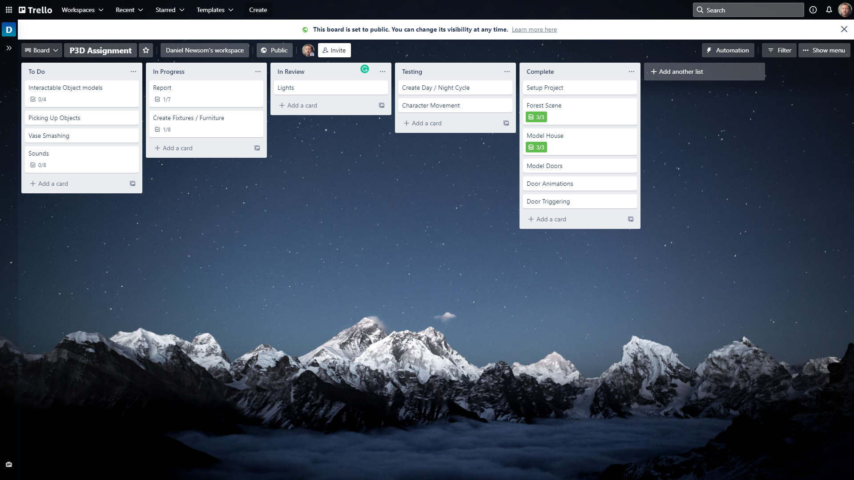

Figure 2.13 - Trello (Atlassian, 2021) board status at the end of week 3

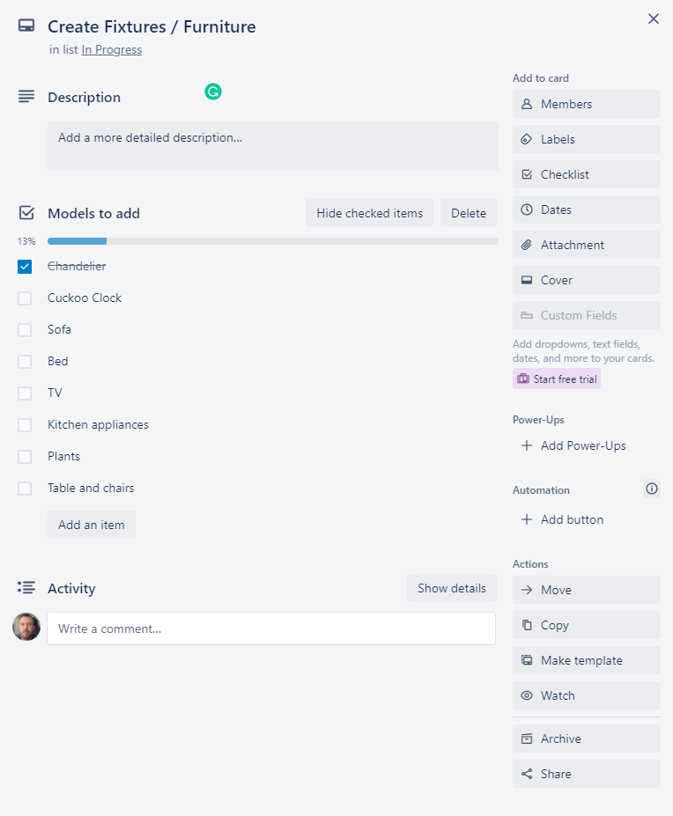

Figure 2.14 – Create Fixtures / Furniture card expanded

## Week 4

The plan for week 4 is as follows

* Model / add Interactable objects
* Start adding furniture (Priority Cuckoo clock)
* Implement picking up / using / throwing objects
* Add VFX fires and triggers

The updated Trello (Atlassian, 2021) board at the end of week 4 is shown below (Figure 2.15) as well as the relevant expanded create fixtures / furniture card (Figures 2.14).

# Technical Element

## Ray Tracing

# Script

# Unique Element

# Summary

# Future Work

# References

## Github

Main Github page - <https://github.com/dgnewsom>

Project Repository - <https://github.com/dgnewsom/215851_P3D>

## External References

Atlassian, 2021. *Trello.* [Online]   
Available at: https://trello.com/  
[Accessed 5 November 2021].

Blender, 2021. *Blender.* [Online]   
Available at: https://www.blender.org/  
[Accessed 5 November 2021].

NatureManufacture, 2021. *Forest Environment - Dynamic Nature.* [Online]   
Available at: https://assetstore.unity.com/packages/3d/vegetation/forest-environment-dynamic-nature-150668  
[Accessed 5 November 2021].

NatureManufacture, 2021. *Mountain Trees - Dynamic Nature.* [Online]   
Available at: https://assetstore.unity.com/packages/3d/vegetation/trees/mountain-trees-dynamic-nature-107004  
[Accessed 5 November 2021].

Unity, 2021. *Starter Assets - First Person Character Controller.* [Online]   
Available at: https://assetstore.unity.com/packages/essentials/starter-assets-first-person-character-controller-196525  
[Accessed 5 November 2021].

Unity, 2021. *Unity.* [Online]   
Available at: https://unity.com/  
[Accessed 25 November 2021].

## Assets

## Scripts

## Report References

# Appendix